***INDEX***

|  |  |  |
| --- | --- | --- |
| **SR. NO** | **TOPIC** | **PAGE NO.** |
| **01** | To learn and Perform addition operation for two 8-bit; sum is 8-bit and 16 bit respectively. | **02** |
| **02** | Perform subtraction operation of two 8-bit and 16-bit numbers. | **04** |
| **03** | Find 1’s complement of 8 bit number. | **05** |
| **04** | Find 1’s complement of 16 bit number. | **06** |
| **05** | Find 2’s complement of 8 bit and 16 bit number. | **08** |
| **06** | Find 2’s complement of 16 bit number. | **09** |
| **07** | Find sum of series of 8 bit numbers. | **11** |

**Practical No:-1**

**Aim** :-To learn and Perform addition operation for two 8-bit; sum is 8-bit and 16 bit respectively.

**Apparatus** :- 8085 Kit /GNUsim8085 software.

**Program:-**

|  |  |  |  |
| --- | --- | --- | --- |
| Memory address | Opcode | Mnemonics | Comment |
| 0800 | 3E 90 | MVI A,90h | Place 1st number in accumulator |
| 0802 | C6 90 | ADI 90h | Add 2nd number to accumulator & store the result in accumulator |
| 0804 | 0E 00 | MVI C,000h | Store value 00 in Register C |
| 0806 | 32 00 00 | STA 0000h | Store the content of Accumulator to address 0000 |
| 0809 | D2 0d 08 | JNC Loc1 | Jump to Loc1 if No carry. |
| 080C | 0C | INR C | Increment the value of Register C by 1. |
| 080D | 79 | Loc1:MOV A,C | Shift contents of register C to accumulator. |
| 080E | 32 01 00 | STA 0001h | Store the contents of Accumulator to address 0001. |
| 0811 | 76 | HLT | End of Program. |

**Procedure:-**

1. Switch on the power supply and kit will display “UP 8085”.
2. Press reset ~examine memory ~ program starting memory address ~ next ~ opcode ~ next and so on up to the end of program opcodes.
3. To execute the program press Reset ~ go ~ starting address ~ execute buttons
4. To check the result press Reset ~ examine memory~Memory address(where the result has beenstored in program) ~Next.

**Result:-**

We have seen the result 20 H at the memory address 0000H and carry 01H at the memory address 0001H , which is the addition of 90H and 90H.

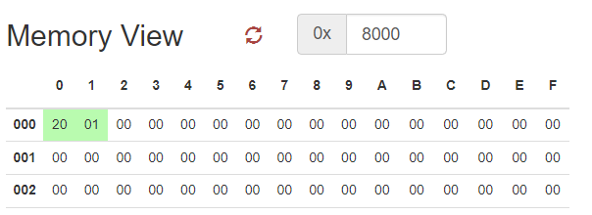

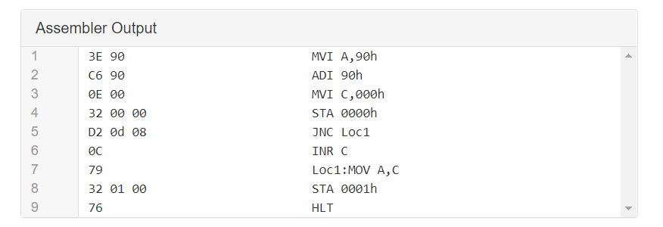

**Practical No:-02**

**Aim** :- Perform subtraction operation of two 8-bit and 16-bit numbers.

**Apparatus** :- 8085 Kit /GNUsim8085 software.

**Program:-**

|  |  |  |  |
| --- | --- | --- | --- |
| Memory address | Op code(HEX) | Mnemonics | Comment |
| 0800 | 3E 56 | MVI A,56h | Place 1st number in accumulator |
| 0802 | 06 40 | MVI B,40h | Place 2nd number in register B |
| 0804 | 90 | SUB B | Subtract B from accumulator and store result inaccumulator. |
| 0806 | 32 00 00 | STA 0000h | Store the content of Accumulator to address 0000. |
| 0809 | 76 | HLT | End of Program. |

**Procedure:-**

1.Switch on the power supply and kit will display “UP 8085”.

2.Press reset ~examine memory ~ program starting memory address ~ next ~ opcode ~ next and so on up to the end of program opcodes.

3.To execute the program press Reset ~ go ~ starting address ~ execute buttons

4.To check the result press Reset ~ examine memory~Memory address(where the result has beenstored in program) ~Next.

**Result:-**

We have seen the result 16 H at the memory address 0000H , which is the subtraction of 56H and 40H.

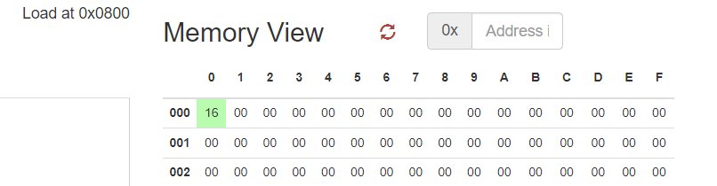

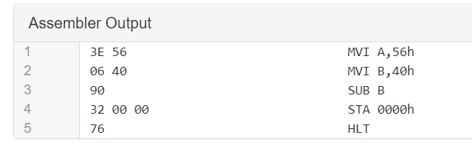

**Practical No:-03**

**Aim** :- Find 1’s complement of 8 bit number.

**Apparatus** :- 8085 Kit /GNUsim8085 software.

**Program:-**

|  |  |  |  |
| --- | --- | --- | --- |
| Memory address | Op code | Mnemonics | Comment |
| 0800 | 3E 20 | MVI A ,20h | Place 1st numbet in accumulator |
| 0802 | 2F | CMA | Complement the content of accumulator |
| 0804 | 32 00 00 | STA 0000h | Store the content of accumulator to address 0000 |
| 0806 | 76 | HLT | End of the program |

**Procedure:-**

1. Switch on the power supply and kit will display “UP 8085”.

2. Press reset ~examine memory ~ program starting memory address ~ next ~ opcode ~ next and so on up to the end of program opcodes.

3. To execute the program press Reset ~ go ~ starting address ~ execute buttons

4. To check the result press Reset ~ examine memory~Memory address(where the result has beenstored in program) ~Next.

**Result:-**

We have seen the result DF H at the memory address 0000H address , which is the 1’s complement of 20H.

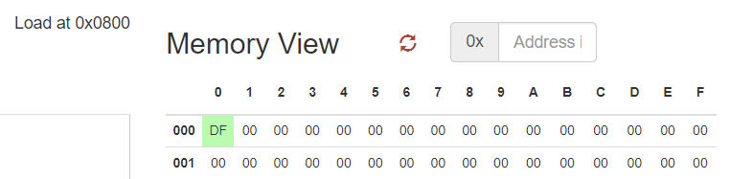

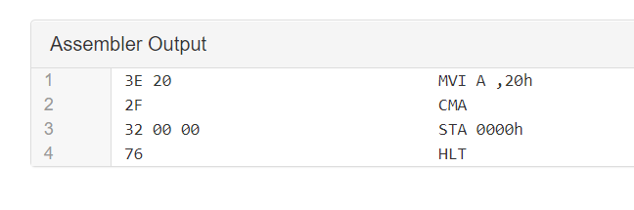

**Practical No:-04**

**Aim** :- Find 1’s complement of 16 bit number.

**Apparatus** :- 8085 Kit /GNUsim8085 software.

**Program:-**

|  |  |  |  |
| --- | --- | --- | --- |
| Memory address | Op code | Mnemonics | Comment |
| 0800 | 3E 25 | MVI A,25h | Place 1st number(MSB) in accumulator |
| 0802 | 32 00 00 | STA 0000h | Store the content of accumulator at adddress 0000 |
| 0805 | 3E 26 | MVI A,26h | Place 2nd number(LSB) in accumulator |
| 0807 | 32 01 00 | STA 0001h | Store the content of accumulator at adddress 0001 |
| 080A | 2A 00 00 | LHLD 0000h | Load H-L pair with address 0000. |
| 080D | 7C | MOV A,H | Place content of H in accumulator. |
| 080E | 2F | CMA | Complement the content of accumulator. |
| 080F | 67 | MOV H,A | Move the content of accumulator in register H. |
| 0810 | 7D | MOV A,L | Move the content of register L to accumulator. |
| 0811 | 2F | CMA | Complement the content of accumulator. |
| 0812 | 6F | MOV L,A | Move the content of accumulator in register L. |
| 0813 | 22 20 00 | SHLD 0020h | Store the content of H-L pair at address 0020. |
| 0816 | 76 | HLT | End of the program. |

**Procedure:-**

1. Switch on the power supply and kit will display “UP 8085”.

2. Press reset ~examine memory ~ program starting memory address ~ next ~ opcode ~ next and so on up to the end of program opcodes.

3. To execute the program press Reset ~ go ~ starting address ~ execute buttons

4. To check the result press Reset ~ examine memory~Memory address(where the result has beenstored in program) ~Next.

**Result:-**

We have seen the result DAD9 H at the memory address 0020H address , which is the 1’s complement of 2526H.

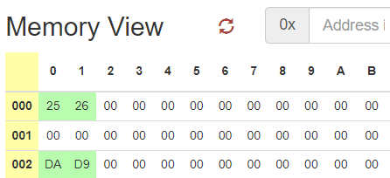

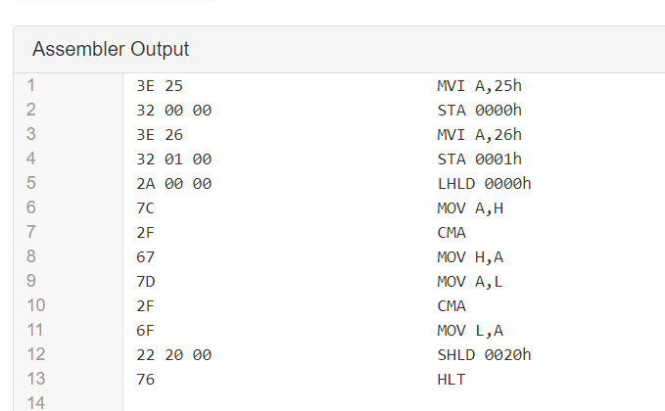

**Practical No:-05**

**Aim** :- Find 2’s complement of 8 bit number.

**Apparatus** :- 8085 Kit /GNUsim8085 software.

**Program:-**

|  |  |  |  |
| --- | --- | --- | --- |
| Memory address | Op code | Mnemonics | Comment |
| 0800 | 3E 20 | MVI A ,20h | Place 1st numbet in accumulator |
| 0802 | 2F | CMA | Complement the content of accumulator |
| 0804 | 32 00 00 | STA 0000h | Store the content of accumulator to address 0000 |
| 0806 | C6 01 | ADI 01 | Add 1 to content of accumulator. |
| 0809 | 32 01 00 | STA 0001h | Store the contents of accumulator to address 0001. |
| 080C | 76 | HLT | End of the program |

**Procedure:-**

1. Switch on the power supply and kit will display “UP 8085”.

2. Press reset ~examine memory ~ program starting memory address ~ next ~ opcode ~ next and so on up to the end of program opcodes.

3. To execute the program press Reset ~ go ~ starting address ~ execute buttons

4. To check the result press Reset ~ examine memory~Memory address(where the result has beenstored in program) ~Next.

**Result:-**

We have seen the result DF H at the memory address 0000H address and E0 at memory address 0001H , which is the 2’s complement of 20H.

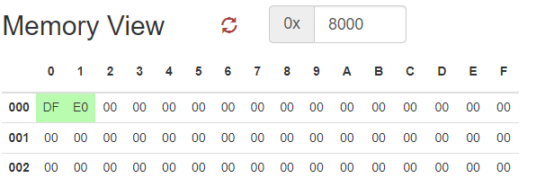

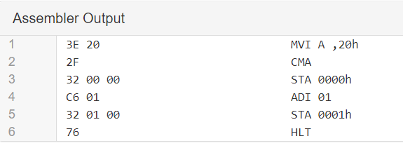

**Practical No:-06**

**Aim** :- Find 2’s complement of 16 bit number.

**Apparatus** :- 8085 Kit /GNUsim8085 software.

**Program:-**

|  |  |  |  |
| --- | --- | --- | --- |
| Memory address | Op code | Mnemonics | Comment |
| 0800 | 3E 26 | MVI A,26h | Place 1st no (LSB) to accumulator |
| 0802 | 32 00 00 | STA 0000h | Store the content of accumulator to address 0000 |
| 0805 | 06 00 | MVI B,00h | Move value 00 in register B. |
| 0807 | 3E 4f | MVI A,4Fh | Place 2nd no (MSB) to accumulator |
| 0809 | 32 01 00 | STA 0001h | Store the content of accumulator to address 0001 |
| 080C | 21 00 00 | LXI H,0000h | Load H-L pair with adderss 0000. |
| 080F | 7E | MOV A,M | Move the LSB to accumulator |
| 0810 | 2F | CMA | Complement the content of accumulator |
| 0811 | C6 01 | ADI 01h | Add 1 to accumulator. |
| 0813 | 32 21 00 | STA 0021h | Store the content of accumulator to address 0021 |
| 0816 | D2 1a 08 | JNC L1 | Jump direct to L1 if there is no Carry. |
|  | 04 | INR B | Increment in the value of register B. |
| 081A | 21 01 00 | L1:LXI H,0001h | Load H-L pair with adderss 0001. |
| 081D | 7E | MOV A,M | Move the MSB to accumulator |
| 081E | 2F | CMA | Complement the content of accumulator |
| 081F | 80 | ADD B | Add the content of register B to accumulator. |
| 0820 | 32 20 00 | STA 0020h | Store the content of accumulator to address 0021 |
| 0823 | 76 | HLT | End of program. |

**Procedure:-**

1. Switch on the power supply and kit will display “UP 8085”.

2. Press reset ~examine memory ~ program starting memory address ~ next ~ opcode ~ next and so on up to the end of program opcodes.

3. To execute the program press Reset ~ go ~ starting address ~ execute buttons

4. To check the result press Reset ~ examine memory~Memory address(where the result has beenstored in program) ~Next.

**Result:-**

We have seen the result B0DA H at the memory address 0020H address , which is the 1’s complement of 4F26H.

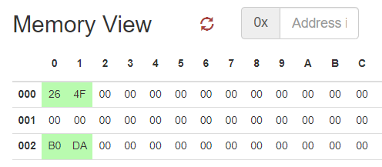

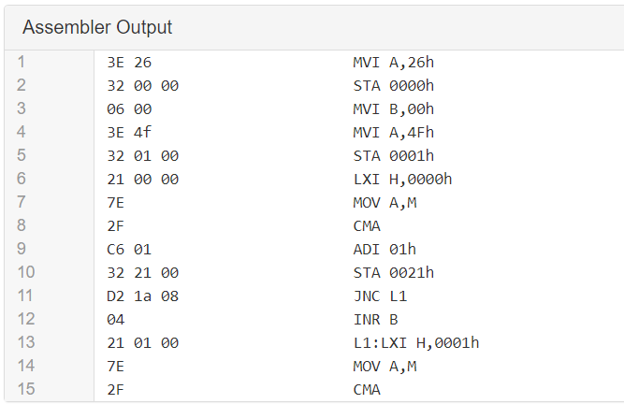



**Practical No:-07**

**Aim** :- Find sum of series of 8 bit numbers

**Apparatus** :- 8085 Kit /GNUsim8085 software.

**Program:-**

|  |  |  |  |
| --- | --- | --- | --- |
| Memory address | Op code(HEX) | Mnemonics | Comment |
| 8000 | 3E 04 | MVI A,04h | Place the number i.e.count of numbers which we want to add in accumulator. |
| 8002 | 32 00 00 | STA 0000h | Store the content of accumulator to adderss 0000. |
| 8005 | 3E 05 | MVI A,05h | Place 1st number in accumulator. |
| 8007 | 32 01 00 | STA 0001h | Store the content of accumulator to adderss 0001. |
| 800A | 3E 09 | MVI A,09h | Place 2nd number in accumulator. |
| 800C | 32 02 00 | STA 0002h | Store the content of accumulator to adderss 0002. |
| 800F | 3E 52 | MVI A,52h | Place 3rd number in accumulator. |
| 8011 | 32 03 00 | STA 0003h | Store the content of accumulator to adderss 0003. |
| 8014 | 3E 80 | MVI A,80h | Place 4th number in accumulator. |
| 8016 | 32 04 00 | STA 0004h | Store the content of accumulator to adderss 0004. |
| 8019 | 21 00 00 | LXI H,0000 | Load H-L pair with adderss 0000. |
| 801C | 4E | MOV C,M | Move the counter form memory to register C |
| 801D | 3E 00 | MVI A,00 | Initilize the value of A with 00**.** |
| 801F | 06 00 | MVI B,00 | Initilize the value of A with 00**.** |
| 8021 | 21 01 00 | LXI H,0001 | Load H-L pair with adderss 0001. |
| 8024 | 86 | Loc1: ADD M | Add the value of memory pointer to accumulator |
| 8025 | D2 29 08 | JNC Loc2 | Jump directly at Loc2 if No carry |
| 8029 | 04 | INR B | Increment the value of register B |
| 802A | 23 | Loc2: INX H | Increment of H-L pair. |
| 802B | 0D | DCR C | Decrement the value of register C. |
| 802E | C2 24 08 | JNZ Loc1 | Jump directly at Loc1 if value of register is Non Zero. |
| 8031 | 32 08 00 | STA 0008 | Store the content of accumulator to adderss 0008. |
| 8032 | 78 | MOV A,B | Move the content of register B to accumulator. |
| 8035 | 32 09 00 | STA 0009 | Store the content of accumulator to adderss 0009. |
| 8036 | 76 | HLT | End of the program. |

**Result:-**

We have seen the result E0 H at the memory address 0008H address and 00 at memory address 0009H because there is no carry.

