This is homepage of web application Customer Relationship Management

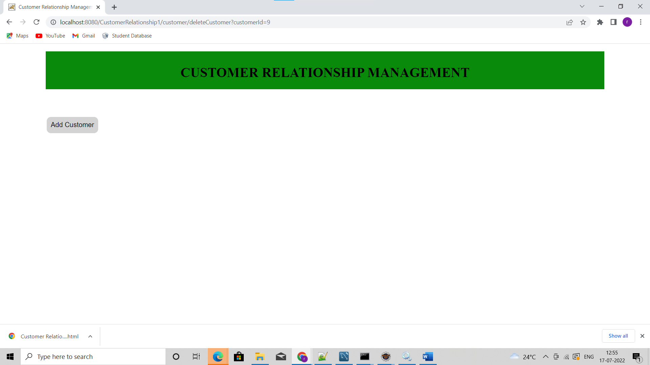

When a user clicks on add customer button, he is redirected to new page where he can add user details

User has an option to save the information and go back to home page.

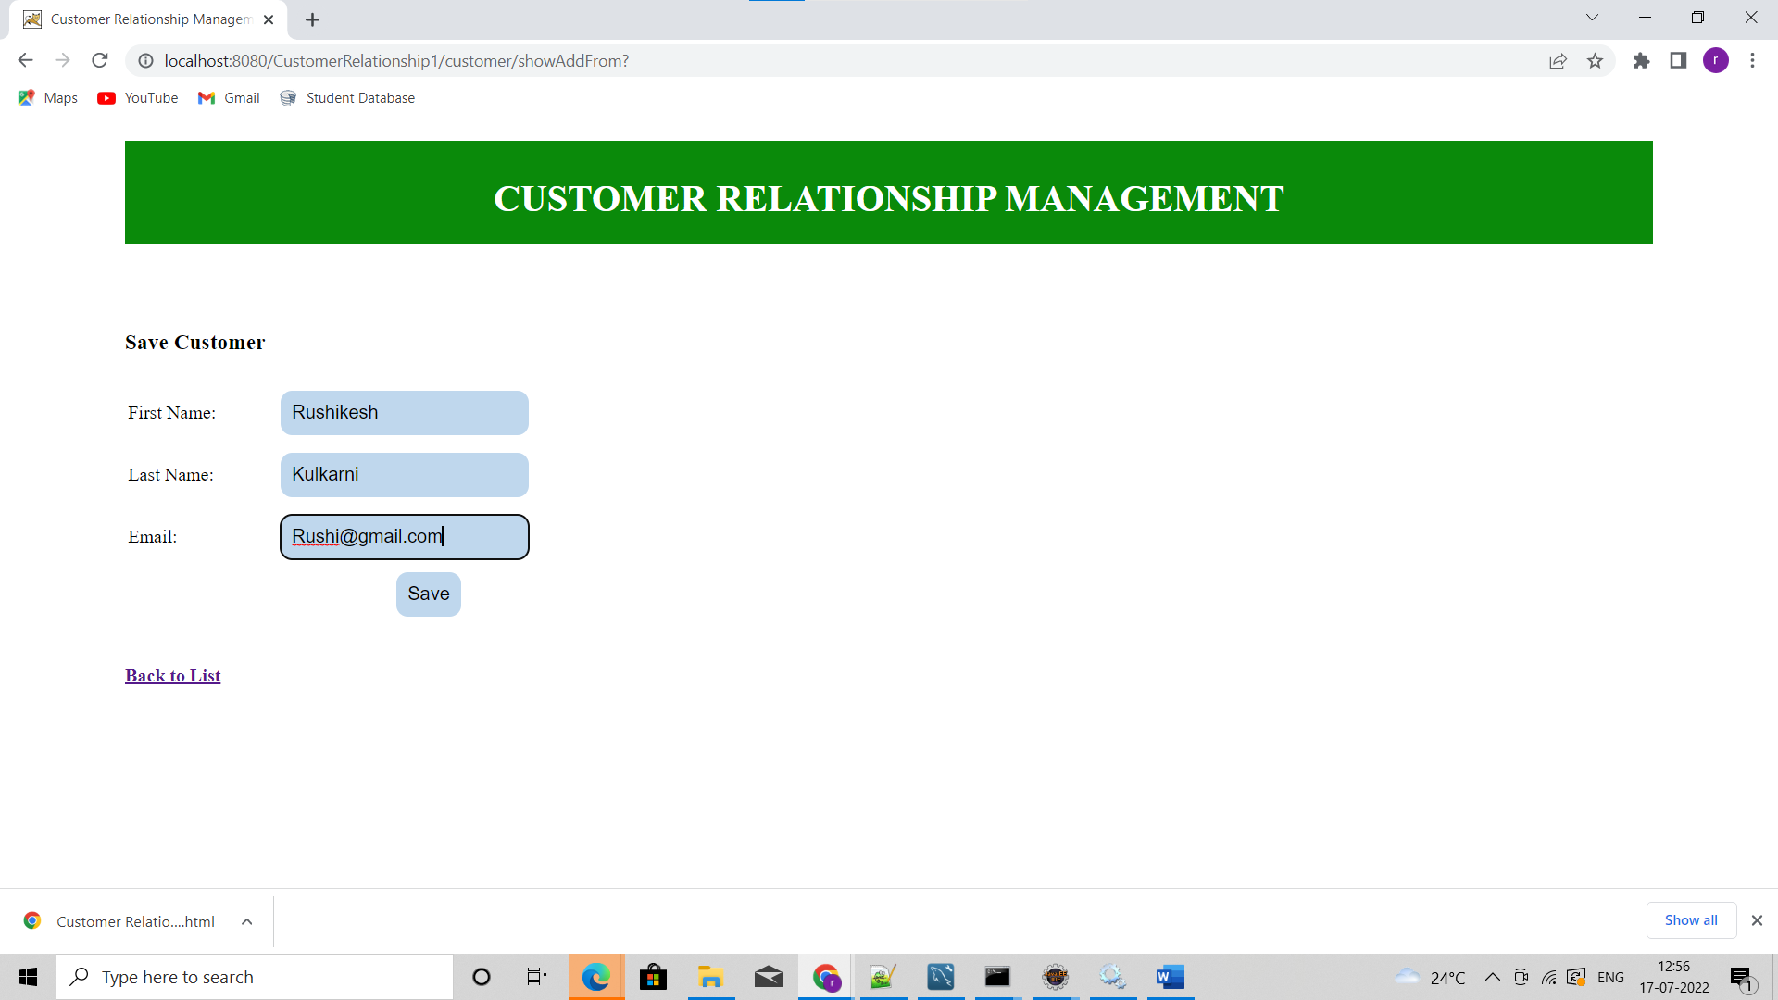

User has option to update or delete the customer

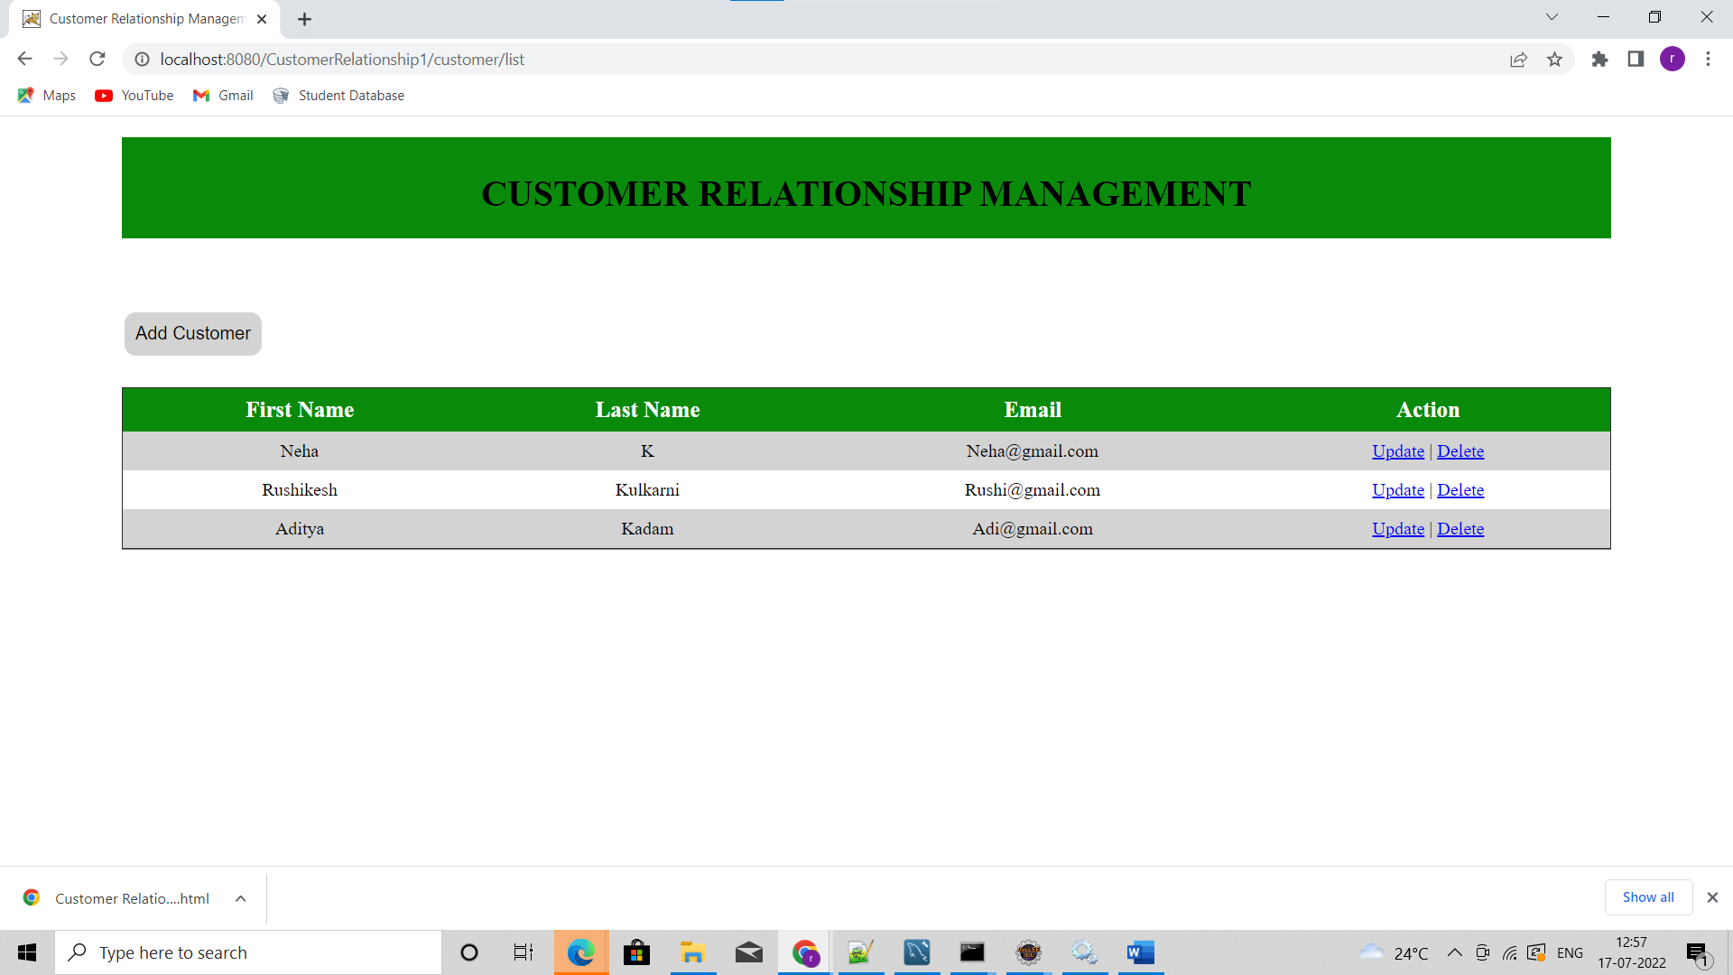

Upon clicking on update user will be redirected to the new page where he can edit the user details and save them.

They will be reflected in database.

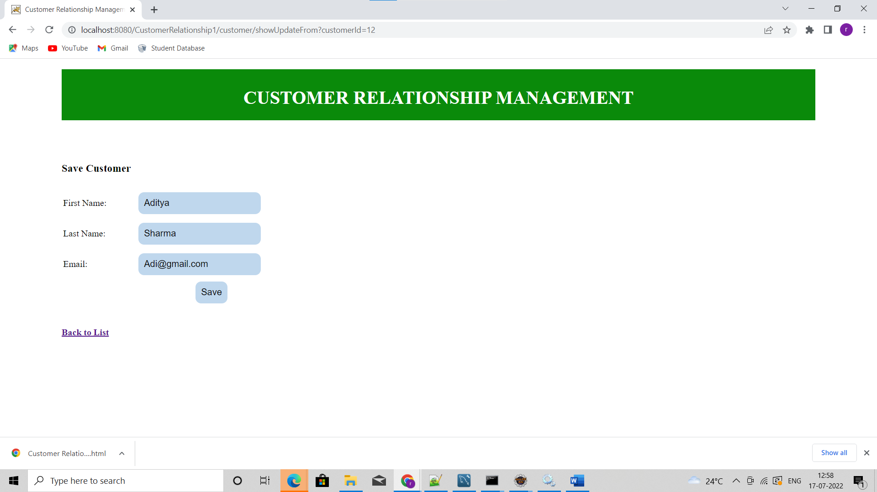

After clicking on back to list surname of user Aditya has changed.

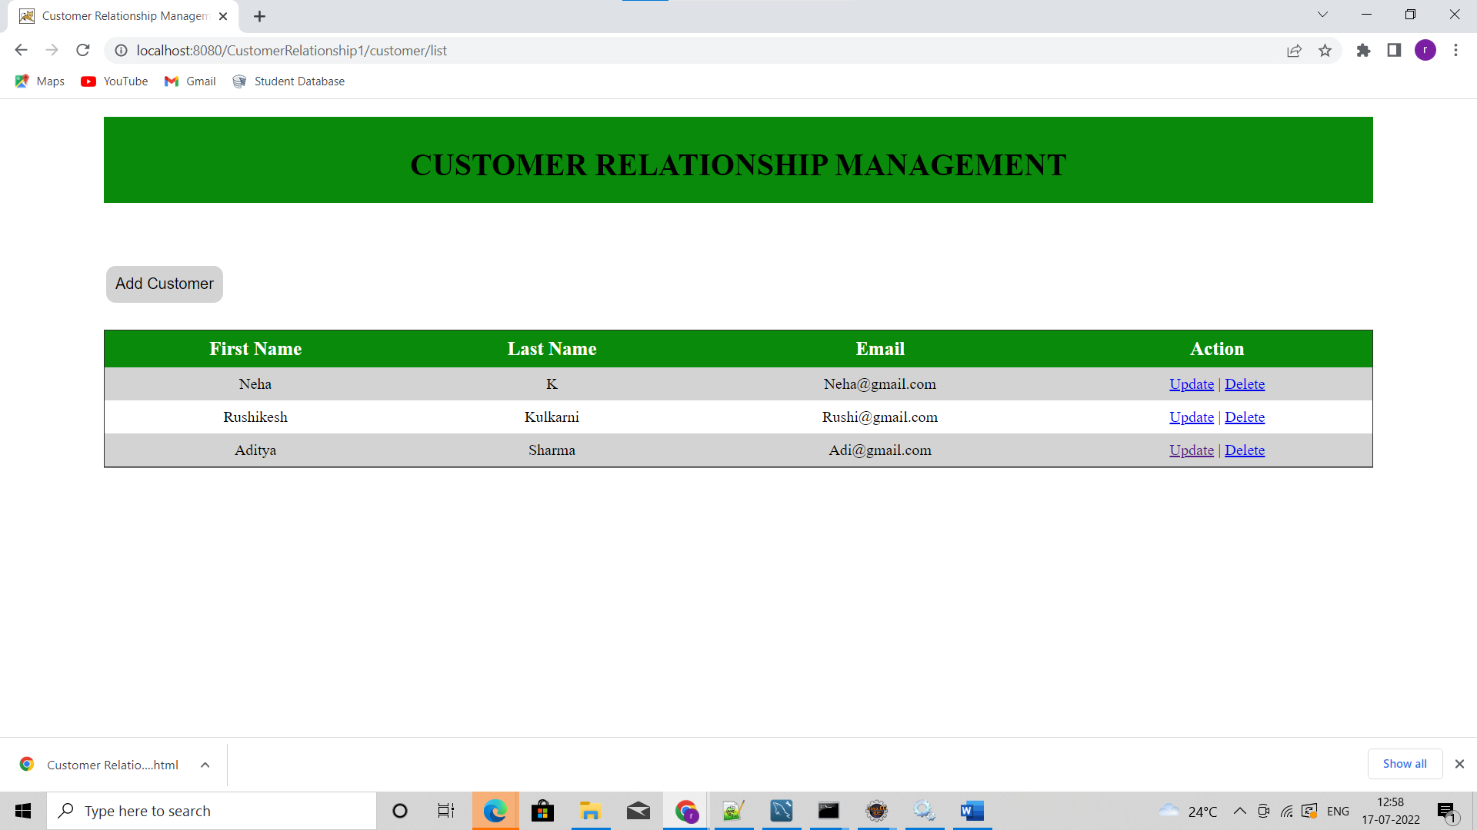

Upon clicking on delete user will be deleted and the same will be reflected in the list

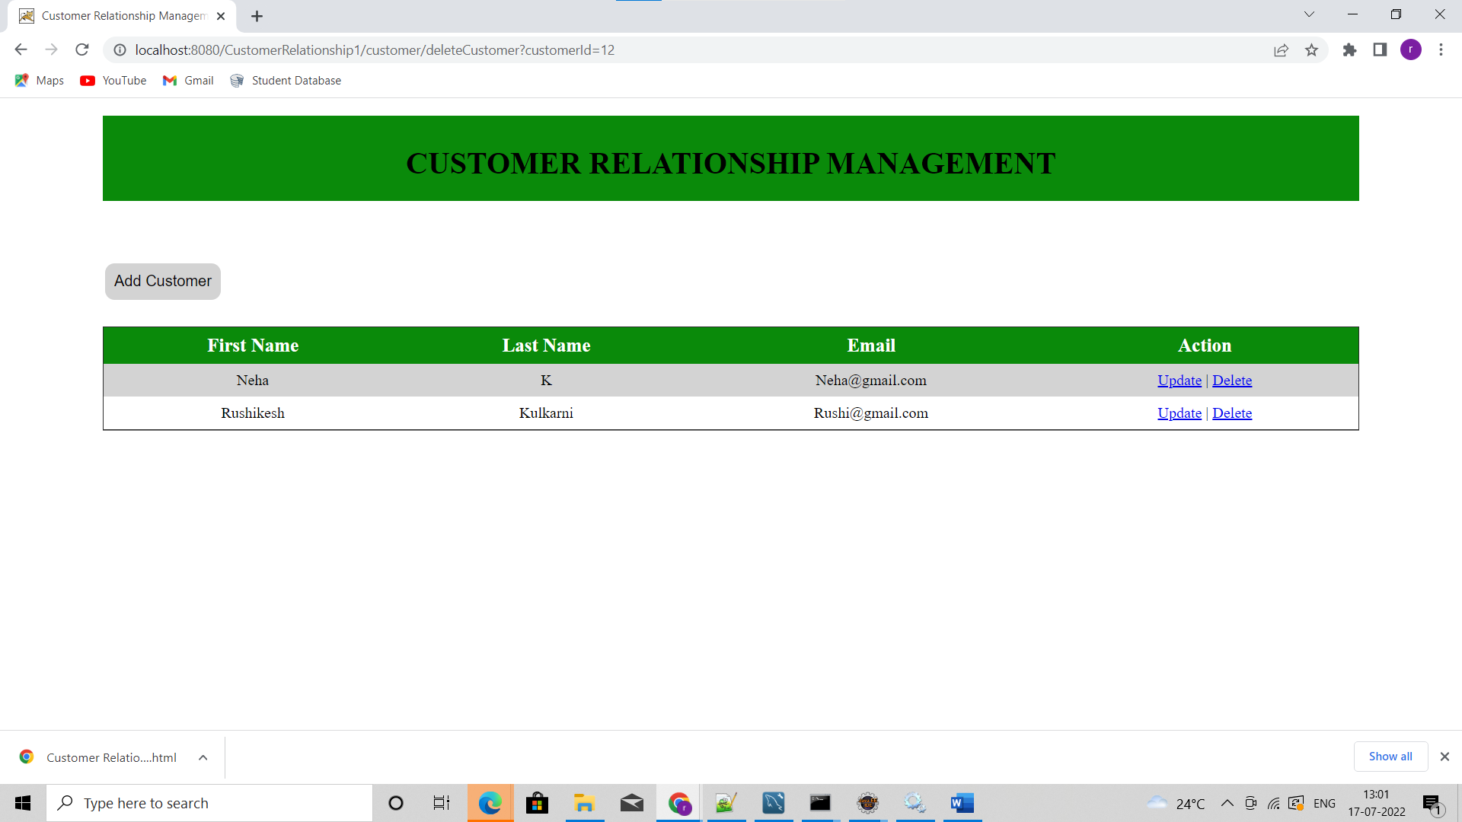

3rd user Aditya sharma has been deleted