Self-Aware LSTM-Based Agents

Introduction

Goal: A Simple Form of Self-Awareness

The goal of this work is the creation of neural-network-based agents that can, given a knowledge base of Boolean logic sentences and a question regarding the value of a Boolean variable, tell us whether the variable in question is true, false, or unknown. In addition to solving simple Boolean logic problems, these agents should exhibit self-awareness and be capable of exploiting this feature to solve a problem cooperatively. Because the term “self-awareness” can be defined in different ways, we provide our definition below:
- An agent must know whether it possesses adequate knowledge to solve a problem.
  - If it possesses adequate knowledge, it should solve the problem.
  - If it lacks adequate knowledge, it should request help solving the problem.
- An agent must know whether its internal knowledge base is contradictory because a contradictory knowledge base in Boolean logic permits any conclusion to be drawn.
  - An agent with a contradictory state of knowledge should report this instead of trying to provide an answer because delivering a solution is impossible in this case.
- An agent should be capable of providing the contents of its knowledge base upon request.
  - This implies that the agent has explicit knowledge of its knowledge base contents, which is another form of self-knowledge.
For the purposes of this work, agents fulfilling these three criteria are considered “self-aware”. Self-awareness allows agents with contradictory knowledge states to warn the user and avoid providing a wrong answer. It also enables agents to cooperate. For example, suppose that an agent lacks adequate knowledge to solve a problem and requests help from a second agent. The second agent’s knowledge may be sufficient to allow the first agent to solve the problem. Here, agent self-awareness permits cooperation because the first agent knows that it must request help (by being aware of the inadequacy of its knowledge state). The second agent has direct, symbolic knowledge of the contents of its knowledge base and can provide those contents on demand.
In this work, we create neural-network-based agents capable of solving simple problems in Boolean logic. Neural networks for solving Boolean logic problems and other problems in symbolic mathematics are not new. Using neural networks for logical entailment, which is very closely connected to such problems, was discussed in (Evans, Saxton, Amos, Pushmeet, & Grefenstette, 2018). Moreover, the related issue of using neural networks for symbolic mathematics was covered in (Lample & Charton, 2019). The present work differs from these two reports because it emphasizes self-awareness and cooperation in neural-network-based agents, a topic not covered in the cited works. Self-aware neural network systems were surveyed in (Du, et al., 2020), where the type of self-awareness focused on the implementation and operation of the neural network itself, with the network having awareness of its own execution environment and the ability to optimize its dataflow, resource use, and execution within that environment for performance optimization. This is a very different type of self-awareness than what is described here, because this paper focuses on awareness of one’s state of knowledge, not on awareness of neural network execution environment and performance.
The present work is organized as follows. We start by defining the propositional (Boolean) logic problems that our agents are trained to solve and then explain the behavior of the logical agents that we have created. Next, we provide an overview of agent architecture, consisting of a knowledge base (implemented as a Python list of strings) and an LSTM neural network. The basic aspects of LSTM neural networks and the particular encoder–decoder architecture used in the present work are then described.

Propositional Logic Problems

Our treatment of propositional logic very closely follows that used in (Norvig, Artificial Intelligence: A Modern Approach, 4th Edition, 2021), with our notation, along with many direct quotations, from (Norvig, aima-python, n.d.). Specifically, our notation is summarized in Table 1.

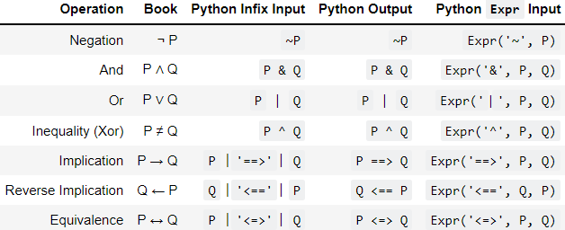
Table 1: Logical Notation

The notation given in the “Python Output” column of Table 1 will be used throughout this paper, as is done in our demonstration system. The propositional logic variables are denoted by capital letters “A” through “J” (inclusive).

Logical Agents
Agents in our system are trained to perform propositional inference. An agent is presented with a set of sentences and then asked about the truth value of a propositional variable. For example, a simple case of modus ponens would be as follows:
Input sentences | A  A ==> B
Question | What is B ?
Answer | B is true.

Agents are based on an LSTM sequence-to-sequence neural network as described in the following two sections. When presented with input sentences and a question, an agent can respond in one of five possible ways:
- True.
- False.
- Input sentences are contradictory, making an answer impossible.
- Input sentences lack adequate information to answer the question.
  - In this case, the agent will output a text string requesting “HELP”.
- Respond to a request for help from another agent by outputting its knowledge base.
For example, a contradiction would be as follows:
Input sentences | ~A  A & B  C ==> A
Question | What is C ?
Answer | Contradictory

In this example, the sentence “A & B” implies that A is true, whereas “~A” means that A is false. Owing to this contradiction, any conclusion may be drawn and the knowledge base itself is invalid. In such a case, the agent needs to report a contradictory state of knowledge from which no conclusion can be drawn.
In another example, we may have insufficient knowledge:
Input sentences | ~A
Question | What is C ?
Answer | Unknown HELP!

