**Assignment 1 Task 2**

**How to run Task 2 code in IntelliJ**

* Set up Maven project following “setup_IDE_win_macos_linux.docx”
* Edit running configuration

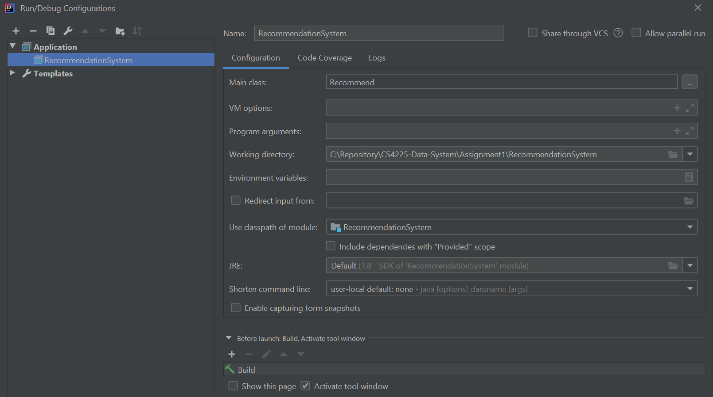

* Expected output (for user 62, only partial result shown here. The full result is in Task2_data/recommend/step5)

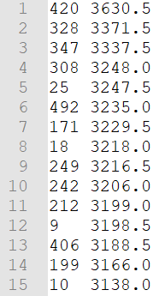

<itemId, score> sorted in score’s descending order

**How to run Task 2 code in HDFS**

* File structure

|  |  |
| --- | --- |
| Folder | Files |
| assignment1_task2 | data.csv |
|  | RecommendationSystem.jar |

docker cp RecommendationSystem.jar d46320c58d59: RecommendationSystem.jar

docker cp assignment1_task2/data.csv d46320c58d59: assignment1_task2/data.csv

* Set up directory and files in HDFS

hadoop fs -mkdir -p assignment1_task2

hdfs dfs -put ./assignment1_task2/* assignment1_task2

docker cp RecommendationSystem.jar d46320c58d59:RecommendationSystem.jar

* Run jar file in Hadoop

hadoop jar RecommendationSystem.jar Recommend

* Check output

hdfs dfs -cat assignment1_task2/recommend/step5/part-r-00000