**How to run Assignment 2 Task 1 Code?**

1. **Set up IntelliJ**

Note: The tool versions are: **JDK 8, sbt 1.3.4, Scala 2.11.12, Spark 2.3.0**

* Create a new project in Intellij  
  Choose Scala and sbt  
  Select proper versions. I use JDK 11, sbt 1.3.4, Scala 2.11.12

Right click on your project directory, add framework support, choose Scala

Go to src/main/scala, right click and create a new scala class

* Add Spark to IntelliJ

Add libraryDependencies += "org.apache.spark" %% "spark-core" % "2.3.0" to build.sbt

1. **File Structure**

|  |  |
| --- | --- |
| Input | Task1_data/task1-input1.txt  Task1_data/task1-input2.txt  Task1_data/stopwords.txt |
| Main source code | CommonWords/src/main/scala/CommonWords.scala |
| Output txt file | Task1_data/output/ |
| Jar file built from sbt | CommonWords/target/scala-2.11/commonwords_2.11-0.1.jar |

1. **How to run**

* Set the input and output file paths in the code

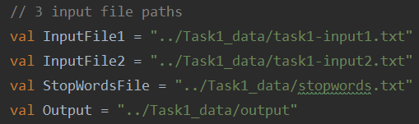

* Click run in Intellij