**Background**

* 1. **Time series stock values**

Price values of the stock market varies with time due to buy and sell transactions and major economical incidents in the world. When analyzing the market trades study these time series data within different time frames. These time frames can be one minute to one month depending on the interest of the trader. Studying raw time series data and making predictions is very difficult. The traders use the graphical representations of time series stock values known as Candlestick graphs for better market analysis.

**2.2 Candlestick chart**

Each and every variation of stock value within a specific time period can be represented using a graphical representation known as Candlesticks. When considering a specific time period, the stock values has Opening price, Closing price, Highest price and the Lowest price within the time period. These price values are considered as the major representations when drawing Candlesticks. There are two main types of Candlesticks, namely bullish candlestick or increasing candlestick and bearish candle or decreasing candle. Traders usually use two different colors for these two types of candlesticks when analyzing the market. Most of the times they use red for decreasing candlestick and green for increasing candlestick. Figure 2.1 shows the open, close high and low values of a candlestick.

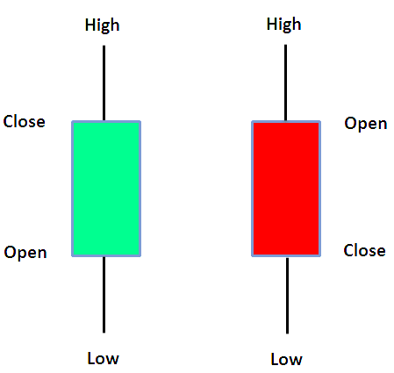

**Candlestick reversal patterns**

Candlestick reversal patterns are specific formations of candlesticks which indicates a reversal of the direction of the market. There are 47 candlestick reversal patterns and 8 of them are considered as major reversal patterns. Table 2.2 shows the major candlestick reversal patterns.

\

* 1. **Market trend**

Market trend is another important factor in stock and currency trading. By using graphical representations, an experienced trader can understand the trend of the market. The trend can be increasing trend, decreasing trend or a consolidation where a specific trend cannot be predicted.

**2.2.1 Increasing trend**

Increasing trend is a continuous increasing candle formation in the market. It indicates a rise of stock values. This can be taken as a future indication for a increasing market.

**2.2.2 Decreasing trend**

Decreasing trend is a continuous decreasing candle formation in the market. It indicates a decline of stock values. This can be taken as a future indication for a decreasing market.

**2.2.3 Consolidation**

Consolidation is an area of the market where a specific trend can to be identified.

* 1. **Market analysis methods** 
     1. **Fundamental analysis**

Fundamental analysis (FA) is a method of analysing the stock and currency market by using economic news and important economical incidents like trade deals among countries.

**Technical analysis**

Technical analysis is a method of analysing stock market by using technical indicators and graphical representations of time series stock values. These indicators are based on mathematical and statistical concepts. In this research a strategy based on technical analysis will be considered for automation.

* 1. **Technical indicators**

Technical indicators are used by the traders to make trading decisions in technical analysis. These indicators are mostly based on mathematical and statistical concepts on time series data. By combining the indicators and Candlestick chart patterns traders make decisions about the future trend of the market.

**2.2.1 Moving Averages**

The **moving average** (MA) is a simple technical analysis tool that smooths out price data by creating a constantly updated **average** price. The **average** is taken over a specific period of time, like 10 days, 20 minutes, 30 weeks or any time period the trader chooses.

**2.2.2 Stochastic oscillator**

A **stochastic oscillator** is a momentum **indicator** comparing a particular closing price of a security to a range of its prices over a certain period of time. The sensitivity of the **oscillator** to market movements is reducible by adjusting that time period or by taking a moving average of the result.

**2.2.3 Relative Strength Index (RSI)**

The **relative strength index** (**RSI**) is a momentum **indicator** used in technical analysis that measures the magnitude of recent price changes to evaluate overbought or oversold conditions in the price of a stock or other asset.

**2.3.4 Bollinger Bands**

A Bollinger Band is a technical analysis tool defined by a set of trendlines plotted two standard deviations (positively and negatively) away from a simple moving average (SMA) of a security's price, but which can be adjusted to user preferences.

Bollinger Bands were developed and copyrighted by famous technical trader John Bollinger, designed to discover opportunities that give investors a higher probability of properly identifying when an asset is oversold or overbought. In this research a strategy based on Bollinger bands indicator and Candlestick charts will be considered for automation.

* 1. **Trading strategy**

Combining candle stick pattern recognition and technical indicators traders build a specific trading strategy. This strategy includes several numbers of steps to follow. For automated trading also there should be a specific strategy to follow. Following table shows mostly used trading strategies and their success rates.

Table