LIVE TRADING SYSTEM FOR STOCK AND CURRENCY EXCHANGE MARKET USING MACHINE LEARNING

A PROJECT REPORT SUBMITTED BY

V.L EDIRISINGHE (S/15/330)

to the

DEPARTMENT OF STATISTICS AND COMPUTER SCIENCE

*in partial fulfillment of the requirement*

*for the award of the degree of*

**BSc. (Honors) in Computer Science**

of the

UNIVERSITY OF PERADENIYA

SRI LANKA

2020

# TABLE OF CONTENTS

INTRODUCTION 2

1.1Problem Domain…… …………………………………………………………2

1.2Research problem…………………………………………………………….........3

1.3 Research Objectives……………………………………………………………….6

1.4Summary of the existing and proposed methodology………….…………………..6

CHAPTER 01

# INTRODUCTION

## Problem Domain

Stock and currency trading is one of the main sources of business in the world. The international stock exchange market is a place that provides opportunities to trade stocks, commodities, and currencies. The daily turnover of the international stock and currency exchange market is 6.6 trillion dollars. For decades traders are buying and selling stocks, commodities, and currencies in the international stock and currency exchange market. This buying and selling procedure directly affects the economy of the world. For example, if a specific country provides a large number of commodities and stocks for the international exchange market, that country is considered to have a strong economy.

Traders are more likely to buy stocks, commodities, and currencies that are expected to increase their value in the future. On the other hand, traders are likely to refrain from buying a stock whose value is expected to fall in the future. Investing in the stock market is something that needs to be studied over a period of time and lack of understanding can lead to losses. Having an efficient way of determining the trend of the stock market helps to increase the profit of the trader. Stock market forecasting is still a challenging issue as there are many factors influencing stock market prices such as the global economic news, industry performance, global economic incidents, and investor sentiment.

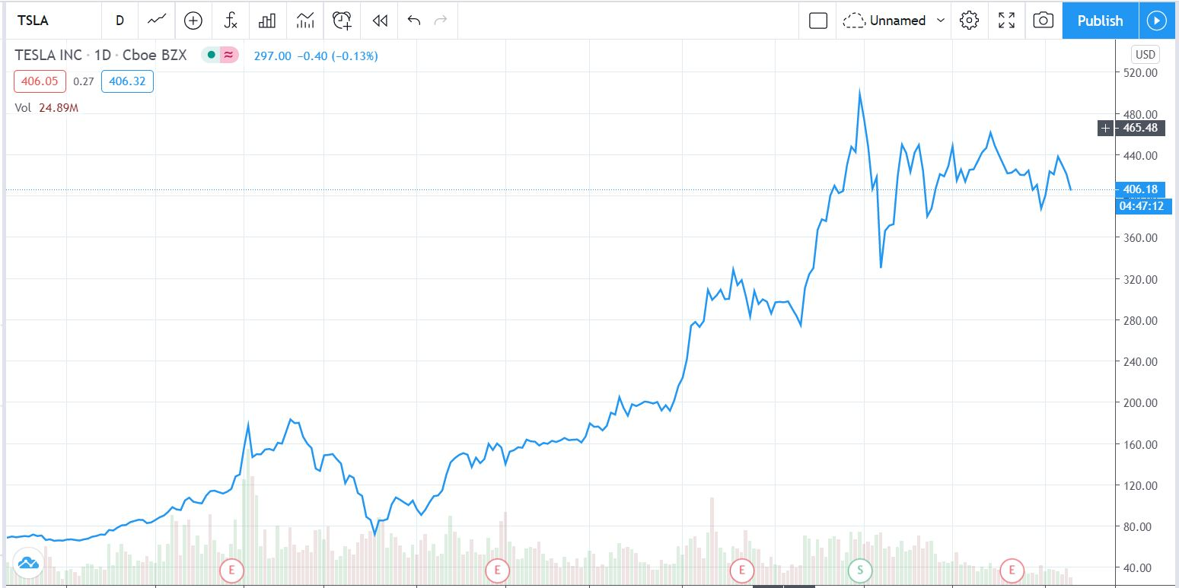

**Figure1.1** Tesla company stock values

## Research problem

Traders analyze the stock market in different ways such as technical analysis, fundamental analysis and sentimental analysis. It is said to be 99% of the traders in the stock market loss their money due to wrong decisions. Even if they make right decisions most of the trades become less profitable or unprofitable due to common human emotions like panic, over confidence and greed for money.

To become profitable in the stock and currency exchange market a trader should have a specific strategy for trading. Making a strategy is the most difficult work for the trader because they need to study the markets for several months. After recognizing a specific strategy, the trader needs to backtest the strategy to find whether it is profitable or not.

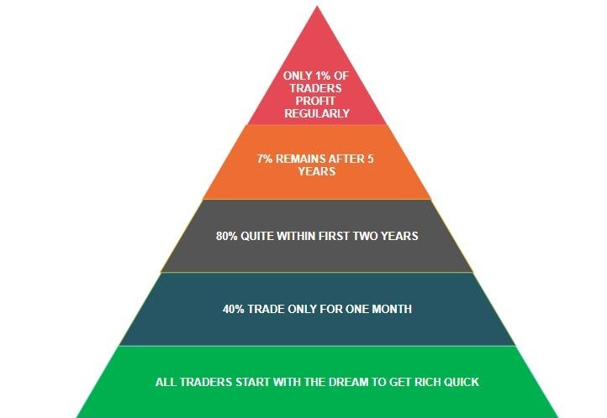

**Figure1.2:** Trader behavior in the market

In international stock and currency, exchange market price values of stocks and currencies vary with time. Analyzing time-series data and making predictions is a very difficult task. Because of that traders use graphical representations of time series data to analyze the market. Graphical representations of currency and stock values are known as Candlestick charts. Candlestick charts represent specific candlestick patterns and by using these candlestick patterns it is easier to recognize trends, reversal points, and neutral positions in the market.

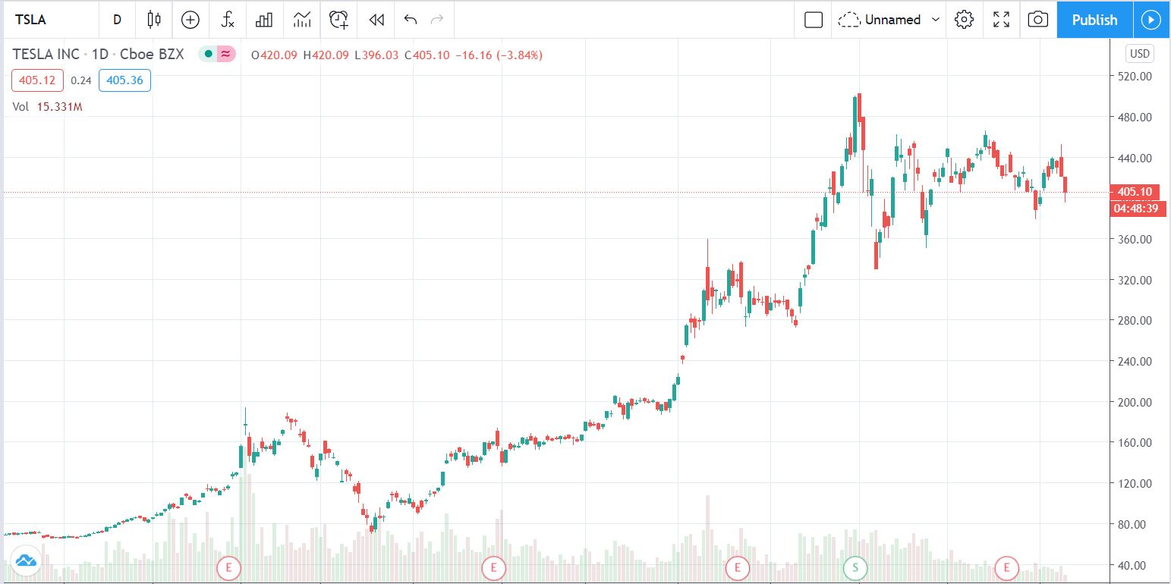

**Figure 1.3:** Tesla stocks candlestick chart

**The stock and currency exchange market is a 24-hour live market. Traders have to study the markets and capture every movement within the day to make future predictions. This is a critical task because humans need to sleep and rest. Because of this, traders take support from programmed scripts, indicators, and other computerized systems for trading. If a trader can avoid emotional mistakes when analyzing the stock markets most of the decisions would be correct and most of the trades would be profitable.**

The best thing is to use computers and machines for trading because machines have no emotional problems like humans. Due to the speed and calculational power machines can make decisions quickly and effectively than humans. With the current technological advances, machine learning has become a solution to many emerging problems. The usage of deep neural networks has become an emerging field in the business and financial field. In this research, we mainly focus on developing a fully automated trading system using deep neural networks to look into stock and currency price charts and make trades profitable.

## 1.3 Research Objectives

In this research, to develop a fully automated live trading system the following objectives will be looked at,

* Studying the exchange market to make a profitable strategy for trading.
* Converting Time series data into candlestick images.
* Build up a model to recognize candlestick reversal patterns.
* Connecting pattern recognition with the trading strategy for developing a fully automated live trading system.

## Summary of the existing and proposed methodology

* + 1. **Existing trading signal generators and indicators**

**There are several trading signal generators and indicators used by traders. They are not based on any artificial intelligence technologies. These indicators and signal generators are developed by a language called MT4 which is based on C++ language. These indicators and signal generators help to analyze the market but they cannot read the charts like humans**

* + 1. **Proposed methodology**

In this research, we are focusing on developing a fully automated trading system which can read the charts like humans. Having a profitable strategy in the stock and currency market is very important for trading. For the initial step, we are going to study stock and currency trading for several months and recognize a profitable strategy. We are going to develop a model that can classify the Candlestick pattern images and identify the trend of the market using Machine Learning. By combining the above-mentioned strategy and pattern recognition model, it is possible to develop a fully automated trading system. Not like trading signal generators and indicators, this proposed trading system will be able to read the charts and trade like humans.

.