COMP1682 Final Report

**Project Name**

**Student Name**

**Supervisor: **name\*\***

**Final Year Report**

**COMP1682 Final Year Project**

**Program Title: BSc Hons Computing**

**Word count: 10.000 (Minimum)**

**Abstract**

An abstract is a brief summary of your project: for Endeavor abstracts, from **200 to 350 words**. It is used typically for academic presentations to give the reader a synopsis of the research project, and it can also be used to summarize a creativity project.

Sample’s abstract:

Project Name: **Using GIS Site Suitability Analysis to Study Adaptability and Evolution of Life: Locating Springs in Mantle Units of Ophiolites**

GIS is a powerful tool that can be used to locate springs sourced in ophiolites. The unique features associated with these springs include a reducing subsurface environment reacting at low temperatures producing high pH, Ca-rich formation fluids with high dissolved hydrogen and methane. Because of their unique chemical characteristics, these areas are often associated with microbes and are thought to be similar to the features that enabled life to evolve on Earth. Locating and sampling these springs could offer a deeper look into Earth's deep biosphere and the history of life on Earth. Springs have traditionally been located using expensive and time-consuming field techniques. Field work can be dangerous. The goal of this study was to develop a model that could locate these unique geological features without first going into the field, thus saving time, money and reducing the risks associated with remote field localities. A GIS site suitability analysis works by overlaying existing geo-referenced data into a computer program and adding the different data sets after assigning a numerical value to the important fields. For this project, I used surface and ground water maps, geologic maps, a soil map, and a fault map for four counties in Northern California. The model has demonstrated that it is possible to use this time of model and apply it to a complex geologic area to produce a usable field map for future field work.

**Acknowledgements**

I would like to express my deepest appreciation to all those who provided me the possibility to complete this report. A special gratitude I give to our final year project manager, [Ms/Mr/Dr Surname], whose contribution in stimulating suggestions and encouragement, helped me to coordinate my project especially in writing this report.

Furthermore, I would also like to acknowledge with much appreciation the crucial role of the staff of [Ms/Mr/Dr Surname], who gave the permission to use all required equipment and the necessary materials to complete the task “SPECIFY NAME”. A special thanks goes to my team mate, [Ms/Mr/Dr Surname], who help me to assemble the parts and gave suggestion about the task “SPECIFY NAME”. Last but not least, many thanks go to the head of the project, [Ms/Mr/Dr Surname] whose have invested his full effort in guiding the team in achieving the goal. I have to appreciate the guidance given by other supervisor as well as the panels especially in our project presentation that has improved our presentation skills thanks to their comment and advices.

*Note: cái này là tham khảo, không sử dụng lại vì sẽ dính đạo văn*

Table of contents

1. Introduction 6

1.1 Background 6

1.2 Aim 6

2. Objectives 7

3. Approach 8

3.1 Justification of the suitability of a Methodology or a Framework followed. 8

4. Literature Review 9

4.1 Approach to literature searching 9

4.2 Technology A 9

4.3 Technology B 9

4.4 Technology C 9

4.5 Market analysis 9

5. Legal, Social, Ethical and Professional Issues and Considerations 10

6. Requirements 11

6.1 Analysis of requirements 11

6.2 Existing Solutions 11

6.2.1 Product A 11

6.2.2 Product B 11

6.2.3 Product C 11

6.2.4 Conclusion 11

7. Business Requirements 12

7.1 Overall Picture 12

7.2 Functional Requirements with MoSCoW prioritisation 12

7.3 Non-functional Requirements 12

8. Analysis and Design 13

8.1 Architecture 13

8.2 High Level Design 13

8.2.1 Assumptions 13

8.2.2 Endpoints 13

8.2.3 3rd party Services 13

8.2.4 Overall Picture 13

8.3 Technology choices 13

8.3.1 Front End 13

8.3.2 Back End 13

8.3.2.1 Database 13

8.3.3 Mobile App 13

8.3.4 Operation System 13

8.3.5 Hosting ( AWS, GCloud, Heroku, Azure … ) 13

8.4 Use case Diagram 13

8.4.1 Primary and Secondary Use-case scenario 13

8.5 Entity Relationship Diagrams 13

8.5.1 Physical design (Capacity) 13

8.6 Wireframes for prototypes 13

8.7 Class Diagram 13

8.8 Activity Diagram / Sequence Diagram 13

9. Implementation 14

9.1 Database 14

9.2 Front End 14

9.2.1 Project Folder Structure 14

9.2.2 Source code samples 14

9.3 Back End 14

9.3.1 Project Folder Structure 14

9.3.2 Source code samples 14

9.4 Deployment 14

9.5 Images 14

10. Testing 15

11. Evaluation 16

11.1 Summarised Key findings from the project 16

11.2 Recommendations for future development 16

11.3 Project Evaluation 16

11.4 Personal Evaluation 16

11.5 Conclusion 16

12. References 17

13. Appendix A – Project Proposal 18

14. Appendix B - Planning 19

15. Appendix C 20

# Introduction

## Background

## Aim

Note: triển khai thêm từ Project Proposal

# Objectives

*Note: lấy từ project proposal, chỉnh sửa và triển khai thêm sau quá trình chạy dự án*

# Approach

## Justification of the suitability of a Methodology or a Framework followed.

*Note: lựa chọn và giải thích mô hình SDLC nào được sử dụng trong việc chạy dự án: Waterfall, DSDM, Scrum …*

# Literature Review

## Approach to literature searching

## Technology A

## Technology B

## Technology C

## Market analysis

*Note:*

* *Nêu cách các bạn nghiên cứu: tìm Internet, tự đi Survey, tham khảo các nguồn uy tín …*
* *Thấy những technology nào phù hợp để phát triển dự án ( Web tech, Mobile Tech, AI Tech … )*
* *Quy mô thị trường và nhu cầu của thị trường như thế nào về sản phẩm của các bạn ( mục đích là chứng minh sản phẩm tạo ra là hữu dụng )*

# Legal, Social, Ethical and Professional Issues and Considerations

*Note: được học kỹ ở môn Requirements Management*

# Requirements

## Analysis of requirements

*Note: sẽ chỉ nêu general về yêu cầu của sản phẩm*

## Existing Solutions

### Product A

Introduction

Pros

Cons

### Product B

Introduction

Pros

Cons

### Product C

Introduction

Pros

Cons

*Note: từ yêu cầu, đi so sánh với những sản phẩm / giải pháp đang tồn tại trên thị trường, chỉ ra điểm mạnh / yếu*

### Conclusion

*Note: sau khi đã so sánh, rút ra kết luận là sản phẩm của minh sẽ có những ưu điểm gì vượt trội so với những sản phẩm đang có trên thị trường*

# Business Requirements

## Overall Picture

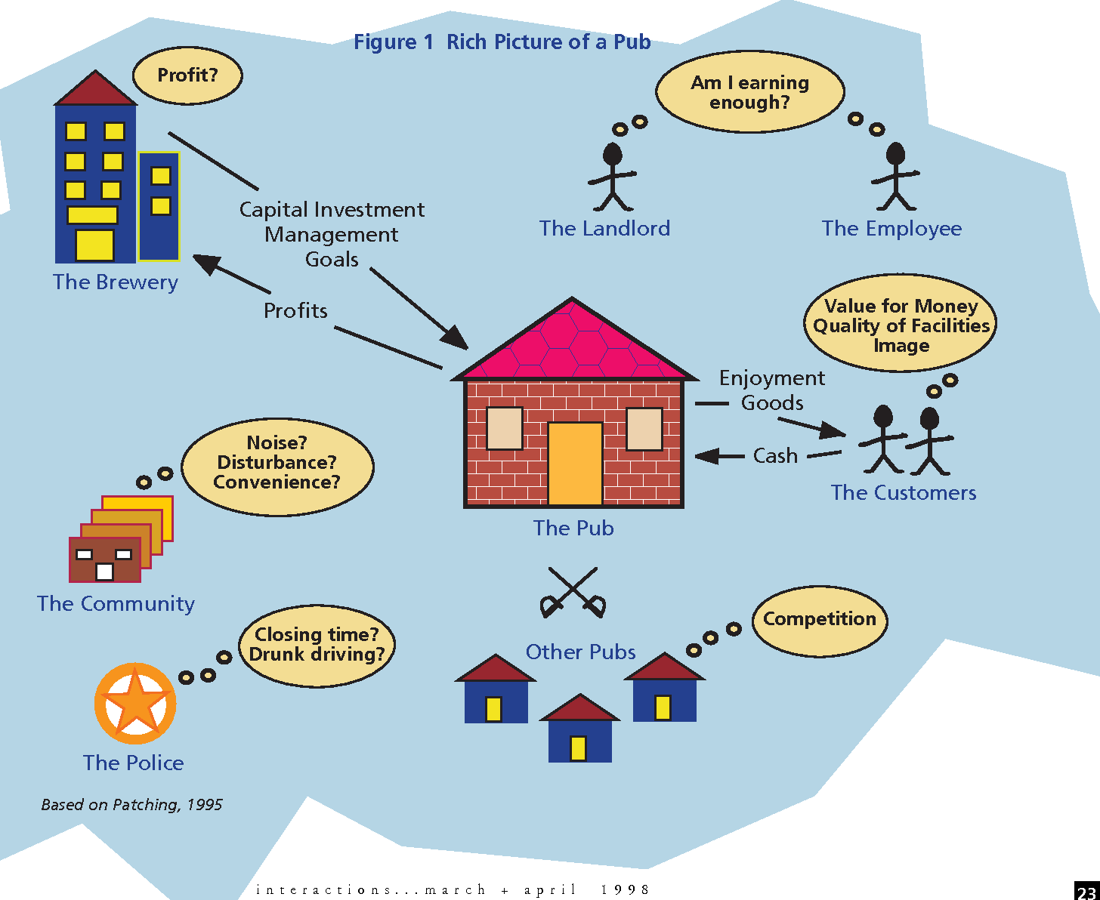

*Note: include hình miêu tả tổng về dự án của mình*

## Functional Requirements with MoSCoW prioritisation

*Note: học kỹ hơn ở môn Requirements Management*

## Non-functional Requirements

*Note: học kỹ hơn ở môn Requirements Management*

# Analysis and Design

## Architecture

*Note: lựa chọn Architecture nào để phát triển dự án (Monolith, Client – Server, Layered Architecture, Microservices) và giải thích lý do lựa chọn*

## High Level Design

### Assumptions

### Endpoints

### 3rd party Services

*Note: làm rõ là dự án có dùng những Service bên thứ 3 ví dụ: login với Google, Payment với paypal hay VNPay*

### Overall Picture

## Technology choices

### Front End

### Back End

### Database

### Mobile App (opt.)

### Operation System

### Hosting ( AWS, GCloud, Heroku, Azure … )

*Note:*

* *lựa chọn công nghệ để phát triển dự án: Front End, Back End, Mobile App, etc .*
* *Nếu có sư dụng những Lib thì cũng phải include*

## Use case Diagram

### Primary and Secondary Use-case scenario

## Entity Relationship Diagrams

### Physical design (Capacity)

## Wireframes for prototypes

## Class Diagram

## Activity Diagram / Sequence Diagram

# Implementation

## Database

*Note: đưa những dẫn chứng những thứ mình đã dev.*

*Database: final ERD + giải thích implement như thế nào*

## Front End

### Project Folder Structure

*Note: đưa cấu trúc dự án của phía Front End + giải thích*

### Source code samples

*Note: đưa ra samples những đoạn code hay component quan trọng của front end*

## Back End

### Project Folder Structure

*Note: đưa cấu trúc dự án của phía Back End + giải thích*

### Source code samples

*Note: đưa ra samples những đoạn code hay component quan trọng của front end*

## Deployment

*Note: đưa ra những hình ảnh mô tả việc deploy + kết quả cuối cùng*

## Images

*Note: đưa ra kết quả cuối cùng của dự án (screenshots + giải thích 2 – 3 dòng)*

# Testing

# Evaluation

## Summarised Key findings from the project

*Note: tóm tắt lại những gì minh đã khám phá được trong quá trình chạy dự án*

* *Về mặt tech*
* *Về mặt business*

## Recommendations for future development

*Note: nêu ra những gì có thể được phát triển thêm trong tương lai*

## Project Evaluation

* *Review lại dự án*
* *Những gì đã hoạt động tốt*
* *Những gì chưa hoạt động*

## Personal Evaluation

* *Những gì tốt*
* *Những gì chưa tốt*
* *Những gì đã học được trong quá trình dự án*

## Conclusion

# References

# Appendix A – Project Proposal

# Appendix B - Planning

# Appendix C