**A**

**MINI PROJECT REPORT**

**ON**

***<<“ PROJECT TITLE ”>>***

SUBMITTED IN PARTIAL FULFILLMENT OF THE REQUIREMENT

FOR THE DEGREE OF

**Bachelor of Technology**

**SHIVAJI UNIVERSITY, KOLHAPUR**

SUBMITTED BY

*Mr. SAURABH SANJAY PATIL 157*

*Mr. HARSHAL BHIMGONDA PATIL 145*

*Mr. PRATIK SURESH PATIL 152*

**UNDER THE GUIDANCE OF**

***<<Guide Name>>***



**DEPARTMENT OF COMPUTER SCIENCE AND ENGINEERING**

**TATYASAHEB KORE INSTITUTE OF ENGINEERING AND TECHNOLOGY, WARANANAGAR**

**Academic Year 2020-21**

SWVSM’s

**TATYASAHEB KORE INSTITUTE OF ENGINEERING AND TECHNOLOGY,**

**WARANANAGAR**

**DEPARTMENT OF COMPUTER SCIENCE AND ENGINEERING**



`

**CERTIFICATE**

This is to certify that the Mini Project report entitled,

**<<“PROJECT TITLE ”>>**

Submitted by

|  |  |
| --- | --- |
| **Name** | **Exam Seat No.** |
| *Mr. SAURABH SANJAY PATIL* | *157* |
| *Mr. HARSHAL BHIMGONDA PATIL* | *145* |
| *Mr. PRATIK SURESH PATIL* | *152* |

of S. Y. B. Tech in the partial fulfillment of the requirement for the award of degree of Bachelor of Technology in Computer Science and Engineering from Shivaji University, Kolhapur. It is also certified that all corrections/suggestions indicated for internal assessment have been incorporated in the report. This Mini project work is a record of students’ own work, carried out by them under our supervision and guidance during academic year 2020-21

Prof.Bhagyashree Chougule. Prof. Dr.G.V.Patil Dr. S. V. Anekar

**Project Guide HOD, CSE Principals**

………………...

Date :-19/07/21

(External Examiner) Place :- Warananagar

**ACKNOWLEDGEMENT**

This space is dedicated to acknowledge all those who have helped in bringing this project to fruition.

We are greatly indebted to our guide Prof.Bhagyashree Chougule for his unstinted support and valuable suggestions. We are grateful to him not only for the guidance, but also for his unending patience and keeping our spirits high throughout. We express our sincere thanks to our beloved Head of the Department, **Prof. Dr.G.V.Patil** and Principal, **Dr. S. V. Anekar** for being source of inspiration and providing us the opportunity to work on this project.

We extend heartfelt thanks to all the teaching and non-teaching staff of the department of Computer Science and Engineering for their assistance and cooperation.

Finally, we would like to thank our parents and friends for their moral support and encouragement throughout our academics.

**Student Name. Roll No. Sign**

*Mr. SAURABH SANJAY PATIL*  *[EXAM SEAT NO.]*

*Mr. HARSHAL BHIMGONDA PATIL [EXAM SEAT NO.]*

*Mr. PRATIK SURESH PATIL*  *[EXAM SEAT NO.]*

**Date:**

**Place:**Warananagar

**Table of Contents**

|  |  |  |  |
| --- | --- | --- | --- |
| **Chapter No.** | **Chapter** | | **Page** |
| **1** | **Introduction** | |  |
|  | 1.1 | Introduction | 05 |
|  | 1.2 | Problem Statement | 06 |
| **2** | **Proposed Design** | |  |
|  | 2.1 | Flowchart | 07 |
| **3** | **Solution Techniques** | |  |
|  | 3.1 | Data Structures / Explanation of Algorithm Used | 08 |
| **4** | **System Requirements** | |  |
|  | 4.1 | Hardware Requirement | 09 |
|  | 4.2 | Software Requirements | 09 |
| **5** | **Implementation Details** | |  |
|  | 5.1 | System defined functions | 10 |
|  | 5.2 | User defined functions | 10 |
|  | 5.3 | User Manual (Screen Shots) | 11 |
|  | **References** | | 13 |

**Chapter1**

**INTRODUCTION**

* 1. **Introduction :**

In this mini project we are going to learn about logic gates and also going to understand the conversion system working, etc.

The logical gates are the switches that turn ON or OFF depending on what the user is doing. They are also considered as the building blocks for how computer works, Here we are going to take a look over variety in logic gates.

We probably already know what are number conversion system is – ever here of binary number or hexadecimal numbers? Simply put, a number system is a way to represent numbers. We are used to using the base -10 number system which is also called decimal. Other common number conversion system include base -16 i.e. [hexadecimal], base -8 [octal], and base -2[binary],etc…

**1.2 Problem Statement**

The purpose of the project is to build a program to reduce the manual work to convert one number System to another one. It’s simply Get input in One No. system and Give output in Which we want to print it. this project is beneficial to understand computer language .We normally type letters or words through keyboard of the computer, but computer does not understand the words and letters. Rather, those words and letters are translated into binary numbers.

Logic gates

We display output of AND, OR, NOT, NOR, NAND Truth table according to users Need. Logic gate play very important Role in microprocessor, electronic and electrical project circuit.

**Chapter 2**

**PROPOSED DESIGN**

**Flowchart**

START

OR

MAIN-MENU

RETURN

RETURN

SWITCH

CONVERSION

GATES

SWITCH

SWITCH

EXIT

AND

NOR

|  |
| --- |
| BINERY TO OCTAL |
| BINERY TO DECIMAL |
| BINERY TO HEXA-DECIMAL |
| OCTAL TO BINERY |
| OCTAL TO DECIMAL |
| OCTAL TO HEXA-DECIMAL |
| DECIMAL TO BINERY |
| DECIMAL TO OCTAL |
| DECIMAL TO HEXA-DECIMAL |
| HEXA-DECIMAL TO BINERY |
| HEXA-DECIMAL TO OCTAL |
| HEXA-DECIMAL TO DECIMAL |

OR

NAND

NOT

**Chapter 3**

**SOLUTION TECHNIQUE**

**Data Structures / Explanation of Algorithm Used**

* Enter whether you want information about gates or you want to do conversion.
* If you want information about Gates you get the information in detail.
* If you want to do conversion then we ask which conversion you wanted to do?
* After knowing the information we ask the number you want to convert, and then it do suitable conversion and display that number after conversion on screen.
* End.

**Chapter 4**

**SYSTEM REQUIREMENT**

**Hardware Requirement**

* Personal Computer.

**Software Requirement**

* Windows OS.
* Language- C.
* Dev C or code block.

**Chapter 5**

**Implementation Details**

**System Defined functions**

Stdio.h , stdlib.h , math.h , string.h , int ,main , printf , scanf , switch , break , do , while , if , else, for, long long int , unsigned long long int,etc…

**User Defined functions**

Op , gate , num , I , AND_OP , OR_OP , NOT_OP, NAND_OP, NOR_OP, binary , number , temp , octal , j , dec , inc ,binaryNum , hexa , etc…

**User Manual (Screen Shots)**

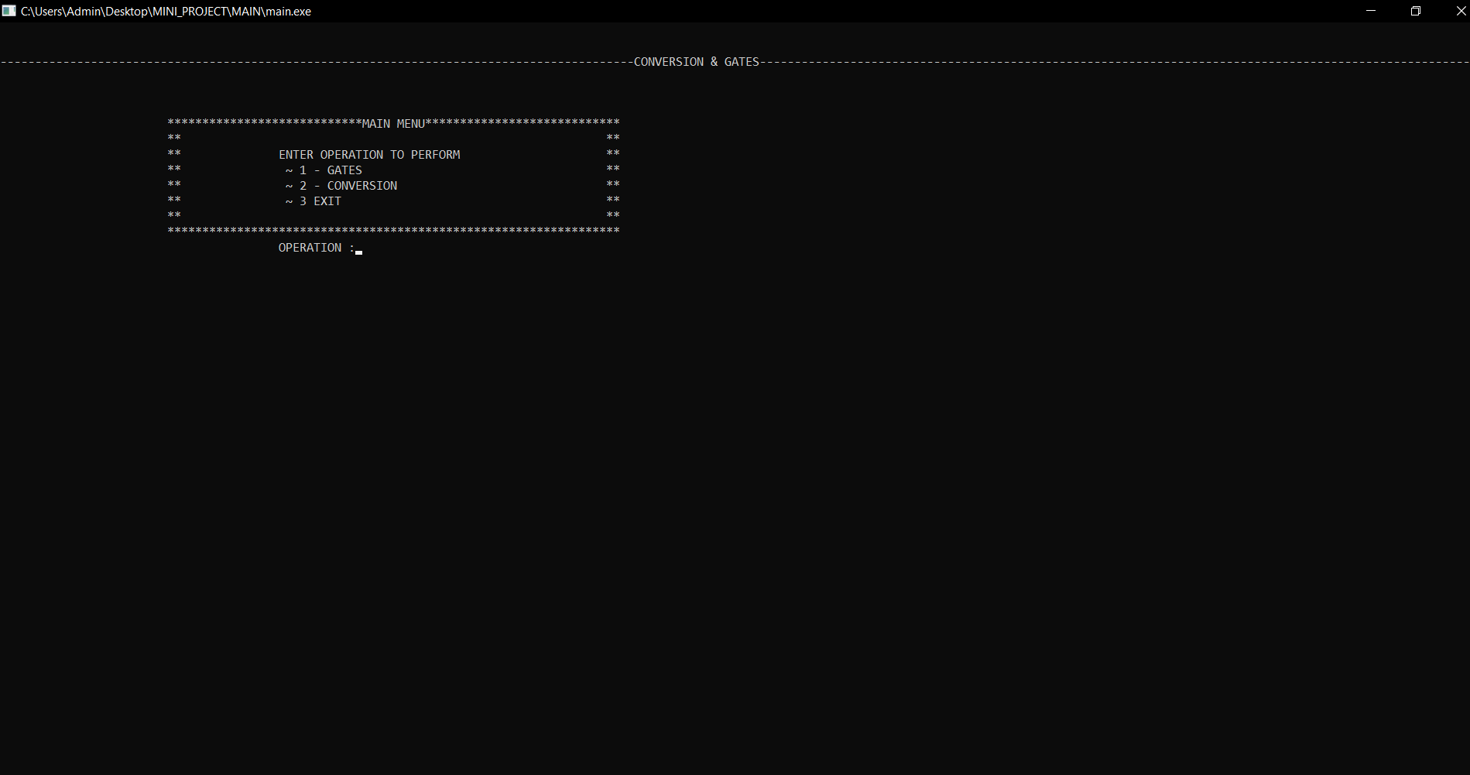

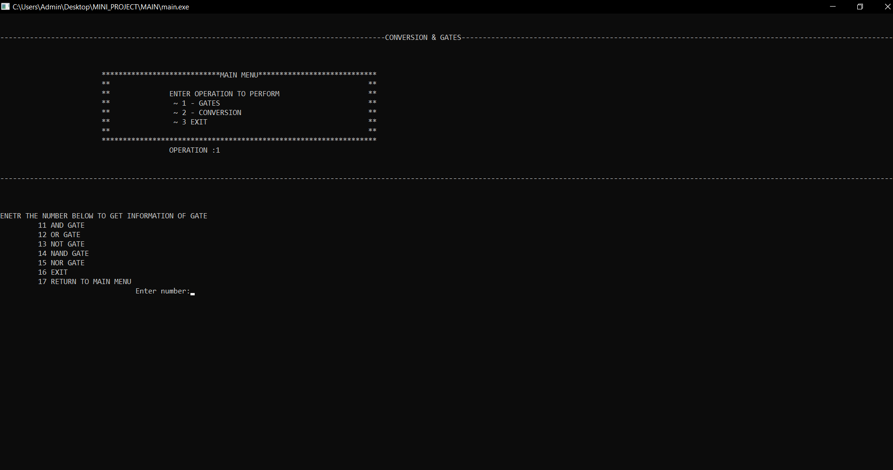

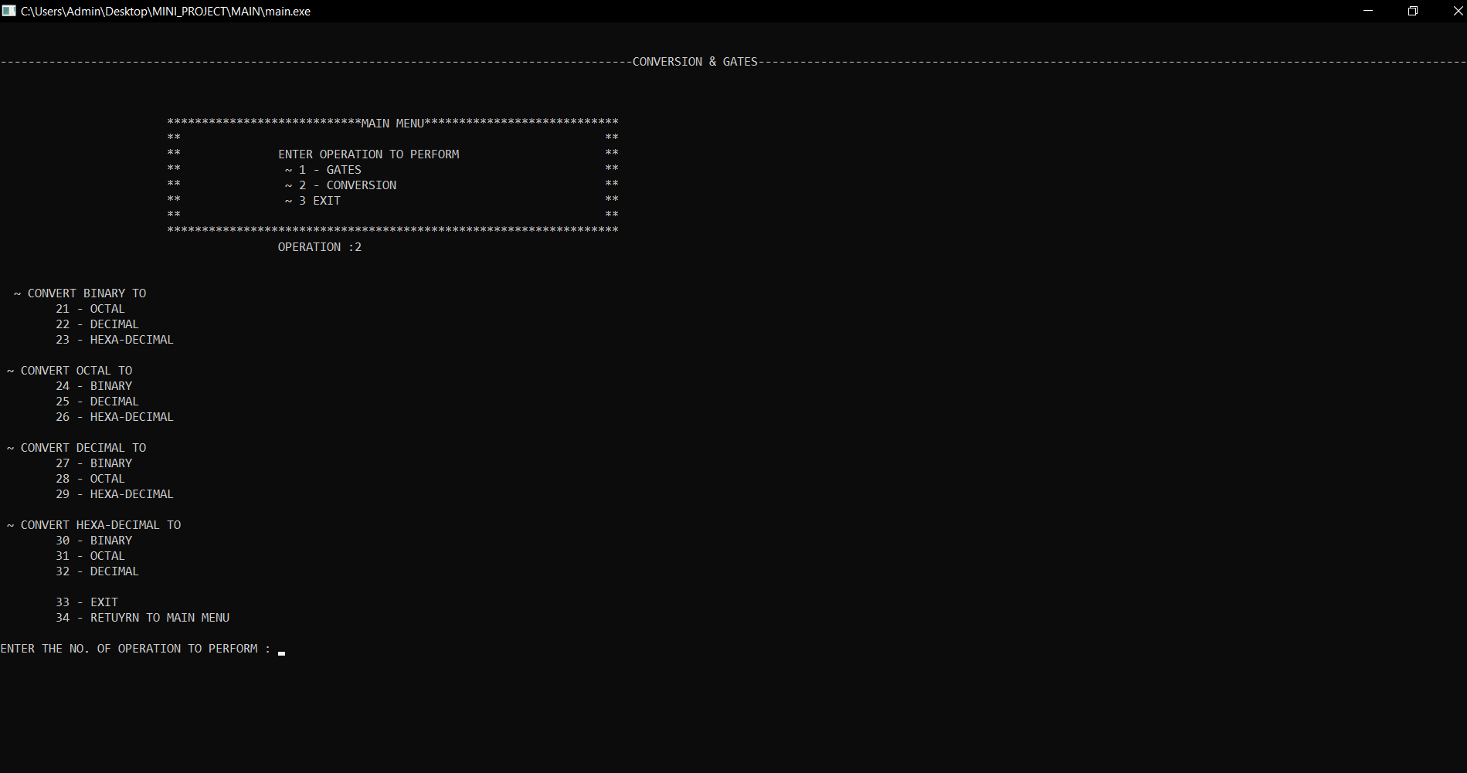

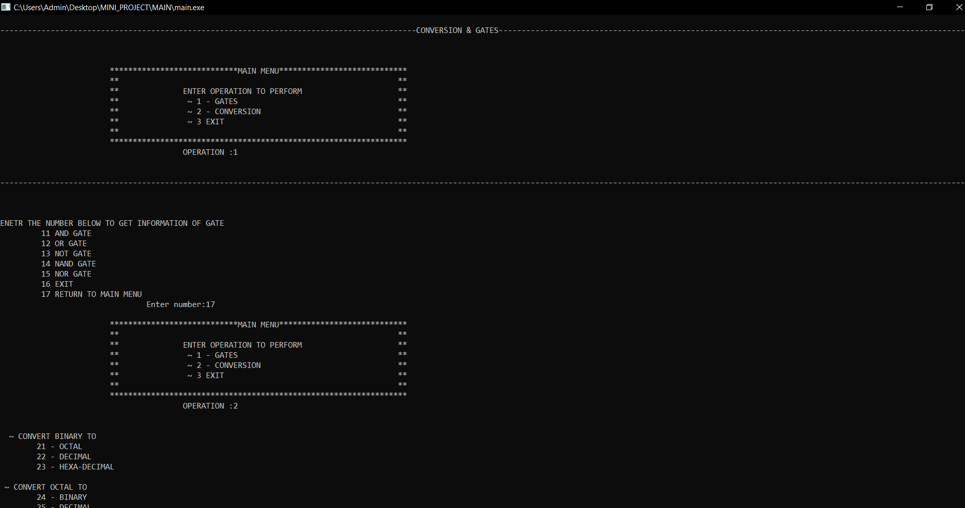

**REFERENCES**

* Simplified Electronics. (Dr.V.G.Shelake)
* [www.tutorialpoint.com](http://www.tutorialpoint.com/)
* [www.HYPERLINK "http://www.snapfitness.com/"elprocusHYPERLINK "http://www.snapfitness.com/".com](http://www.snapfitness.com/)