**使用mlxtend包**

from mlxtend.frequent_patterns import apriori, association_rules

import pandas as pd

import matplotlib.pyplot as plt

import seaborn as sns

import networkx as nx

# 读取数据

user_goods = pd.read_excel('goods_new.xls', header=None)

# 数据预处理为0-1矩阵

ct = lambda x: pd.Series(1, index=x[pd.notnull(x)])

b = map(ct, user_goods.values)

data = pd.DataFrame(list(b)).fillna(0).astype(int)

# 将数据转换为布尔类型

data = data.astype(bool)

# Apriori算法

frequent_itemsets = apriori(data, min_support=0.2, use_colnames=True)

# 关联规则分析

rules = association_rules(frequent_itemsets, metric="confidence", min_threshold=0.5, num_itemsets=len(frequent_itemsets))

# 输出结果

rules.to_excel('apriori_rules.xlsx', index=False)

print("Apriori规则分析结果已保存为 'apriori_rules.xlsx'")

# 1. 散点图: 支持度 vs 置信度，颜色表示提升度

plt.figure(figsize=(10, 6))

plt.scatter(rules['support'], rules['confidence'], c=rules['lift'], cmap='viridis', s=100)

plt.colorbar(label='Lift')

plt.xlabel('Support')

plt.ylabel('Confidence')

plt.title('Support vs Confidence (Color: Lift)')

plt.grid(True)

plt.show()

# 2. 频繁项集支持度柱状图

top_items = frequent_itemsets.nlargest(10, 'support')

plt.figure(figsize=(10, 6))

plt.barh(top_items['itemsets'].astype(str), top_items['support'], color='skyblue')

plt.xlabel('Support')

plt.ylabel('Itemsets')

plt.title('Top 10 Frequent Itemsets')

plt.gca().invert_yaxis()

plt.show()

# 3. 关联规则热力图 (基于提升度)

pivot = rules.pivot(index='antecedents', columns='consequents', values='lift')

pivot.fillna(0, inplace=True)

plt.figure(figsize=(12, 8))

sns.heatmap(pivot, annot=True, fmt=".2f", cmap="YlGnBu", cbar=True)

plt.title('Heatmap of Lift between Antecedents and Consequents')

plt.show()

# 4. 规则网络图 (展示前10个关联规则)

G = nx.DiGraph()

# 添加节点和边

for _, row in rules.head(10).iterrows():

for antecedent in row['antecedents']:

for consequent in row['consequents']:

G.add_edge(antecedent, consequent, weight=row['lift'])

# 绘制网络图

plt.figure(figsize=(12, 8))

pos = nx.spring_layout(G, k=0.5)

nx.draw_networkx_nodes(G, pos, node_size=700, node_color='lightblue')

nx.draw_networkx_edges(G, pos, arrowstyle='->', arrowsize=20, edge_color='gray')

nx.draw_networkx_labels(G, pos, font_size=10, font_color='black')

plt.title('Top 10 Association Rules Network Graph')

plt.axis('off')

plt.show()

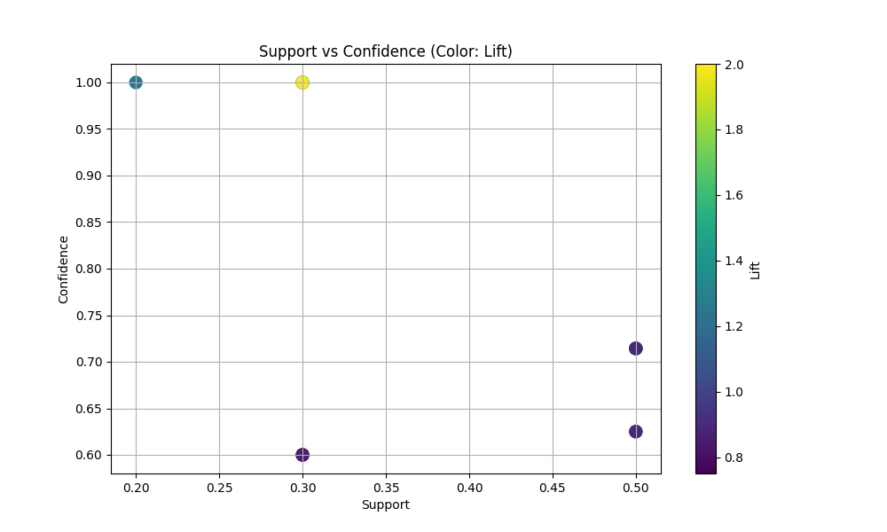

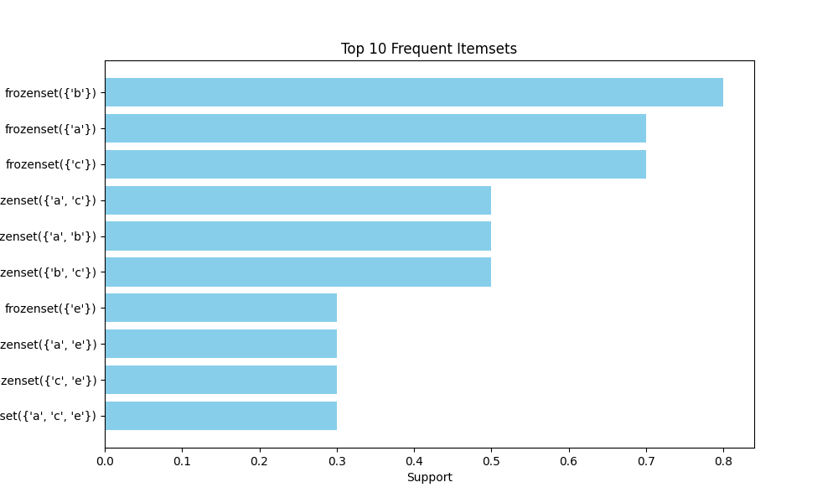

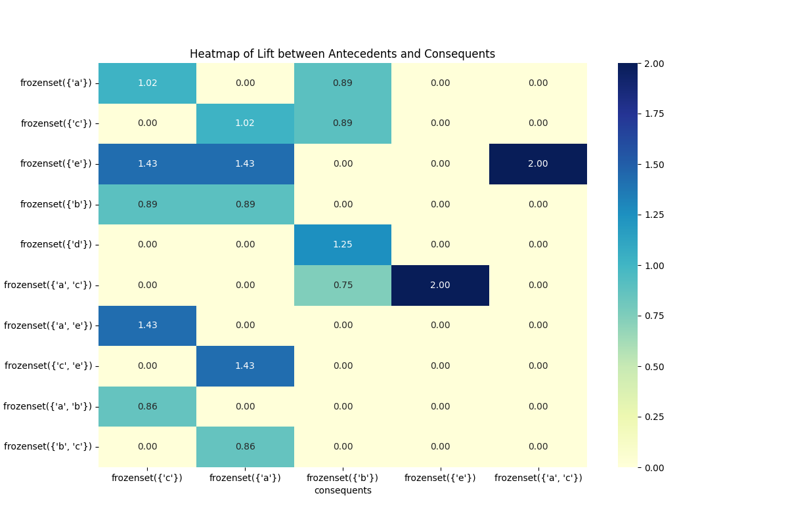

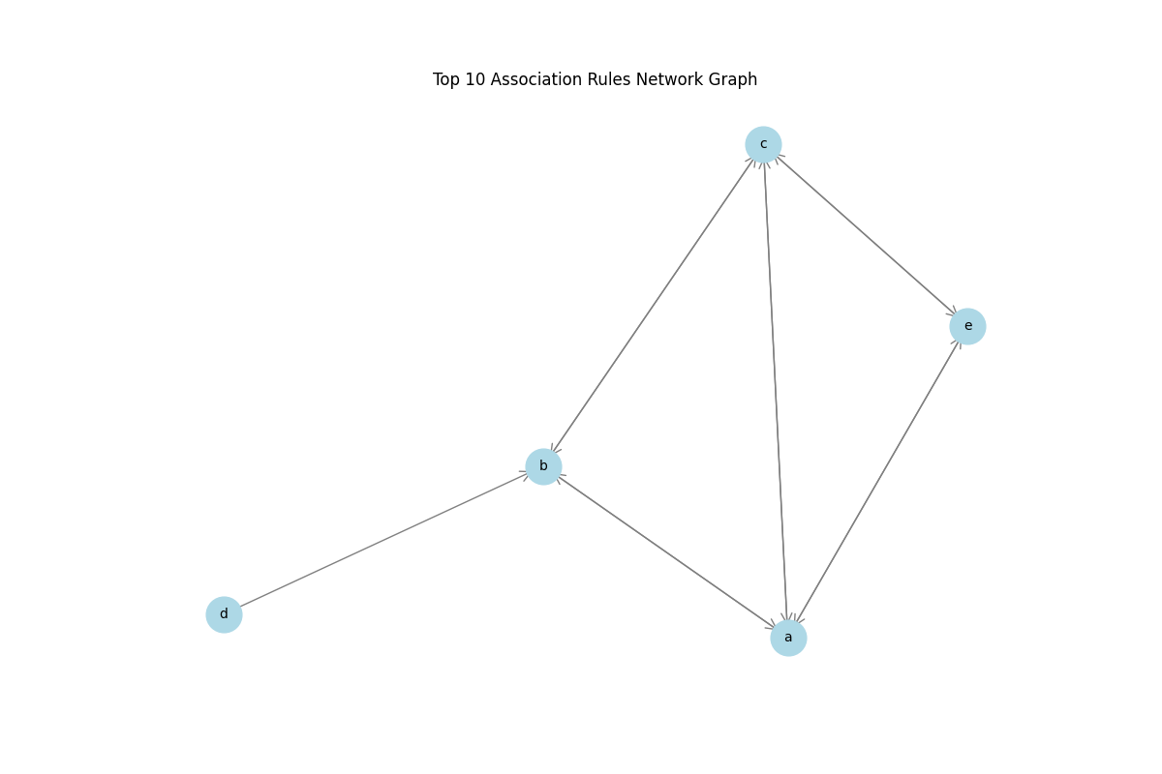

**使用FP-Growth算法**

from mlxtend.frequent_patterns import apriori, association_rules

import pandas as pd

import matplotlib.pyplot as plt

import seaborn as sns

import networkx as nx

# 读取数据

user_goods = pd.read_excel('goods_new.xls', header=None)

# 数据预处理为0-1矩阵

ct = lambda x: pd.Series(1, index=x[pd.notnull(x)])

b = map(ct, user_goods.values)

data = pd.DataFrame(list(b)).fillna(0).astype(int)

# 将数据转换为布尔类型

data = data.astype(bool)

# Apriori算法

frequent_itemsets = apriori(data, min_support=0.2, use_colnames=True)

# 关联规则分析

rules = association_rules(frequent_itemsets, metric="confidence", min_threshold=0.5, num_itemsets=len(frequent_itemsets))

# 输出结果

rules.to_excel('apriori_rules.xlsx', index=False)

print("Apriori规则分析结果已保存为 'apriori_rules.xlsx'")

# 1. 散点图: 支持度 vs 置信度，颜色表示提升度

plt.figure(figsize=(10, 6))

plt.scatter(rules['support'], rules['confidence'], c=rules['lift'], cmap='viridis', s=100)

plt.colorbar(label='Lift')

plt.xlabel('Support')

plt.ylabel('Confidence')

plt.title('Support vs Confidence (Color: Lift)')

plt.grid(True)

plt.show()

# 2. 频繁项集支持度柱状图

top_items = frequent_itemsets.nlargest(10, 'support')

plt.figure(figsize=(10, 6))

plt.barh(top_items['itemsets'].astype(str), top_items['support'], color='skyblue')

plt.xlabel('Support')

plt.ylabel('Itemsets')

plt.title('Top 10 Frequent Itemsets')

plt.gca().invert_yaxis()

plt.show()

# 3. 关联规则热力图 (基于提升度)

pivot = rules.pivot(index='antecedents', columns='consequents', values='lift')

pivot.fillna(0, inplace=True)

plt.figure(figsize=(12, 8))

sns.heatmap(pivot, annot=True, fmt=".2f", cmap="YlGnBu", cbar=True)

plt.title('Heatmap of Lift between Antecedents and Consequents')

plt.show()

# 4. 规则网络图 (展示前10个关联规则)

G = nx.DiGraph()

# 添加节点和边

for _, row in rules.head(10).iterrows():

for antecedent in row['antecedents']:

for consequent in row['consequents']:

G.add_edge(antecedent, consequent, weight=row['lift'])

# 绘制网络图

plt.figure(figsize=(12, 8))

pos = nx.spring_layout(G, k=0.5)

nx.draw_networkx_nodes(G, pos, node_size=700, node_color='lightblue')

nx.draw_networkx_edges(G, pos, arrowstyle='->', arrowsize=20, edge_color='gray')

nx.draw_networkx_labels(G, pos, font_size=10, font_color='black')

plt.title('Top 10 Association Rules Network Graph')

plt.axis('off')

plt.show()

