  - Shri Vile Parle Kelavani Mandal
  - Shri Bhagubhai Mafatlal Polytechnic
  - Vile Parle-(West), Mumbai-400056

FinAuditPro
  - Smarter Audit, Faster Work

Synopsis By:

Group No: 07
Aryan Yadav (T010)
Jeet Shah (T013)
Hitansh Jasani (T032)

Under Guidance of:
Mr. Abhijit Dongaonkar

Contents:
Abstract 3
Problem Statement 3
Introduction 4
System Requirement Specification 4
Hardware Requirements 4
Software Requirements 4
Proposed System 5
Features 5
Estimation and Planning 6
Diagrams 6
Use Case Diagrams: 6
Class Diagram: 8
Activity Diagram: 8
Flowchart: 9
Deployment Diagram: 12
Future Scope 12
Conclusion 12
References 13

Diagrams:
Figure 1: Gant Chart 6
Figure 2.1: Use Case Diagram 1 6
Figure 2.1: Use Case Diagram 2 7
Figure 2.3: Use Case Diagram 3 7
Figure 3: Class Diagram 8
Figure 4: Activity Diagram 8
Figure 5: Flowchart-1 9
Figure 6:Flowchart-2 10
Figure 7:Flowchart-3 11
Figure 8:Deployment Diagram 12

Abstract
This project caters the requirements of a car repair shop by developing a portal that can handle the entire repair shop without human intervention. The portal handles creation of job orders, estimation, and invoicing. It creates a planner for the jobs and assigns appropriate technicians for the same. Customers can use the portal for booking appointments and generating quotations. Managers can access historical data for analytical processing to aid decision making. CRM service which handles customer feedback, complaints and enquiries is provided.
With a workshop software garages can streamline all the processes at once. There is a need to provide customers with mobility giving them flexibility and keeping them in control. It is essential to use technology to become productive, more organised, more efficient in quoting and repairing; for better customer experience, which increases loyalty and retention which helps in growing business. As per the automotive industry trends, every auto repair shop must have a garage management software system.

Problem Statement
The traditional financial auditing industry faces problems like managing massive volumes of unstructured data, manual tracking of client records, and a high risk of errors in manual verification. The CRM and management of documents currently lack secure local processing. The need for an offline AI analysis tool is a requisite for establishing transparency and trust, enabling auditors to securely process sensitive financial data without uploading it to cloud servers. They require an enterprise-grade portal which can provide actionable insights, automate risk detection, and drive their auditing decisions.
The software should generate quick, accurate working papers and reduce paperwork so there is no need to worry about losing information. Everything is to be stored in a local SQLite database giving auditors access anytime to review past or present information securely. Everything should be automated to reduce the time taken for various regular audit operations. Ingesting, diagnosing, and reporting are some of the time-consuming tasks that are to be replaced with software. They expect the incoming audits to be scheduled to prevent overworking. The document portfolios, risk progress, and the track record of the firm, along with compliance checklists, the auditing software should be able to handle all these things at once.

Introduction
The traditional auditing processes face problems because of manual managing of client details, tasks, and document assignment. Documenting evidence and generating reports is not well automated. There is a lack of ability in offline AI-assisted report generation. This project is based on the industrial requirements for a highly secure local AI auditing application. The application will handle the creation of audit working papers, risk detection, and AI analysis of financial statements. It will create an efficient workspace for the auditors and manage client portfolios for the same. Users will be able to use the application for querying local LLMs and generating compliance checklists. The application will generate quick, accurate risk estimation and everything will be stored in a local SQLite database, so it is secure and accessible anytime anywhere. Ingesting, diagnosing, querying, and reporting are some of the tasks that will be sped up with the software. The incoming audit jobs will be scheduled and displayed for smooth completion.
The document portfolio, AI inference progress, and the track record of the firm, along with risk reporting and finances, this software will be able to handle all these things at once. The desktop application has various functionalities based on the auditing workflow. It generates working papers for the auditing process and exports them to PDF. It creates an efficient workspace for assigning tasks and monitoring the jobs registered. The application will have frontend using PySide6. The backend uses Python, FAISS, Ollama, and SQLite for database. The principal purpose is to meet the needs of the industry such that it can significantly help the risk management and ensure strict data privacy.

System Requirement Specification

Hardware Requirements

Server:
Processor: 2.5GHz CPU or more (Multi-core for local AI)
Memory: 16GB RAM or more
Disk Space: 50GB or more

Client:
Processor: 2.0 GHz CPU or more
Memory: 8GB RAM or more
Disk Space: 20GB or more

Software Requirements

Server:
Operating System: Windows/MacOS/Linux
Framework: PySide6 (Qt for Python)
Additional Requirements: Ollama, FAISS, Pandas
Database: SQLite with SQLAlchemy ORM

Client:
Operating System: Windows/MacOS/Linux
Environment: Python 3.10+

Proposed System
Our project will be able to handle document ingestion, AI-based financial queries, and track records of the audit processes, along with working paper generation. The software will manage the entire audit workflow with intelligent offline-first AI assistance. Automating the audit will provide efficiency, productivity, and absolute data privacy. It reduces the time taken for various regular auditing operations as everything will be streamlined. So, auditors do not have to spend their time on manual data extraction instead focus entirely on providing the best financial assessment. This system will handle the creation of executive summaries, risk reports, and compliance lists using relevant information ingested by the RAG pipeline. The local LLM integration is provided for establishing strict data security, enabling professionals to make informed, confident decisions on audit approvals without internet reliance.
Extracting, diagnosing, organizing, and generating reports will be automated. The incoming tasks will be scheduled to prevent overworking and resource clashing. Organizing documents and categorizing risks will be done by the system. This requirement could be catered using Python and SQLite with frontend functionalities to elevate the need of workflow management for a financial audit firm. The offline nature of our portal would improve client trust by ensuring zero data leaks. Our application will be the interface between auditors and the raw financial ledgers, showing information securely and intuitively.

Features
- Offline AI Audit Chat for auditors.
- Context-aware RAG pipeline on local documents.
- Automated risk analysis and categorization.
- Dynamic dashboard and interactive statistics.
- Reduces paperwork through digital processing.
- Secure local SQLite database management.
- Thread-safe architecture for smooth UI.
- Working paper and report generation.
- Client and document portfolio management.
- Strict offline data privacy and transparency.
- Effortless process management.
- Zero input collision handling.
- Enterprise-grade UI/UX design.

Estimation and Planning
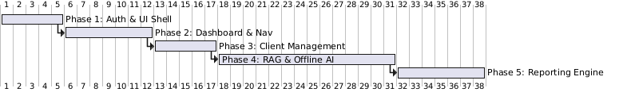
Figure 1: Gant Chart

Diagrams

Use Case Diagrams:
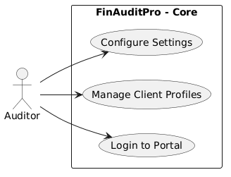
Figure 2.1: Use Case Diagram 1
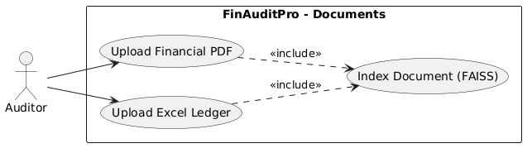
Figure 3.1: Use Case Diagram 2
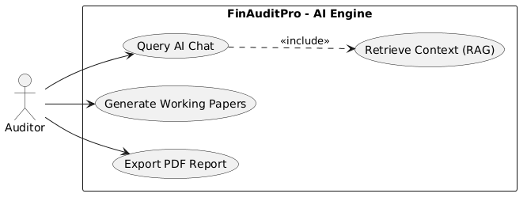
Figure 4.3: Use Case Diagram 3

Class Diagram:
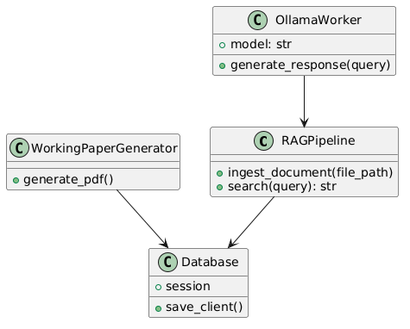
Figure 5: Class Diagram
Activity Diagram:
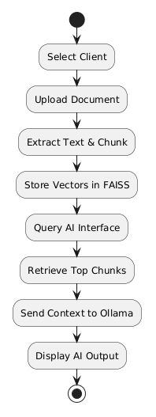
Figure 6: Activity Diagram

Flowchart:

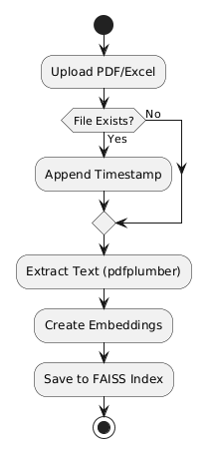
Figure 7: Flowchart-1
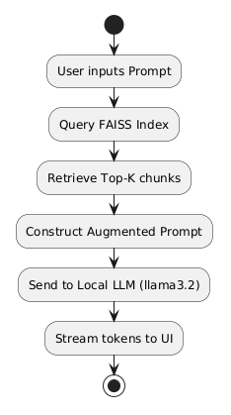
Figure 8:Flowchart-2
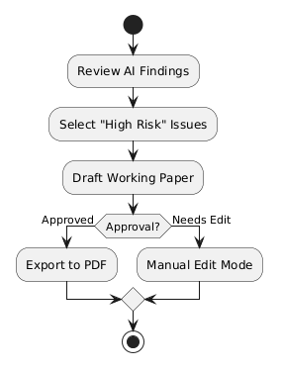
Figure 9:Flowchart-3

Deployment Diagram:
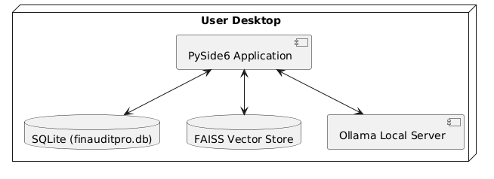
Figure 10:Deployment Diagram

Future Scope
- The implementation has generic standards which can be used in various compliance firms with minor changes.
- An auto-sync feature could be added for local network synchronization.
- Direct integration with third-party accounting APIs.
- Multi-user authentication and role-based access.

Conclusion
The desktop application is highly helpful for financial auditing firms throughout the process of analyzing and generating reports. It organizes the audit records and improves the efficiency of the workplace. The application can aid the functioning of the firm by reducing the time taken in manual data extraction. It increases professional productivity through numerous AI-driven services and a user-friendly interface. Features for proving transparency, data privacy, and accurate risk detection, sanctioning auditors to form educated, assured choices on financial approvals are provided for higher expertise, which increases loyalty and retention that helps in growing business. It is essential to use technology to become productive, more organized, and more efficient in auditing, but more importantly, to ensure absolute data security.

References
[1] PySide6 Documentation, https://doc.qt.io/qtforpython-6/
[2] Ollama Local AI Models, https://ollama.com/
[3] SQLAlchemy ORM, https://www.sqlalchemy.org/
[4] FAISS Vector Database, https://github.com/facebookresearch/faiss

