Ryu Muthui

February 20th, 2013.

CS161 Winter 2013

GUI Printouts:   
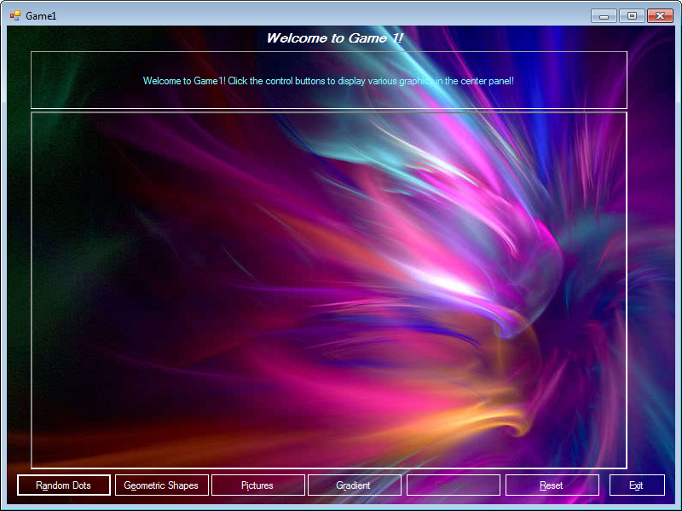GUI as it first shows up at program launch. 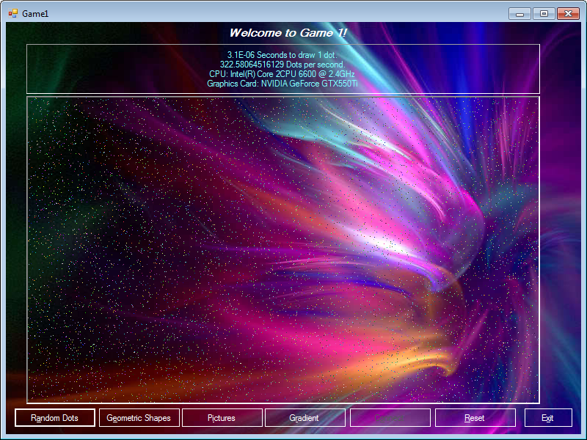  
GUI with “Random Dots” feature shown.

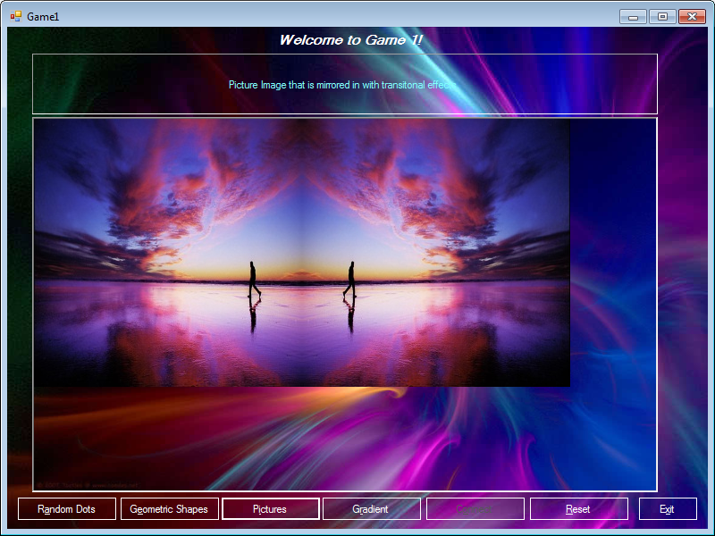  
GUI with “Picture” feature shown.

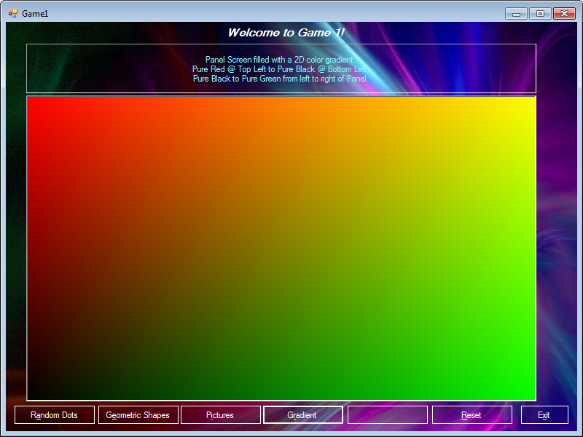  
GUI with “Gradient” feature shown.

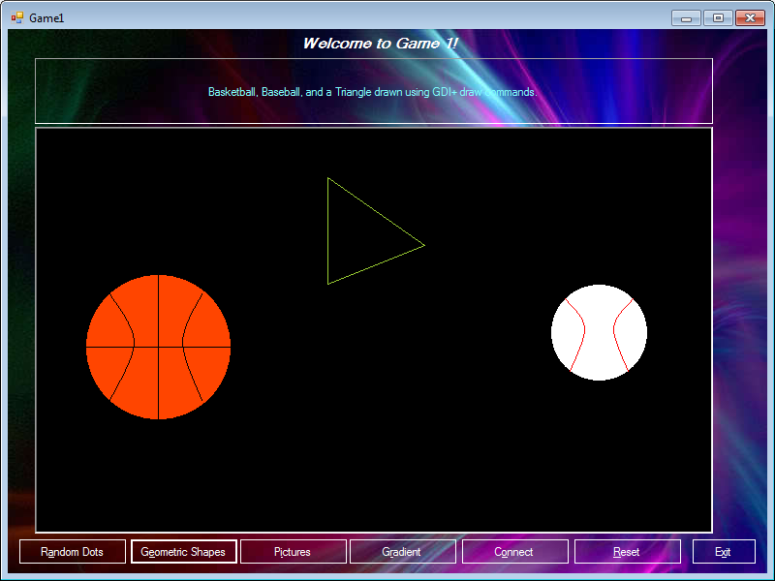  
GUI with “Geometric Shapes” feature shown.

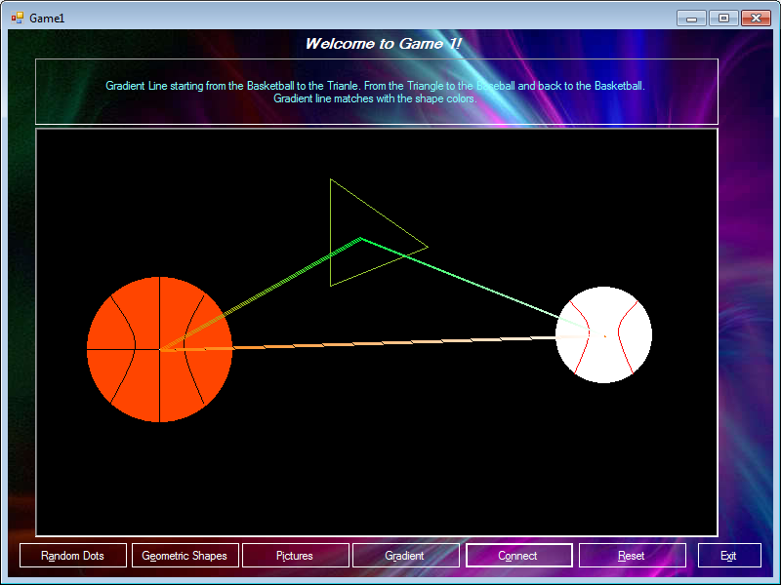  
GUI with “Connect” feature shown.