X

X

Search for:

X
- Posts
- Looks
- Shop
- Gift Guides
Subscribe
Skip to content
- Posts
- Looks
- Shop
- Gift Guides
Subscribe
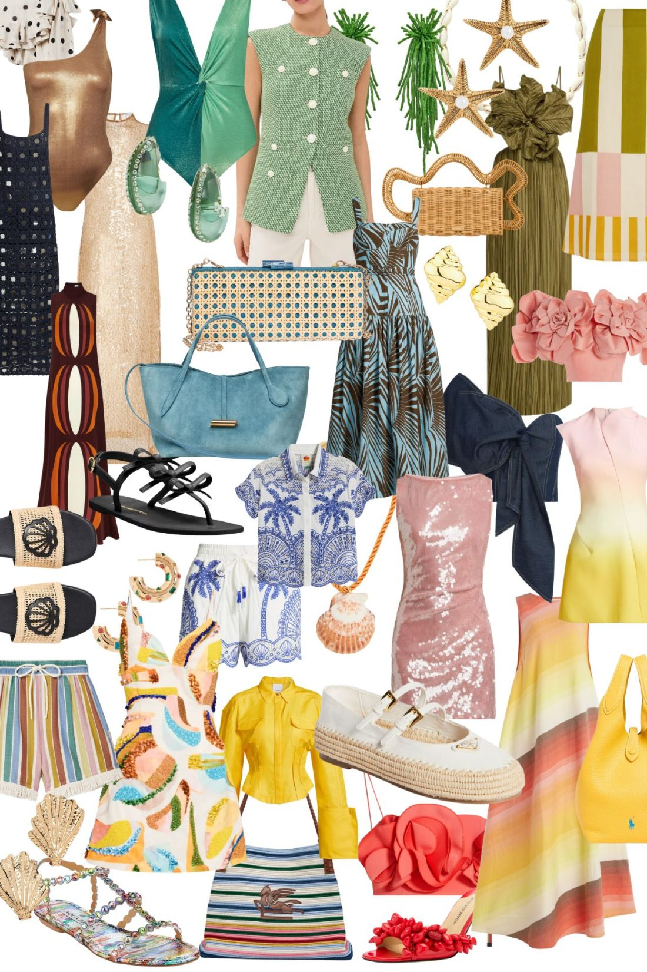

SUNSHINE STYLES
Read Post
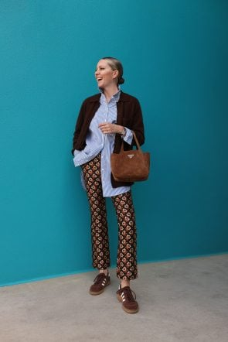

CARDIGAN OUTFITS AND HOW TO STYLE
Read Post
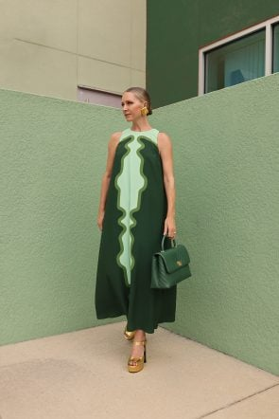

TUCKERNUCK’S END OF YEAR SALE
Read Post
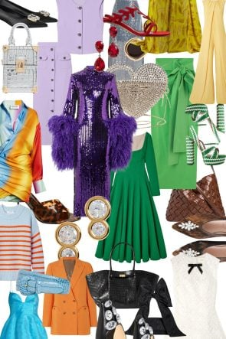

50 SALE ITEMS TO LOVE
Read Post

Looks
View All
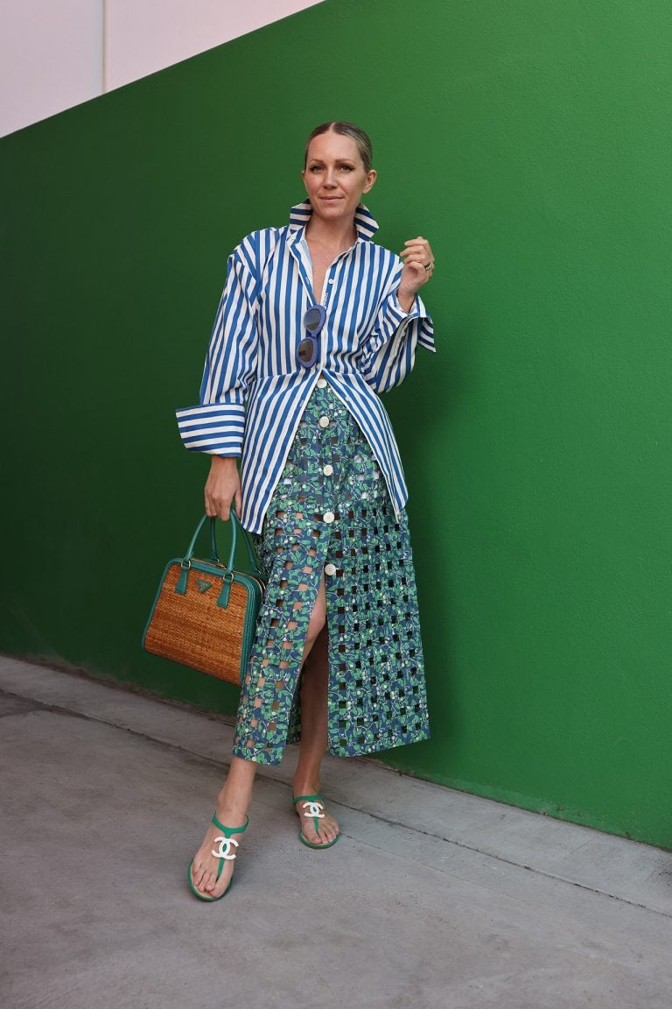

COCO
View More

Shirt: Simon Miller // Skirt: Coco Shop // Shoes: Chanel (love these) // Bag: Prada (tracked down ONE in white here) // Sunglasses: Zara
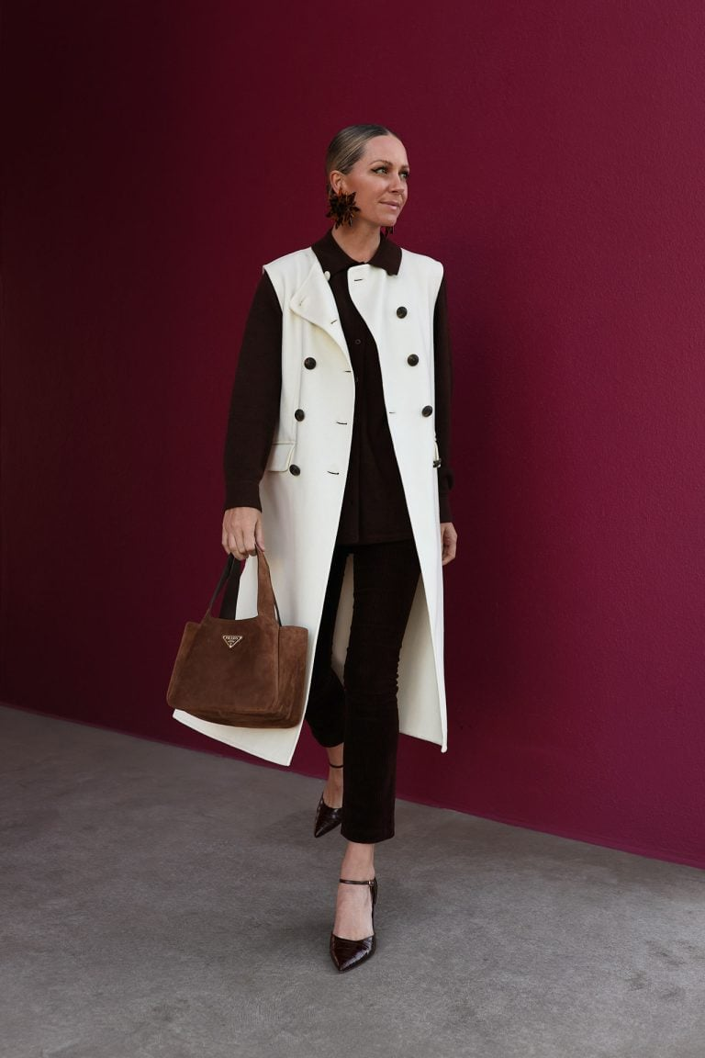

BROWNS
View More

Pants: Tuckernuck // Vest: Veronica Beard (on sale) // Sweater: White + Warren // Shoes: Tuckernuck // Bag: Prada // Earrings: Chefanie
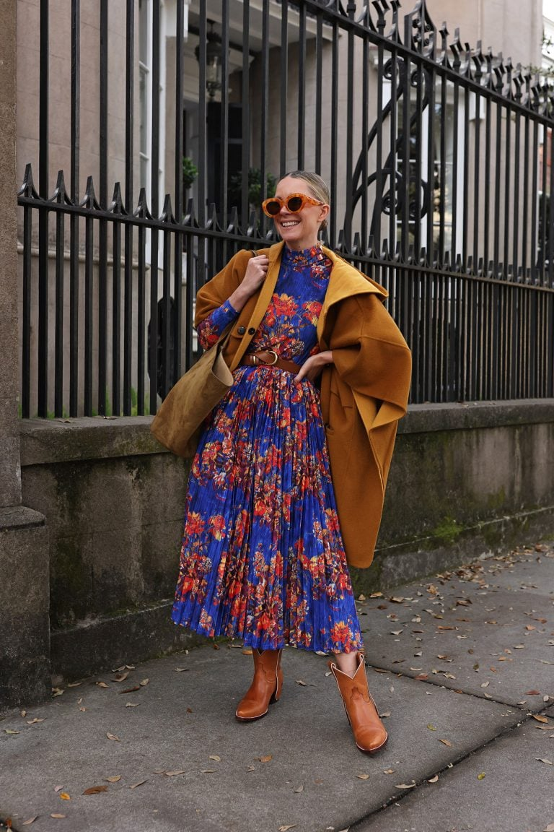

THANKS
View More

Cape: Sezane // Boots: City Boots // Dress: Hunter Bell // Belt: Sezane // Bag: Zara (linked here)
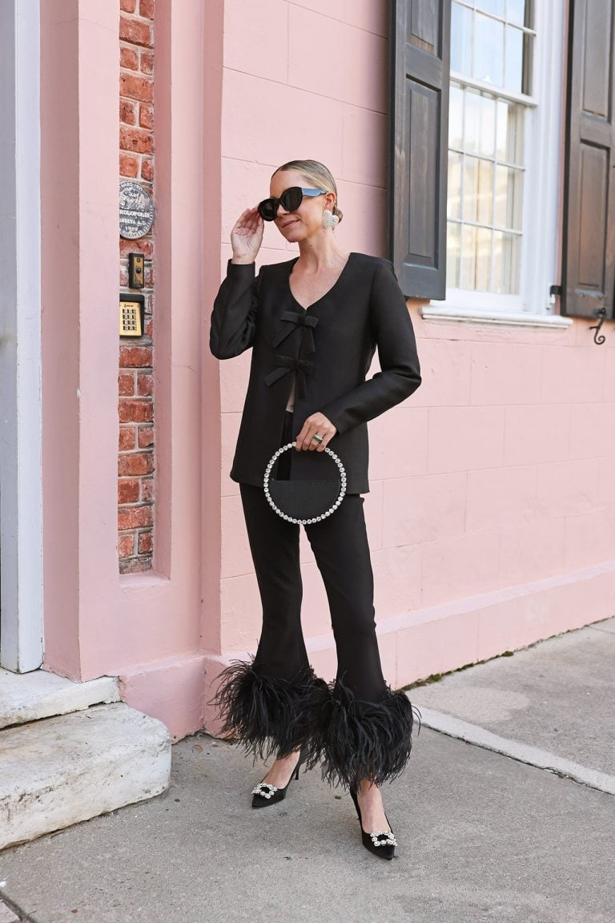

FEATHER
View More

Pants: Tnuck // Bow Top: Aligne // Shoes: Roger Vivier // Earrings: Nicola Bathie

Shop
Shop All
Previous

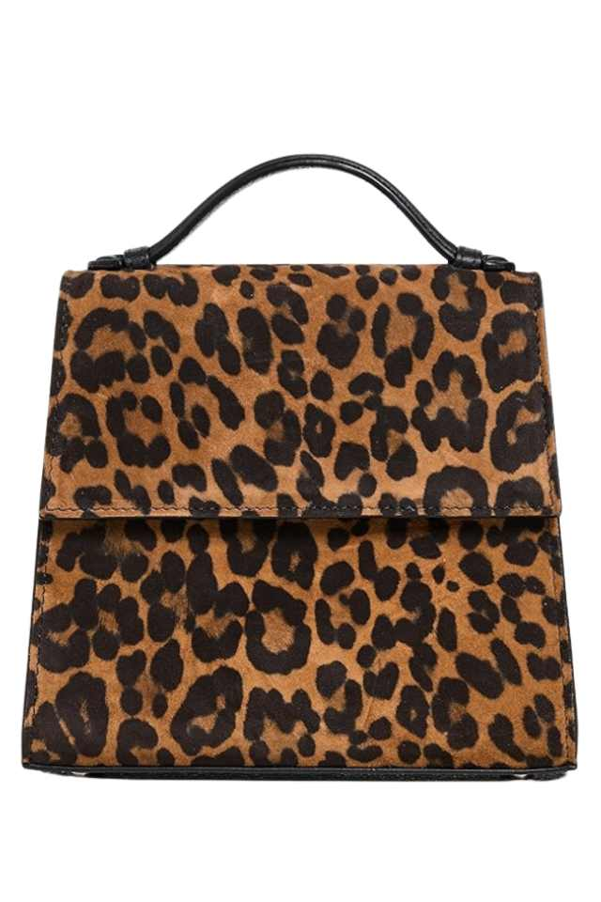
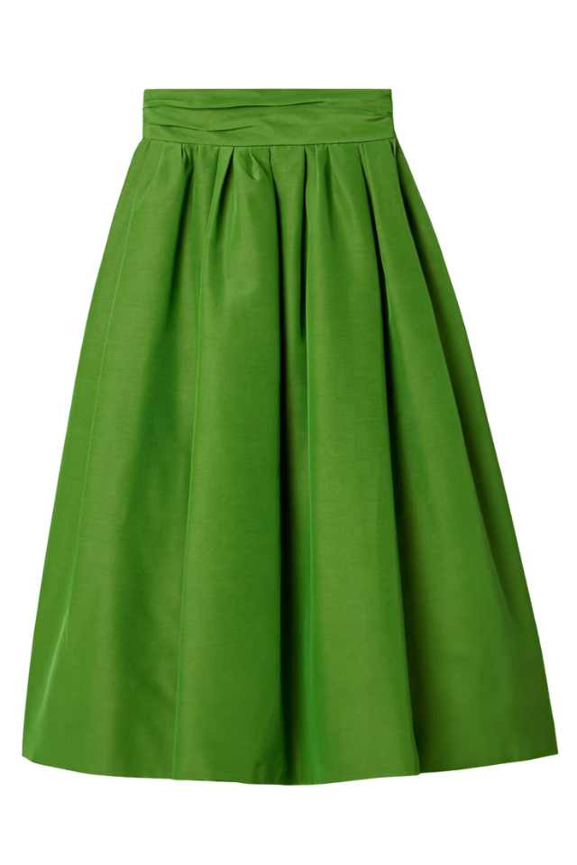
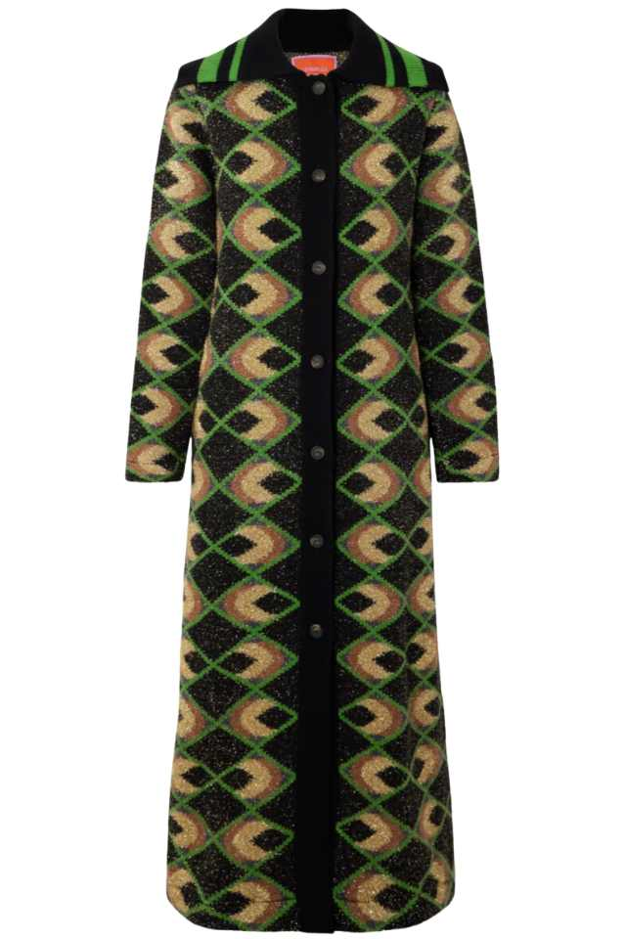
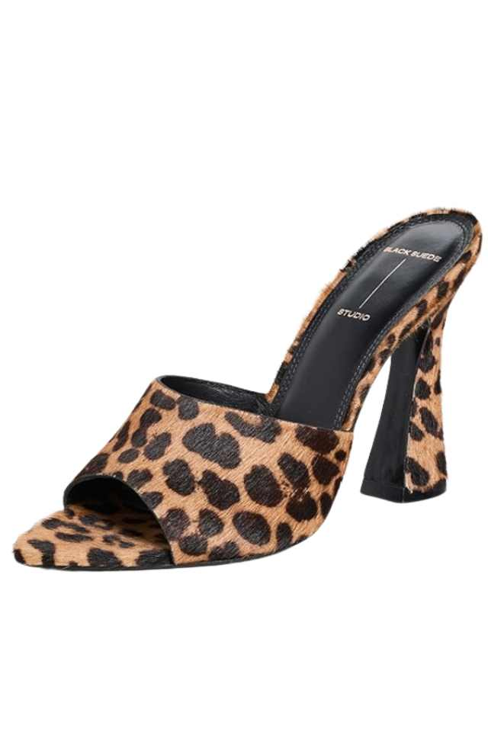

Next

More Recent Posts
View More
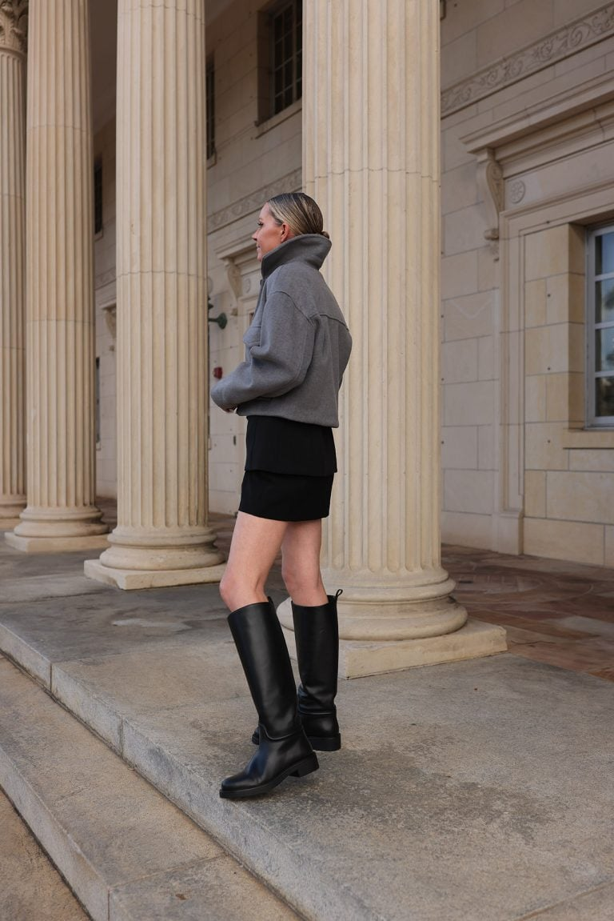

BACK TO BASICS
Read Post
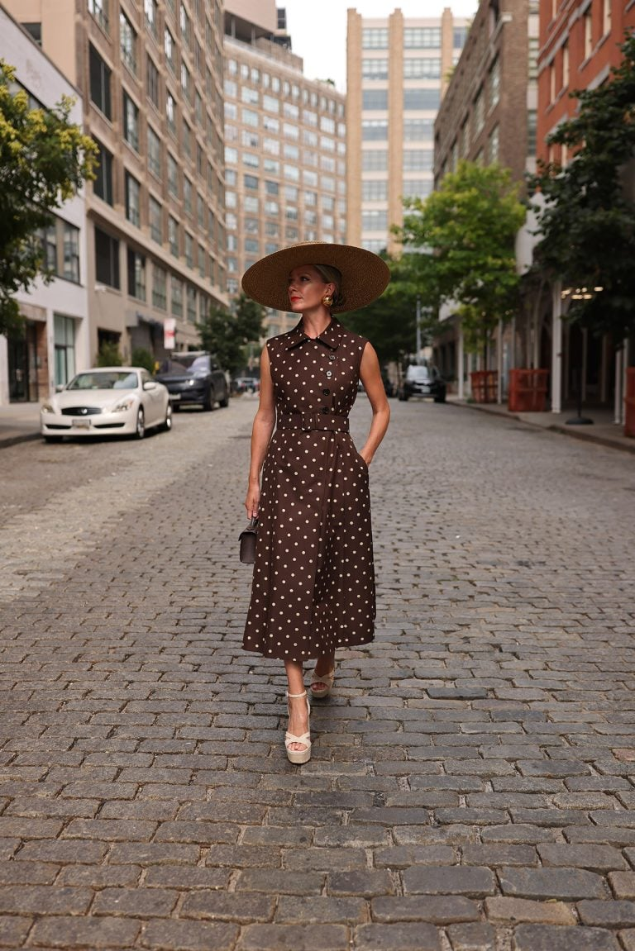

MY BEST BUYS OF 2024
Read Post
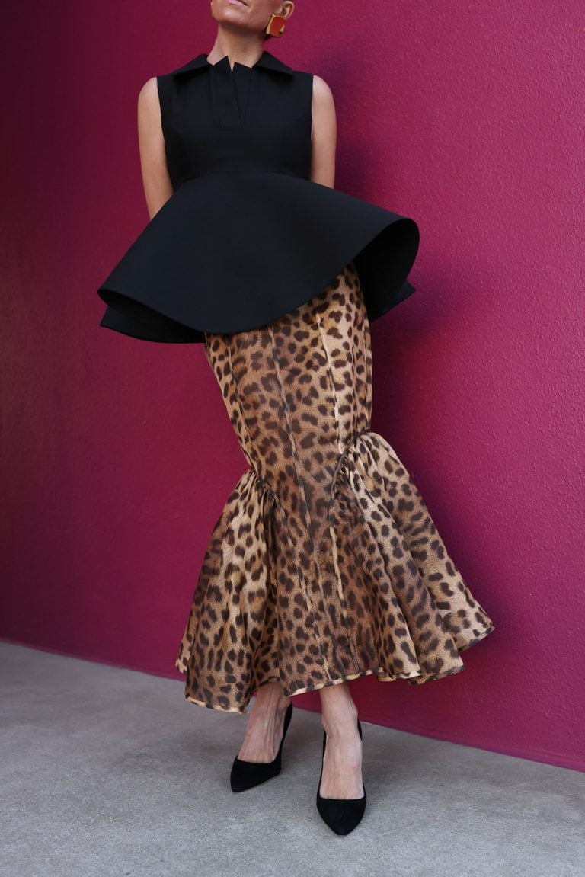

D-R-A-M-A: PERFECT PARTY PIECES
Read Post

Subscribe
Exclusive content & weekly updates

- About
- Contact
- Policy
© 2025 Atlantic - Pacific
Site by S9CO + WPFI
Scroll Up

