[Skip to main content](https://www.businessoffashion.com/" \l "main)

[Join **BoF Professional**](https://www.businessoffashion.com/subscriptions/packages/)

* [**NEWSLETTERS**](https://www.businessoffashion.com/newsletters/)
* [**NEWS & ANALYSIS**](https://www.businessoffashion.com/latest/)
* [**DATA & ADVISORY**](https://shop.businessoffashion.com/)
* [**CASE STUDIES**](https://www.businessoffashion.com/case-studies/)
* [**JOBS**](https://www.businessoffashion.com/careers/jobs/?int_source=onsite&int_medium=homepage_product_nav&int_campaign=jobs)
* [**EVENTS**](https://www.businessoffashion.com/events/)
* [**PEOPLE**](https://www.businessoffashion.com/bof500/)
* [**COMPANIES**](https://www.businessoffashion.com/search/?f=Organisations)

[Visit **BoF Careers**](https://www.businessoffashion.com/careers/?int_source=onsite&int_medium=homepage_product_nav&int_campaign=visit_bof_careers)

[The Business of Fashion](https://www.businessoffashion.com/)

[Retail](https://www.businessoffashion.com/topics/retail/)

[Luxury](https://www.businessoffashion.com/topics/luxury/)

[Technology](https://www.businessoffashion.com/topics/technology/)

[Sustainability](https://www.businessoffashion.com/topics/sustainability/)

[Marketing](https://www.businessoffashion.com/topics/marketing-pr/)

[Beauty](https://www.businessoffashion.com/topics/beauty/)

[DTC](https://www.businessoffashion.com/topics/direct-to-consumer/)

[Global Markets](https://www.businessoffashion.com/topics/global-markets/)

[Fashion Week](https://www.businessoffashion.com/topics/fashion-week/)

[Workplace & Talent](https://www.businessoffashion.com/topics/workplace-talent/)

Join BoF Professional today for agenda-setting analysis and advice. Start your 30-day trial for just ₹100.

[START TRIAL](https://www.businessoffashion.com/subscriptions/packages/)

[**Why the ‘Walmart Birkin’ Struck a Nerve**](https://www.businessoffashion.com/articles/marketing-pr/the-walmart-birkin-conversation/)

[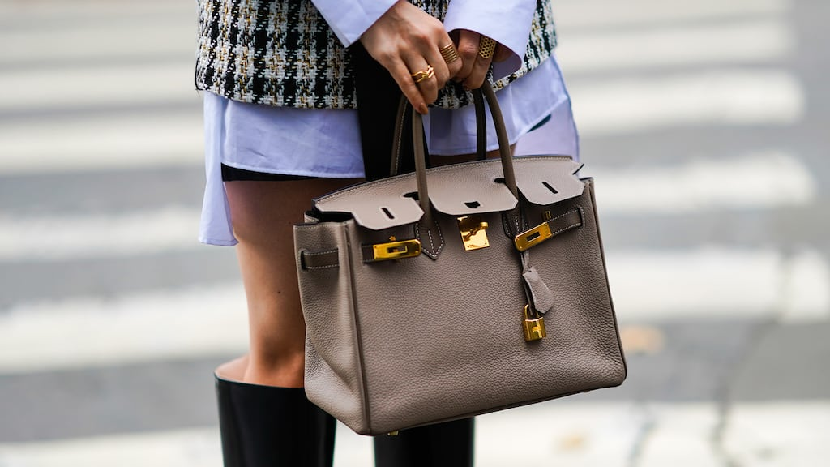](https://www.businessoffashion.com/articles/marketing-pr/the-walmart-birkin-conversation/)

[**TODAY'S MUST READ**](https://www.businessoffashion.com/articles/marketing-pr/the-walmart-birkin-conversation/)There are countless “dupes” for luxury goods available, but the fact that a copycat version of Hermès' ultra-coveted bag attracted so much attention online speaks to a shift in consumer sentiment around buying knockoffs.

ADVERTISEMENT

**Latest News & Analysis**

ADVERTISEMENT

ADVERTISEMENT

**The News in Brief**

[**TikTok’s Live Video Feature ‘Groomed’ Minors, Utah AG Claims**](https://www.businessoffashion.com/news/technology/tiktoks-live-video-feature-groomed-minors-utah-ag-claims/)

A newly unredacted lawsuit reveals that TikTok has long been aware its livestream feature facilitated sexual exploitation of minors, money laundering, and even funded terrorism.

03 January 2025

[**Laura Ashley Bought by US Owner of Ben Sherman**](https://www.businessoffashion.com/news/retail/laura-ashley-bought-by-us-owner-of-ben-sherman/)

The British brand known for its floral fashion and home furnishings has been acquired by New York-based Marquee Brands, which plans to expand its lifestyle offerings while retaining the UK team and opening its first European headquarters in London.

03 January 2025

[**Fire Devastates Ghana’s Kantamanto Used Clothing Market**](https://www.businessoffashion.com/news/global-markets/kantamanto-fire-secondhand-clothing-trade-ghana/)

The blaze late Wednesday dealt a huge blow to the secondhand trading hub, displacing thousands of traders.

03 January 2025

[**UK Lawmakers Summon Shein and Temu for Questioning Over Labour Practices**](https://www.businessoffashion.com/news/retail/uk-lawmakers-summon-shein-and-temu-for-questioning-over-labour-practices/)

The committee, chaired by former Labour minister Liam Byrne, is examining the government’s flagship employment rights bill in the context of protections for British workers.

03 January 2025

[**Trouble in China’s Shopping Paradise as Hainan Duty-Free Spending Falls 29%**](https://www.businessoffashion.com/news/china/trouble-in-chinas-shopping-paradise-as-hainan-duty-free-spending-falls-29/)

Shoppers visiting Hainan, known for its glitzy seafront hotels and sandy beaches, spent 30.94 billion yuan ($4.24 billion) on duty-free goods in 2024, local customs data showed on Thursday, falling 29.3 percent from a year earlier.

03 January 2025

[**view more**](https://www.businessoffashion.com/news/)

**MOST POPULAR**

1

**[The 10 Themes That Will Define the Fashion Agenda in the Year Ahead](https://www.businessoffashion.com/articles/news-analysis/the-state-of-fashion-2025-report-industry-outlook-economy-market/)**

2

**[The Best of BoF 2024: Designer Reboots and a Rocky Market](https://www.businessoffashion.com/articles/luxury/best-of-2024-luxury-fashion-show-designer/)**

3

**[Inside Luxury’s Broken Audit System](https://www.businessoffashion.com/articles/luxury/inside-luxurys-broken-audit-system/)**

4

**[The Best of BoF 2024: How Beauty’s Biggest Companies Fared in 2024](https://www.businessoffashion.com/articles/beauty/best-of-2024-beauty-conglomerates/)**

5

**[The Best of BoF 2024: Finding Stability in a Hostile Workplace & Talent Environment](https://www.businessoffashion.com/articles/workplace-talent/best-of-2024-workplace-talent/)**

6

**[The Best of BoF 2024: When Beauty Trends Tap Culture](https://www.businessoffashion.com/articles/beauty/best-of-2024-beauty-retail-marketing/)**

7

**[The Best of BoF 2024: Finding Technology’s Value](https://www.businessoffashion.com/articles/technology/best-of-2024-technology-ai/)**

8

**[The Best of BoF 2024: Navigating the Wellness Hype Cycle](https://www.businessoffashion.com/articles/beauty/best-of-2024-beauty-wellness/)**

9

**[The BoF Podcast | What Happens When It’s Too Hot to Make Fashion?](https://www.businessoffashion.com/podcasts/sustainability/the-bof-podcast-what-happens-when-its-too-hot-to-make-fashion/)**

10

**[The Best of BoF 2024: A Return to Beauty Retail](https://www.businessoffashion.com/articles/beauty/the-best-of-bof-2024-a-return-to-beauty-retail-at-stores-like-nordstrom-ulta-and-sephora/)**

**SPOTLIGHT**

[**BoF CAREERS**](https://www.businessoffashion.com/careers/?int_source=onsite&int_medium=homepage_product_nav&int_campaign=visit_bof_careers)

[Gap](https://www.businessoffashion.com/organisations/gap/)

Gap is an American apparel retail company. Founded in 1969 in San Francisco, Gap is owned by parent company Gap Inc., which also operates Old Navy, Banana Republic and Athleta.

[Assistant Site Merchandiser](https://www.businessoffashion.com/careers/job/277015/assistant-site-merchandiser/?TrackID=11)

[San Francisco, California, United States](https://www.businessoffashion.com/careers/job/277015/assistant-site-merchandiser/?TrackID=11)

[Copywriter, Gap](https://www.businessoffashion.com/careers/job/276690/copywriter-gap/?TrackID=11)

[San Francisco, California, United States](https://www.businessoffashion.com/careers/job/276690/copywriter-gap/?TrackID=11)

[Merchandiser, GO Mens](https://www.businessoffashion.com/careers/job/276530/merchandiser-go-mens/?TrackID=11)

[New York, New York, United States](https://www.businessoffashion.com/careers/job/276530/merchandiser-go-mens/?TrackID=11)

[View more jobs](https://www.businessoffashion.com/careers/searchjobs/?keywords=gap&int_campaign=BoFSite&int_medium=Referral&int_source=CompanyPageViewAllJobs)

To showcase your brand, and attract top talent, [contact us.](https://careerspartners.businessoffashion.com/contact/)

**Latest by Topic**

[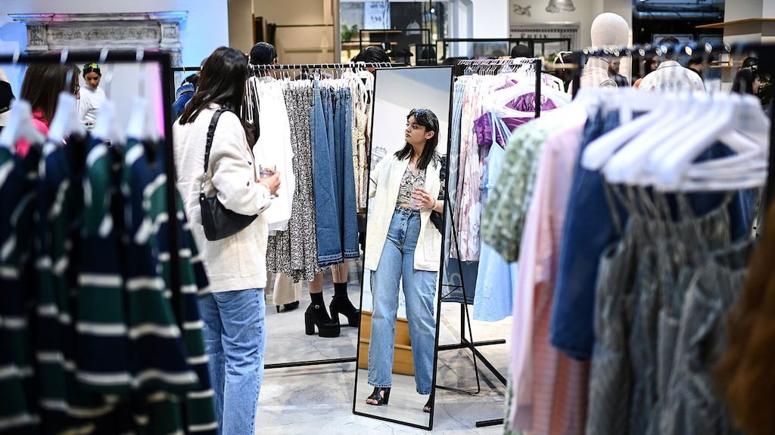](https://www.businessoffashion.com/topics/retail/)

Retail

Analysis and advice from the front lines of the retail transformation.

**[Tackling Fashion’s Excess Inventory Problem](https://www.businessoffashion.com/articles/retail/the-state-of-fashion-2025-report-inventory-excess-stock-supply-chain/)**

**[Why Brick-and-Mortar Resale Is Flourishing](https://www.businessoffashion.com/articles/retail/brick-and-mortar-resale-boom/)**

**[Nordstrom Goes Private in $6.25 Billion Deal](https://www.businessoffashion.com/news/retail/nordstrom-goes-private-in-625-billion-deal/)**

[**VIEW MORE**](https://www.businessoffashion.com/topics/retail/)

[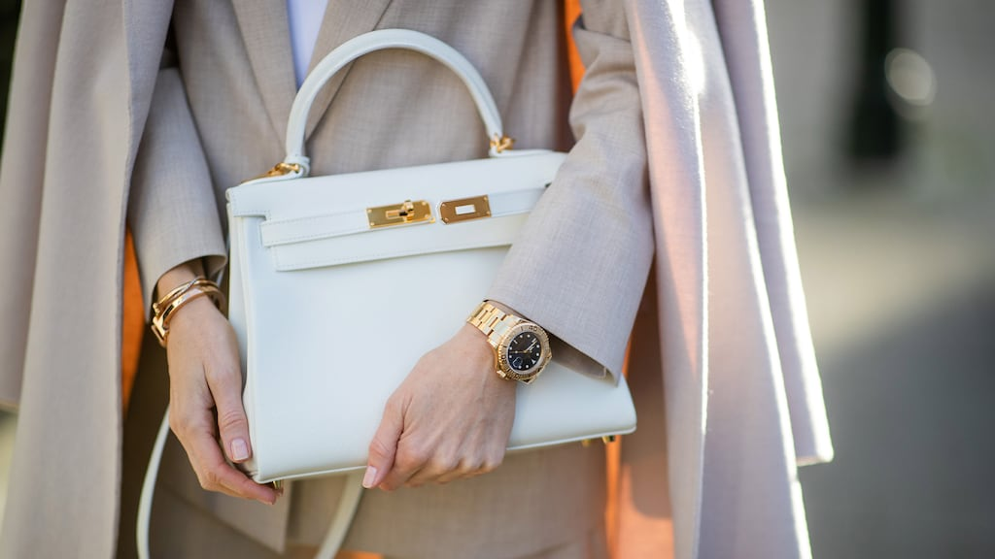](https://www.businessoffashion.com/topics/luxury/)

Luxury

How rapid change is reshaping the tradition-soaked luxury sector in Europe and beyond.

**[Inside Luxury’s Broken Audit System](https://www.businessoffashion.com/articles/luxury/inside-luxurys-broken-audit-system/)**

**[The Best of BoF 2024: Designer Reboots and a Rocky Market](https://www.businessoffashion.com/articles/luxury/best-of-2024-luxury-fashion-show-designer/)**

**[The BoF Podcast | Alessandro Michele and Jacopo Venturini on the New Valentino](https://www.businessoffashion.com/podcasts/luxury/the-bof-podcast-alessandro-michele-and-jacopo-venturini-on-the-new-valentino/)**

[**VIEW MORE**](https://www.businessoffashion.com/topics/luxury/)

[](https://www.businessoffashion.com/topics/technology/)

Technology

Analysis and advice on how technology is disrupting fashion and creating new opportunities.

**[What Fashion’s E-Commerce and Tech Professionals Need to Know Today](https://www.businessoffashion.com/articles/technology/careers-market-insights-industry-news-fashion-technology-ecommerce/)**

**[The Best of BoF 2024: Finding Technology’s Value](https://www.businessoffashion.com/articles/technology/best-of-2024-technology-ai/)**

**[As Bitcoin Soars, Luxury Brands Consider Accepting Crypto Payments](https://www.businessoffashion.com/articles/technology/as-bitcoin-soars-luxury-brands-consider-accepting-crypto-payments/)**

[**VIEW MORE**](https://www.businessoffashion.com/topics/technology/)

[](https://www.businessoffashion.com/topics/sustainability/)

Sustainability

How fashion can do better for people and the planet.

**[It’s Time for Fashion to Get Real About its Climate Risks](https://www.businessoffashion.com/articles/sustainability/climate-change-fashion-risk-adaptation-crisis/)**

**[The BoF Podcast | What Happens When It’s Too Hot to Make Fashion?](https://www.businessoffashion.com/podcasts/sustainability/the-bof-podcast-what-happens-when-its-too-hot-to-make-fashion/)**

**[The Best of BoF 2024: Fashion’s Sustainability Pullback](https://www.businessoffashion.com/articles/sustainability/best-of-2024-sustainability-regulation-workers-rights/)**

[**VIEW MORE**](https://www.businessoffashion.com/topics/sustainability/)

[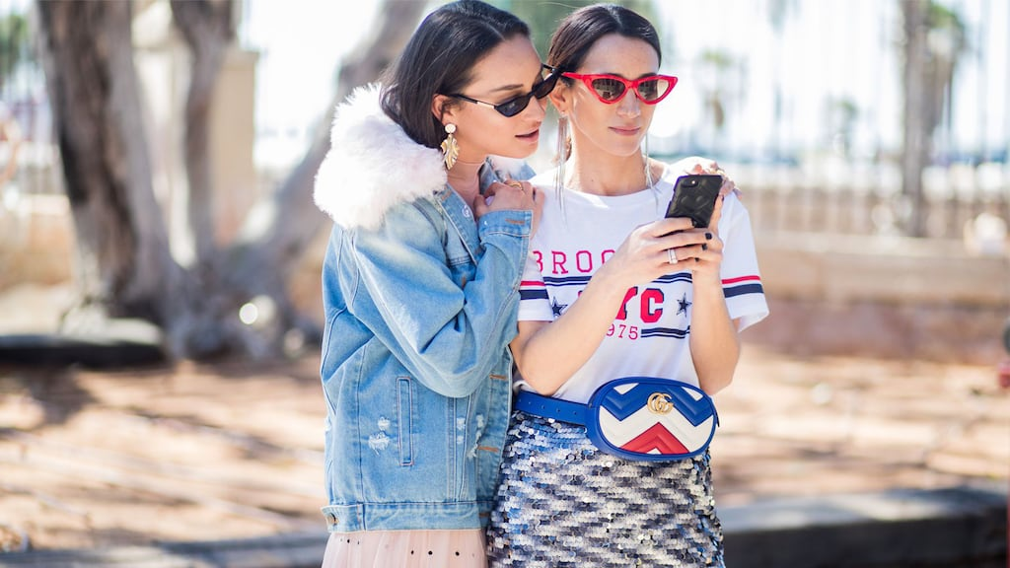](https://www.businessoffashion.com/topics/marketing-pr/)

Marketing

How new technologies and cultural shifts are rewiring fashion communications.

**[Why the ‘Walmart Birkin’ Struck a Nerve](https://www.businessoffashion.com/articles/marketing-pr/the-walmart-birkin-conversation/)**

**[The Best of BoF 2024: Fashion’s Cultural Crossover Continues](https://www.businessoffashion.com/articles/marketing-pr/best-of-2024-marketing-media-influencer/)**

**[2024 Was the Year of Entertainment in Marketing](https://www.businessoffashion.com/articles/marketing-pr/2024-was-the-year-of-entertainment-in-marketing/)**

[**VIEW MORE**](https://www.businessoffashion.com/topics/marketing-pr/)

[](https://www.businessoffashion.com/topics/beauty/)

Beauty

Analysis and advice on the fast-evolving beauty business.

**[The Best of BoF 2024: Beauty Launches](https://www.businessoffashion.com/articles/beauty/best-of-2024-beauty-launch/)**

**[Why the Obesity Drug Revolution Is a Work in Progress](https://www.businessoffashion.com/articles/beauty/why-the-obesity-drug-revolution-is-a-work-in-progress/)**

**[The Best of BoF 2024: The Big Beauty M&A Year That Wasn’t](https://www.businessoffashion.com/articles/beauty/best-of-2024-beauty-merger-acquisition/)**

[**VIEW MORE**](https://www.businessoffashion.com/topics/beauty/)

[](https://www.businessoffashion.com/topics/direct-to-consumer/)

Direct-to-Consumer

How direct-to-consumer brands and retail concepts are reshaping the industry, online and off.

**[The Best of BoF 2024: Rewriting the Direct-to-Consumer Playbook](https://www.businessoffashion.com/articles/direct-to-consumer/best-of-2024-direct-to-consumer-ecommerce/)**

**[Telfar’s First Store: A Block Party for the ‘Bushwick Birkin’](https://www.businessoffashion.com/articles/direct-to-consumer/inside-telfars-first-flagship-store/)**

**[The Debrief | How Dupe Culture is Challenging Traditional Luxury](https://www.businessoffashion.com/podcasts/direct-to-consumer/the-debrief-how-dupe-culture-is-challenging-traditional-luxury/)**

[**VIEW MORE**](https://www.businessoffashion.com/topics/direct-to-consumer/)

[](https://www.businessoffashion.com/topics/global-markets/)

Global Markets

A guide to unlocking opportunity in emerging and frontier fashion markets.

**[The Best of BoF 2024: Navigating Risks and Opportunities Around the World](https://www.businessoffashion.com/articles/global-markets/best-of-2024-global-markets/)**

**[Why A Dior Handbag Caused a Stir in South Korean Politics](https://www.businessoffashion.com/news/global-markets/why-a-dior-handbag-caused-a-stir-in-south-korean-politics/)**

**[Worldview | Dazed Magazine Launches Middle East Edition](https://www.businessoffashion.com/articles/global-markets/worldview-dazed-magazine-launches-middle-east-edition/)**

[**VIEW MORE**](https://www.businessoffashion.com/topics/global-markets/)

[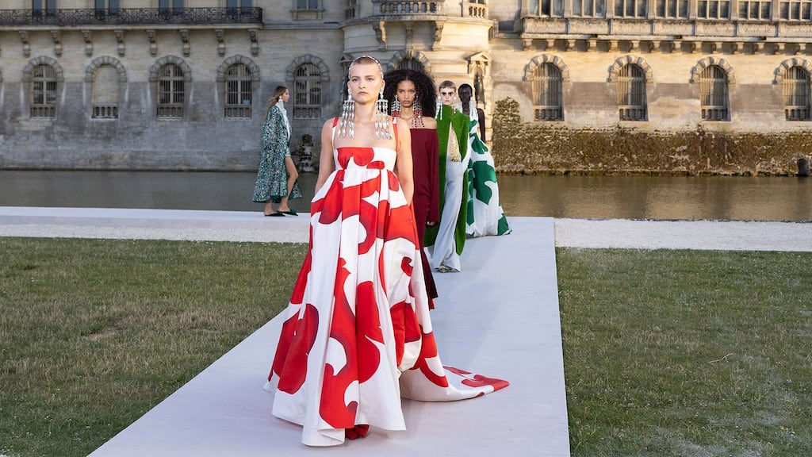](https://www.businessoffashion.com/topics/fashion-week/)

Fashion Week

Independent show reviews from fashion’s top critics.

**[The BoF Podcast | Tim Blanks and Imran Amed Reflect on the Spring/Summer 2025 Shows](https://www.businessoffashion.com/podcasts/fashion-week/tim-blanks-and-imran-amed-on-fashions-realignment/)**

**[The Top 10 Shows of the Season](https://www.businessoffashion.com/articles/fashion-week/the-top-10-shows-of-the-season-fashion-week/)**

**[At Paris Fashion Week, Fear and Fearlessness](https://www.businessoffashion.com/reviews/fashion-week/paris-fashion-week-spring-summer-2025-review/)**

[**VIEW MORE**](https://www.businessoffashion.com/topics/fashion-week/)

[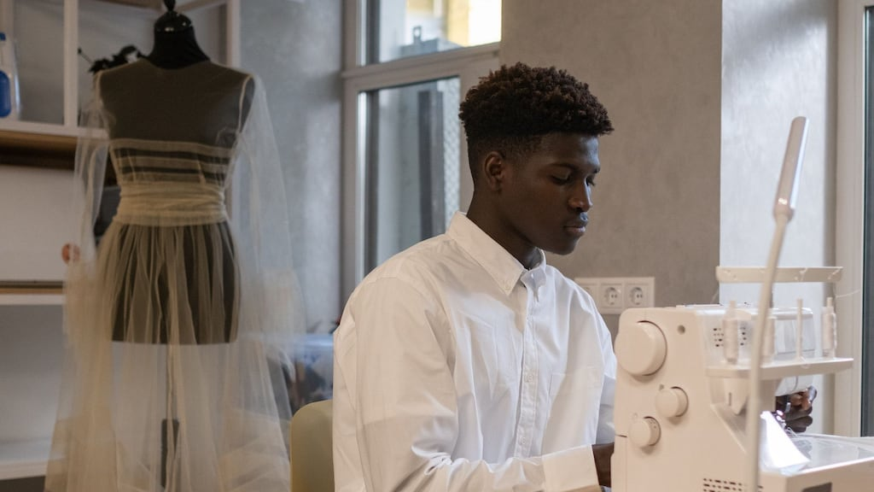](https://www.businessoffashion.com/topics/workplace-talent/)

Workplace & Talent

Analysis and advice on the future of work, careers and management.

**[The Best Jobs on BoF Careers](https://www.businessoffashion.com/articles/workplace-talent/best-fashion-jobs-bof-careers-opportunities-new-roles/)**

**[The Best of BoF 2024: Finding Stability in a Hostile Workplace & Talent Environment](https://www.businessoffashion.com/articles/workplace-talent/best-of-2024-workplace-talent/)**

**[What Fashion Designers Need to Know Today](https://www.businessoffashion.com/articles/workplace-talent/careers-market-insights-industry-news-fashion-design/)**

[**VIEW MORE**](https://www.businessoffashion.com/topics/workplace-talent/)

Top of Form

**Subscribe to the BoF Daily Digest**

The essential daily round-up of fashion news, analysis, and breaking news alerts.

Subscribe

Receive news, offers and invites from BoF

Our newsletters may include 3rd-party advertising, by subscribing you agree to the [Terms and Conditions](https://www.businessoffashion.com/legal/#terms) & [Privacy Policy](https://www.businessoffashion.com/legal/#privacy).

Bottom of Form

**The Business of Fashion**

Agenda-setting intelligence, analysis and advice for the global fashion community.

**About Us**

* [About Us](https://www.businessoffashion.com/about-us/)
* [What We Do](https://www.businessoffashion.com/what-we-do/)
* [Our Journalism](https://www.businessoffashion.com/our-journalism/)
* [Who We Are](https://www.businessoffashion.com/who-we-are/)
* [Work With Us](https://www.businessoffashion.com/work-with-us/)
* [Imran Amed](https://www.businessoffashion.com/imran-amed/)

**Contact Us**

* [Contact Us](https://www.businessoffashion.com/contact-us/)

**Our Products**

* [Newsletters](https://www.businessoffashion.com/newsletters/)
* [BoF Professional](https://www.businessoffashion.com/subscriptions/packages/)
* [BoF Careers](https://www.businessoffashion.com/careers/?int_source=onsite&int_medium=footer&int_campaign=bof_careers)
* [BoF Insights](https://shop.businessoffashion.com/)
* [BoF Events](https://www.businessoffashion.com/events/)

**CONNECT WITH US ON**

[](https://www.businessoffashion.com/reports/news-analysis/the-state-of-fashion-2025-bof-mckinsey-report/?utm_campaign=sof_2025&utm_medium=onsite&utm_source=footer_banner)

© 2025 The Business of Fashion. All rights reserved. For more information read our [Terms & Conditions](https://www.businessoffashion.com/legal/#terms), [Privacy Policy](https://www.businessoffashion.com/legal/#privacy-policy), [Cookie Policy](https://www.businessoffashion.com/cookie-policy/) and [Accessibility Statement](https://www.businessoffashion.com/accessibility/).