UK Edition

* [Trends](https://www.whowhatwear.com/uk/fashion/trends)
* [Outfits](https://www.whowhatwear.com/uk/fashion/outfit-ideas)
* [Shopping](https://www.whowhatwear.com/uk/fashion/shopping)
* [Beauty](https://www.whowhatwear.com/uk/beauty)
* [Living](https://www.whowhatwear.com/uk/living)

• [NEWSLETTER](https://www.whowhatwear.com/newsletter)

[[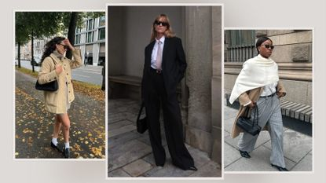](https://www.whowhatwear.com/fashion/trends/european-fashion-trends-2025)](https://www.whowhatwear.com/fashion/trends/european-fashion-trends-2025" \t "_self)

[Prediction: The Most Stylish People You Know Will Wear These 7 European Fashion Trends in 2025](https://www.whowhatwear.com/fashion/trends/european-fashion-trends-2025" \t "_self)

[I'm placing my bets.](https://www.whowhatwear.com/fashion/trends/european-fashion-trends-2025" \t "_self)

Top stories

[[](https://www.whowhatwear.com/fashion/shoes/sock-boots-trend)](https://www.whowhatwear.com/fashion/shoes/sock-boots-trend" \t "_self)

[Wait, What? Every Millennial's Favourite Boot Trend Is Suddenly Back for 2025](https://www.whowhatwear.com/fashion/shoes/sock-boots-trend" \t "_self)

[Can it be?](https://www.whowhatwear.com/fashion/shoes/sock-boots-trend" \t "_self)

[By Natalie Munro](https://www.whowhatwear.com/fashion/shoes/sock-boots-trend" \t "_self)

[[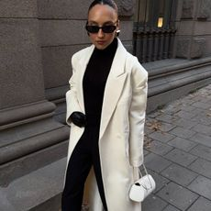](https://www.whowhatwear.com/fashion/handbags/cream-bag-trend)](https://www.whowhatwear.com/fashion/handbags/cream-bag-trend" \t "_self)

[Black and Brown Bags Will Always Be Chic, But This Elegant Colour Is More 2025](https://www.whowhatwear.com/fashion/handbags/cream-bag-trend" \t "_self)

[It's fresher, alright.](https://www.whowhatwear.com/fashion/handbags/cream-bag-trend" \t "_self)

[By Maxine Eggenberger](https://www.whowhatwear.com/fashion/handbags/cream-bag-trend" \t "_self)

[[](https://www.whowhatwear.com/beauty/hair/mushroom-brown-hair-trend)](https://www.whowhatwear.com/beauty/hair/mushroom-brown-hair-trend" \t "_self)

[Is It Just Me, Or Are So Many Stylish People Changing Their Hair Colour to This Rich-Looking Shade?](https://www.whowhatwear.com/beauty/hair/mushroom-brown-hair-trend" \t "_self)

[I'm tempted.](https://www.whowhatwear.com/beauty/hair/mushroom-brown-hair-trend" \t "_self)

[By Grace Lindsay](https://www.whowhatwear.com/beauty/hair/mushroom-brown-hair-trend" \t "_self)

[[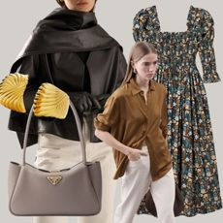](https://www.whowhatwear.com/maxine-eggenberger-shopping-picks)](https://www.whowhatwear.com/maxine-eggenberger-shopping-picks" \t "_self)

[I'm an Editor Who's Hard to Impress—9 New, Very Chic Pieces That Get a Yes From Me](https://www.whowhatwear.com/maxine-eggenberger-shopping-picks" \t "_self)

[A perfectionist's edit.](https://www.whowhatwear.com/maxine-eggenberger-shopping-picks" \t "_self)

[By Maxine Eggenberger](https://www.whowhatwear.com/maxine-eggenberger-shopping-picks" \t "_self)

[[](https://www.whowhatwear.com/beauty/hair/hair-trends-2025)](https://www.whowhatwear.com/beauty/hair/hair-trends-2025" \t "_self)

[A Trend Forecaster Says These 8 Hair Looks Are Ready to Dominate 2025](https://www.whowhatwear.com/beauty/hair/hair-trends-2025" \t "_self)

[Which will you go for?](https://www.whowhatwear.com/beauty/hair/hair-trends-2025" \t "_self)

[By Eleanor Vousden](https://www.whowhatwear.com/beauty/hair/hair-trends-2025" \t "_self)

[[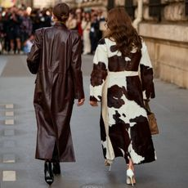](https://www.whowhatwear.com/designer-coats-on-sale)](https://www.whowhatwear.com/designer-coats-on-sale" \t "_self)

[I Only Buy Designer Coats When They're on Sale—Here Are My Top Picks This Winter](https://www.whowhatwear.com/designer-coats-on-sale" \t "_self)

[Thank me later.](https://www.whowhatwear.com/designer-coats-on-sale" \t "_self)

[By Emily Dawes](https://www.whowhatwear.com/designer-coats-on-sale" \t "_self)

Trends

[[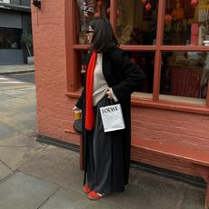](https://www.whowhatwear.com/uk/easy-winter-outfits)](https://www.whowhatwear.com/uk/easy-winter-outfits" \t "_self)

[9 Stylish But Low-Effort Winter Outfits You'll Want to Copy Immediately](https://www.whowhatwear.com/uk/easy-winter-outfits" \t "_self)

[I know I do.](https://www.whowhatwear.com/uk/easy-winter-outfits" \t "_self)

[By Bébhinn Campbell](https://www.whowhatwear.com/uk/easy-winter-outfits" \t "_self)

[[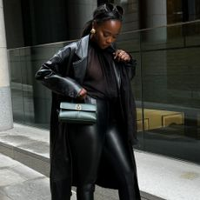](https://www.whowhatwear.com/fashion/trends/leather-leggings-trend)](https://www.whowhatwear.com/fashion/trends/leather-leggings-trend" \t "_self)

[Move Over Skinny Jeans, This "Dated" Trouser Trend Just Made an Unexpected Return for 2025](https://www.whowhatwear.com/fashion/trends/leather-leggings-trend" \t "_self)

[It's got the A-list talking...](https://www.whowhatwear.com/fashion/trends/leather-leggings-trend" \t "_self)

[By Remy Farrell](https://www.whowhatwear.com/fashion/trends/leather-leggings-trend" \t "_self)

[[](https://www.whowhatwear.com/fashion/trends/handbag-trends-2025)](https://www.whowhatwear.com/fashion/trends/handbag-trends-2025" \t "_self)

[We've Done the Research—These Are the Handbag Trends Everyone Will Be Carrying in 2025](https://www.whowhatwear.com/fashion/trends/handbag-trends-2025" \t "_self)

[It's in the bag.](https://www.whowhatwear.com/fashion/trends/handbag-trends-2025" \t "_self)

[By Remy Farrell](https://www.whowhatwear.com/fashion/trends/handbag-trends-2025" \t "_self)

[[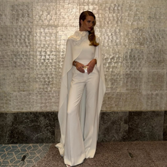](https://www.whowhatwear.com/fashion/trends/celebrity-fashion-trends-2025)](https://www.whowhatwear.com/fashion/trends/celebrity-fashion-trends-2025" \t "_self)

[8 Celebrity-Backed Trends I’m Copying to Look Elegant and Cool This Year](https://www.whowhatwear.com/fashion/trends/celebrity-fashion-trends-2025" \t "_self)

[Get ahead of the curve.](https://www.whowhatwear.com/fashion/trends/celebrity-fashion-trends-2025" \t "_self)

[By Jess Kelham-Hohler](https://www.whowhatwear.com/fashion/trends/celebrity-fashion-trends-2025" \t "_self)

[[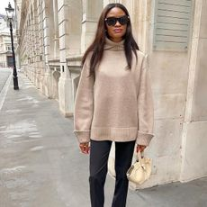](https://www.whowhatwear.com/designer-knitwear)](https://www.whowhatwear.com/designer-knitwear" \t "_self)

[24 Timeless Designer Knits You'll Never Regret Investing In](https://www.whowhatwear.com/designer-knitwear" \t "_self)

[From Ganni to Khaite.](https://www.whowhatwear.com/designer-knitwear" \t "_self)

[By Maxine Eggenberger](https://www.whowhatwear.com/designer-knitwear" \t "_self)

[VIEW MORE](https://www.whowhatwear.com/uk/fashion/trends)

Beauty

[[](https://www.whowhatwear.com/beauty/hair/mushroom-brown-hair-trend)](https://www.whowhatwear.com/beauty/hair/mushroom-brown-hair-trend" \t "_self)

[Is It Just Me, Or Are So Many Stylish People Changing Their Hair Colour to This Rich-Looking Shade?](https://www.whowhatwear.com/beauty/hair/mushroom-brown-hair-trend" \t "_self)

[I'm tempted.](https://www.whowhatwear.com/beauty/hair/mushroom-brown-hair-trend" \t "_self)

[By Grace Lindsay](https://www.whowhatwear.com/beauty/hair/mushroom-brown-hair-trend" \t "_self)

[[](https://www.whowhatwear.com/beauty/hair/hair-trends-2025)](https://www.whowhatwear.com/beauty/hair/hair-trends-2025" \t "_self)

[A Trend Forecaster Says These 8 Hair Looks Are Ready to Dominate 2025](https://www.whowhatwear.com/beauty/hair/hair-trends-2025" \t "_self)

[Which will you go for?](https://www.whowhatwear.com/beauty/hair/hair-trends-2025" \t "_self)

[By Eleanor Vousden](https://www.whowhatwear.com/beauty/hair/hair-trends-2025" \t "_self)

[[](https://www.whowhatwear.com/beauty/hair/ghd-curve-creative-curl-wand-review)](https://www.whowhatwear.com/beauty/hair/ghd-curve-creative-curl-wand-review" \t "_self)

[I've Tried Hundreds of Hair Tools—This Is the One I Rely on for Salon-Worthy Waves](https://www.whowhatwear.com/beauty/hair/ghd-curve-creative-curl-wand-review" \t "_self)

[It's unbeatable.](https://www.whowhatwear.com/beauty/hair/ghd-curve-creative-curl-wand-review" \t "_self)

[By Grace Lindsay](https://www.whowhatwear.com/beauty/hair/ghd-curve-creative-curl-wand-review" \t "_self)

[[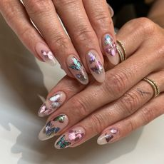](https://www.whowhatwear.com/butterfly-nails)](https://www.whowhatwear.com/butterfly-nails" \t "_self)

[Butterfly Nails Just Might Be the Cutest Y2K Nail Trend of the Year—Already](https://www.whowhatwear.com/butterfly-nails" \t "_self)

[My heart's aflutter.](https://www.whowhatwear.com/butterfly-nails" \t "_self)

[By Keeks Reid](https://www.whowhatwear.com/butterfly-nails" \t "_self)

[[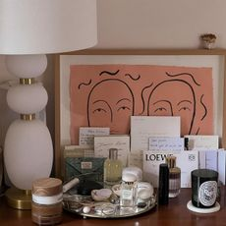](https://www.whowhatwear.com/uk/best-clean-smelling-perfume)](https://www.whowhatwear.com/uk/best-clean-smelling-perfume" \t "_self)

[It's True: Wearing These Elegant Perfumes Will Prompt People to Tell You How Good You Smell](https://www.whowhatwear.com/uk/best-clean-smelling-perfume" \t "_self)

[An instant pick-me-up.](https://www.whowhatwear.com/uk/best-clean-smelling-perfume" \t "_self)

[By Shannon Lawlor](https://www.whowhatwear.com/uk/best-clean-smelling-perfume" \t "_self)

[VIEW MORE](https://www.whowhatwear.com/uk/beauty)

Celebrity Style

[[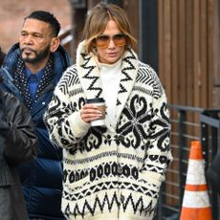](https://www.whowhatwear.com/fashion/celebrity-style/nordic-knitwear-trend-jennifer-lopez)](https://www.whowhatwear.com/fashion/celebrity-style/nordic-knitwear-trend-jennifer-lopez" \t "_self)

[Jennifer Lopez Just Wore the Knitwear Trend European Girls Are Really Into](https://www.whowhatwear.com/fashion/celebrity-style/nordic-knitwear-trend-jennifer-lopez" \t "_self)

[It's time to get cosy.](https://www.whowhatwear.com/fashion/celebrity-style/nordic-knitwear-trend-jennifer-lopez" \t "_self)

[By Brittany Davy](https://www.whowhatwear.com/fashion/celebrity-style/nordic-knitwear-trend-jennifer-lopez" \t "_self)

[[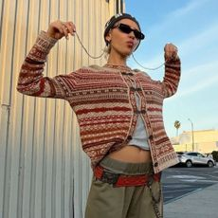](https://www.whowhatwear.com/fashion/celebrity-style/iris-law-olive-green-trouser-trend)](https://www.whowhatwear.com/fashion/celebrity-style/iris-law-olive-green-trouser-trend" \t "_self)

[Iris Law Just Swapped Her Jeans for Stylish Trousers in a Very Trendy Colour](https://www.whowhatwear.com/fashion/celebrity-style/iris-law-olive-green-trouser-trend" \t "_self)

[An instant outfit-enhancer.](https://www.whowhatwear.com/fashion/celebrity-style/iris-law-olive-green-trouser-trend" \t "_self)

[By Natalie Munro](https://www.whowhatwear.com/fashion/celebrity-style/iris-law-olive-green-trouser-trend" \t "_self)

[[](https://www.whowhatwear.com/fashion/celebrity-style/sienna-miller-sezane-trench-coat)](https://www.whowhatwear.com/fashion/celebrity-style/sienna-miller-sezane-trench-coat" \t "_self)

[Sienna Miller and French Women Are Obsessed With this Sézane Trench Coat—Now, It's Finally Back In Stock](https://www.whowhatwear.com/fashion/celebrity-style/sienna-miller-sezane-trench-coat" \t "_self)

[At last!](https://www.whowhatwear.com/fashion/celebrity-style/sienna-miller-sezane-trench-coat" \t "_self)

[By Natalie Munro](https://www.whowhatwear.com/fashion/celebrity-style/sienna-miller-sezane-trench-coat" \t "_self)

[[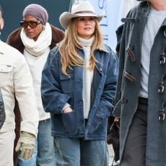](https://www.whowhatwear.com/fashion/celebrity-style/jennifer-lopez-horseshoe-jeans-hiker-boot-outfit)](https://www.whowhatwear.com/fashion/celebrity-style/jennifer-lopez-horseshoe-jeans-hiker-boot-outfit" \t "_self)

[Jennifer Lopez Just Wore Horseshoe Jeans With the Most Surprising Boot Trend](https://www.whowhatwear.com/fashion/celebrity-style/jennifer-lopez-horseshoe-jeans-hiker-boot-outfit" \t "_self)

[A fresh take on ski styling.](https://www.whowhatwear.com/fashion/celebrity-style/jennifer-lopez-horseshoe-jeans-hiker-boot-outfit" \t "_self)

[By Natalie Munro](https://www.whowhatwear.com/fashion/celebrity-style/jennifer-lopez-horseshoe-jeans-hiker-boot-outfit" \t "_self)

[[](https://www.whowhatwear.com/fashion/celebrity-style/celebrity-puffer-coat-outfits)](https://www.whowhatwear.com/fashion/celebrity-style/celebrity-puffer-coat-outfits" \t "_self)

[I Didn't Think Puffer Coats Could Look Polished—These 5 Celebrity Outfits Proved Me Wrong](https://www.whowhatwear.com/fashion/celebrity-style/celebrity-puffer-coat-outfits" \t "_self)

[I'm pleasantly surprised.](https://www.whowhatwear.com/fashion/celebrity-style/celebrity-puffer-coat-outfits" \t "_self)

[By Natalie Munro](https://www.whowhatwear.com/fashion/celebrity-style/celebrity-puffer-coat-outfits" \t "_self)

[[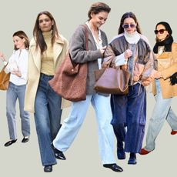](https://www.whowhatwear.com/fashion/celebrity-style/katie-holmes-jeans-and-flat-shoes-outfits)](https://www.whowhatwear.com/fashion/celebrity-style/katie-holmes-jeans-and-flat-shoes-outfits" \t "_self)

[Katie Holmes Is My Queen of Easy-Chic—I've Bookmarked These 8 Jeans-and-Flats Outfits](https://www.whowhatwear.com/fashion/celebrity-style/katie-holmes-jeans-and-flat-shoes-outfits" \t "_self)

[Casual looks to copy forever.](https://www.whowhatwear.com/fashion/celebrity-style/katie-holmes-jeans-and-flat-shoes-outfits" \t "_self)

[By Hannah Almassi](https://www.whowhatwear.com/fashion/celebrity-style/katie-holmes-jeans-and-flat-shoes-outfits" \t "_self)

[VIEW MORE](https://www.whowhatwear.com/uk/fashion/celebrity/celebrity-style)

Shopping

[[](https://www.whowhatwear.com/fashion/shoes/sock-boots-trend)](https://www.whowhatwear.com/fashion/shoes/sock-boots-trend" \t "_self)

[Wait, What? Every Millennial's Favourite Boot Trend Is Suddenly Back for 2025](https://www.whowhatwear.com/fashion/shoes/sock-boots-trend" \t "_self)

[Can it be?](https://www.whowhatwear.com/fashion/shoes/sock-boots-trend" \t "_self)

[By Natalie Munro](https://www.whowhatwear.com/fashion/shoes/sock-boots-trend" \t "_self)

[[](https://www.whowhatwear.com/fashion/handbags/cream-bag-trend)](https://www.whowhatwear.com/fashion/handbags/cream-bag-trend" \t "_self)

[Black and Brown Bags Will Always Be Chic, But This Elegant Colour Is More 2025](https://www.whowhatwear.com/fashion/handbags/cream-bag-trend" \t "_self)

[It's fresher, alright.](https://www.whowhatwear.com/fashion/handbags/cream-bag-trend" \t "_self)

[By Maxine Eggenberger](https://www.whowhatwear.com/fashion/handbags/cream-bag-trend" \t "_self)

[[](https://www.whowhatwear.com/maxine-eggenberger-shopping-picks)](https://www.whowhatwear.com/maxine-eggenberger-shopping-picks" \t "_self)

[I'm an Editor Who's Hard to Impress—9 New, Very Chic Pieces That Get a Yes From Me](https://www.whowhatwear.com/maxine-eggenberger-shopping-picks" \t "_self)

[A perfectionist's edit.](https://www.whowhatwear.com/maxine-eggenberger-shopping-picks" \t "_self)

[By Maxine Eggenberger](https://www.whowhatwear.com/maxine-eggenberger-shopping-picks" \t "_self)

[[](https://www.whowhatwear.com/designer-coats-on-sale)](https://www.whowhatwear.com/designer-coats-on-sale" \t "_self)

[I Only Buy Designer Coats When They're on Sale—Here Are My Top Picks This Winter](https://www.whowhatwear.com/designer-coats-on-sale" \t "_self)

[Thank me later.](https://www.whowhatwear.com/designer-coats-on-sale" \t "_self)

[By Emily Dawes](https://www.whowhatwear.com/designer-coats-on-sale" \t "_self)

[[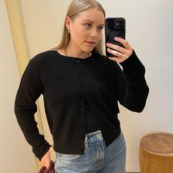](https://www.whowhatwear.com/fashion/shopping/best-cashmere-sales)](https://www.whowhatwear.com/fashion/shopping/best-cashmere-sales" \t "_self)

[I Only Buy Cashmere When It's on Sale—From Timeless Knits to Cosy Socks, These Are My Best Discounted Finds](https://www.whowhatwear.com/fashion/shopping/best-cashmere-sales" \t "_self)

[Add a touch of luxury.](https://www.whowhatwear.com/fashion/shopping/best-cashmere-sales" \t "_self)

[By Florrie Alexander](https://www.whowhatwear.com/fashion/shopping/best-cashmere-sales" \t "_self)

[[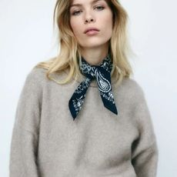](https://www.whowhatwear.com/uk/hm-anti-trend-items)](https://www.whowhatwear.com/uk/hm-anti-trend-items" \t "_self)

[17 New-In Anti-Trend Items From H&M That Have My 57-Year-Old Mum and I Hooked](https://www.whowhatwear.com/uk/hm-anti-trend-items" \t "_self)

[We're both in love.](https://www.whowhatwear.com/uk/hm-anti-trend-items" \t "_self)

[By Poppy Nash](https://www.whowhatwear.com/uk/hm-anti-trend-items" \t "_self)

[[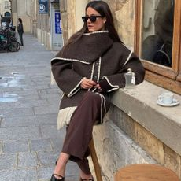](https://www.whowhatwear.com/uk/fashion/luxury/best-fashion-investment-items)](https://www.whowhatwear.com/uk/fashion/luxury/best-fashion-investment-items" \t "_self)

[I'm Convinced That These Are the 10 Most Timeless Investment Buys](https://www.whowhatwear.com/uk/fashion/luxury/best-fashion-investment-items" \t "_self)

[Forever pieces.](https://www.whowhatwear.com/uk/fashion/luxury/best-fashion-investment-items" \t "_self)

[By Kristen Nichols](https://www.whowhatwear.com/uk/fashion/luxury/best-fashion-investment-items" \t "_self)

[[](https://www.whowhatwear.com/fashion/handbags/polene-numero-neuf-bag)](https://www.whowhatwear.com/fashion/handbags/polene-numero-neuf-bag" \t "_self)

[The Chic, Elegant and Premium-Looking French Handbag Stylish People in London Are Carrying Now](https://www.whowhatwear.com/fashion/handbags/polene-numero-neuf-bag" \t "_self)

[It's a beauty.](https://www.whowhatwear.com/fashion/handbags/polene-numero-neuf-bag" \t "_self)

[By Avalon Afriyie](https://www.whowhatwear.com/fashion/handbags/polene-numero-neuf-bag" \t "_self)

[[](https://www.whowhatwear.com/uk/what-to-buy-in-january)](https://www.whowhatwear.com/uk/what-to-buy-in-january" \t "_self)

[People Say I Have Impeccable Taste—Here Are 15 New Yet Classic Pieces I Love Now](https://www.whowhatwear.com/uk/what-to-buy-in-january" \t "_self)

[And just like that, it's 2025.](https://www.whowhatwear.com/uk/what-to-buy-in-january" \t "_self)

[By Avalon Afriyie](https://www.whowhatwear.com/uk/what-to-buy-in-january" \t "_self)

[VIEW MORE](https://www.whowhatwear.com/uk/fashion/shopping)

Product Reviews

[[](https://www.whowhatwear.com/beauty/hair/ghd-curve-creative-curl-wand-review)](https://www.whowhatwear.com/beauty/hair/ghd-curve-creative-curl-wand-review" \t "_self)

[I've Tried Hundreds of Hair Tools—This Is the One I Rely on for Salon-Worthy Waves](https://www.whowhatwear.com/beauty/hair/ghd-curve-creative-curl-wand-review" \t "_self)

[It's unbeatable.](https://www.whowhatwear.com/beauty/hair/ghd-curve-creative-curl-wand-review" \t "_self)

[By Grace Lindsay](https://www.whowhatwear.com/beauty/hair/ghd-curve-creative-curl-wand-review" \t "_self)

[[](https://www.whowhatwear.com/beauty/makeup/loreal-paris-big-deal-mascara-review)](https://www.whowhatwear.com/beauty/makeup/loreal-paris-big-deal-mascara-review" \t "_self)

[This New £13 Mascara Has All My Friends Asking If I'm Wearing Lash Extensions](https://www.whowhatwear.com/beauty/makeup/loreal-paris-big-deal-mascara-review" \t "_self)

[I'm never looking back.](https://www.whowhatwear.com/beauty/makeup/loreal-paris-big-deal-mascara-review" \t "_self)

[By Eleanor Vousden](https://www.whowhatwear.com/beauty/makeup/loreal-paris-big-deal-mascara-review" \t "_self)

[[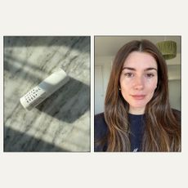](https://www.whowhatwear.com/beauty/skin/beauty-pie-anti-wrinkle-eye-cream-review)](https://www.whowhatwear.com/beauty/skin/beauty-pie-anti-wrinkle-eye-cream-review" \t "_self)

[I Cancelled My Next Botox Appointment After Discovering This £15 Eye Cream](https://www.whowhatwear.com/beauty/skin/beauty-pie-anti-wrinkle-eye-cream-review" \t "_self)

[It's that good.](https://www.whowhatwear.com/beauty/skin/beauty-pie-anti-wrinkle-eye-cream-review" \t "_self)

[By Eleanor Vousden](https://www.whowhatwear.com/beauty/skin/beauty-pie-anti-wrinkle-eye-cream-review" \t "_self)

[[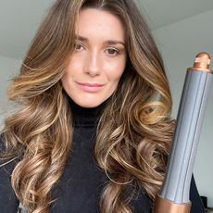](https://www.whowhatwear.com/uk/dyson-airwrap-review)](https://www.whowhatwear.com/uk/dyson-airwrap-review" \t "_self)

[I'm a Beauty Editor—This Is My No-Holds-Barred Review of the Dyson Airwrap](https://www.whowhatwear.com/uk/dyson-airwrap-review" \t "_self)

[Which is currently on sale!](https://www.whowhatwear.com/uk/dyson-airwrap-review" \t "_self)

[By Eleanor Vousden](https://www.whowhatwear.com/uk/dyson-airwrap-review" \t "_self)

[[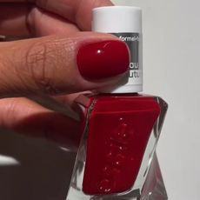](https://www.whowhatwear.com/beauty/nails/best-essie-nail-colours)](https://www.whowhatwear.com/beauty/nails/best-essie-nail-colours" \t "_self)

[The Experts Have Spoken—These Are the Best Essie Nail Colours for a Chic and Elegant Mani](https://www.whowhatwear.com/beauty/nails/best-essie-nail-colours" \t "_self)

[A colour for every occasion.](https://www.whowhatwear.com/beauty/nails/best-essie-nail-colours" \t "_self)

[By Mollie Burdell](https://www.whowhatwear.com/beauty/nails/best-essie-nail-colours" \t "_self)

[[](https://www.whowhatwear.com/beauty/makeup/rhode-peptide-lip-treatment-review)](https://www.whowhatwear.com/beauty/makeup/rhode-peptide-lip-treatment-review" \t "_self)

[I Just Tried All of Rhode's Peptide Lip Treatments—Here’s How They Ranked](https://www.whowhatwear.com/beauty/makeup/rhode-peptide-lip-treatment-review" \t "_self)

[A lip balm obsessive's take.](https://www.whowhatwear.com/beauty/makeup/rhode-peptide-lip-treatment-review" \t "_self)

[By Eleanor Vousden](https://www.whowhatwear.com/beauty/makeup/rhode-peptide-lip-treatment-review" \t "_self)

[VIEW MORE](https://www.whowhatwear.com/uk/reviews)

* [about us](https://www.whowhatwear.com/about-who-what-wear)
* [Contact Future's experts](https://futureplc.com/contact/)
* [Terms and conditions](https://www.futureplc.com/terms-conditions/)
* [Privacy policy](https://www.futureplc.com/privacy-policy/)
* [Cookies policy](https://www.futureplc.com/cookies-policy/)
* [Careers](https://www.futureplc.com/careers/)
* [Contact us](https://www.whowhatwear.com/contact)
* [Contact Future's experts](https://www.futureplc.com/contact/)
* [Accessibility Statement](https://www.futureplc.com/accessibility-statement/)
* [Advertise with us](https://go.future-advertising.com/Who-What-Wear-Media-Kit.html)

Who What Wear UK is part of Future plc, an international media group and leading digital publisher. [Visit our corporate site](https://futureplc.com/).  
© Future Publishing Limited Quay House, The Ambury, Bath BA1 1UA. All rights reserved. England and Wales company registration number 2008885.