**[Skip to main content](https://fashionista.com/" \l "main-content)**

Top of Form



Bottom of Form

[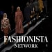](https://bit.ly/453hQGY)

[**Fashionista Network**](https://fashionista.com/)

[**Never Miss a Chat - Subscribe Today!**](https://bit.ly/453hQGY)

[](https://share.hsforms.com/1m--_fMJYRvGzsdhnYAd9Fws25du)

[**DAILY NEWSLETTER**](https://fashionista.com/)

[**SUBSCRIBE NOW**](https://share.hsforms.com/1m--_fMJYRvGzsdhnYAd9Fws25du)

* [**Fashionista Network**](https://fashionista.com/tag/fashionista-network)
* [**Business**](https://fashionista.com/business)
* [**Careers**](https://fashionista.com/fashion-careers)
* [**Style**](https://fashionista.com/style)
* [**Beauty**](https://fashionista.com/beauty)
* [**Schools**](https://fashionista.com/tag/fashion-schools)
* [**Shopping**](https://fashionista.com/shopping)
* [**Fashion Week**](https://fashionista.com/fashion-week)
* [**Editors' Picks**](https://fashionista.com/editors-picks)
* [**Newsletter**](https://share.hsforms.com/1m--_fMJYRvGzsdhnYAd9Fws25du)



[**News**](https://fashionista.com/news)

**[Fashionista's Official 2024 Wrap-Up](https://fashionista.com/2024/12/fashionista-end-of-year-roundup-2024)**

[**By Brooke Frischer**](https://fashionista.com/author/brooke-frischer)

**Dec 30, 2024**

[[](https://fashionista.com/2024/12/fashion-students-gen-z-shopping-habits)](https://fashionista.com/2024/12/fashion-students-gen-z-shopping-habits" \o "How to Dress Well on a Fashion Student Budget)

[**Style**](https://fashionista.com/style)

**[How to Dress Well on a Fashion Student Budget](https://fashionista.com/2024/12/fashion-students-gen-z-shopping-habits)**

[**By Emma Greene**](https://fashionista.com/author/emma-greene)**Dec 12, 2024**

[[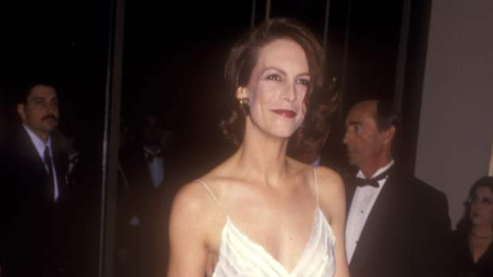](https://fashionista.com/2025/01/jamie-lee-curtis-1995-golden-globes-dress)](https://fashionista.com/2025/01/jamie-lee-curtis-1995-golden-globes-dress" \o "Great Outfits in Fashion History: Jamie Lee Curtis' Sleek White 1995 Golden Globes Gown)

[**Style**](https://fashionista.com/style)

**[Great Outfits in Fashion History: Jamie Lee Curtis' Sleek White 1995 Golden Globes Gown](https://fashionista.com/2025/01/jamie-lee-curtis-1995-golden-globes-dress)**

[**By Catie Pusateri**](https://fashionista.com/author/catie-pusateri)**18 hours ago**

[[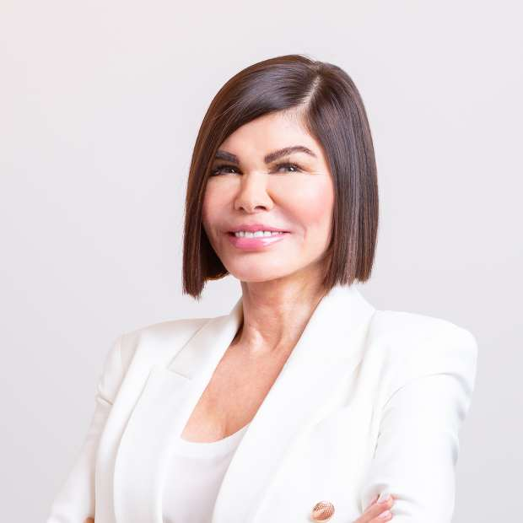](https://f.chat/jBq2)](https://f.chat/jBq2" \t "_blank)

[From the Beauty Aisle: Jan Marini](https://f.chat/jBq2" \t "_blank)

[[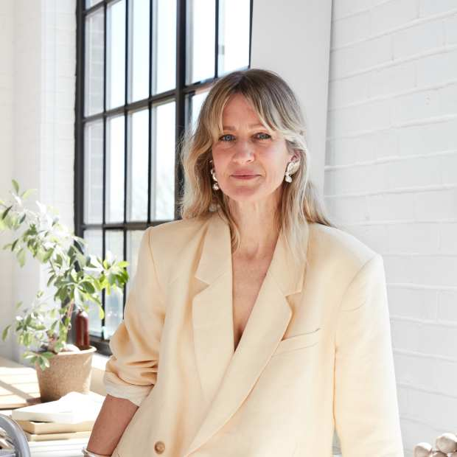](https://f.chat/S6Ns)](https://f.chat/S6Ns" \t "_blank)

[Talking Shop: Jenny Bird](https://f.chat/S6Ns" \t "_blank)

[[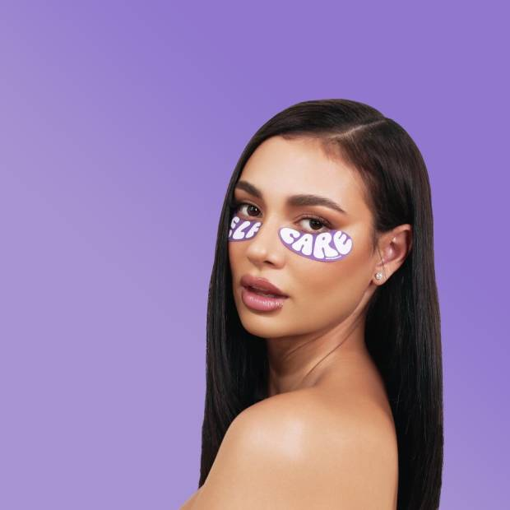](https://f.chat/RYXX)](https://f.chat/RYXX" \t "_blank)

[From the Beauty Aisle: Kristen Noel Crawley](https://f.chat/RYXX" \t "_blank)

[[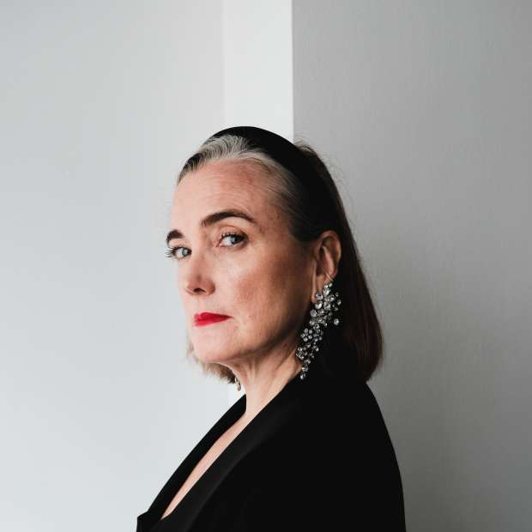](https://f.chat/RFTE)](https://f.chat/RFTE" \t "_blank)

[Talking Shop: Jennifer Behr](https://f.chat/RFTE" \t "_blank)

[[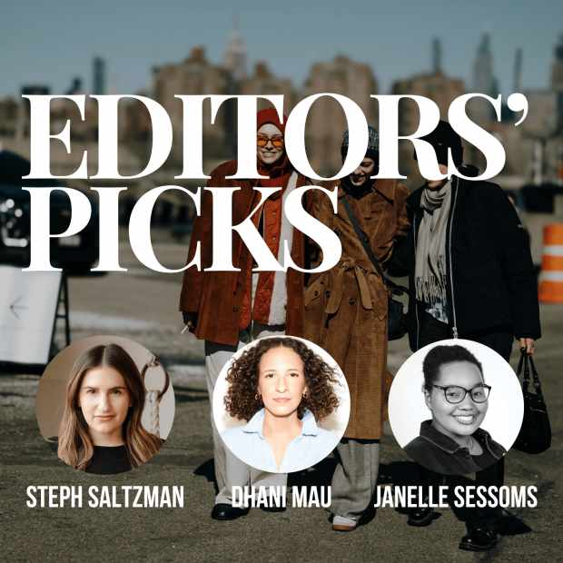](https://f.chat/18YK)](https://f.chat/18YK" \t "_blank)

[Editors' Picks: December](https://f.chat/18YK" \t "_blank)

[[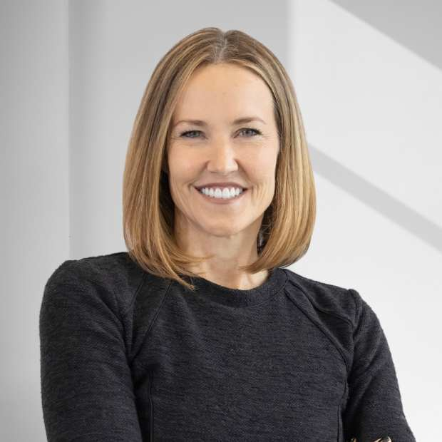](https://f.chat/WtgK)](https://f.chat/WtgK" \t "_blank)

[Talking Shop: Sarah Davis](https://f.chat/WtgK" \t "_blank)

**SUBSCRIBE TO OUR NEWSLETTER**

[**SUBSCRIBE**](https://breakingmedia.us1.list-manage.com/subscribe?u=9ddd1593650687cb23ac29940&id=a23c93579d)



[[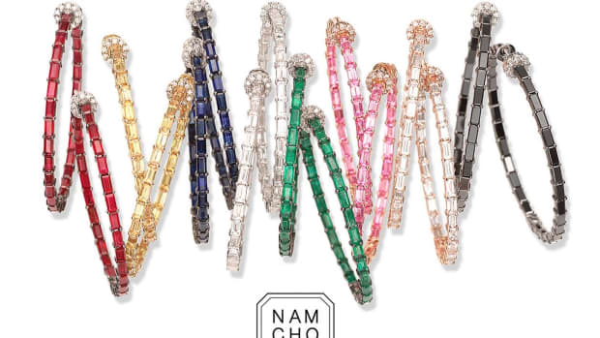](https://fashionista.com/2025/01/nam-cho-fine-jewelry-is-hiring-an-office-coordinator-in-new-york-city)](https://fashionista.com/2025/01/nam-cho-fine-jewelry-is-hiring-an-office-coordinator-in-new-york-city" \o "Nam Cho Fine Jewelry Is Hiring An Office Coordinator In New York City)

[**Sponsored Story**](https://fashionista.com/fashion-careers)

**[Nam Cho Fine Jewelry Is Hiring An Office Coordinator In New York City](https://fashionista.com/2025/01/nam-cho-fine-jewelry-is-hiring-an-office-coordinator-in-new-york-city)**

Nam Cho Fine Jewelry is looking for a responsible Office Coordinator to perform a wide range of administrative and operational tasks. We are a small but growing fine jewelry designer (currently at the wholesale level.

[**By Winnie Liu**](https://fashionista.com/author/wliu)**14 hours ago**

[[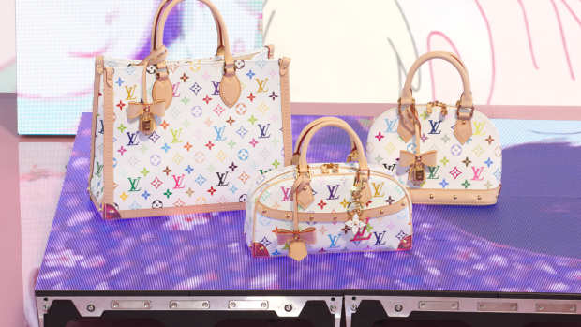](https://fashionista.com/2025/01/louis-vuitton-murakami-re-edition-collection-launch)](https://fashionista.com/2025/01/louis-vuitton-murakami-re-edition-collection-launch" \o "Must Read: The Louis Vuitton x Murakami Re-edition Collection Is Here, Ghanian Secondhand Market Devastated by Fire)

[**News**](https://fashionista.com/news)

**[Must Read: The Louis Vuitton x Murakami Re-edition Collection Is Here, Ghanian Secondhand Market Devastated by Fire](https://fashionista.com/2025/01/louis-vuitton-murakami-re-edition-collection-launch)**

Plus, Levi's sues Philipp Plein for trademark infringement.

[**By Catie Pusateri**](https://fashionista.com/author/catie-pusateri)**15 hours ago**

[[](https://fashionista.com/2025/01/kzk-studio-slow-fashion-brand)](https://fashionista.com/2025/01/kzk-studio-slow-fashion-brand" \o "KZ_K Studio: A Minimalist, Slow-Fashion Brand Maximizing Multifunctional Design)

[**Shopping**](https://fashionista.com/shopping)

**[KZ\_K Studio: A Minimalist, Slow-Fashion Brand Maximizing Multifunctional Design](https://fashionista.com/2025/01/kzk-studio-slow-fashion-brand)**

The New York City-based label puts the focus on utility and versatility.

[**By Fashionista**](https://fashionista.com/author/fashionista)**17 hours ago**

[[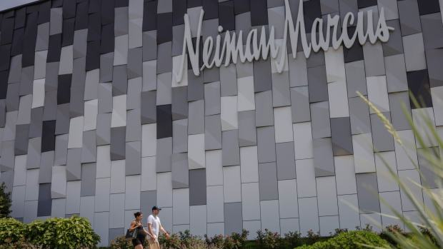](https://fashionista.com/2025/01/saks-neiman-marcus-acquisition-finalized)](https://fashionista.com/2025/01/saks-neiman-marcus-acquisition-finalized" \o "Must Read: Saks Finalizes Neiman Marcus Acquisition, Nordstrom Family Takes Retailer Private in $6.25 Billion Deal)

[**News**](https://fashionista.com/news)

**[Must Read: Saks Finalizes Neiman Marcus Acquisition, Nordstrom Family Takes Retailer Private in $6.25 Billion Deal](https://fashionista.com/2025/01/saks-neiman-marcus-acquisition-finalized)**

Plus, Missoni co-founder dies at 93.

[**By Catie Pusateri**](https://fashionista.com/author/catie-pusateri)**Jan 2, 2025**

[[](https://fashionista.com/2025/01/chuks-collins-is-hiring-a-business-development-marketing-and-sales-manager-and-seeking-interns-in-new-york-ny-hybrid-position)](https://fashionista.com/2025/01/chuks-collins-is-hiring-a-business-development-marketing-and-sales-manager-and-seeking-interns-in-new-york-ny-hybrid-position" \o "Chuks Collins Is Hiring A Business Development, Marketing, and Sales Manager And Seeking Interns In New York, NY (Hybrid Position))

[**Sponsored Story**](https://fashionista.com/fashion-careers)

**[Chuks Collins Is Hiring A Business Development, Marketing, and Sales Manager And Seeking Interns In New York, NY (Hybrid Position)](https://fashionista.com/2025/01/chuks-collins-is-hiring-a-business-development-marketing-and-sales-manager-and-seeking-interns-in-new-york-ny-hybrid-position)**

Chuks Collins started as a made-to-measure custom designer for private clients, and later began producing seasonal couture and ready-to-wear collections for men and women.

[**By Winnie Liu**](https://fashionista.com/author/wliu)**Jan 2, 2025**

[[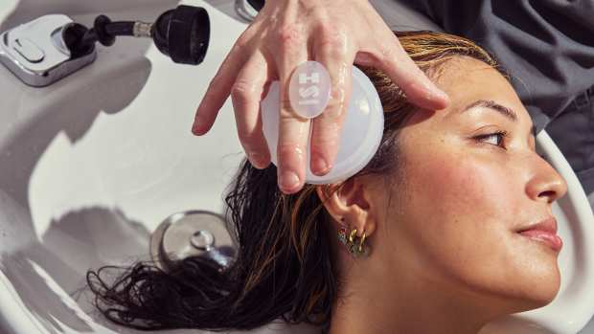](https://fashionista.com/2025/01/hairstory-hair-care-brand)](https://fashionista.com/2025/01/hairstory-hair-care-brand" \o "Hairstory: A Hair-Care Brand That Doesn't Make Shampoo)

[**Shopping**](https://fashionista.com/shopping)

**[Hairstory: A Hair-Care Brand That Doesn't Make Shampoo](https://fashionista.com/2025/01/hairstory-hair-care-brand)**

Launched in 2015, this NYC-based brand offers cleansing and styling products for all hair types.

[**By Fashionista**](https://fashionista.com/author/fashionista)**Jan 2, 2025**

[[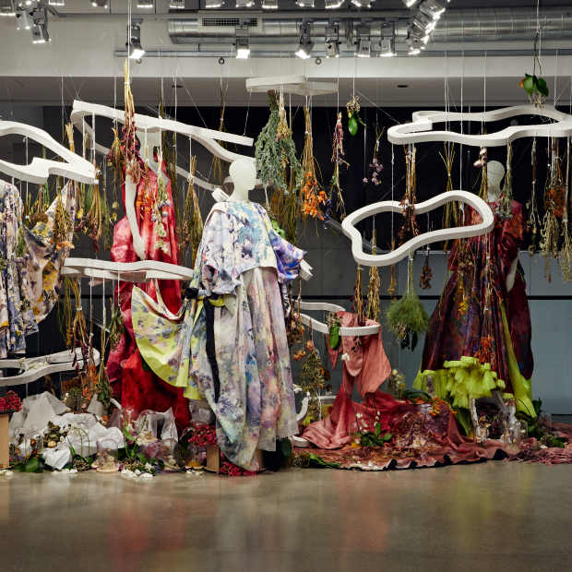](https://bit.ly/2RlHbqH)](https://bit.ly/2RlHbqH" \t "_blank)

[School of the Art Institute of Chicago - Chicago, IL](https://bit.ly/2RlHbqH" \t "_blank)

[[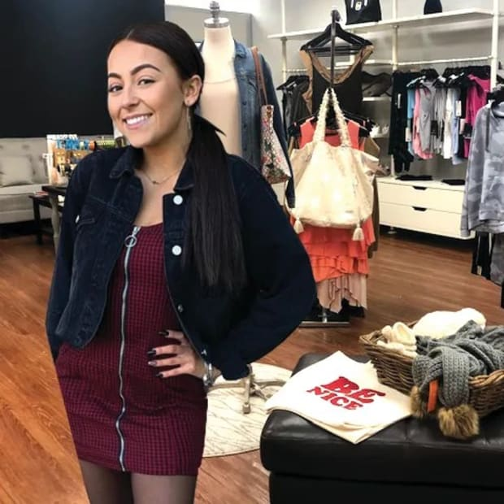](https://bit.ly/3WcMOv5)](https://bit.ly/3WcMOv5" \t "_blank)

[Long Island University (LIU) - Bronxville, NY](https://bit.ly/3WcMOv5" \t "_blank)

[[](https://bit.ly/3zK57Ph)](https://bit.ly/3zK57Ph" \t "_blank)

[Domus Academy Milano - Milan, Italy](https://bit.ly/3zK57Ph" \t "_blank)

[[](https://bit.ly/DEMONFORT)](https://bit.ly/DEMONFORT" \t "_blank)

[School of Fashion and Textiles, De Montfort University (DMU) Leicester - Leicester, United Kingdom](https://bit.ly/DEMONFORT" \t "_blank)

[[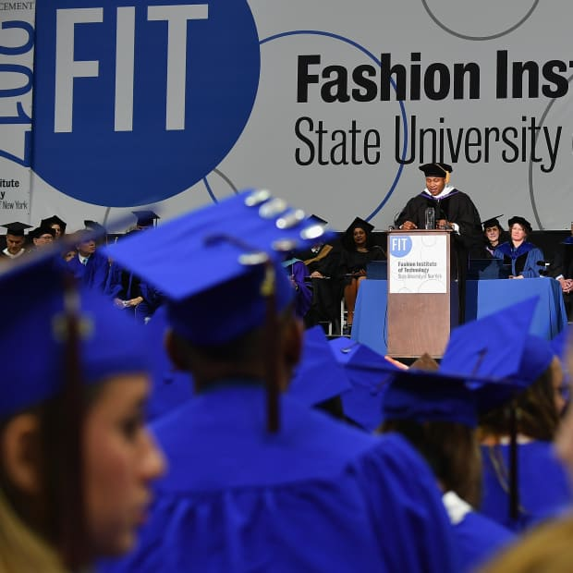](https://bit.ly/4cS5fuC)](https://bit.ly/4cS5fuC" \t "_blank)

[Fashion Institute of Technology (FIT) - New York, NY](https://bit.ly/4cS5fuC" \t "_blank)

[[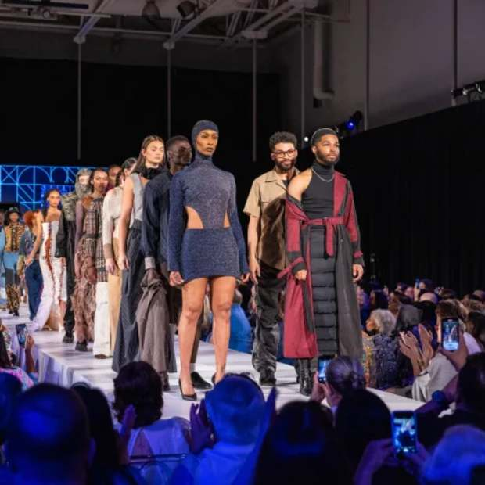](https://bit.ly/460fcnC)](https://bit.ly/460fcnC" \t "_blank)

[Thomas Jefferson University - Philadelphia, PA](https://bit.ly/460fcnC" \t "_blank)

[[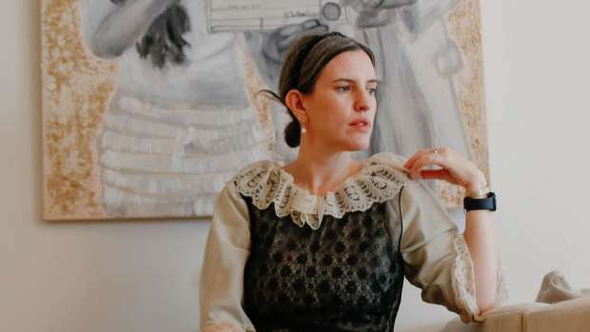](https://fashionista.com/2025/01/leigh-batnick-plessner-catbird-fashionista-network)](https://fashionista.com/2025/01/leigh-batnick-plessner-catbird-fashionista-network" \o "Meet Catbird's Leigh Batnick Plessner on The Fashionista Network)

[**Careers**](https://fashionista.com/fashion-careers)

**[Meet Catbird's Leigh Batnick Plessner on The Fashionista Network](https://fashionista.com/2025/01/leigh-batnick-plessner-catbird-fashionista-network)**

Join us for a live discussion about her 20-year career with the beloved jewelry brand.

[**By Dhani Mau**](https://fashionista.com/author/dmau)**Jan 2, 2025**

[[](https://fashionista.com/2024/12/kiltane-cashmere-wool-fashion-accessories-brand)](https://fashionista.com/2024/12/kiltane-cashmere-wool-fashion-accessories-brand" \o "Kiltane: A Kate Middleton-Approved Scottish Cashmere Brand)

[**Shopping**](https://fashionista.com/shopping)

**[Kiltane: A Kate Middleton-Approved Scottish Cashmere Brand](https://fashionista.com/2024/12/kiltane-cashmere-wool-fashion-accessories-brand)**

Founded in 1989, the label offers luxe cashmere and lambswool designs befitting a capsule wardrobe.

[**By Fashionista**](https://fashionista.com/author/fashionista)**Dec 31, 2024**

[[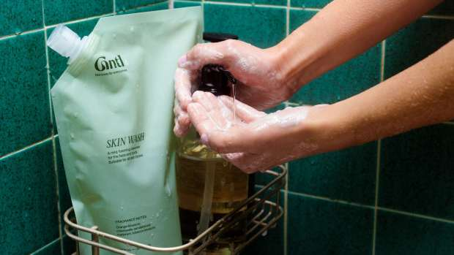](https://fashionista.com/2024/12/gntl-skin-care-brand)](https://fashionista.com/2024/12/gntl-skin-care-brand" \o "Gntl: A Multifunctional Skin-Care Brand Aiming to Address Overconsumption)

[**Shopping**](https://fashionista.com/shopping)

**[Gntl: A Multifunctional Skin-Care Brand Aiming to Address Overconsumption](https://fashionista.com/2024/12/gntl-skin-care-brand)**

The California-based brand's Skin Wash is available at Credo Beauty for less than $40.

[**By Fashionista**](https://fashionista.com/author/fashionista)**Dec 30, 2024**

[[](https://fashionista.com/2024/12/fashionista-editors-best-purchases-december-2024)](https://fashionista.com/2024/12/fashionista-editors-best-purchases-december-2024" \o "Fashionista's December Shopping List: 26 Items Our Editors Love)

[**Editors' Picks**](https://fashionista.com/editors-picks)

**[Fashionista's December Shopping List: 26 Items Our Editors Love](https://fashionista.com/2024/12/fashionista-editors-best-purchases-december-2024)**

Our post-Black Friday hauls are filled with classic knitwear and season-spanning footwear.

[**By Catie Pusateri**](https://fashionista.com/author/catie-pusateri)**Dec 30, 2024**

[[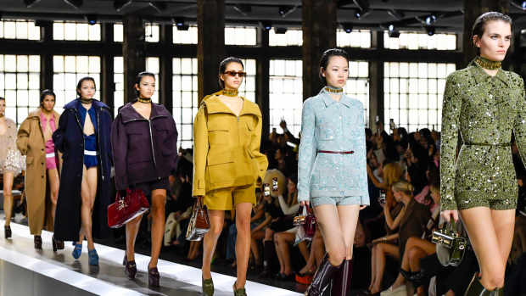](https://fashionista.com/2024/12/top-biggest-fashion-news-stories-2024)](https://fashionista.com/2024/12/top-biggest-fashion-news-stories-2024" \o "The 11 Biggest Fashion News Stories of 2024)

[**News**](https://fashionista.com/news)

**[The 11 Biggest Fashion News Stories of 2024](https://fashionista.com/2024/12/top-biggest-fashion-news-stories-2024)**

The revolving door of creative directors continued to spin this year, while beloved publications and brands shut their doors amid declining sales and rising costs.

[**By Brooke Frischer**](https://fashionista.com/author/brooke-frischer)**Dec 27, 2024**

[[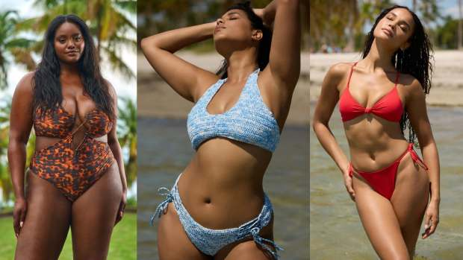](https://fashionista.com/2024/12/jmp-the-label-swimwear-apparel-brand)](https://fashionista.com/2024/12/jmp-the-label-swimwear-apparel-brand" \o "JMP the Label: A Size-Inclusive Swimwear Brand That Uses Recycled Fabrics)

[**Shopping**](https://fashionista.com/shopping)

**[JMP the Label: A Size-Inclusive Swimwear Brand That Uses Recycled Fabrics](https://fashionista.com/2024/12/jmp-the-label-swimwear-apparel-brand)**

As seen on the cover of the 2024 "Sports Illustrated" Swimsuit Issue.

[**By Fashionista**](https://fashionista.com/author/fashionista)**Dec 27, 2024**

[[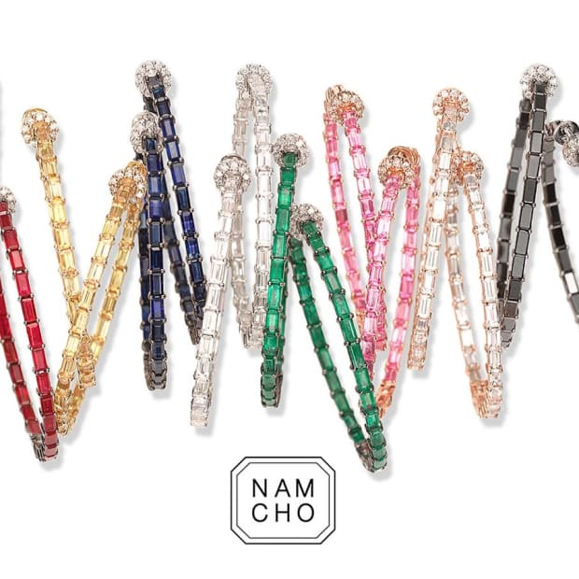](https://fashionista.com/2025/01/nam-cho-fine-jewelry-is-hiring-an-office-coordinator-in-new-york-city)](https://fashionista.com/2025/01/nam-cho-fine-jewelry-is-hiring-an-office-coordinator-in-new-york-city" \o "Nam Cho Fine Jewelry Is Hiring An Office Coordinator In New York City)

[Nam Cho Fine Jewelry Is Hiring An Office Coordinator In New York City](https://fashionista.com/2025/01/nam-cho-fine-jewelry-is-hiring-an-office-coordinator-in-new-york-city)

[[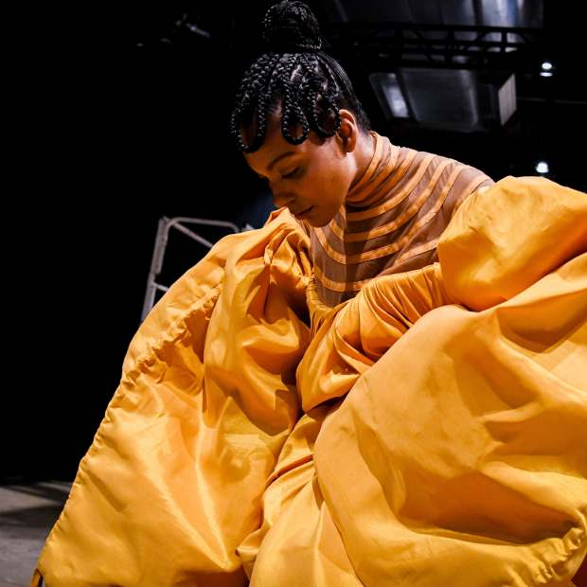](https://fashionista.com/2025/01/chuks-collins-is-hiring-a-business-development-marketing-and-sales-manager-and-seeking-interns-in-new-york-ny-hybrid-position)](https://fashionista.com/2025/01/chuks-collins-is-hiring-a-business-development-marketing-and-sales-manager-and-seeking-interns-in-new-york-ny-hybrid-position" \o "Chuks Collins Is Hiring A Business Development, Marketing, and Sales Manager And Seeking Interns In New York, NY (Hybrid Position))

[Chuks Collins Is Hiring A Business Development, Marketing, and Sales Manager And Seeking Interns In New York, NY (Hybrid Position)](https://fashionista.com/2025/01/chuks-collins-is-hiring-a-business-development-marketing-and-sales-manager-and-seeking-interns-in-new-york-ny-hybrid-position)

[[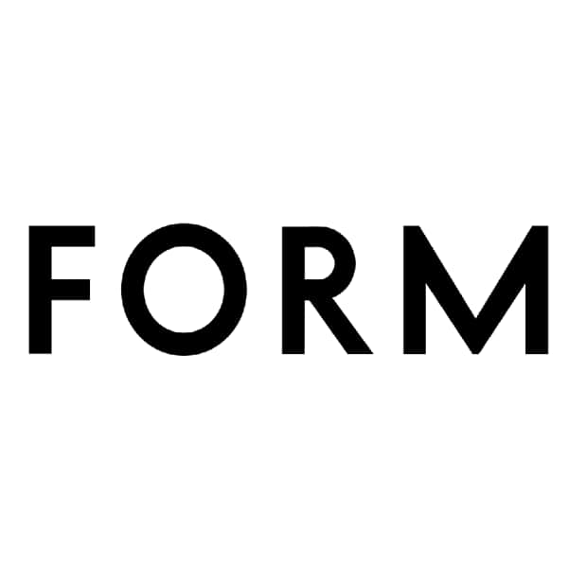](https://fashionista.com/2024/12/fforme-is-seeking-a-spring-2025-intern-in-new-york-ny)](https://fashionista.com/2024/12/fforme-is-seeking-a-spring-2025-intern-in-new-york-ny" \o "FFORME Is Seeking A Spring 2025 Intern In New York, NY)

[FFORME Is Seeking A Spring 2025 Intern In New York, NY](https://fashionista.com/2024/12/fforme-is-seeking-a-spring-2025-intern-in-new-york-ny)

[[](https://fashionista.com/2024/12/autumn-cashmere-is-hiring-a-marketing-and-pr-coordinator-in-new-york-ny)](https://fashionista.com/2024/12/autumn-cashmere-is-hiring-a-marketing-and-pr-coordinator-in-new-york-ny" \o "Autumn Cashmere Is Hiring A Marketing and PR Coordinator In New York, NY)

[Autumn Cashmere Is Hiring A Marketing and PR Coordinator In New York, NY](https://fashionista.com/2024/12/autumn-cashmere-is-hiring-a-marketing-and-pr-coordinator-in-new-york-ny)

[[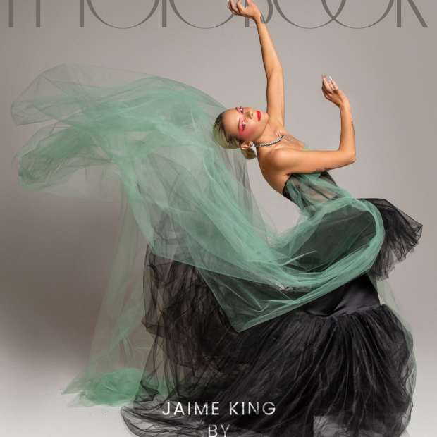](https://fashionista.com/2024/12/photobook-fashion-stylist-alison-hernon-is-seeking-a-social-media-intern-in-new-york-ny)](https://fashionista.com/2024/12/photobook-fashion-stylist-alison-hernon-is-seeking-a-social-media-intern-in-new-york-ny" \o "PhotoBook + Fashion Stylist Alison Hernon Is Seeking A Social Media Intern In New York, NY)

[PhotoBook + Fashion Stylist Alison Hernon Is Seeking A Social Media Intern In New York, NY](https://fashionista.com/2024/12/photobook-fashion-stylist-alison-hernon-is-seeking-a-social-media-intern-in-new-york-ny)

[[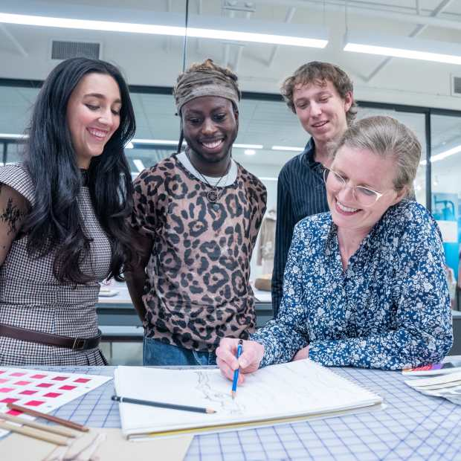](https://fashionista.com/2024/12/assistant-professor-or-professor-of-practice-in-fashion-at-belmont-university)](https://fashionista.com/2024/12/assistant-professor-or-professor-of-practice-in-fashion-at-belmont-university" \o "Assistant Professor or Professor of Practice in Fashion at Belmont University)

[Assistant Professor or Professor of Practice in Fashion at Belmont University](https://fashionista.com/2024/12/assistant-professor-or-professor-of-practice-in-fashion-at-belmont-university)

[[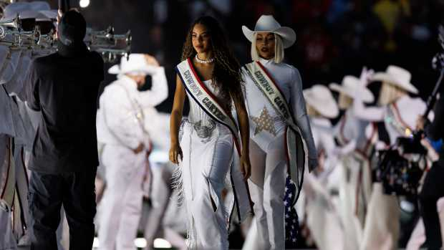](https://fashionista.com/2024/12/beyonce-blue-ivy-carter-christmas-halftime-outfits)](https://fashionista.com/2024/12/beyonce-blue-ivy-carter-christmas-halftime-outfits" \o "Blue Ivy Carter Wore Ukrainian Designer Frolov for Beyoncé's Christmas Halftime Show)

[**Style**](https://fashionista.com/style)

**[Blue Ivy Carter Wore Ukrainian Designer Frolov for Beyoncé's Christmas Halftime Show](https://fashionista.com/2024/12/beyonce-blue-ivy-carter-christmas-halftime-outfits)**

The work of several major and emerging designers made appearances throughout the dazzling performance.

[**By Brooke Frischer**](https://fashionista.com/author/brooke-frischer)**Dec 26, 2024**

[[](https://fashionista.com/2024/12/glamnetic-nail-lash-brand)](https://fashionista.com/2024/12/glamnetic-nail-lash-brand" \o "Glamnetic: A TikTok-Viral Brand Known for Press-On Nails and Magnetic Lashes)

[**Shopping**](https://fashionista.com/shopping)

**[Glamnetic: A TikTok-Viral Brand Known for Press-On Nails and Magnetic Lashes](https://fashionista.com/2024/12/glamnetic-nail-lash-brand)**

With products priced under $22, the brand is carried at Sephora, Ulta Beauty, Target and more.

[**By Fashionista**](https://fashionista.com/author/fashionista)**Dec 26, 2024**

[[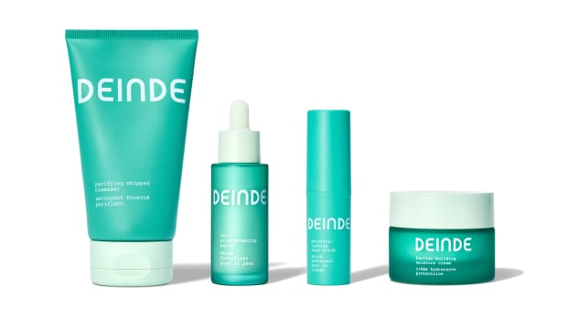](https://fashionista.com/2024/12/deinde-skin-care-brand)](https://fashionista.com/2024/12/deinde-skin-care-brand" \o "Deinde: A Skin-Care Brand That Focuses on 'Inflammaging')

[**Shopping**](https://fashionista.com/shopping)

**[Deinde: A Skin-Care Brand That Focuses on 'Inflammaging'](https://fashionista.com/2024/12/deinde-skin-care-brand)**

Deinde entered the skin-care scene in 2024 with its patented biotech-derived ingredient Naringenin.

[**By Fashionista**](https://fashionista.com/author/fashionista)**Dec 23, 2024**

[[](https://fashionista.com/2024/12/fashionista-favorite-stories-2024)](https://fashionista.com/2024/12/fashionista-favorite-stories-2024" \o "Fashionista's Best Stories of 2024)

[**News**](https://fashionista.com/news)

**[Fashionista's Best Stories of 2024](https://fashionista.com/2024/12/fashionista-favorite-stories-2024)**

Take a look back at the articles our editors and readers loved the most this year.

[**By Brooke Frischer**](https://fashionista.com/author/brooke-frischer)**Dec 23, 2024**

[[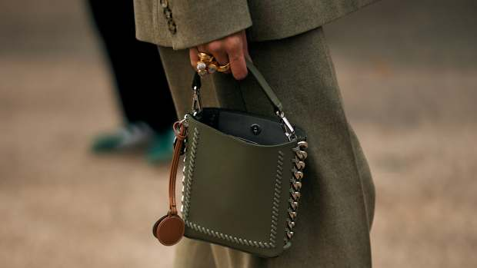](https://fashionista.com/2024/12/fashion-news-you-need-to-know-december-21)](https://fashionista.com/2024/12/fashion-news-you-need-to-know-december-21" \o "ICYMI: Our Favorite Products of 2024, Pre-Fall Trends & Cozy Pajamas)

[**News**](https://fashionista.com/news)

**[ICYMI: Our Favorite Products of 2024, Pre-Fall Trends & Cozy Pajamas](https://fashionista.com/2024/12/fashion-news-you-need-to-know-december-21)**

A must-read roundup of our most popular stories of the week.

[**By Fashionista**](https://fashionista.com/author/fashionista)**Dec 21, 2024**

[[](https://fashionista.com/2024/12/calvin-klein-nyfw-fall-2025-return)](https://fashionista.com/2024/12/calvin-klein-nyfw-fall-2025-return" \o "Must Read: Calvin Klein Returns to New York Fashion Week, The Resurgence of Silver and Sterling Jewelry)

[**News**](https://fashionista.com/news)

**[Must Read: Calvin Klein Returns to New York Fashion Week, The Resurgence of Silver and Sterling Jewelry](https://fashionista.com/2024/12/calvin-klein-nyfw-fall-2025-return)**

Plus, Nike delivers better-than-expected Q2 results following CEO shift.

[**By Catie Pusateri**](https://fashionista.com/author/catie-pusateri)**Dec 20, 2024**

[[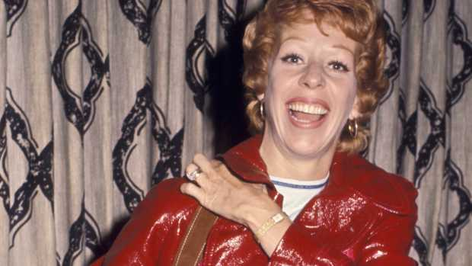](https://fashionista.com/2024/12/carol-burnett-1971-style-red-trench-coat)](https://fashionista.com/2024/12/carol-burnett-1971-style-red-trench-coat" \o "Great Outfits in Fashion History: Carol Burnett's Fiery Red Leather Trench)

[**Style**](https://fashionista.com/style)

**[Great Outfits in Fashion History: Carol Burnett's Fiery Red Leather Trench](https://fashionista.com/2024/12/carol-burnett-1971-style-red-trench-coat)**

It's one of many underrated, fabulously vivid looks from the "Queen of Comedy."

[**By Brooke Frischer**](https://fashionista.com/author/brooke-frischer)**Dec 20, 2024**

[[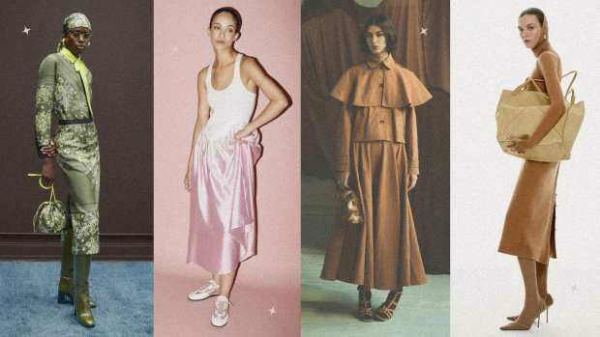](https://fashionista.com/2024/12/pre-fall-2025-top-fashion-trends)](https://fashionista.com/2024/12/pre-fall-2025-top-fashion-trends" \o "These Pre-Fall 2025 Trends Reveal What Fashion Has In Store for Next Year)

[**Fashion Week**](https://fashionista.com/fashion-week)

**[These Pre-Fall 2025 Trends Reveal What Fashion Has In Store for Next Year](https://fashionista.com/2024/12/pre-fall-2025-top-fashion-trends)**

[**By Dhani Mau**](https://fashionista.com/author/dmau)**Dec 20, 2024**

[[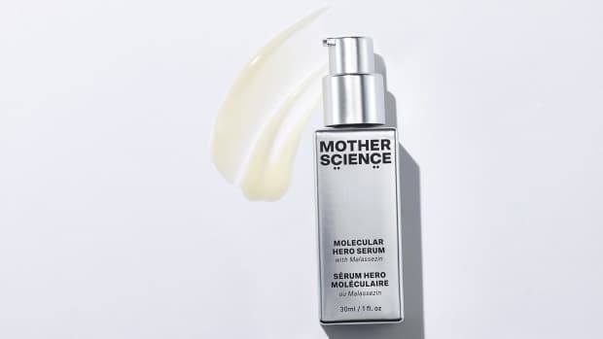](https://fashionista.com/2024/12/mother-science-skin-care-brand)](https://fashionista.com/2024/12/mother-science-skin-care-brand" \o "Mother Science: The Musician-Founded Skin-Care Brand Utilizing a New Ingredient)

[**Shopping**](https://fashionista.com/shopping)

**[Mother Science: The Musician-Founded Skin-Care Brand Utilizing a New Ingredient](https://fashionista.com/2024/12/mother-science-skin-care-brand)**

Meet the only brand with malassezin in its arsenal (and an Incubus guitarist as its founder).

[**By Fashionista**](https://fashionista.com/author/fashionista)**Dec 20, 2024**

See More

© 2025 Breaking Media, Inc. All rights reserved.

* [Site Map](https://fashionista.com/sitemap)
* [Meet the Editors](https://fashionista.com/page/the-team)
* [About](https://fashionista.com/page/about)
* [Contact](https://fashionista.com/page/contact)
* [Advertise](https://fashionista.com/page/fashionista-advertising)
* [Job Listings](https://fashionista.com/job-listings)
* [Events](https://fashionista.com/event-listings)
* [Newsletter](https://share.hsforms.com/1m--_fMJYRvGzsdhnYAd9Fws25du)
* [Privacy](https://fashionista.com/page/privacy-policy)
* [Terms of Service](https://fashionista.com/page/terms-of-service)
* [Platform Privacy](https://thearenagroup.net/privacy-policy/)