IMPLEMENTATION OF PCA, LDA ANALYSIS ON DIABETES DATA SET USING PYTHON

1. Introduction
This report presents the process of applying Principal Component Analysis (PCA) and Linear Discriminant Analysis (LDA) on the Diabetes dataset using Google Colab. Both techniques are demonstrated with code, results, and key insights.

2. Loading Dataset in Google Colab
from google.colab import files
uploaded = files.upload()
import pandas as pd
df = pd.read_csv("diabetes.csv")
df.head()
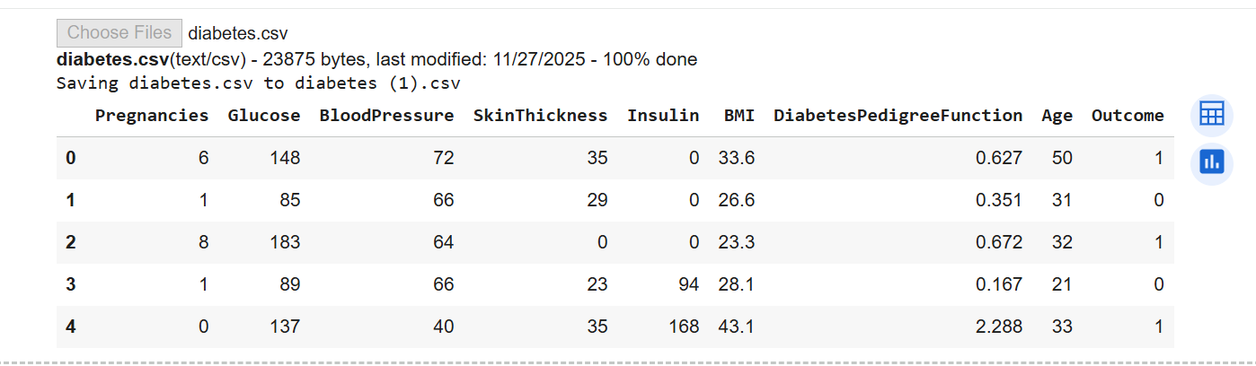

3. Data Preprocessing
X = df.drop("Outcome", axis=1)
y = df["Outcome"]
from sklearn.preprocessing import StandardScaler
scaler = StandardScaler()
X_scaled = scaler.fit_transform(X)

4. PCA (Principal Component Analysis)
PCA is an unsupervised technique used to reduce dimensionality by maximizing variance.
from sklearn.decomposition import PCA
pca = PCA(n_components=2)
X_pca = pca.fit_transform(X_scaled)
print("Explained variance ratio:", pca.explained_variance_ratio_)
import matplotlib.pyplot as plt
plt.figure(figsize=(7,5))
plt.scatter(X_pca[:,0], X_pca[:,1], c=y)
plt.xlabel("PC1")
plt.ylabel("PC2")
plt.title("PCA Scatter Plot")
plt.show()
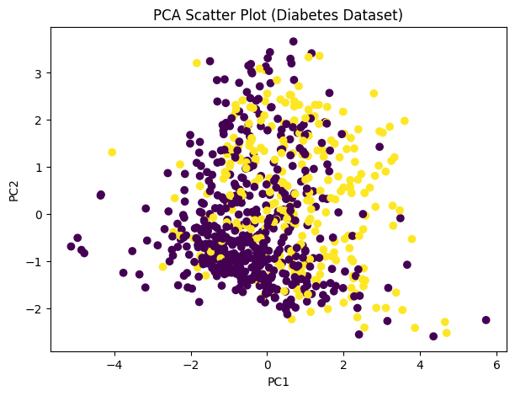

5. LDA (Linear Discriminant Analysis)
LDA is a supervised dimensionality reduction method that maximizes class separability.
from sklearn.discriminant_analysis import LinearDiscriminantAnalysis
lda = LinearDiscriminantAnalysis(n_components=1)
X_lda = lda.fit_transform(X_scaled, y)
plt.figure(figsize=(7,5))
plt.scatter(X_lda, [0]*len(X_lda), c=y)
plt.xlabel("LD1")
plt.title("LDA Projection")
plt.show()
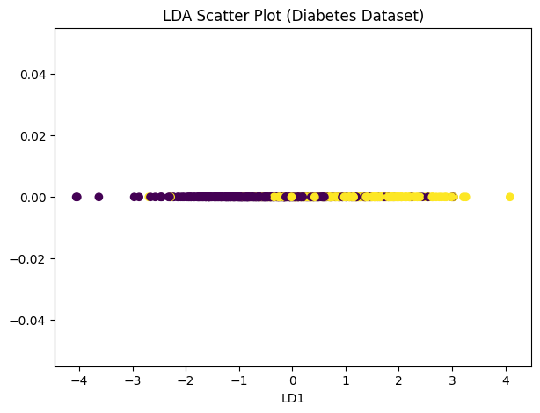

6. Classification Using PCA and LDA Features
from sklearn.linear_model import LogisticRegression
from sklearn.model_selection import train_test_split
from sklearn.metrics import accuracy_score, classification_report
# Train-test split
X_train_lda, X_test_lda, y_train_lda, y_test_lda = train_test_split(
X_lda, y, test_size=0.3, random_state=42)
X_train_pca, X_test_pca, y_train_pca, y_test_pca = train_test_split(
X_pca, y, test_size=0.3, random_state=42)
# Logistic regression
lda_model = LogisticRegression()
lda_model.fit(X_train_lda, y_train_lda)
lda_pred = lda_model.predict(X_test_lda)
pca_model = LogisticRegression()
pca_model.fit(X_train_pca, y_train_pca)
pca_pred = pca_model.predict(X_test_pca)
print("LDA Accuracy:", accuracy_score(y_test_lda, lda_pred))
print("PCA Accuracy:", accuracy_score(y_test_pca, pca_pred))
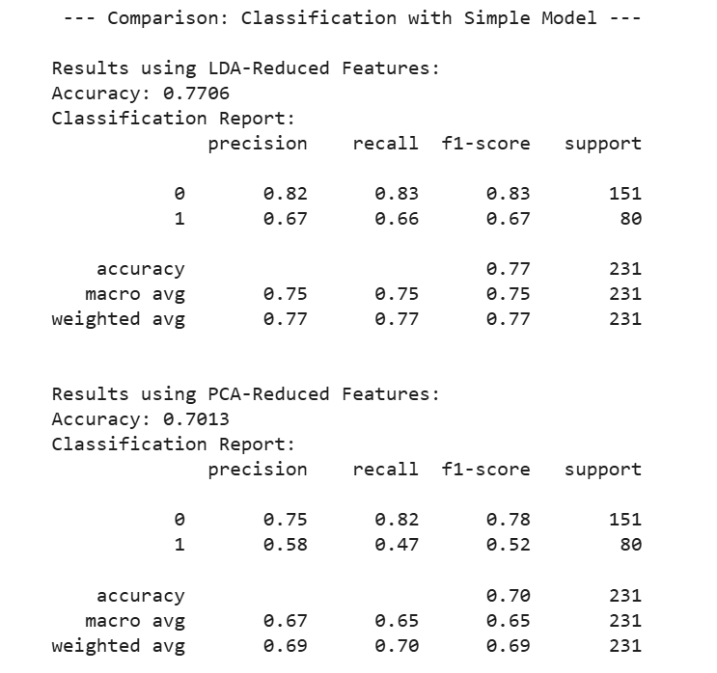

7. Conclusion
LDA outperformed PCA for the supervised diabetes classification task, achieving higher accuracy and better class separation. PCA remains useful for variance-based dimensionality reduction, visualization, and noise reduction.

