|  |  |  |  |  |
| --- | --- | --- | --- | --- |
| ***Front-End UI / Web Applications***  ***ColdFusion***  ***AngularJS / ExtJS / Bootstrap***  ***Databases*** | | | |  |
| **Jose G. Alfonso**  1020 D Street San Rafael, CA 94901 | | 415 532-9500  jgalfonso@me.com | |
|  | | | | |
| Latest projects: | | | | |
| **Certain Software, San Francisco, CA 2013-2014 - Contract:**  Participated in the development of an event management application built in **AngularJs**, **Bootstrap 3** and connected to **Java RESTful services**. Helped maintained legacy ColdFusion sections. | | | **MHW Ltd. – New York 2012 and 2014 - Contract:**  Developed a Client Reporting Application featuring a full Web 2.0 event-driven UI built with the **ExtJS 4.x** JavaScript Library with Google docs integration, **ColdFusion 9** using OO methodology and a MySQL database. | |
| Strengths: | | | | |
| JavaScript, AngularJS, Bootstrap 3, ExtJs, jQuery, AJAX, CSS, HTML HTML5, DHTML, XML. ColdFusion, Java, Spring, Hibernate, Oracle, PL/SQL stored procedures and packages, Oracle Objects, SQL, Visual Basic. SQL Server, Microsoft Access.   * Over 16 years experience designing, developing, integrating, and supporting corporate tools and applications, including content management and HR applications. * Ability to build applications from the ground up and manage multiple projects simultaneously, learn and apply new technologies quickly and efficiently. * Self-starter, independent, motivated, resourceful, creative and innovative. * Solid communication, presentation, analytical, and problem-solving skills. * Excellent application flow and user interface design skills. * Proven experienced in Database design and MS SQL to Oracle Database Migration. | | | | |
| Technical Skills: | | | | |
| **Languages:** | JavaScript, CSS, HTML, HTML5, DHTML, XML, XSL, PL/SQL, SQL, CFML, Visual Basic. | | | |
| **Methodologies:** | Extjs JavaScript Library, Oracle Objects, OOP, ColdFusion, ColdSpring IoC, Web Services. | | | |
| **Databases:** | Oracle 11g, 10/9/8, MySQL, SQL Server, PostgreSQL, Microsoft Access. | | | |
| **Tools:** | Intelij, Eclipse, Sublime, Aptana, Firefox Firebug, YSlow, JSLint, Chrome Developer Tools, Dreamweaver, ColdFusion Studio. Oracle SQL Developer, TOAD, Navicat. Subversion (SVN), Visual SourceSafe, perforce, Git. | | | |
| **Platforms:** | Mac OS, Windows Vista/XP/NT, Linux, UNIX, CentOS.  Server Configuration: Microsoft IIS, Exchange, ISA and NT Server. | | | |
| **Graphics:** | Adobe Photoshop, Illustrator, PageMaker, OmniGraffle, Corel Xara, Visio, AutoCAD. | | | |
| Experience: | | | | |
| With over 16 years of experience working primarily as contractor, the following is a list of some companies I have done work for. They include:   * MHW Ltd. New York, NY * Certain Software. * MasterCard. St. Louis, MO. * Adobe Systems Inc. * Life Technologies/Applied Biosystems. Foster City, CA. * Fragomen, Del Rey, Bernsen & Loewy, LLP. New York, NY. * Barclays Global Investors. San Francisco, CA. * Logitech. Santa Clara, CA * Pacifc Bell Directory. San Francisco, CA. | | | | |
| For a detailed chronology of projects and employment experience see page 3. | | | | |
| **Education/Certification: JavaScript** classes UC Berkeley Extension San Francisco. **Advanced Cold Fusion Development** Courses. Macromedia and Brainbench Cold Fusion certifications. Business & computer courses at College of Marin, CA 1995-1997. Architectural Design & Drafting Courses, De Anza College Cupertino, City College Of San Francisco, and Foothill College, Los Altos, CA. 1989-1990 - Architectural And Graphic Design, Argentina. | | | | |

**Recent Projects Screen Shots:**

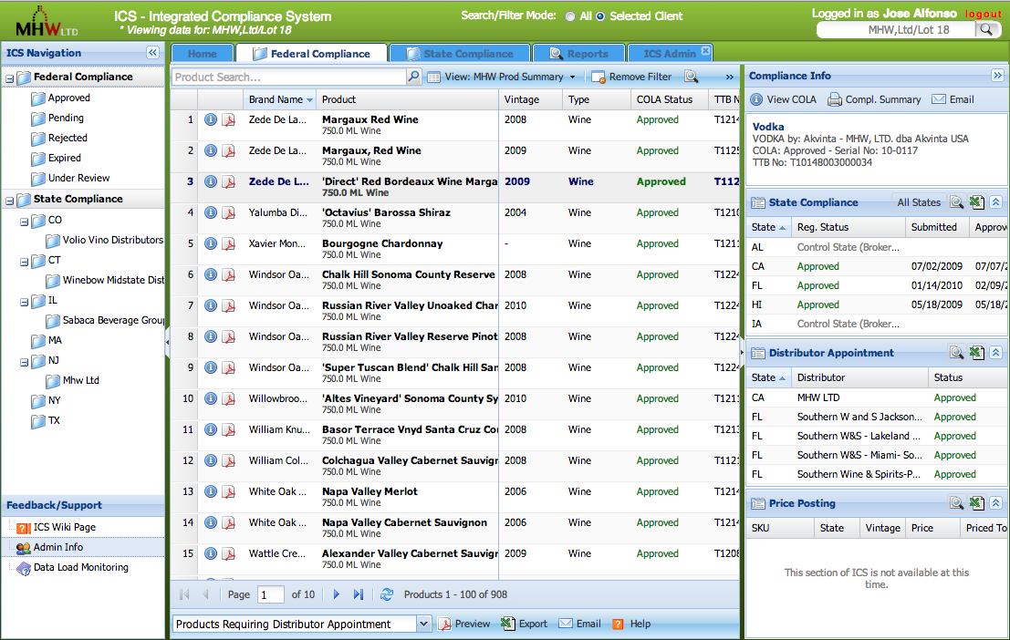(Please keep information confidential)

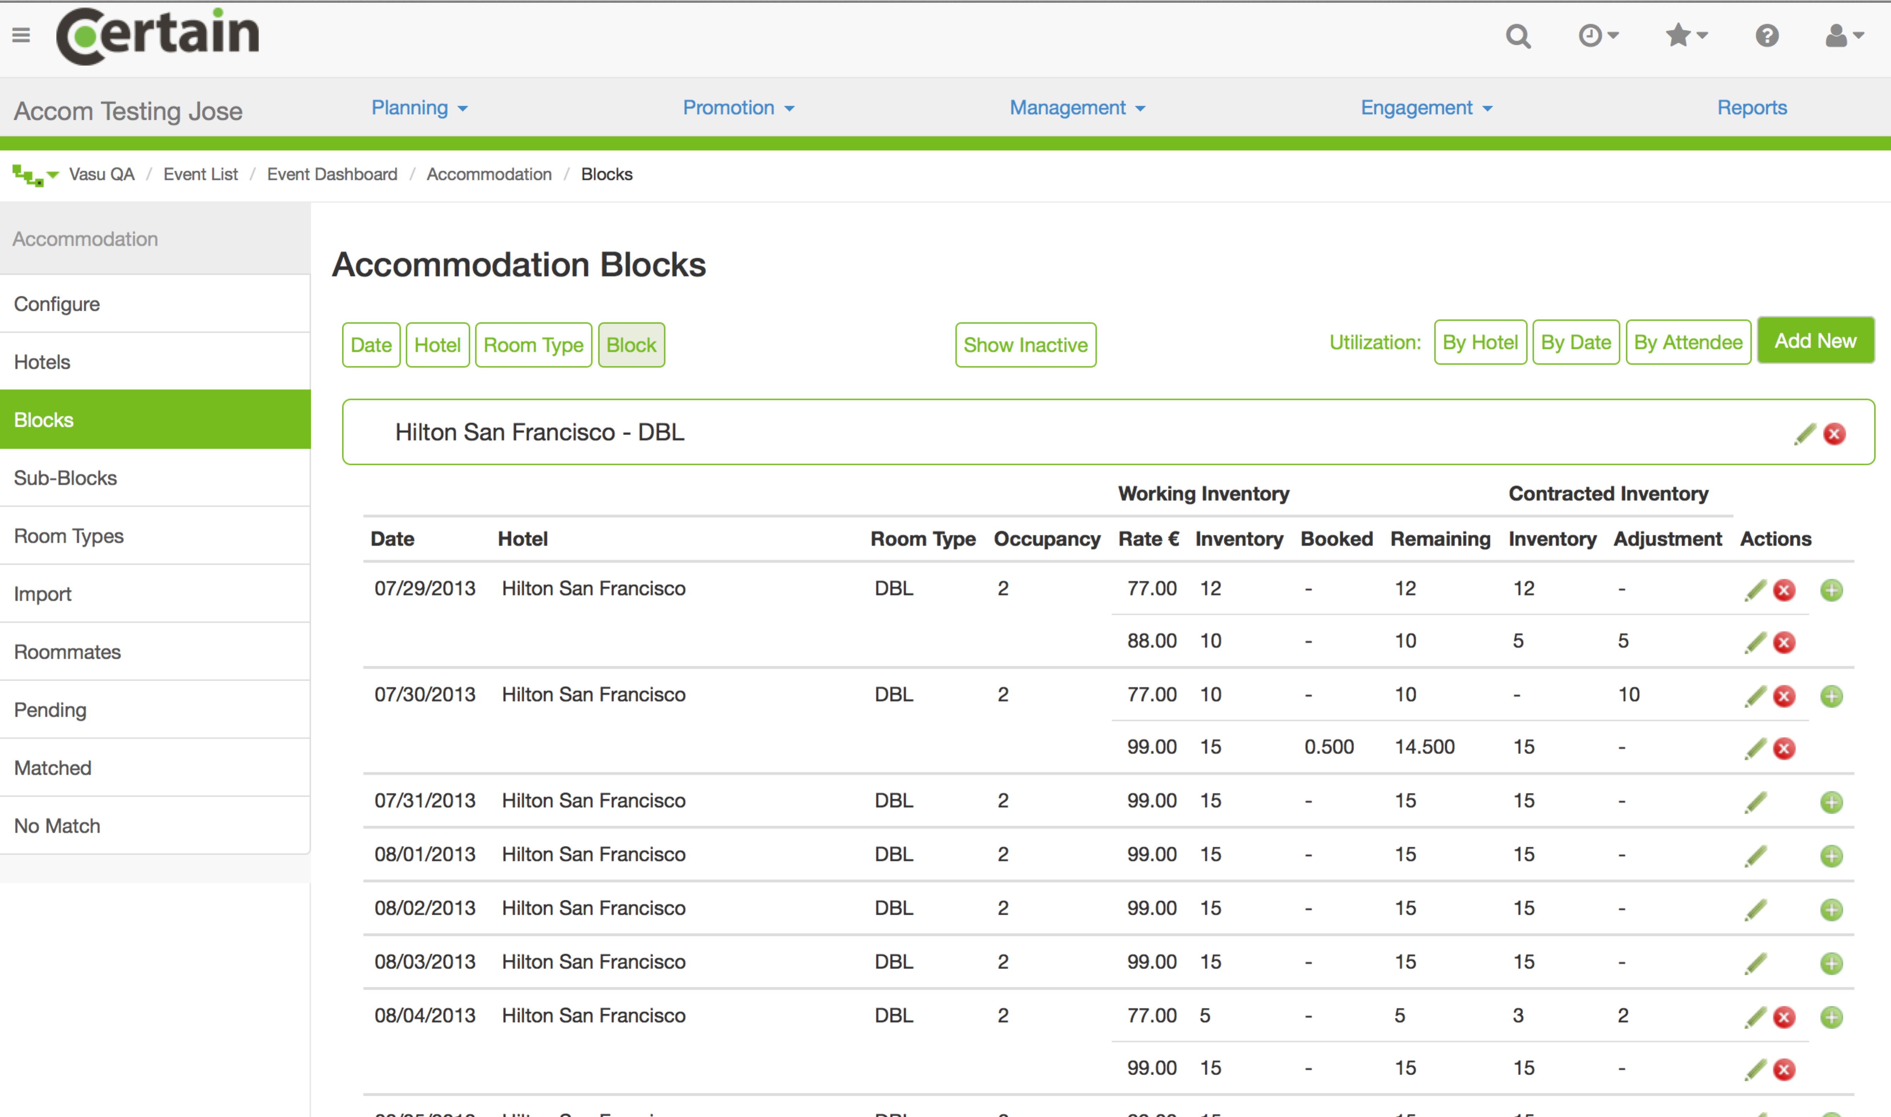

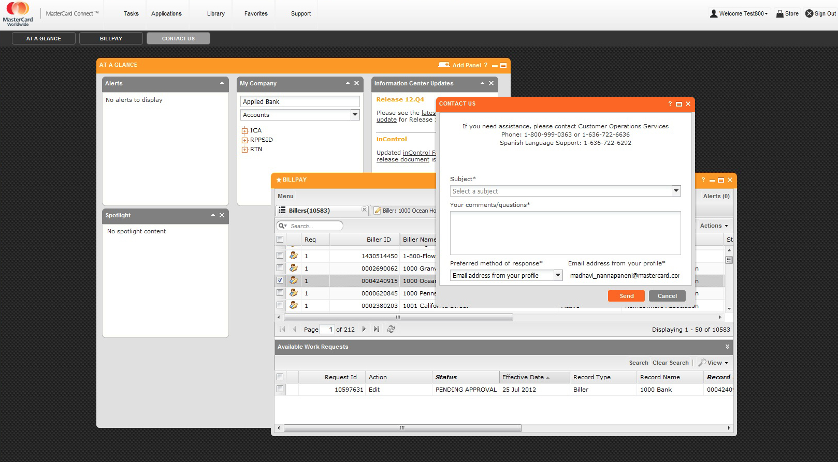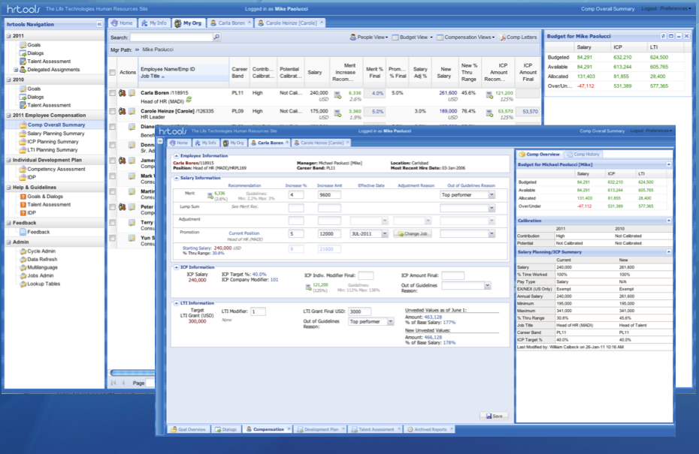

|  |  |  |  |  |
| --- | --- | --- | --- | --- |
| Extended Project/Employment Chronology: | | | | |
|  | | | | |
| **Certain Software – San Francisco CA** | Application Developer Contract 2013-2014 | | | |
| Participated in the development of an event management application built in AngularJs, Bootstrap 3 and connected to Java RESTful services. Helped maintained legacy ColdFusion sections. | | | | |
| **MHW Ltd. – New York, NY** | Web Application Developer Contract 2012 | | | |
| Developed a Client Reporting Application featuring a full Web 2.0 event-driven UI built with the ExtJS 4.x JavaScript Library with Google docs integration, ColdFusion 9 using OO methodology and a MySQL database. | | | | |
| **MasterCard, St Louis MO** | Front-End Development Contract 2012 | | | |
| As subcontractor of Sencha Inc. I themed the UI for masterCard Connect, a B2B application developed with ExtJS 3.x JavaScript library. Modified the standard UI based on a provided graphic design. Created a small documentation app for the Human Interface Guide to the application. | | | | |
| **Adobe Systems Inc., CA** | | Ecom Team Developer Contract 2011 | | |
| As a member of the ecommerce engineering team, collaborated on a fast-paced scrum team, analyzing, designing, implementing and testing enhancements and/or new projects associated with Adobe.com ecommerce site. Worked with ColdFusion 9, Oracle, JQuery, JavaScript and CSS. | | | | |
| **Life Technologies/Applied Biosystems - Foster City, CA** | | Lead Developer Contractor 2004-2011 | | |
| Responsible for the development and deployment of hrtools, an Intranet suite of integrated tools that managed employee evaluation, talent assessment, compensation planning and succession planning. hrtools underwent several revision cycles to accommodate changes in the business process, organizational changes and a company merger.  Responsible for all the application design and development in ColdFusion, Oracle PL/SQL stored procedures and packages and for the front-end development HTML, XHTML, CSS, JavaScript, ExtJS and jQuery.   * 2010-2011: hrtoolsNG: Integrated Compensation Planning and Long Term Incentive. * 2009-2010: Equity and Salary Planning. * 2008-2009: Goals & Dialogs. * 2007-2008: Equity and Salary Planning. Development Planning. * 2004-2006: Online Performance Management, Succession Planning, and Talent Assessment. | | | | |
| **Thermo Fisher Scientific – Santa Clara, CA** | | | Contract 2009-2010 | |
| * Developed an Inspection Management Web 2.0/event-driven application using the **ExtJS 2.2/3.1** JavaScript library for the front-end. RSP uses a Service Layer developed with **ColdFusion** componentswith an OO methodology, Coldspring for dependency injection and a **MySQL** database. App features included photo upload, offline data gathering and upload using an Excel application written in VBA. * Developed an Excel application in VBA to support the offline gathering of data. | | | | |
| **Fragomen, Del Rey, Bernsen & Loewy, LLP. New York** | | | Contract 2008 | |
| * MSSQL 2000 to Oracle 10g Database Migration:Adapted all ColdFusion and database code to the new environment and fully migrated data using Oracle SQL Developer. Installed and maintained ColdFusion 7 and Oracle 10g on Windows 2003 servers. | | | | |
| **Barclays Global Investors – San Francisco, CA** | | | Contract 2003 | |
| * Developed a component-based configurable rendering framework in ColdFusion MX to support an infrastructure reporting system with an object based Sybase database. The rendering implementation was controlled by components with sections defined via XML and a cacheing facility to improve application performance. | | | | |
| **Ronald W. Freeman P.C. New York. Client Management Application Phase II** | | | Contract 2003 | |
| * ColdFusion MX implementation of the Client Management application project completed previously. Phase II included a Multilanguage framework, text-indexing, content management and file management. | | | | |
| **DTA, Inc. Mill Valley, CA** | Contract 2003 | | | |
| * Construction Defects Investigation Application. A photo investigation/data gathering application for the construction and forensic architecture industry. Implemented in ColdFusion MX with a MS SQL 2000 Database. | | | | |
| **WorldShipNet/800wine.com/WSN – San Francisco, CA** | Contract 2001-2003 | | | |
| * Designed and developed an automated order processing and validation application using MS SQL 2000 and ColdFusion. The framework included automated record modifications, runtime-generated JavaScript for data validation on forms, and an XML API for the automation of product updates and order processing. * **800wine.com**: Cold Fusion: Modified an existing Fusebox application. Complete site overhaul. The re-designed e-commerce site included a content management system, catalog and branding. Designed and built site themes for 4 storefronts and corporate logo. | | | | |
| **American Academy of Ophthalmology - San Francisco, CA** | Contract 2002 | | | |
| * Site improvements and code revisions on existing applications. Assisted in projects involving data migration and site implementation. Oracle 8 and ColdFusion. | | | | |
| **Ecom Enterprises, Inc. – Sunnyvale, CA for Logitech** | Contract 2001 | | | |
| * As a subcontractor of Ecom revised and re-wrote several sections of the **logitech.com** web site including the products pages using **Oracle 8**, Cold Fusion, WDDX, DHTML and JavaScript to produce fast displaying product catalogs. * Customized expanded and implemented a Cold Fusion discussion Forum for the **RiskWeb** Intranet Site at **Hewlett-Packard**. Improvements to the application included subscription to forum registration and notification. Digest notification and a site feedback section. | | | | |
| Ronald W. Freeman P.C. New York. Client Management Application Phase I | | | | Contract 1999-2001 |
| * Client Management Application Phase I: Designed and built a SQL 2000/ColdFusion 5 case management application for generic data gathering and automated PDF Form population. Data entry forms were dynamically produced by a data-driven Object-based design where administrators were able to defined their own data gathering forms and navigation trees were dynamically produced with DHTML and JavaScript. * rwfpc.com Corporate Web site redesign Contract (2001)converted all of the Ronald Freeman P.C static web site pages to a database-driven ColdFusion Dynamic content publishing system. * Client Reporting Application (1999): Developed an Online Cold Fusion based client request and status-reporting application for immigration data. The Application framework was based on a hybrid-version of Fusebox. | | | | |
| PeakStar, Inc. – 2000 (Co-Founder and CTO) | Co-Founder/CTO 2000 | | | |
| * Developed a prototype database-driven data gathering Web application for the Real Estate/AEC/Consulting Industry using **Oracle 8i** Cold Fusion 4.5. The database had an Object-based design and the Cold Fusion application Framework used a component-independent approach. | | | | |
| SBC Pacific Bell Directory, San Francisco, CA Web Application Projects | 1997 - 1999 | | | |
| * Enterprise-wide Questionnaire/Test/Survey database driven web application for the Intranet. The application design was based on Objects-and-Classes approach, which allowed the display of questionnaires and response tallying reporting to be controlled by modular and configurable templates. * CARE district Intranet site which included: * A Dynamic content publishing application. ColdFusion 4/5 and MS SQL 6.5 * A LDAP employee locator integrated into the enterprise MS Exchange messaging system. * Enterprise-wide Service Level Agreement (SLA) survey to help determine level of service and support requirements. * Migrated the COOP Sales application from ColdFusion 3.1 to 4.0 with an Oracle 7.x back-end. Developed Test Plans, staging and production deployment. | | | | |
| SBC Pacific Bell Directory Business Process Design and Re-engineering | | | 1998 | |
| * Researching, developing, testing, and implementing an information technology solution for an integrated IT Requisition system to be implemented by the SBC Directory Operations as a result of the SBC-Pacific Telesis merger. Developed a complete document including Business Processes, Technology alternatives and solutions based on the corporate standards.  IT System Integration Roll‑out support Participated in the coordination and deployment and replacement of 700 + laptops for the Pacific Bell Directory Sales force throughout California. The project consisted in configuring the laptops with a standard Windows images, testing and quality control. Responsible for the database tracking system for the laptop exchange. | | | | |
| Database Development Pacific Bell Directory | 1996 - 1997 | | | |
| * **CSA (Computer Systems Access Team):** Developed a multi-user Microsoft Access Database for the tracking of information system access security. * **SmartDesk:** Developed a Microsoft Access database for the tracking of the Smartdesk Project. The project involved a *Needs Analysis* face leasing or procurement and deployment of more than 2500 desktops as well as the re-configuration of existing laptops.   **Other Client/Server Prototypes:** NCS (Network Control System Database) Integrated database for asset management. Billing Assistant, NT Client Configuration Tracking and Integrated Client Services database. | | | | |
| Database Development Pacific Bell Directory | 1996 - 1997 | | | |
| DTA, Inc. Mill Valley, CA Configuration and maintenance a Windows NT/Windows 2000 Network including a VPN service, MS Exchange Server, Microsoft ISA server and a construction Databases server. Additional projects over this period include Y2k compliance, remote access implementation using Windows NT Terminal Server Edition and Provided technical consulting/evaluation of new technologies. Other IT Experience 1989 - 1997 Local Area Network configuration and support. Business software End-user support: CADD, Accounting, Database, Desktop publishing, Word processing, Construction, Cost Estimating, Scheduling, Tracking, Engineering, Contacts and communications. AutoCAD and ASG advanced customization, AutoLisp routines, menus and macros. | | | | |