Data anaysis is the process of deriving insights from data by analysing it from different sources.
In the era we live in today data is considered as the fuel on which smart bussiness decision making rely on. Terebytes of data is being generated on daily bases by online sites representing different type of bussiness. So analysis of this data has become very important in order for the smooth runnining of these bussinesses. There are multiple ways in which this data is analysed. Following are some of these ways:

- Cross Industry Standard Process for Data Mining (CRISP-DM)
- Knowledge Discovery in Databases (KDD)
- Sample, Explore, Modify, Model and Assess (SEMMA)

Data analysts usally choose one of these stratigies and get on with their analysis or build up a custom strategy involving crucks from all these techniques , in this project we have build a similar stratergy. The stratergy we have adopted involves 4-5 basic stages. These stages include:

- data collection
- data preprocessing
- data exploration
- data modeling
- evaluation

DATA COLLECTION
This step involves collection of data from multiple sources . For this analysis we have used two different types of data sets namely:

- bike shareing dataset
- diabetes dataset

BIKE SHAREING DATA
This data set includes multiple factor influsing the sale of bike, weekly , monthly and so on. A snippet of this data set is given below:

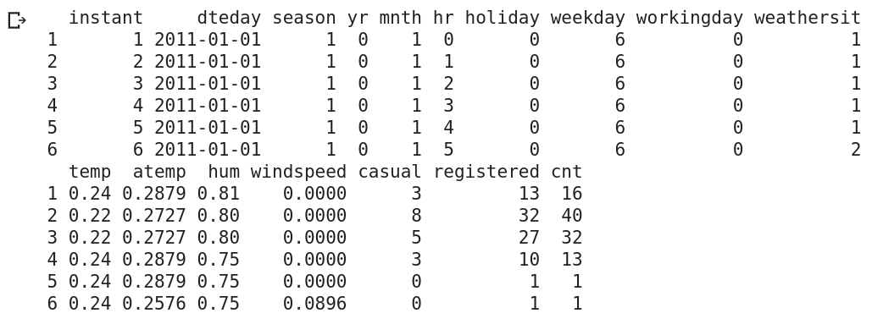

BANK DATASET
This is another data set which we used for our analysis. It consistes of different specification which we , through analysis could use to determine whether a person should be given a loan or not. A snippet fo this dataset is given below:

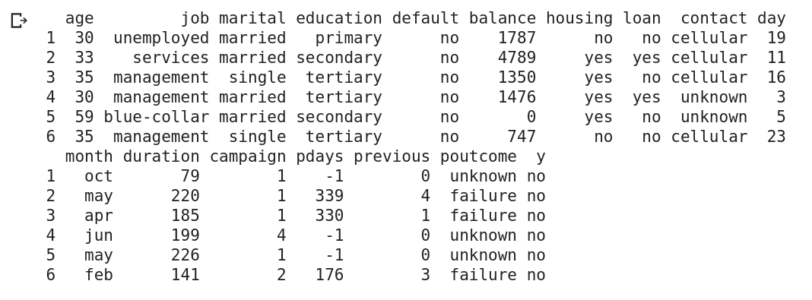

DATA PREPROCESSING
This stage involves the processos of cleaning the raw data, detecting the nan’s and all the stuff which can cause problem in our analysis. The data we are dealing with in this project is already preprocessed only preprocessing we need to do on this kind of data is converting the values into vector form in the modelling phase.

EXPLORATORY DATA ANALYSIS
This phase of our analysis involves the impact of differet features on one another or checking the distribution of each feature vector. Some snippets regarding the same are shown below for both the data sets:
1: For bike sharing data set:
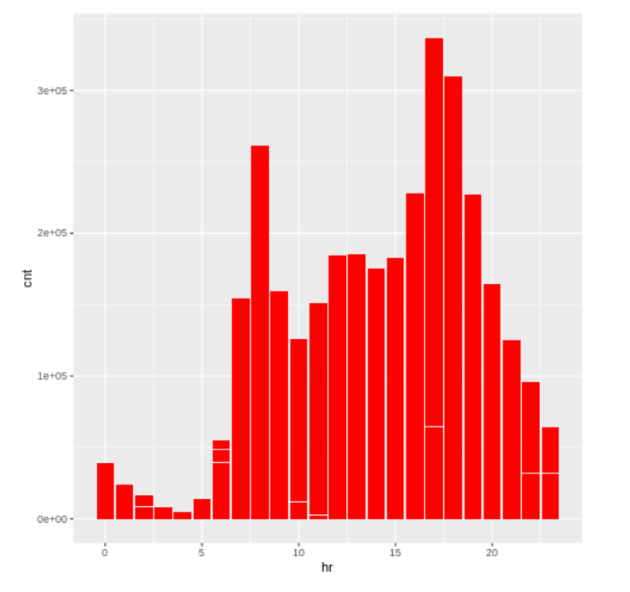
hourly bike sharing

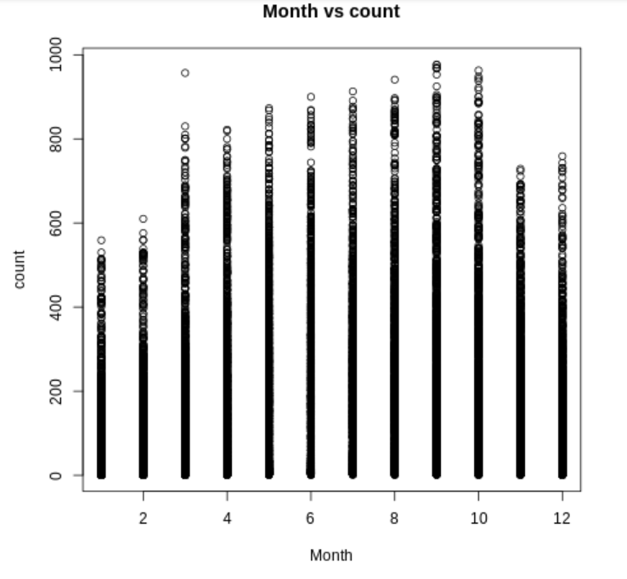
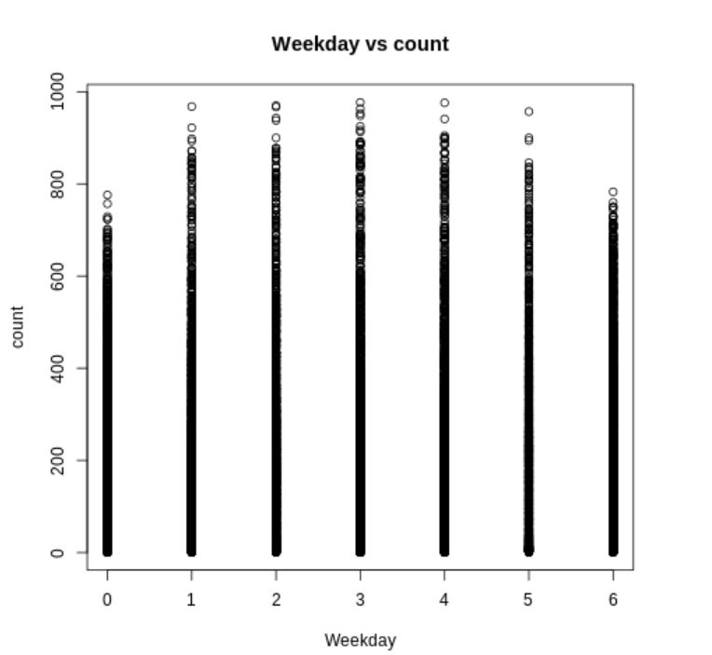
Monthly bike sharing
Weekday bike sharing

2: For Banking dataset:

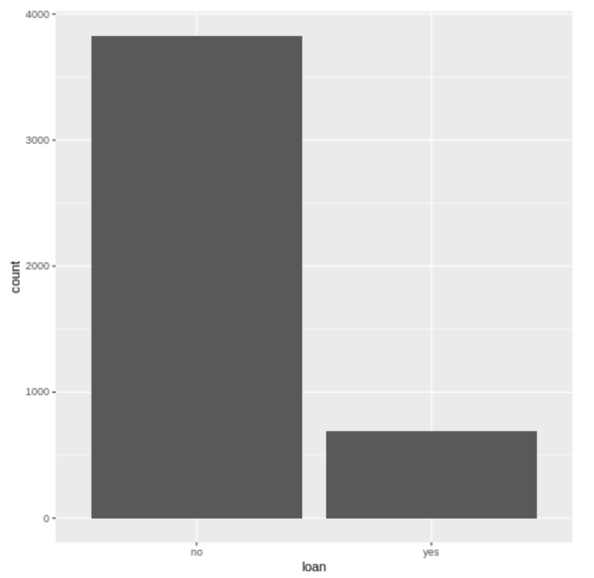

Loan Count

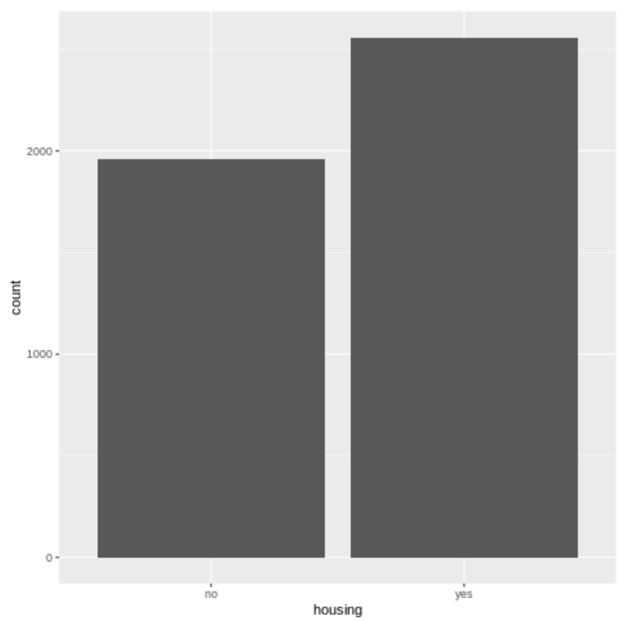
Loans alloted based on housing

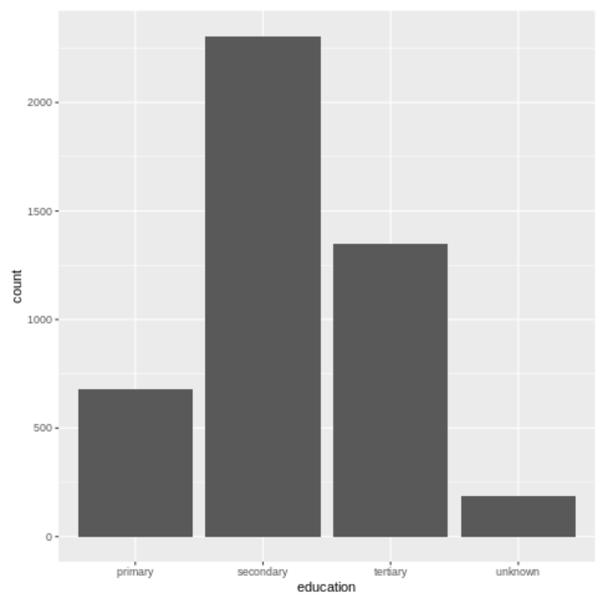
Loans alloted based on educational background

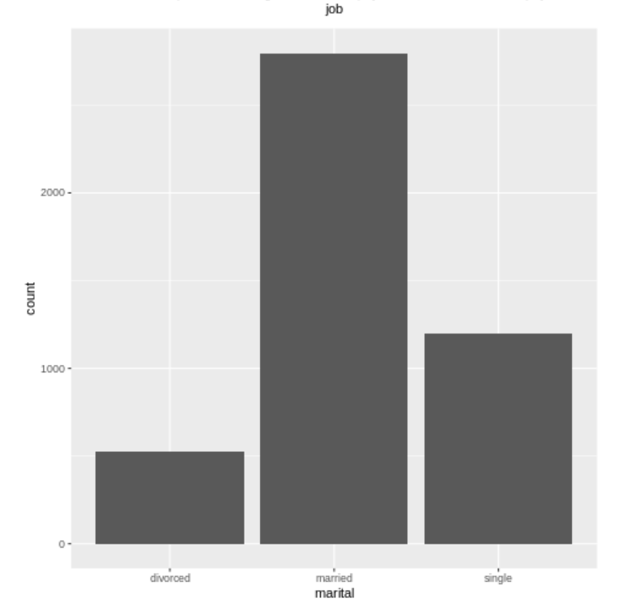
Loans alloted based on marital status

DATA MODELLING
Once the data is processed and all the features are explored we need to transform these features into vectors inorder for our model to train on it , for the Bikesharing data we have modeled it into regression format and have build a regression model in order to perform further modelled regression analysis. And as for bank shareing dataset we have trained a random forest classifier in order to predict classes for the given data set.

EVALUATION

In this phase we see how our models have performed. There are multiple ways of doing it, one of which is visually. And others include Building classification reports. Following snippets represent the evaluation measures of our analysis:
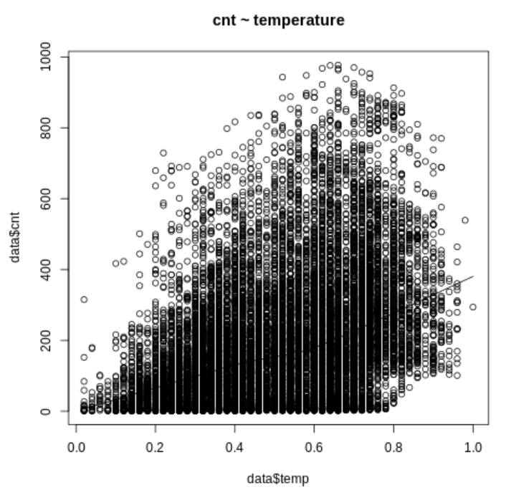
The line in the above snippet represents the regression analyisis

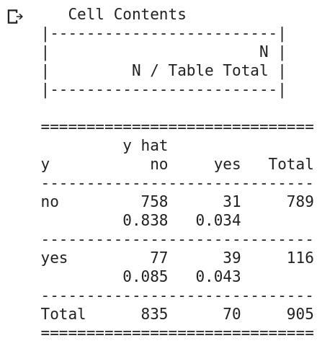

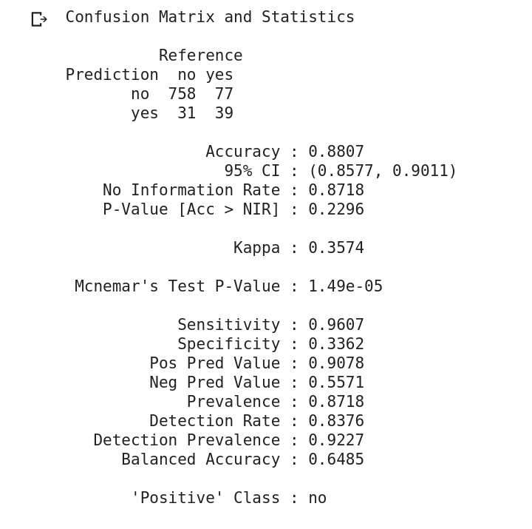
Eval for Random Forest

Confusion matrix and statistic for Random forest

