Graph is a data structure that consists of following two components:
1. A finite set of vertices also called as nodes.
2. A finite set of ordered pair of the form (u, v) called as edge. The pair is ordered because (u, v) is not same as (v, u) in case of directed graph(di-graph). The pair of form (u, v) indicates that there is an edge from vertex u to vertex v. The edges may contain weight/value/cost.

Following two are the most commonly used representations of graph.
1. Adjacency Matrix
2. Adjacency List
There are other representations also like, Incidence Matrix and Incidence List. The choice of the graph representation is situation specific. It totally depends on the type of operations to be performed and ease of use.

The following table gives the time complexity cost of performing various operations on graphs, for each of these representations. In the matrix representations, the entries encode the cost of following an edge. The cost of edges that are not present are assumed to be .
 | Adjacency list | Adjacency matrix | Incidence matrix
Storage
Add vertex
Add edge
Remove vertex
Remove edge
Query: are vertices u, v adjacent? (Assuming that the storage positions for u, v are known)
Remarks | When removing edges or vertices, need to find all vertices or edges | Slow to add or remove vertices, because matrix must be resized/copied | Slow to add or remove vertices and edges, because matrix must be resized/copied
Adjacency lists are generally preferred because they efficiently represent sparse graphs. An adjacency matrix is preferred if the graph is dense, that is the number of edges |E| is close to the number of vertices squared, |V|², or if one must be able to quickly look up if there is an edge connecting two vertices.

Adjacency Matrix:
Adjacency Matrix is a 2D array of size V x V where V is the number of vertices in a graph. Let the 2D array be adj[][], a slot adj[i][j] = 1 indicates that there is an edge from vertex i to vertex j. Adjacency matrix for undirected graph is always symmetric. Adjacency Matrix is also used to represent weighted graphs. If adj[i][j] = w, then there is an edge from vertex i to vertex j with weight w.
The adjacency matrix for the above example graph is:
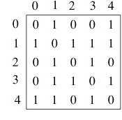
Adjacency Matrix Representation of the above graph
Pros: Representation is easier to implement and follow. Removing an edge takes O(1) time. Queries like whether there is an edge from vertex ‘u’ to vertex ‘v’ are efficient and can be done O(1).
Cons: Consumes more space O(V^2). Even if the graph is sparse(contains less number of edges), it consumes the same space. Adding a vertex is O(V^2) time.

Adjacency List:
An array of linked lists is used. Size of the array is equal to number of vertices. Let the array be array[]. An entry array[i] represents the linked list of vertices adjacent to the ith vertex. This representation can also be used to represent a weighted graph. The weights of edges can be stored in nodes of linked lists. Following is adjacency list representation of the above graph.
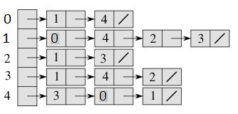
Adjacency List Representation of the above Graph

