moonLoop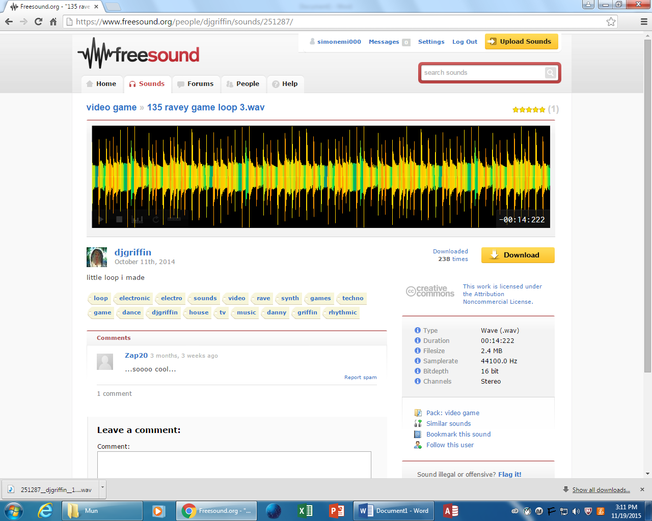

Level Music

* Airik – Floor1 (Level 1)
* (Level 2) (Lab)
* Myrne - Architect (0:00-0:50 before enemies)(0:50-end after enemies) Airik – Encounter (Level 3)
* (Level 4) (Elevator Terminal)
* Wise Young Gent - Destiny (Level 5 Elevator)
* Airik – Mysterious Space (moon level)

Credits

* Venemy – Cosmic (End Credits)
* Tiasu - Raw Airik – Moon Base Theme (Start Screen)

Boss Music

* (Level 1 Boss) (Flamer)
* Waterflame - Clown Party (youtube) Airik – Patch (Level 2 Boss)
* Jskee - I am Pharoah Airik – Parasite (Level 3 Boss)(cut some from beginning)
* Airik – Tank Drone (Level 4 Boss)
* ns Trip40 - Robot Pirate Invasion Airik – Last Order (Elevator Boss)
* Airik – 0-rion (Moon Boss)

PR Music

* Infected State (Radio Transmission) – Never Modern Talk

Other

* Haven – Oblivion (1:06-1:56)(2:45-3:38)
* WAllouche – Fresh Start (1:16-1:45)(2:46-end)
* Duko – Keep My Base
* Haven – Bleeding Through (0:14-0:43) (1:10-2:05)(3:14-4:08)

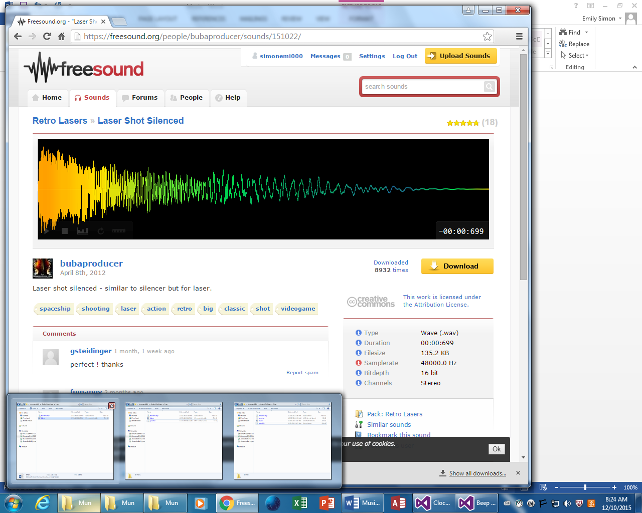

Laser Rifle

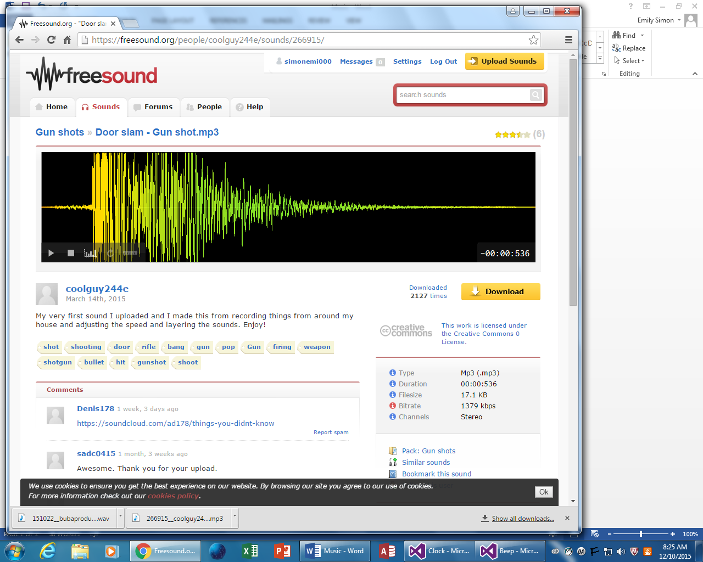

Gunshot

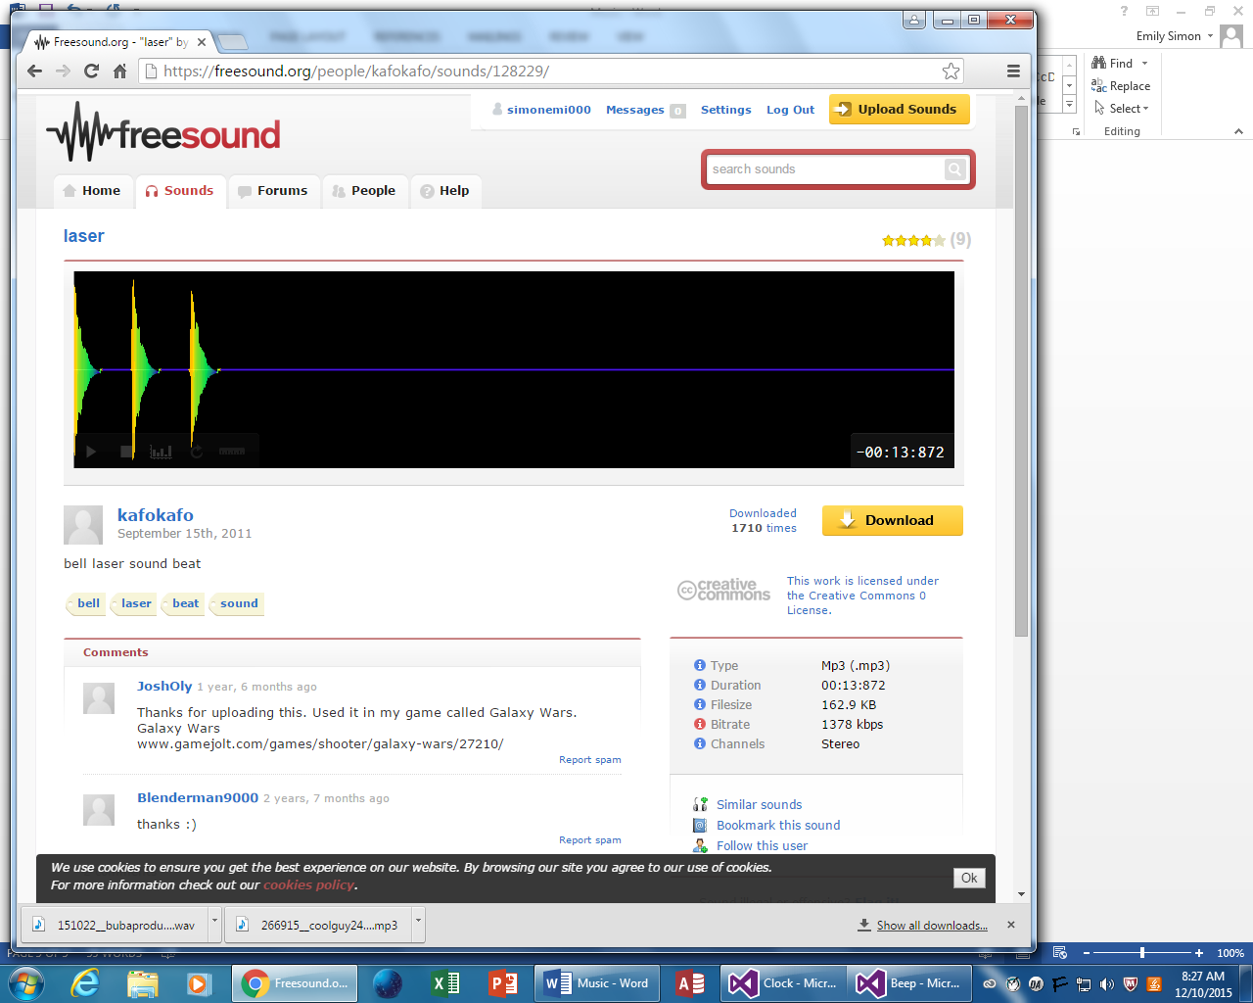

Laser Pistol

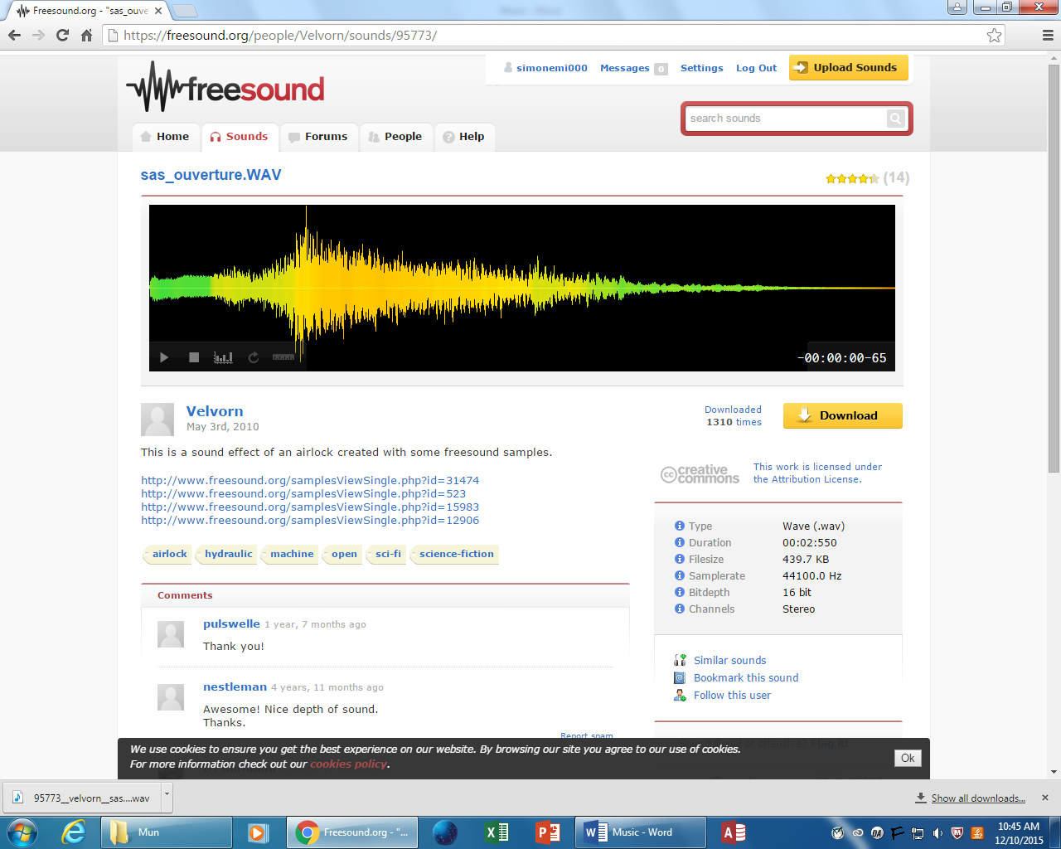

Elevator Door

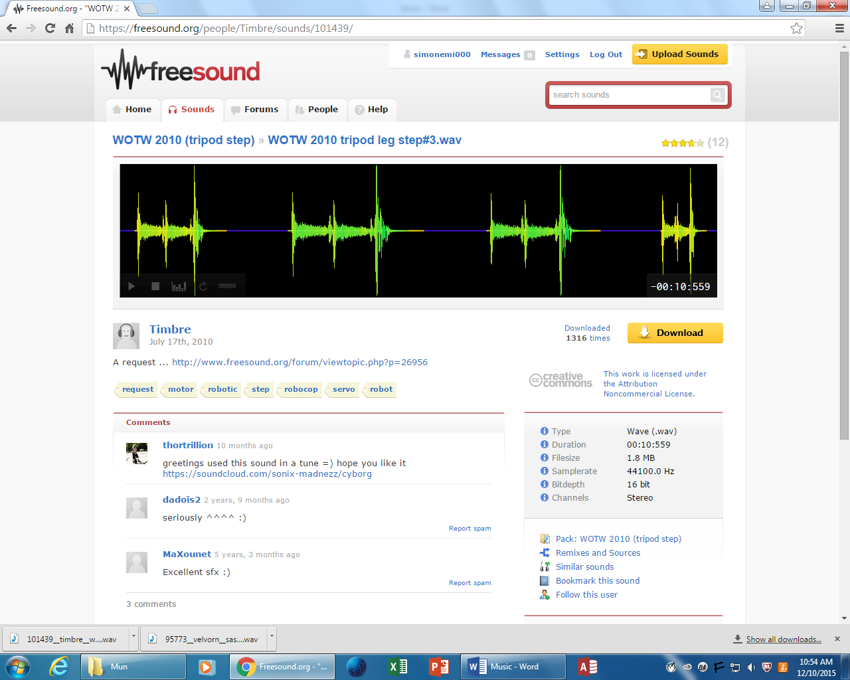

Machine Sound 1

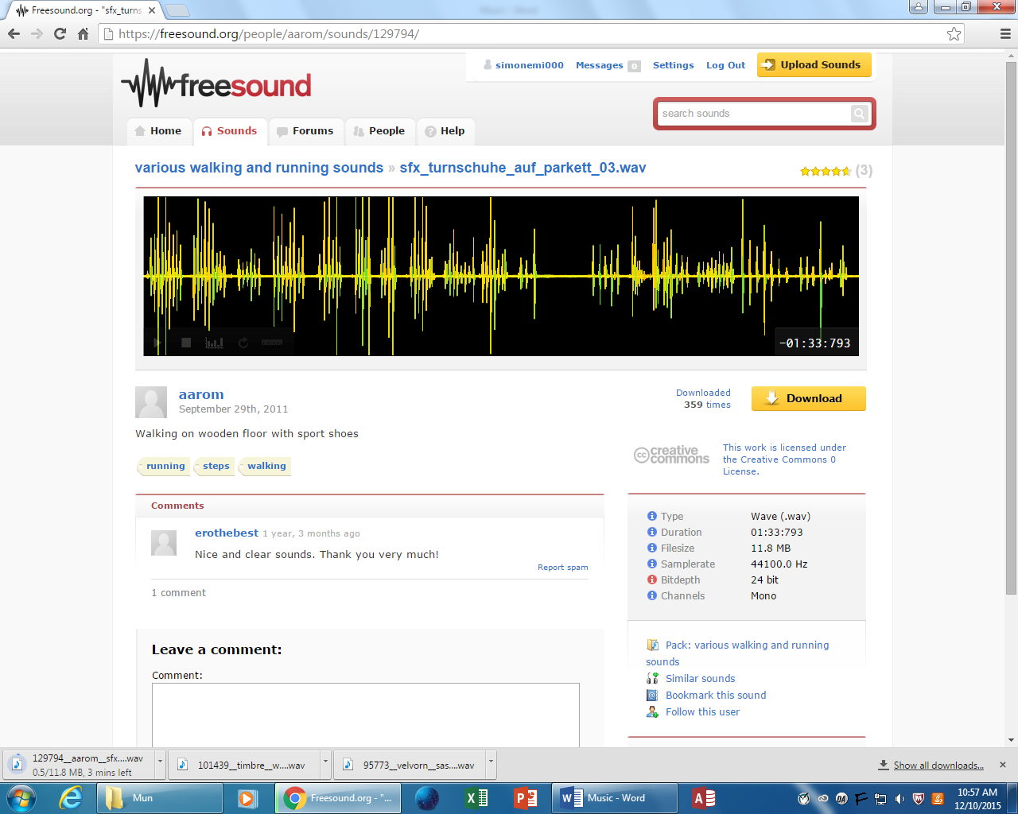

Walking

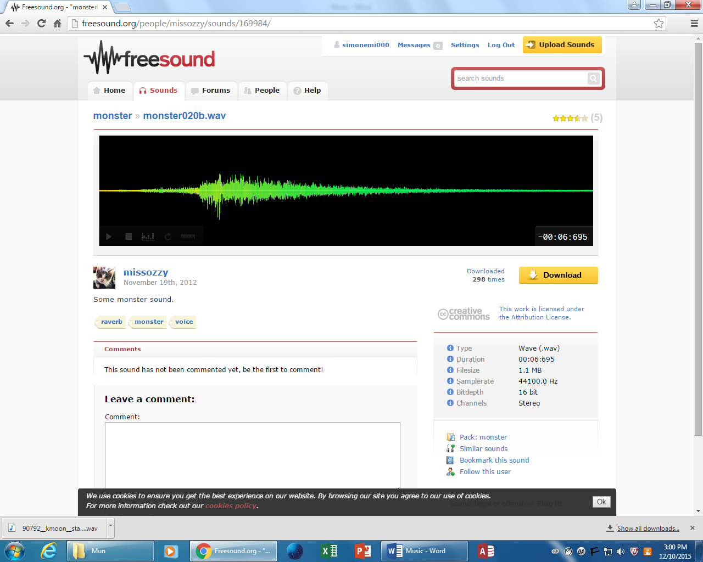

Monster 1

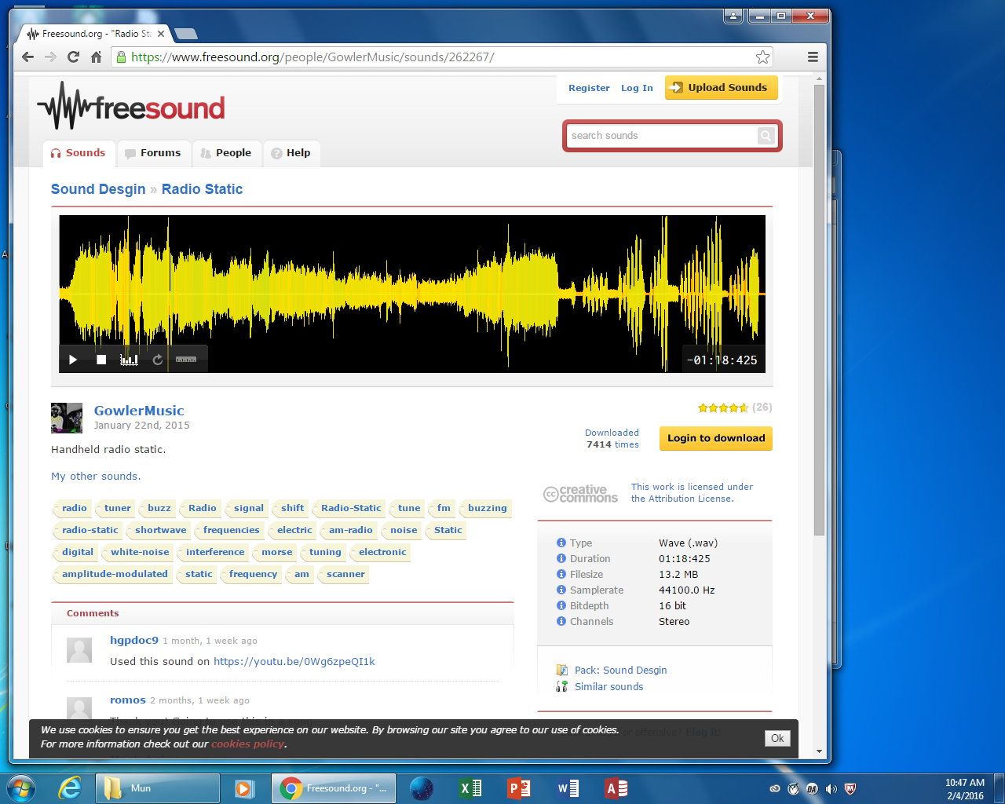

Radio Static

Elevator Running

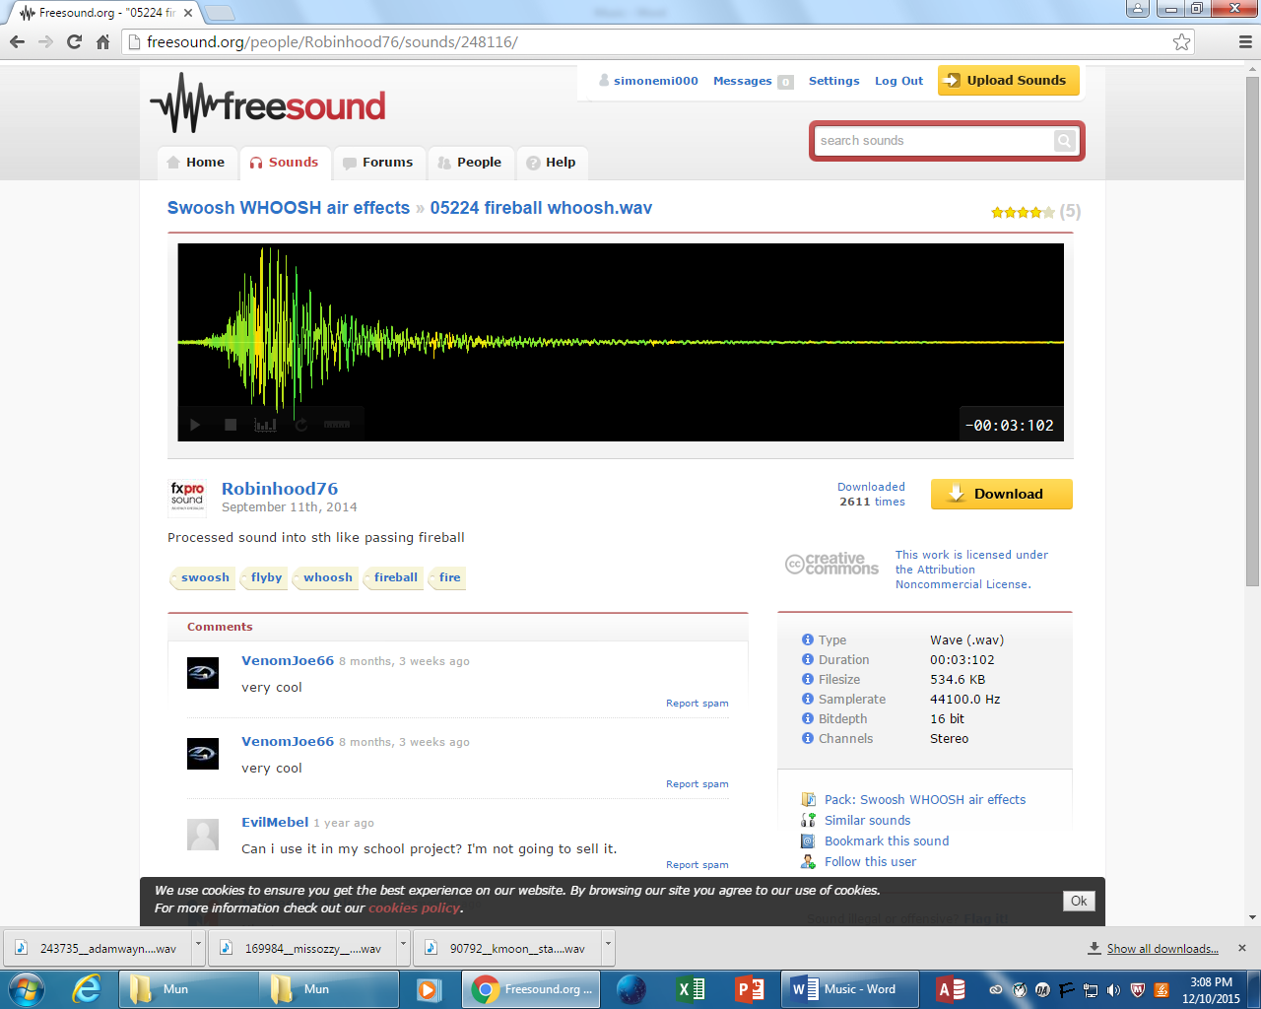

Fireball Whoosh

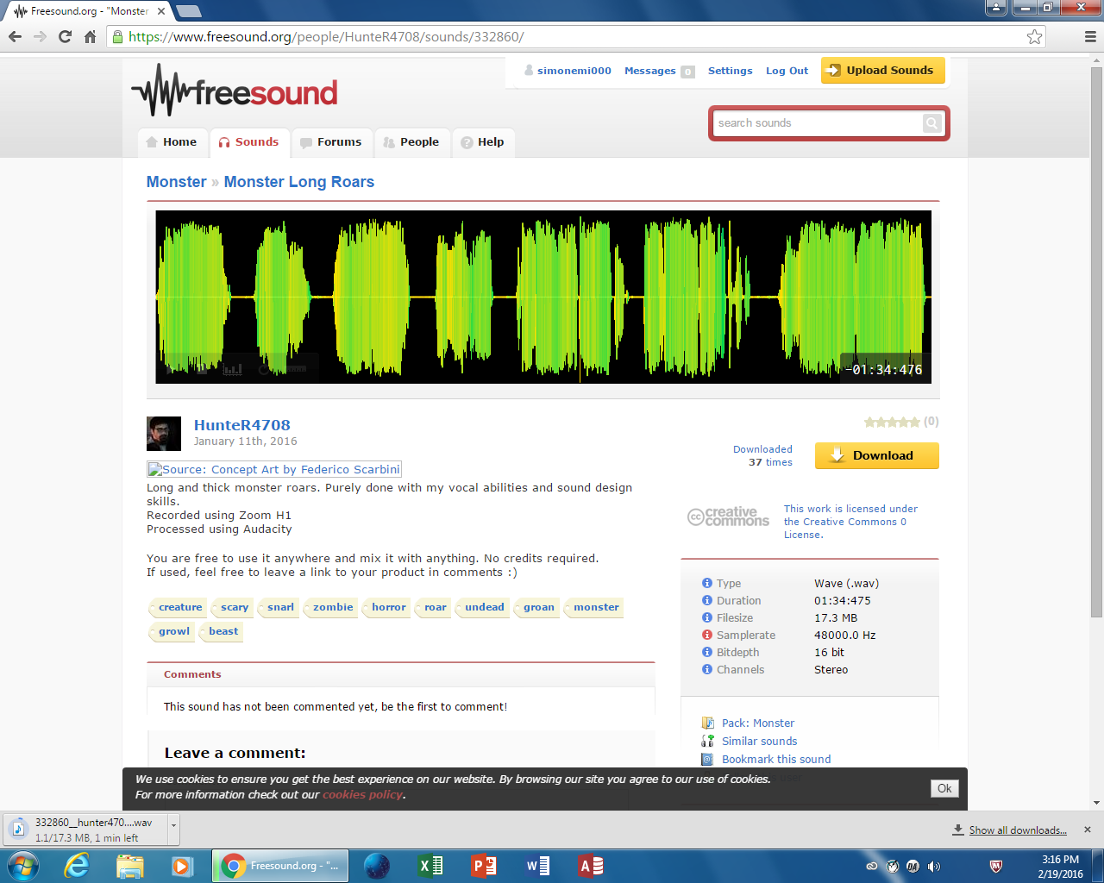

monster2

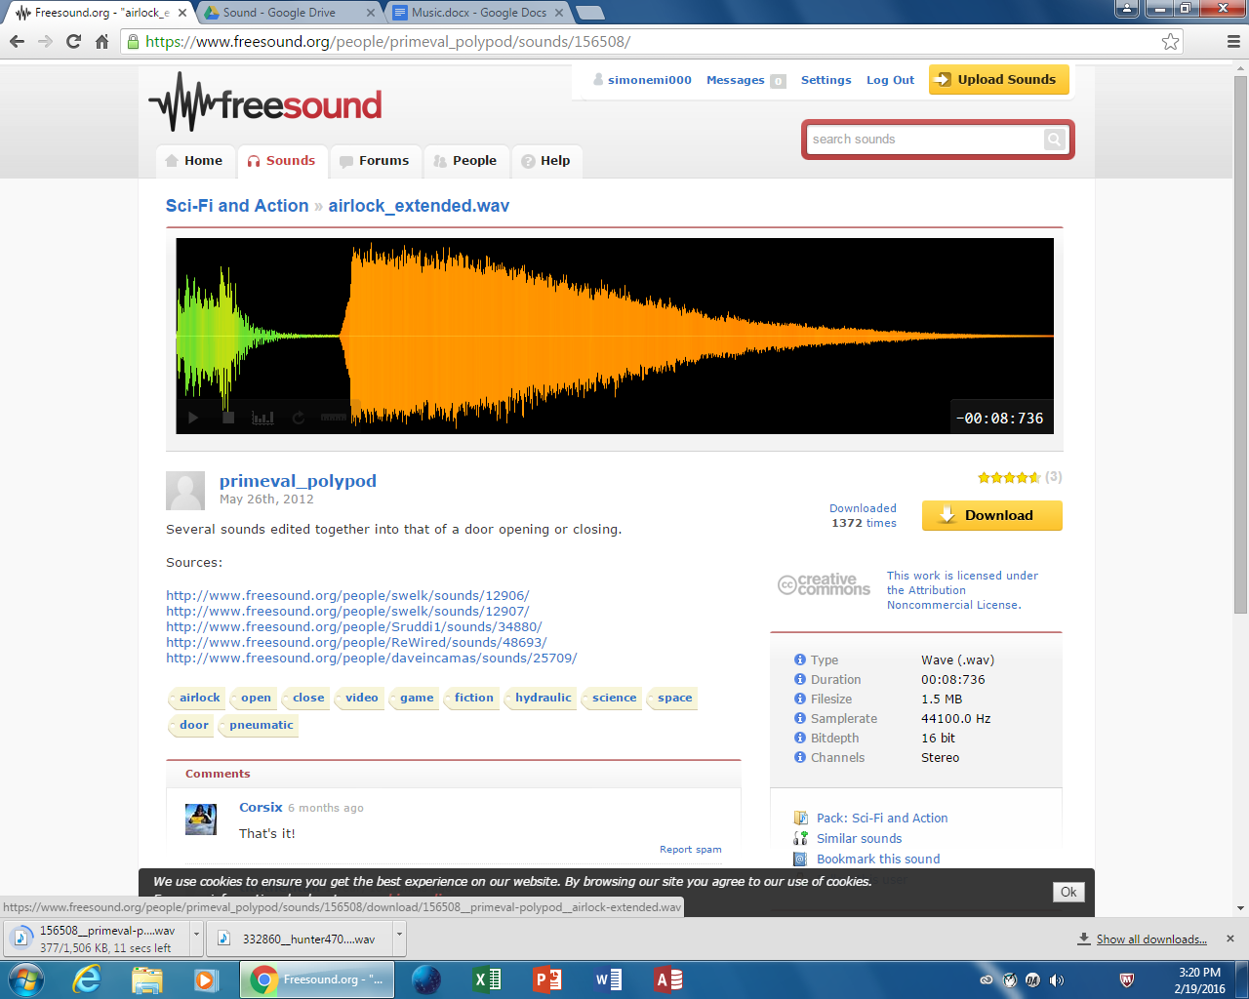

airlockOpen

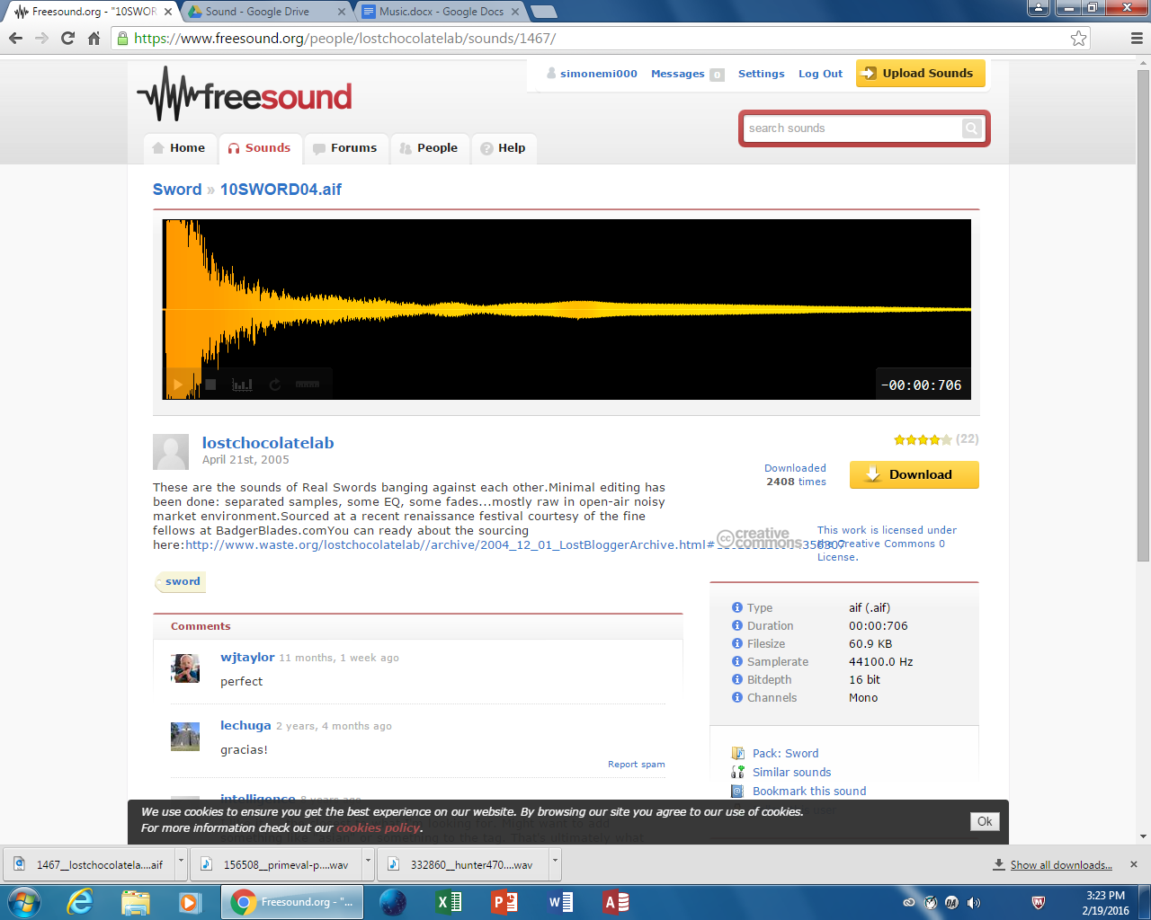

swordClang

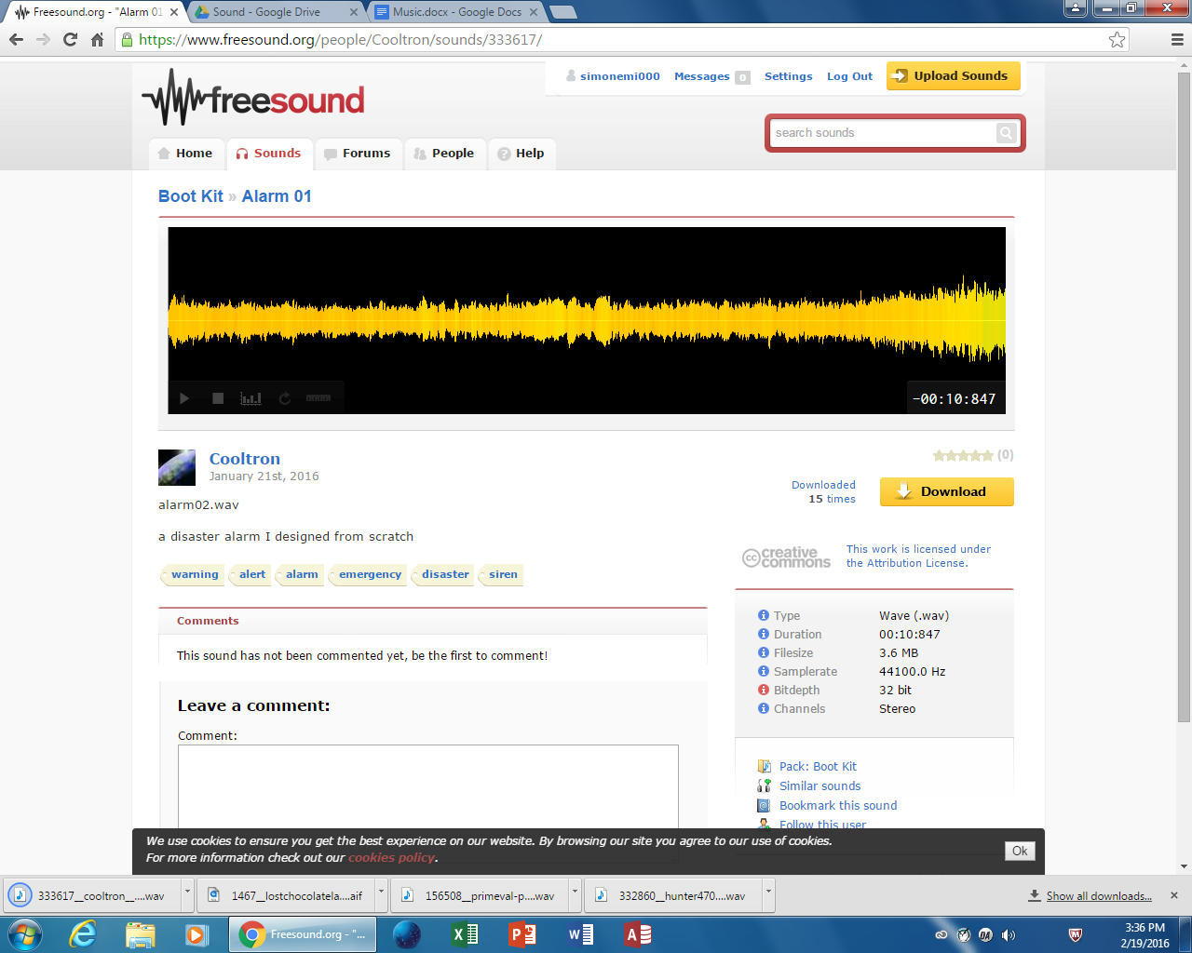

laserCharge

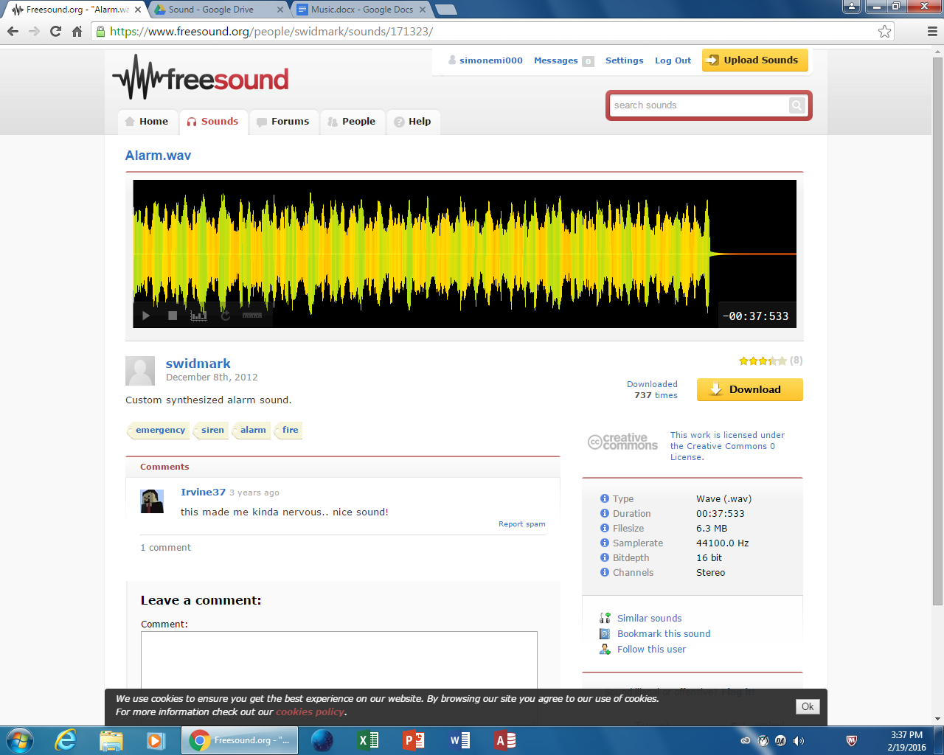

alarmSound

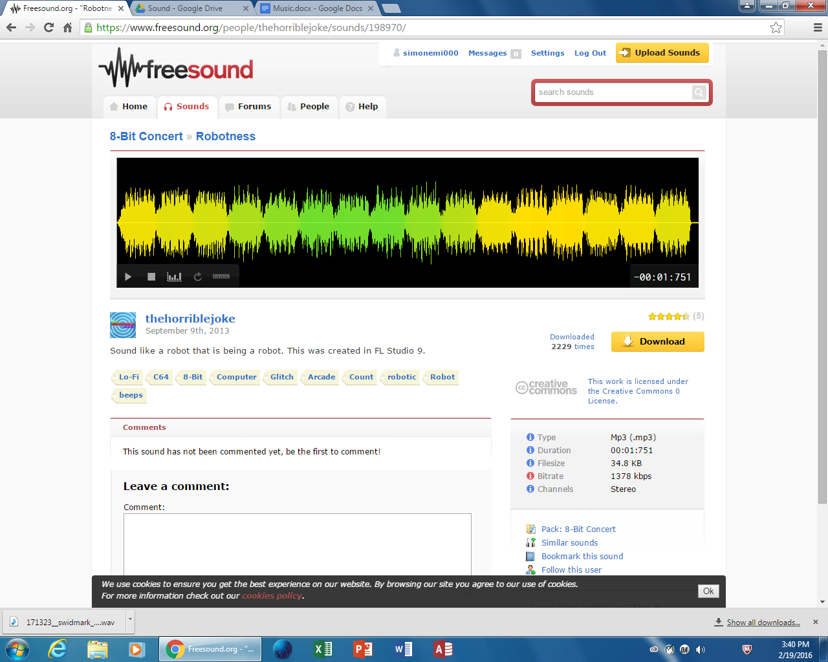

robot1

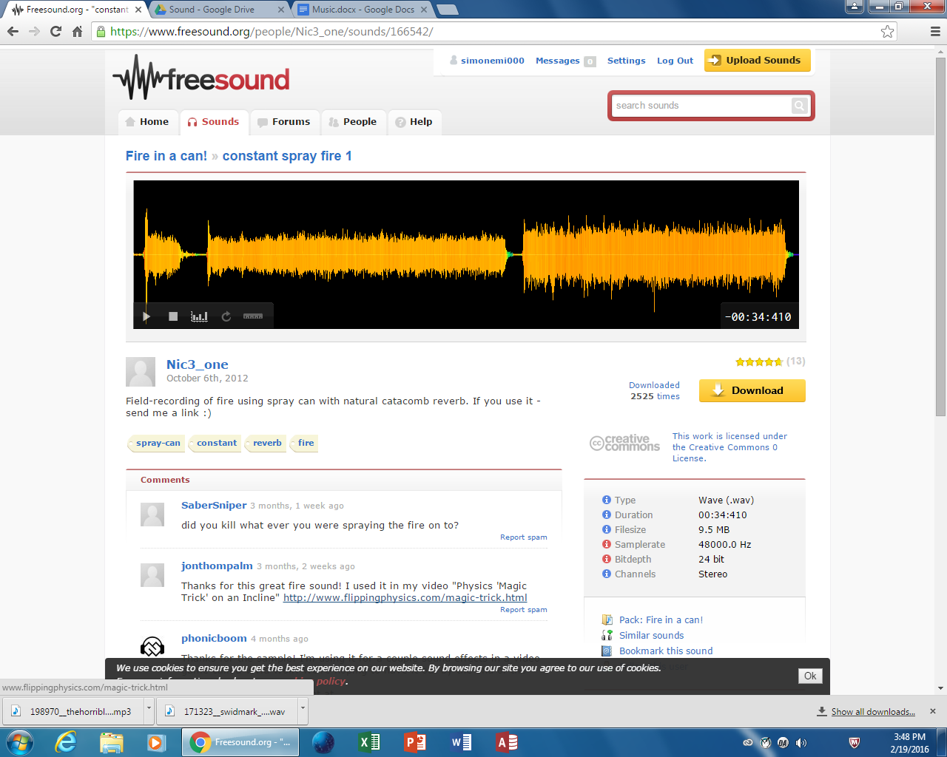

torchSound

Shotgun (make with gunshot)

Monster noises

Door opening noise

Airlock noise

Cutting noise