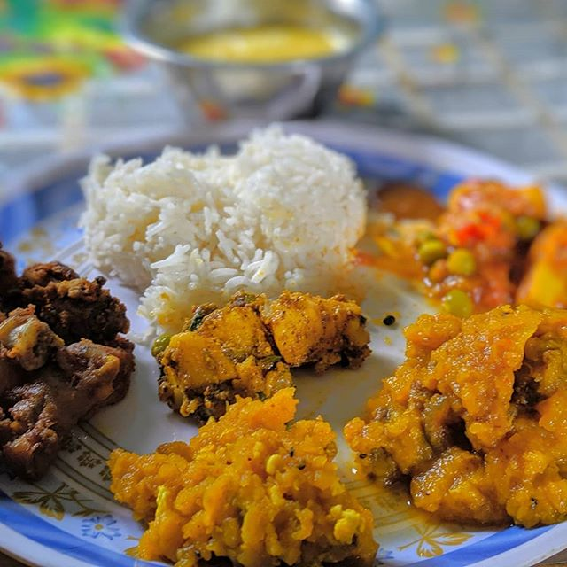

Aama ko Khaana
─ Srijana Khatiwada

Problem:
- Financial crisis due to COVID-19.
- Home-maker mothers with social insecurities who are willing to work but have no idea where and how to start working.
- People fed up having to order the same junk restaurant fast food as their main meals in their day to day life.

Ideate:
1.Humans of Bombay
2.Culture: “Ghar ko khaana”

Goals:
- Employment opportunities
- Women empowerment
- Emotional connection between the customers and company-feel like home
- Healthy service
- Solving financial crisis

User:
Working people staying away from family.

User Interviews:
On interviewing two of the users aged 20 and 22 who are currently working in the city living away from their families, following informations were found:
Problems faced in context of food:
- Quality: restaurant food gives stomach problems.
- Finance: quite expensive to eat on a regular basis.
- Feeling: they feel lonely at some point of time; miss their families.
- They miss their “ghar ko khaana”.

Some qnas:
Q : Would you like to eat “ghar ko khaana”?
A1 : Obviously, I would prefer light home food than restro food.
A2 : Definitely.
Q : How would you like the service to be?
A1,A2 : Easy, satisfactory.
Q : Would they like to order by calling(to make them feel homely) or make a regular order?
A1 : Regular would be okay.
A2 : I am kind of an introvert person so I would like to make a regular order.

Prototype:

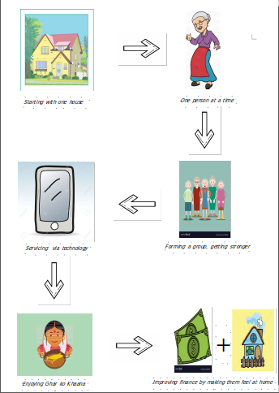

References:
1. Google images
2. Humans of Bombay

Thank You!

