

Submitted by
RISHI SONANIA
22EBKCS101

Organization Name: MTX GROUP Inc Place: Hyderabad

Training Supervisor:
Sahil Batra

Start Date- 05/01/26
End Date - 05/07/26
2026

A

INTERNSHIP TRAINING REPORT

Submitted in partial fulfillment for the Degree of

B.Tech
in
COMPUTER SCIENCE ENGINEERING

Session - 2025 - 26

DEPARTMENT OF COMPUTER SCIENCE
B.K. BIRLA INSTITUTE OF ENGINEERING &TECHNOLOGY
PILANI - 333 031 (RAJ)
(Affiliated to Bikaner Technical University, Bikaner)
ACKNOWLEDGEMENT
I would like to sincerely acknowledge the submission of my quarterly internship report to my internal mentor Mrs Suman Kanta. I am highly grateful for the continuous guidance, encouragement, and support provided throughout this internship period.
I would also like to extend my heartfelt thanks to my external mentor,Mr. Sahil Batra, for sharing valuable insights and providing direction that has greatly enhanced my understanding of real-world applications and industry practices. His mentorship has been instrumental in shaping my learning experience.
The exposure and knowledge gained during this month have significantly contributed to my technical as well as professional growth. I truly appreciate the time and effort invested by both my mentors in reviewing my progress and providing constructive feedback. This internship has been an enriching journey so far, and I look forward to continuing to learn, improve, and contribute in the coming months.

TABLE OF CONTENTS

- Acknowledgment 2
- Content 3
- Offer Letter 4
- Introduction 7
- Monthly Progression Breakdown 8
- Conclusion & Future Objectives 10

Offer Letter
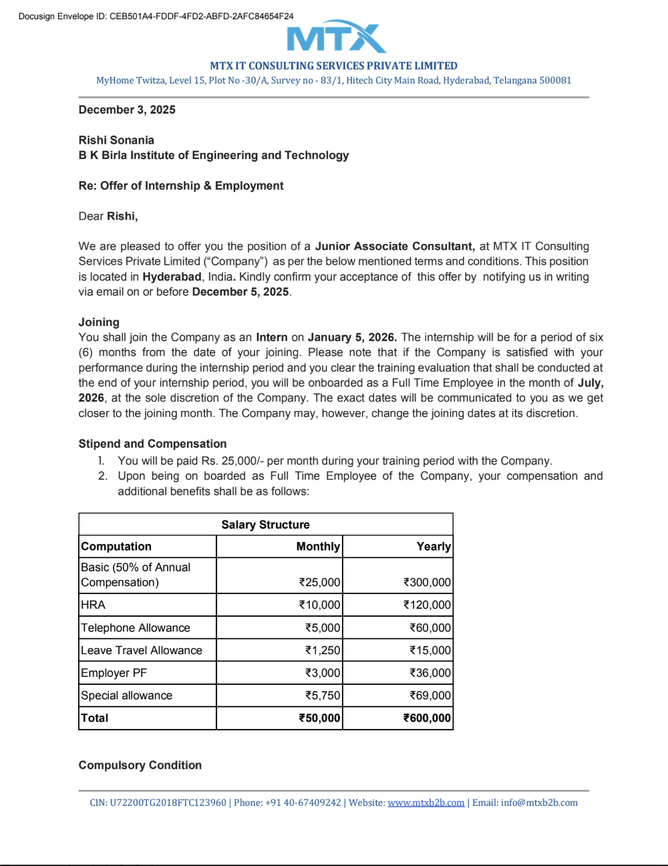
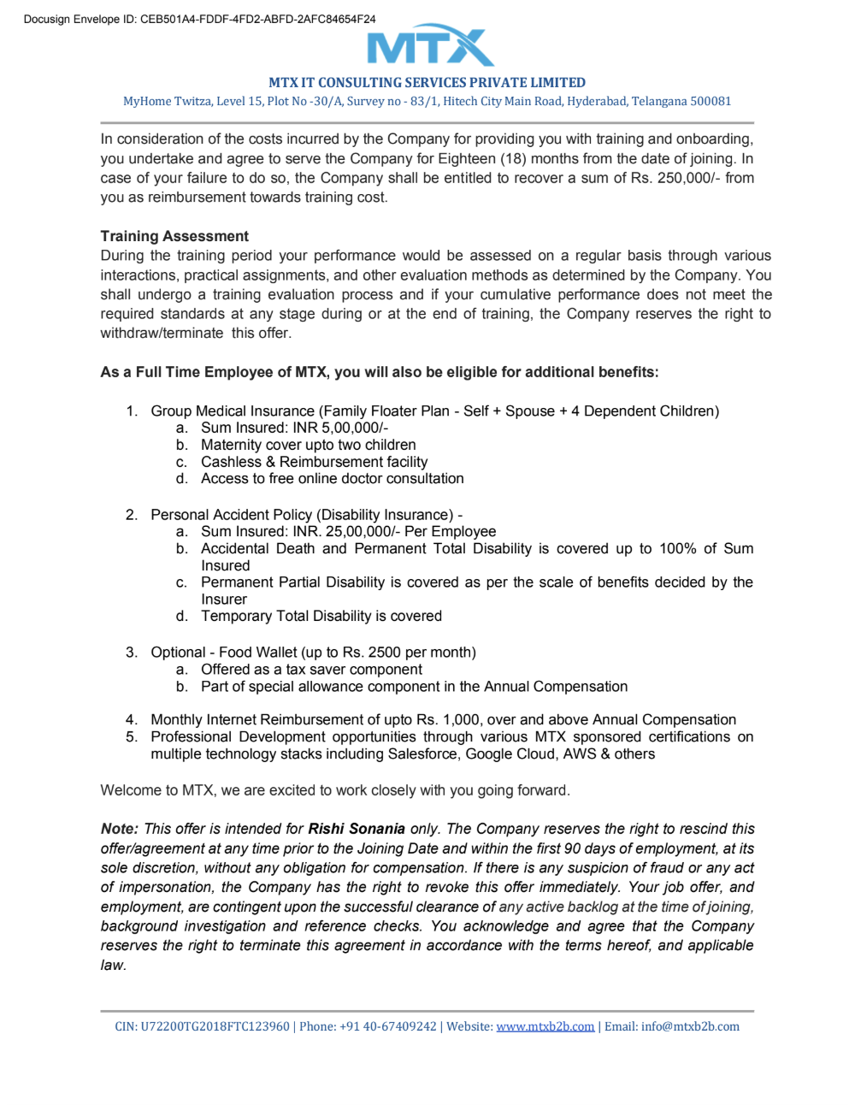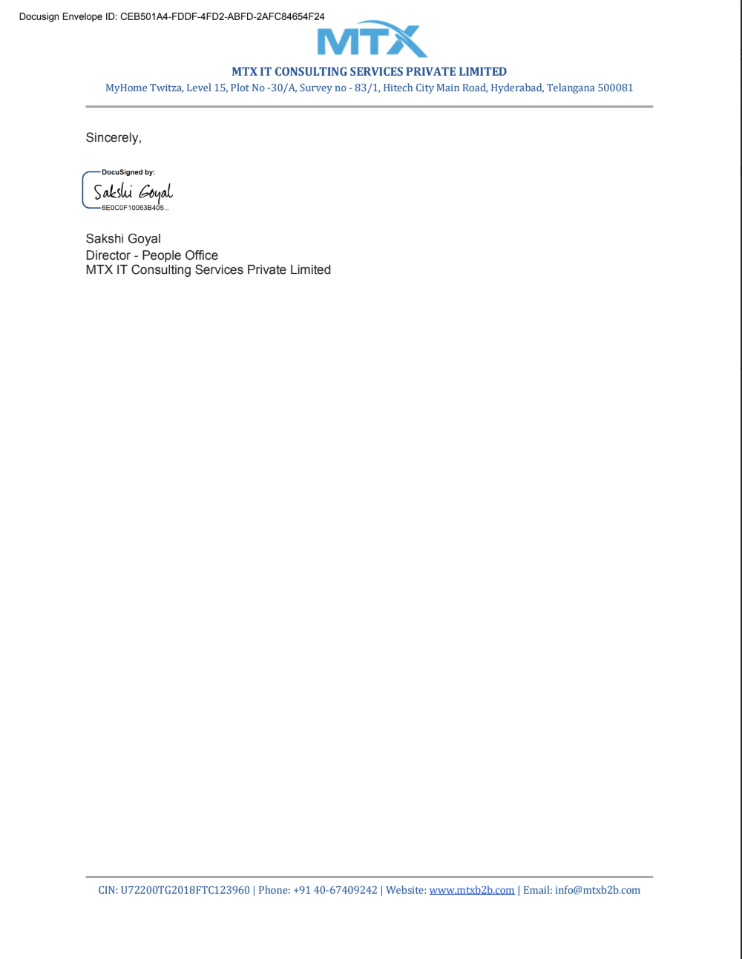

Introduction
The first quarter of my internship at MTX Group has served as a critical transition from academic learning to professional industrial application. As a Functional Consultant Trainee, I have been immersed in a multi-disciplinary environment that combines technical Salesforce configuration with the strategic thinking of Business Analysis and the precision of Quality Assurance.
The objective of this initial phase was to master the Salesforce ecosystem, understand the Software Development Lifecycle (SDLC), and learn how to deliver high-quality, user-centric solutions. This report details the structured training, hands-on tasks, and collaborative projects I undertook during the first three months of my tenure.

MONTHLY PROGRESS BREAKDOWN

MONTH 1: Salesforce Administration & Platform Architecture
- Platform Governance: Developed proficiency in Salesforce Lightning, focusing on how cloud-based CRM solutions optimize business productivity.
- Security Frameworks: Engineered data security models by configuring Profiles, Permission Sets, and Role Hierarchies; implemented Sharing Rules to enforce data confidentiality.
- Relational Data Modeling: Architected custom schemas using Master-Detail and Lookup relationships; streamlined user experience through custom Record Types and Page Layouts.
- Integrity & Automation: Managed bulk data handling using the Data Import Wizard while enforcing data quality via Validation Rules and Lightning Flows.

MONTH 2: Business Analysis (BA) & Quality Assurance
- Requirements Engineering: Focused on the functional side of consultancy, translating stakeholder needs into actionable User Stories and Acceptance Criteria.
- Agile Orchestration: Operated within the Software Development Life Cycle (SDLC) using Agile methodologies, focusing on iterative development and sprint collaboration.
- Quality Assurance (QA): Developed and executed Functional and Regression test suites; utilized bug-tracking workflows to ensure high-velocity, defect-free deployments.

MONTH 3: UI/UX Design & Solution Synthesis
- User-Centered Design: Applied UI/UX principles to create intuitive interfaces, focusing on wireframing and prototyping to drive end-user adoption.
- End-to-End Implementation: Led the functional development of an internal project (Store Inventory Management), transforming abstract requirements into a fully realized Salesforce prototype.
- Cross-Functional Leadership: Collaborated with team members to align technical configurations with business goals, bridging the gap between theory and professional delivery.

MONTH 4: Microsoft Power Platform Immersion (In Progress)
Objective: Diversifying the low-code toolkit through the Microsoft Power Suite.
- Architectural Overview: Commenced a comprehensive deep-dive into the Microsoft Power Platform ecosystem, exploring the theoretical use cases for Power Apps, Power Automate, and Power BI.
- App Conceptualization: Initiated training on Canvas and Model-Driven Apps, focusing on how to translate business logic into mobile-ready and web-based applications.
- Workflow Logic: Exploring the fundamentals of Power Automate, specifically studying how "Triggers" and "Actions" facilitate seamless cross-platform integration and task automation.
- Data-Driven Strategy: Analyzing the role of the Dataverse in storing and managing business data securely, preparing for future hands-on development and dashboard creation.

CONCLUSION & FUTURE OBJECTIVE
The initial phase of my internship at MTX Group has been a transformative experience, marking a definitive transition from an academic mindset to a Professional Consultant framework. By synthesizing Salesforce technical architecture with Business Analysis and Quality Assurance principles, I have developed a holistic understanding of the modern Software Development Life Cycle (SDLC). This period has not only built my technical competency but has also refined my ability to view software solutions through the lens of business value and user impact.

Future Objective
As I progress into the next quarter, my primary objective is mentorship-driven professional growth. Operating under the direct guidance of a Senior Functional Consultant.
Key areas of focus include:
- Enterprise-Scale Operations: Gaining granular insight into the lifecycle of large-scale enterprise projects, specifically observing how complex business requirements are translated into scalable technical solutions.
- Consultative Collaboration: Shadowing senior leadership to master the nuances of client relationship management, requirement negotiation, and strategic problem-solving.
- Live Project Integration: Moving beyond internal simulations to support live project documentation, real-time quality validation, and stakeholder communication in a high-stakes environment.
- Strategic Upskilling: Continuing my foundational training in the Microsoft Power Platform and beginning my long-term roadmap toward AI Professional Certification to enhance my capabilities as a future-ready consultant.

