**SQL PROJECT**

**COVID VACCINE REGISTRATION DATA COLLECTION AND RETREIVAL**

**TABLE FORM**

CREATE TABLE FORM(form_id int(10),form_area char(25),form_type char(25),PRIMARY KEY(form_id));

INSERT INTO FORM VALUES(100,'East','Registration');

INSERT INTO FORM VALUES(200,'West','Registration');

INSERT INTO FORM VALUES(300,'North','Registration');

INSERT INTO FORM VALUES(400,'South','Registration');

SELECT * FROM FORM;

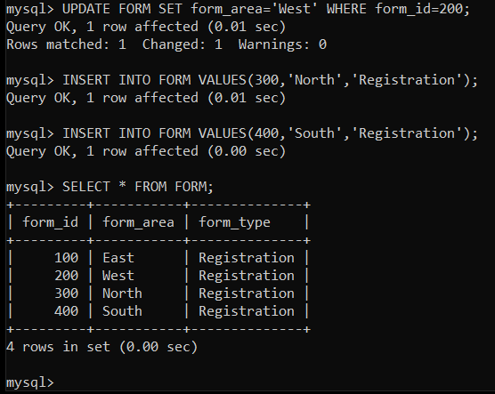

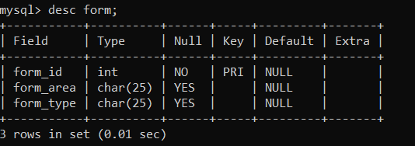

**TABLE Registration**

CREATE TABLE Registration(Name char(50),Age int(100), Gender char(20),Phone int(15),Email varchar(50),City char(50));

ALTER TABLE Registration add FOREIGN KEY(form_id) REFERENCES FORM(form_id);

INSERT INTO Registration [VALUES('Unnati',20,'F',894956100,'unnaticse3019@gmail.com','Surat',200);](mailto:VALUES('Unnati',20,'F',894956100,'unnaticse3019@gmail.com','Surat');)

INSERT INTO Registration VALUES('Kamal',30,'M',994958500,'kamal20@gmail.com','Mumbai',200);

INSERT INTO Registration [VALUES('Aditya',38,'M',7023823628,'adit65@gmail.com','Mumbai',200);](mailto:VALUES('Aditya',38,'M',7023823628,'adit65@gmail.com','Mumbai');)

INSERT INTO Registration [VALUES('Akshat',20,'M',702382303,'khannakshat7@gmail.com','Udaipur',300);](mailto:VALUES('Akshat',20,'M',702382303,'khannakshat7@gmail.com','Udaipur',100);)

INSERT INTO Registration [VALUES('Abhinav',35,'M',975382303,'abhinav37@gmail.com','Noida',300);](mailto:VALUES('Abhinav',35,'M',975382303,'abhinav37@gmail.com','Noida',300);)

INSERT INTO Registration [VALUES('Kajol',21,'F',702489756,'kajol201@gmail.com','Surat',200);](mailto:VALUES('Kajol',21,'F',702489756,'kajol201@gmail.com','Surat',400);)

INSERT INTO Registration [VALUES('Aanchal',25,'F',635687945,'anchal1@gmail.com','Siliguri',100);](mailto:VALUES('Aanchal',25,'F',635687945,'anchal1@gmail.com','Siliguri',100);)

INSERT INTO Registration [VALUES('Ritik',45,'M',987564245,'ritik50@gmail.com','Mizoram',100);](mailto:VALUES('Ritik',45,'M',987564245,'ritik50@gmail.com','Mizoram',100);)

INSERT INTO Registration [VALUES('Hussain',21,'M',879654123,'hussain80@gmail.com','Chennai',400);](mailto:VALUES('Hussain',21,'M',879654123,'hussain80@gmail.com','Chennai',400);)

INSERT INTO Registration VALUES('Kritika',65,'F',998756423,'kritika1@gmail.com','Hyderabad',400);

select* from Registration;

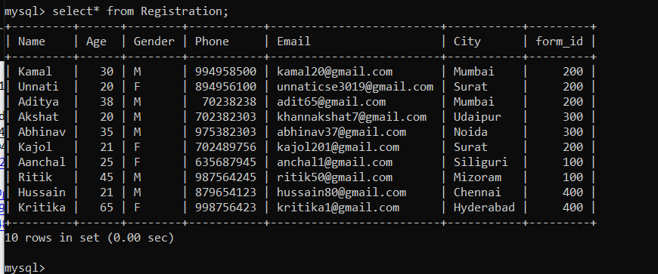

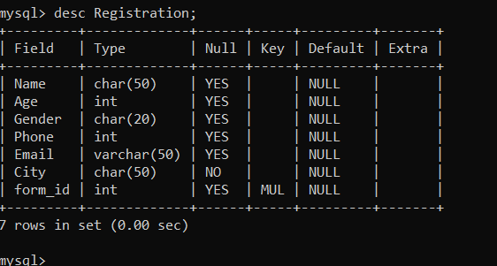

**TABLE Search_city**

CREATE TABLE Search_City(City char(50),form_area char(20));

INSERT INTO Search_city VALUES('Surat','West');

INSERT INTO Search_city VALUES('Mumbai','West');

INSERT INTO Search_city VALUES('Udaipur','North');

INSERT INTO Search_city VALUES('Siliguri','East');

INSERT INTO Search_city VALUES('Noida','North');

INSERT INTO Search_city VALUES('Chennai','South');

INSERT INTO Search_city VALUES('Hyderabad','South');

select*from Search_city;

