Agentic Cloud Cluster
A Go Distributed Cluster Managing Framework with PPO-based Scheduling

A Project Report

Submitted by
Sarthak Siddhpura

Enrollment Number: AU2240041

in partial fulfillment for the award of the degree
BACHELOR OF TECHNOLOGY

in
Computer Science and Engineering

Internal Faculty Mentor

Professor Sanjay Chaudhary



School of Engineering and Applied Science (SEAS) Ahmedabad University
Ahmedabad, Gujarat May, 2026

© Sarthak Siddhpura; 2026
All Rights Reserved

DECLARATION

I hereby declare that the project entitled “Agentic Cloud Cluster: A Go Dis-tributed Cluster Managing Framework with PPO-based Scheduling” submitted for the B. Tech. degree is my original work and the project has not formed the basis for the award of any other degree, diploma, fellowship, or any other similar title.

Signature of Student

Date:

Place: Ahmedabad

CERTIFICATE

This is to certify that the project titled “Agentic Cloud Cluster: A Go Distributed Cluster Managing Framework with PPO-based Scheduling” is the bona fide work carried out by Sarthak Siddhpura, Enrollment Number AU2240041, a student of B. Tech. in Computer Science and Engineering at the School of Engineering and Applied Science, Ahmedabad University, during the academic year 2025–2026, in partial fulfillment of the requirements for the award of the degree of Bachelor of Technology.

This project was done under the supervision of the faculty mentor Professor Sanjay Chaudhary.

Signature of Faculty Mentor

Date:

Place: Ahmedabad

Abstract

Agentic Cloud Cluster is a Go-based distributed task execution and scheduling frame-work. The system operates a master node, multiple worker nodes, execution of tasks based on Docker, persistent task state, worker heartbeats, task retries, and a scheduler interface, capable of switching between baseline and learned policies. What is most valuable about this project is that the cluster is not only running tasks but the scheduling is a learning problem. The framework combines a Proximal Policy Optimization (PPO) scheduler that is trained on cluster traces and deployed on top of a safe Go scheduler boundary.
The report elaborates on the project as it is on the ground. It initially drives the need to schedule distributed clusters and then justifies why reinforcement learning is appropriate in situations where it is optimal to modify resource state based on factors like scheduling. The methodology follows a sequence of steps beginning with tabular Q-learning, and then to Deep Q-Networks and finally to PPO. The PPO policy monitors task requirements and features of worker resources, selects a worker, obtains a shaped reward, and improves using clipped policy-gradient updates. Its implementation is based on Go in the master-worker control plane, and Python/PyTorch in the PPO service.
The last system was tested by using offline trace replay and end-to-end cluster campaigns. The convergence point of the PPO training curve is through the reduction in the policy and value losses, whereas the benchmark plots compare PPO to the baseline schedulers in terms of resource and workload patterns. The findings indicate that the acquired scheduler is most effective when it is necessary to schedule pressure (such as burst and overload situations) and simple baselines can still be competitive in cases of low load. This renders the project a viable exploration of the areas in which reinforcement learning assists in systems work and where conservative fallback design is still required.

Acknowledgements

I am simply thankful to my internal faculty mentor, Professor Sanjay Chaudhary, in terms of invaluable guidance, continuous encouragement, and valuable feedback during the development of this project. His experience and assistance played a significant role in determining the technical course of action and in the successful execution of this piece of work.

I would also like to thank the School of Engineering and Applied Science (SEAS), Ahmedabad University, to have provided me with the academic environment and resources that were required in this research.

I am immensely thankful to my family who has been unwaveringly supportive, patient, and believed in my efforts. They have been my strength and my main source of strength all through my academic life.

Lastly, I would like to appreciate my friends and colleagues on their critical suggestions, technical discussions and refinement comments, which were of much help to the overall ideation and improvement of this project.

Table of Contents

Declaration i
Certificate ii
Abstract iii
Acknowledgements iv
Table of Contents v
List of Figures viii
List of Tables ix
Gantt Chart x
- Introduction 1
  - Project Definition 1
  - Motivation 2
  - Project Objectives 2
  - Scope 2
  - Main Contributions 3
- Literature Survey 4
  - Related Work 4
    - Distributed Task Scheduling 4
    - Reinforcement Learning to Scheduling 4
    - Q-Learning and Q-Tables 4
    - Deep Q-Networks 5
    - Proximal Policy Optimization 5
    - Cluster Trace-Driven Evaluation 6
    - Modern Industry Standards and AI-Driven Trends 6
  - Tools and Technologies 6

Agentic Cloud Cluster
    - Docker-based Execution 6
    - Go for Cluster Control Plane 7
    - gRPC and Protocol Buffers 7
    - Persistence Layer 7
- Methodology 8
  - System Design 8
    - High-Level Architecture 8
    - Go Distributed Cluster Architecture 9
    - Master Node 9
    - Worker Node 10
    - Control Flow in the Go Cluster 11
    - Resource Accounting 11
    - Task Lifecycle 11
    - Task Execution Flow 12
    - Scheduler Interface 12
    - PPO Deployment Design 12
  - Why Reinforcement Learning for Scheduling 13
  - Starting Point: Q-Tables 13
  - Next Step: Deep Q-Networks 14
  - Final Choice: PPO 14
  - PPO Architecture 15
  - Actor and Critic Network 15
  - State Representation 18
  - Action Space and Masking 19
  - Reward Function 19
  - Training Data 20
  - Training Pipeline 21
  - Implementation in the Cluster 21
- Results 24
  - Project Outcomes 24
    - Evaluation Setup 24
    - Training Convergence 25
  - Results of the Offline PPO Model 27
    - Multi-Run Comparison 28
    - Cumulative Completion 29
    - WebUI Operational Visuals 29
    - Latest Campaign Summary 31
    - Pressure Scenarios 32
    - Important Engineering Decisions and Results 33
    - Delivered Components 33
  - My Contribution to the Project 34
  - Learning Outcomes 34
  - Real World Applications 34
- Conclusion 36
  - Future Work 36
Bibliography 37
Appendix 40
- Repository Modules 40
- Representative PPO Configuration 40
- Ports and Service Mapping 41

List of Figures
0.0.1 Project timeline x
3.1.1 Overall architecture of Agentic Cloud Cluster 8
3.6.1 PPO scheduler architecture 15
3.7.1 Actor-critic data flow and PPO learning feedback loop 16
    - PPO scheduling flow inside the Go cluster with failover and requeue 22
    - PPO training reward curve 25
    - PPO policy loss and entropy 26
    - Multi-run scheduler comparison 28
    - Cumulative number of tasks completed over time. 29
    - WebUI dashboard screen whilst running the campaign. 30
    - WebUI trend plot of scheduler performance monitoring. 31

List of Tables

    - Master node modules 10
    - PPO deployment modes 12
    - Task feature vector 18
    - Worker feature vector 18
    - Reward term computation 20

    - Schedulers compared 24
    - Comparison of offline schedulers on trace replay 27
    - New-model campaign scheduler summary 31
    - New PPO improvement over baselines 32
    - Burst scenario interpretation 33
    - Key project decisions and outcomes 33

  - Main repository modules used in the project 40
  - Representative PPO training configuration 40
  - Ports used by the project 41

Gantt Chart

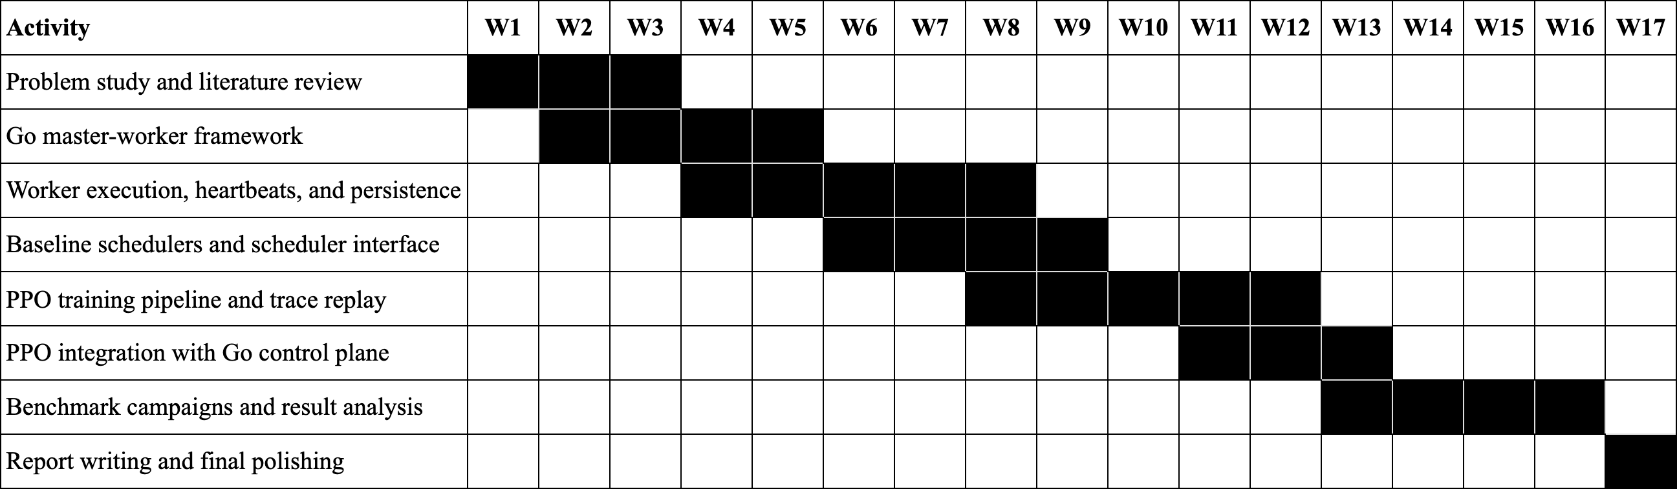

Figure 0.0.1: Project timeline

The timeline now spans 17 weeks. The early weeks established the distributed cluster baseline, the middle weeks focused on PPO training and integration, and week 17 was reserved exclusively for documentation and polishing.

Chapter 1 Introduction
In modern computing workloads, it is seldom the case that a single machine is used to execute the workload. An effective system should be able to take in numerous tasks, comprehend what resources each task requires, pick an appropriate worker, execute the task reliably, and store the outcome. This is even more difficult when there is heterogeneity among workers. A single worker can have a larger CPU, another worker can have a larger memory, and the most optimal choice can change every few seconds as work is started and finished.
The project designed in this work is named as Agentic Cloud Cluster. It is a distributed cluster of Go-based management that schedules Docker-based jobs on worker nodes. The cluster framework and the PPO-based scheduler are the center of attention in the project. The other utilities around are considered as mere auxiliary aspects of the system.

| Project Definition
The project can be defined as follows:

To create a distributed task execution system in Go, and enhance task place-ment decisions with reinforcement learning schedule based on Proximal Policy Optimization.

At its core, the system has one master node and several worker nodes. The master is responsible for receiving tasks, keeping an eye on the workers, saving the progress of each task, and asking the scheduler which worker should handle the next job. Each worker runs its assigned task inside a Docker container and then reports back to the master with the outcome. Because the scheduler sits behind a clean interface, it can be swapped or upgraded without touching the worker execution code.

  - | Motivation
The simplest rule is the first scheduling solution most systems employ. Round-Robin is simple to conceptualize: dispatch one job to worker 1, the next to worker 2, etc. This comes in handy as a benchmark but does not take into consideration whether the worker has sufficient resources, whether it is already busy, and whether the work is bound to miss its deadline.
This can be enhanced by heuristic schedulers that include rules. An illustrative example is that a scheduler can give preference to the worker with the most available CPU or the least estimated risk. Nonetheless, it is hard to tune the fixed rules as the correct trade-off depends on the type of workload. A memory-heavy task, a burst of short tasks, and a CPU-intensive task, do not require the same decision rule.
This is what led us to explore reinforcement learning. In reinforcement learning, an agent tries different actions and learns from the feedback it gets back [1]. When this idea is applied to cluster scheduling, the state is the current snapshot of the cluster, the action is the worker that gets picked, and the reward reflects how good that placement turned out to be. This fits scheduling naturally, because every time a task is placed on a worker, the cluster state changes as a result.

| Project Objectives
The project had the following objectives:

    - Create a working Go master-worker cluster that is capable of executing Docker-based tasks.
    - Worker registration, heartbeat, resource tracking, task lifecycle, and result storage.
    - Have a clean scheduling boundary, such that the various scheduling algorithms can be compared.
    - Introduce baseline scheduling and PPO-based scheduling.
    - Train PPO with realistic cluster traces and a reward function consistent with feasibility, queue pressure, tail pressure, and load balance.
    - Test the system using repeatable campaigns and communicate the findings in a candid manner.

  - | Scope
The distributed cluster and PPO scheduler is the core scope. The report deliberately avoids one-sided attention to the auxiliary interfaces or monitoring tools. They can be present in the form of supporting utilities in the repository, but the technical contribution is the Go control plane, worker execution layer, and reinforcement learning scheduler.

| Main Contributions
The main contributions are:

- A Go-based distributed task execution system with master nodes and worker nodes.
- A scheduler interface, which allows simple baselines and PPO scheduling.
- A PPO service that accepts scheduling requests via gRPC and gives a worker decision.
- A trace replay training environment using lifecycle based resource accounting.
- Reward design penalizing infeasible placement, queue pressure, tail pressure, and imbalance.
- A benchmark environment to compare scheduling behavior to load patterns.

Chapter 2 Literature Survey

| Related Work

| Distributed Task Scheduling
Distributed systems divide work among several machines. The scheduler in a cluster chooses the location where every task is to be executed. The implications of this decision are on completion time, resource utilization, fairness, and recovery after failure. A scheduler also has to respond to the imperfect information, since the state of the workers is changing as the tasks are being submitted.

| Reinforcement Learning to Scheduling
Reinforcement learning is the study of how an agent may learn to make decisions by acting on an environment and receiving feedback signals of reinforcement of its actions onto an environment [1]. A typical RL configuration has:

      - State: what the agent can see.
      - Action: what the agent has a choice of.
      - Reward: feedback post action.
      - Policy: the rule or model upon which actions are chosen.

In this project, the mapping is straightforward. The task and workers that are present are the state. The action is the selected worker. The reward is a quality of placement. Scheduler is the policy.

| Q-Learning and Q-Tables
Q-learning is an example of a classic reinforcement learning algorithm proposed by Watkins and Dayan [2]. It learns a value, referred to as the Q(s, a) value meaning the expected

long-term reward of taking action a in state s [2]. These values can be stored in a table in a small environment.
The main strength of a Q-table is its simplicity. When the number of states and actions is small, every state-action pair can fit neatly into a single table. However, cluster scheduling does not have a small state space. Factors such as CPU, memory, storage, task type, queue depth, how many workers are free, and how busy each worker is can combine to produce a very large number of distinct states. Storing all of them would make the table impractically huge, and rounding the values into coarse bins would throw away details that matter for good scheduling.

| Deep Q-Networks
Deep Q-Networks (DQN) are the replacement of Q-table with a neural network [3]. Mnih et al. demonstrated that deep neural networks can approximate action-value functions when the inputs are of high dimension size [3]. This addresses the storage issue of Q-tables since the model generalizes the similar states.
DQN is a natural next step after Q-tables, but it is still not ideal for this project. DQN estimates a value for each discrete action. In cluster scheduling, the number of candidate workers can change, workers can become infeasible, and invalid actions must be masked. DQN can be adapted, but the implementation becomes less natural when the action set is dynamic and the objective is to improve a stochastic placement policy.

| Proximal Policy Optimization
Proximal Policy Optimization (PPO) is a policy-gradient algorithm proposed by Schulman et al. [4]. Instead of only learning a Q-value, PPO directly learns a policy that maps states to action probabilities. It also learns a value function to estimate future return. The key idea in PPO is to avoid changing the policy too aggressively by using a clipped objective [4].
A recent algorithm-level survey for cloud job scheduling and resource management identifies PPO as a strong and practical DRL choice for this domain [5]. In line with that evidence, PPO was selected because it fits the scheduling problem better than a Q-table or plain DQN:

      - It directly learns a worker-selection policy.
      - It has the ability to make use of action masks in order to shun infeasible workers.
      - It allows stable updates, using clipping.
      - It is designed to co-exist with continuous states attributes like resource ratios.
      - It enables offline training and optional online adaptation.

| Cluster Trace-Driven Evaluation
The scheduler can be rendered unrealistic by training him only on random synthetic tasks. The Alibaba cluster trace trace is a production cluster workload data that has been published to cluster management research [6]. In this project, Alibaba trace replay was used to subject the PPO scheduler to realistic patterns of task resource utilization and arrival characteristics.

| Modern Industry Standards and AI-Driven Trends
Within the present-day technological context, Kubernetes (K8s) has become the industry standard in terms of container orchestration [7].Google had a massively strong influence on Kubernetes; Borg, the default cluster manager at Google, was the inspiration, and the default scheduler heavily relies on heuristics: first, it filters to find viable nodes; second, it scores the nodes based on the availability of resources and affinity rules.
Besides general-purpose orchestration, there are specialized projects such as Volcano
[8] and Apache Yunikorn [9] that have been created to support high-performance batch workloads and AI/ML training jobs on Kubernetes. These systems bring in advanced queuing and gang scheduling which are essential in the distributed training.
The emergence of both Ray [10] and Dask has also shifted the focus onto task-parallel computing, in this case, to Python-centric AI workloads. These frameworks offer top-down application-level scheduling, in contrast to Kubernetes which is often viewed as a bottom-up infrastructure manager.
Most recent developments in the field of AIOps and autonomous infrastructure are focused on the shift towards systems that are Agentic and autonomous in nature. In such systems, autonomous agents utilize machine learning-often based on variants of Reinforcement Learning such as PPO [4] or Soft Actor-Critic (SAC) [11]-to perform proactive failure recovery, dynamic auto-scaling and predictive load balancing. This project will be in line with these trends by having a custom Go-based framework that will incorporate a PPO agent straight into the scheduling loop, rather than having a centralized set of heuristics.

| Tools and Technologies

| Docker-based Execution
Container-based execution is a viable approach to portability of tasks. Docker takes an application and its dependencies and packages them into a container image, which can then be run by the worker node in an environment that is repeatable [12]. In this project, the worker node involves Docker as the boundary of execution and the master node stays in charge of making decisions regarding placement.

| Go for Cluster Control Plane
Go was chosen as the master-worker model as it is highly compatible with networked systems. It has built-in goroutines and channels are supported with concurrency, a large standard library, and performance compiled executables. According to the official documentation of Go, the language is an open-source project aimed at making a programmer more productive [13]. Go is used in the master server, worker server, task handling, scheduler interface and worker communication logic in this project.

| gRPC and Protocol Buffers
gRPC is used by the master and a worker. gRPC is a high-performance Remote Procedure Call framework which uses Protocol Buffers as service definitions and structured messages [14]. This renders it viable to the project since the master requires strictly defined calls like registering workers, assigning them tasks, heartbeat reporting, log streaming, and PPO worker selection.

| Persistence Layer
The implementation of task execution systems must be persistent since a task has a lifecycle: created, queued, assigned, running, completed, failed, or retried. The state of tasks, worker metadata, results, and scheduler model records were stored using MongoDB. MongoDB is document-based (records) that are represented by field-value pairs [15], which is useful in the case of task and worker objects, which may change during development.

Chapter 3 Methodology

| System Design

| High-Level Architecture

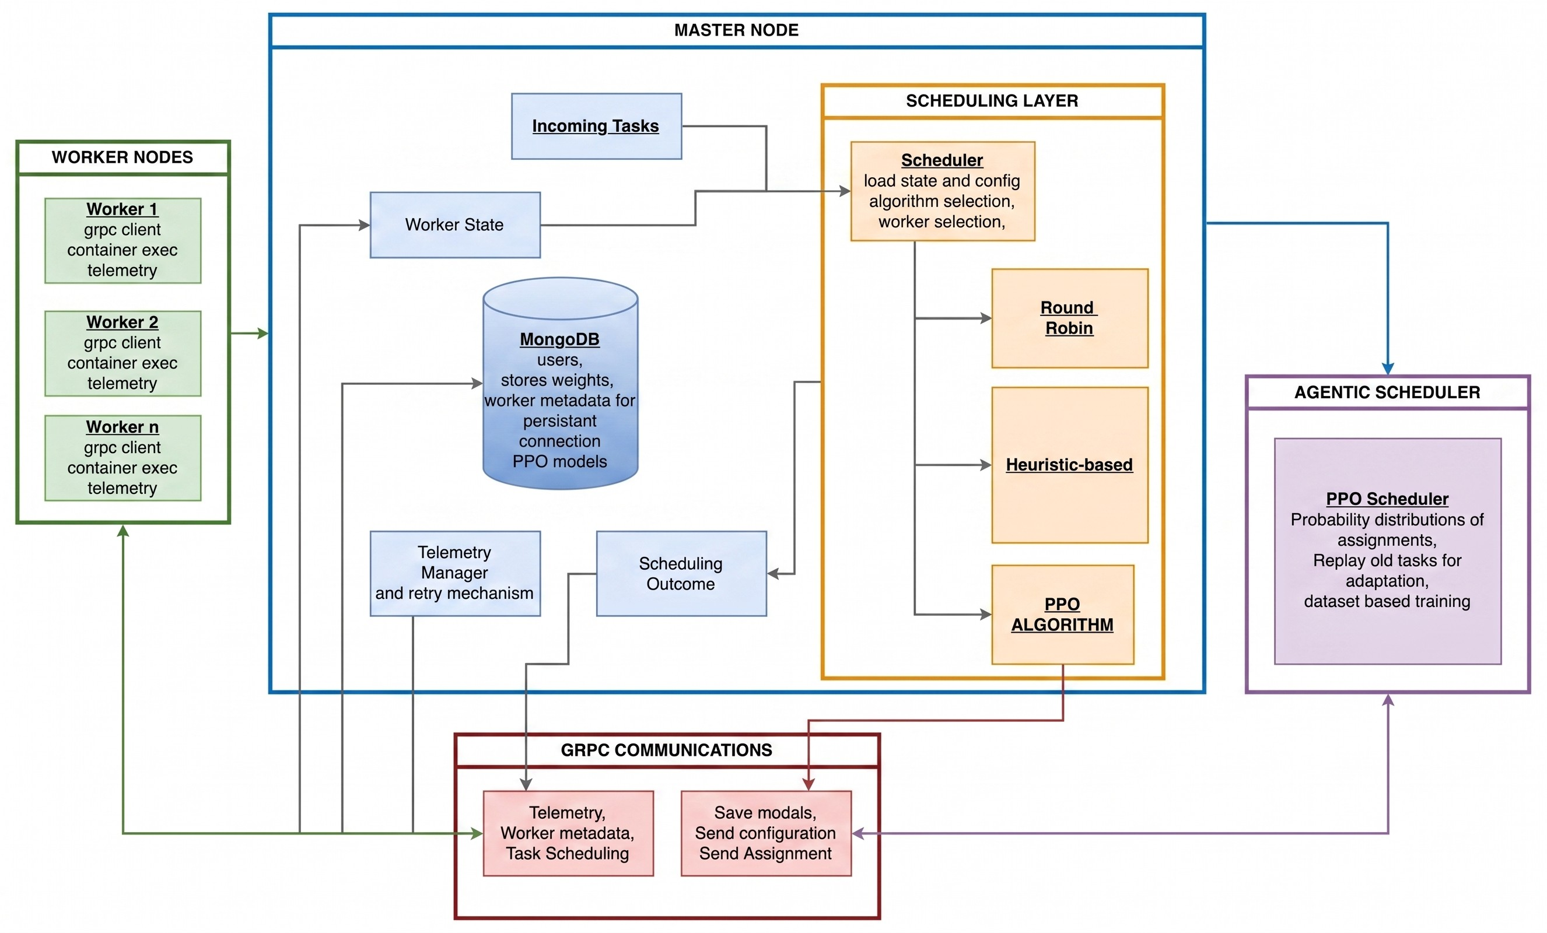
Figure 3.1.1: Overall architecture of Agentic Cloud Cluster

Description of Figure 1, the overall architecture: The system follows a master-worker layout. When a task comes in, the master node saves its details, keeps track of which workers are available, and asks the scheduler to choose one. The worker nodes then run the Docker containers they are given and send the results back to the master. Because the PPO scheduler runs as a separate Python service, the main Go control plane can stay stable on its own while the learning model is updated or retrained without affecting the

rest of the system.

| Go Distributed Cluster Architecture
The distributed cluster is achieved by a control plane in Go. Its design is based on a simple rule: the master decides to coordinate and the workers perform the work. This maintains the system easy to reason about. It is not necessary that a worker should know about other workers. It simply has to accept assignments of the master, execute the container and report health and task status.
At runtime, the cluster has four main layers:

      - Client and API layer: this layer accepts a task submission and management commands.
      - Master control plane: validates requests, stores task state, tracks workers, and picks a scheduler.
      - Scheduler layer: selects a worker by Round-Robin, RTS or PPO.
      - Worker execution layer: executes Docker containers and returns results.

GRPC is used to communicate between master and workers. Request and response formats get declared in Protocol Buffer files, and makes communication rigid and typed. Persistent storage is also used by the master to store records of tasks, worker records, task attempt records and result metadata records. The design consideration here is that scheduling, execution, and persistence are independent modules. This facilitated easier debugging of the project since a scheduler bug would not necessitate the re-writing of the worker executor, and a bug in worker execution would not require the PPO model to be changed.

| Master Node
The coordinator is the master node. Its responsibilities are:

- Accept task submissions.
- Keep worker registry and worker health.
- Track available CPU, memory and storage.
- Invoke the active scheduler on each of the tasks.
- Assign workers to do tasks.
- Store task state, attempts and results.
- Requeue tasks in case of failure by workers or when resources are not available.

On the inside, the master has a couple of significant modules:
Table 3.1.1: Master node modules

Module Role

Server layer Exposes gRPC calls being used by workers to register, heartbeat, task status, and report results.
Task handling Generates tasks, records state transitions, queues tasks when workers are offline, and records attempts.
Registry of workers Holds up-to-date worker identities, addresses, resource capacities, and current availability.
Scheduler package Provides a common interface to Round-Robin, RTS, as well as PPO scheduling.
Persistence layer Stores workers, tasks, assignments, attempts, and results.
Telemetry manager Maintains the recent state of health and resources of workers to schedule and inspect the operators.

Of particular importance is the scheduler boundary. The master does not even have to be aware of the internal algorithm. It simply poses: given this task and these workers, which worker is to be given the task? The scheduler will reply with a worker ID and the master will verify that the worker has not disappeared yet and has sufficient resources before dispatching the task.

| Worker Node
The worker node has the role of carrying out tasks. Every worker opens a gRPC server, accepts orders made by the master, launches a Docker container, monitors the execution, streams logs, and reports final status. The worker also transmits heartbeat information allowing the master to have a live view of cluster resources.
The worker is responsible of three things:

- Registration and heartbeat: after registration, the worker periodically reports resource and status changes to the master.
- Container execution: the worker pulls or uses the requested Docker image, creates the container with the requested resource limits, runs it, and monitors the exit code.
- Result reporting: Once the container has left the worker reports success or failure and posts any output files produced by the task.

This makes the worker mostly stateless from a cluster point of view. When one worker unintentionally vanishes, the master will notice the missed heartbeats, and is also capable of requeuing tasks. The worker does not liaise with other workers, preventing the distributed locking of a complex nature.

| Control Flow in the Go Cluster
Normal task flow is:

      - A task is posted with image name, command and resource requirements.
      - The master puts the task in created or queued state.
      - The master develops a live picture of workable workers.
      - The active scheduler picks a worker.
      - The master articulates the task to such a worker using gRPC.
      - The worker executes the Docker container and logs or streams logs.
      - The worker gives a report on completion.
      - The result is stored in the master which emancipates the worker resources.

The system also promotes recovery behavior. In case a worker is lost, the master will record the attempt as lost and reenact the logical task. What is significant about this separation between a logical task and an attempt to execute the task is that a task may require many more than one attempt before it reaches a final state.

| Resource Accounting
Resource accounting is concerned with scheduling. Every employee promotes a sum of the CPU, memory, and storage. The master tracks allow available resources to be tracked by the difference between the resources used by the tasks that are currently being assigned. As soon as a piece of work is done, these resources are freed. The simple types of schedulers use this accounting, as well as the action mask of PPO.
The design does not provide tasks to workers that they cannot fit in. Although PPO may be true about a worker, the Go master will still confirm the decision prior to assignment. This safeguards the cluster against stale model output or stale worker state.

| Task Lifecycle
Tasks are first in the master queue and stay in the queue until at least one worker is available to meet the resource constraints. When feasible worker is available, the scheduler picks a target and the master picks an execution attempt. In case of dispatch failure because of stale state or connectivity failures, the attempt is marked lost and the logical task is returned to the queue to go through another scheduling cycle.
Once it has begun to execute, the worker sends back to the master status of completion. Complete runs are recorded as complete. Recoverable and non-recoverable: Failed runs are classified as recoverable or non-recoverable, recoverable failures are retried using requeueing, and non-recoverable failures terminate the task as failed.

| Task Execution Flow
The definite path of execution begins at the API where the task is tested and stored and then transferred to the master queue. The queue processor constructs a new worker snapshot, calls the active scheduler, and checks the viability of the selected worker before reserving resources and sending an AssignTask call.
When the worker accepts and initiates the container, the effort is continued until the end and the master maintains the end result and releases reserved resources. In case of assignment or execution failure caused by transient failures (such as loss of workers), the attempt is marked lost and the logical task is requeued to reschedule it. It is this attempt-level recovery that allows safe retries without any loss in task-level traceability.

| Scheduler Interface
The scheduler receives:

- task CPU requirement,
- task memory requirement,
- store requirement,
- task type,
- worker capacity,
- worker availability,
- worker activity status.

It yields a worker ID. This easy interface enabled the project to begin with baselines and subsequently incorporate PPO. The PPO scheduler connects to a Python service using gRPC. When the PPO service is not available or has an inappropriate worker, the Go scheduler will revert to a safer scheduler. This was an intentional design choice since a learning model is expected to enhance scheduling, and not render the entire cluster vulnerable.

| PPO Deployment Design
The PPO deployment is in support of three modes:
Table 3.1.2: PPO deployment modes

Mode Meaning

Active PPO makes the scheduling decision and falls back on failure.
Shadow PPO is queried for comparison, but the fallback scheduler is used for the actual placement.
Fallback PPO is not used but the fallback scheduler is invoked directly.

This design was selected since the deployment of models in systems work should be conservative. The system is able to test the PPO decisions without necessarily believing them in the production paths.

| Why Reinforcement Learning for Scheduling
Scheduling is a repeated decision problem. Each task placement affects the future state of the cluster. If a large task is placed on the only high-memory worker, a later memory-heavy task may fail or wait. If all tasks are sent evenly without checking resource demand, a weak worker may become overloaded. This is why the scheduler should learn from consequences, not only follow a fixed rule.
In reinforcement learning terms:

- Agent: the scheduler.
- Environment: the cluster and incoming task stream.
- State: task features and worker resource features.
- Action: select one worker.
- Reward: score the placement based on feasibility, delay risk, and balance.

| Starting Point: Q-Tables
The simplest RL idea is a Q-table. It keeps a score for every combination of state and action. According to Watkins and Dayan [2], the update rule is:

Q(s, a) ← Q(s, a) + α r + γ max Q(s^{𝘚}, a^{𝘚}) − Q(s, a)
è é
a𝘚

In the equation above, s stands for the current state, a is the action that was taken, r is the immediate reward, s^{𝘚} is the state that follows, α controls how fast the table values are updated, and γ decides how much weight is given to future rewards [2].
For a small example, this works nicely. Suppose there are only two workers and three task types. A table can store the value of placing each task type on each worker. But the real cluster state is much larger. A worker is not just “free” or “busy”. It has CPU, memory, storage, current load, and active status. A task also has CPU, memory, storage, task type, and SLA multiplier. If each feature is discretized into even a few buckets, the number of table rows grows very quickly.
Decision: Q-tables were useful for understanding the RL formulation, but not suitable for implementation because the state space is too large and continuous.

| Next Step: Deep Q-Networks
DQN solves the table-size problem by using a neural network to approximate Q-values:

Q(s, a; θ) ≈ expected future reward
This is better because the network can generalize. If it has seen a worker at 60 percent memory usage, it can still make a reasonable prediction for 62 percent memory usage.
Nonetheless, DQN has drawbacks to this project:

- This action set relies on the number of workers.
- There are workers who cannot do a task due to lack of sufficient resources.
- The scheduler must have a clean method to conceal the invalid actions.
- We desired a direct policy regarding workers, not merely a value estimate.
- Stable DQN training typically involves replay buffers and target networks, compli-cating the case when results are delayed.

Decision: DQN was the next logical idea that comes after Q-tables, but PPO was chosen because policy-gradient learning is more natural as a worker-selection action [5].

| Final Choice: PPO
PPO learns directly a policy, denoted by the probability of selecting worker, a, in state, s, denoted as PPO, which is the probability of making the choice. It also approximates a value function V_{θ}(s), which approximates the goodness of the current state.
The main PPO objective used is the clipped surrogate objective [4]:
L^{CLIP} (θ) = E_{t} èmin 1r_{t}(θ)Aˆt, clip(r_{t}(θ), 1 − ϵ, 1 + ϵ)Aˆt2é

where:

r_{t}(θ) =

π_{θ}(a_{t}|s_{t})
πθold(at|st)

Aˆt is the advantage estimate. In simple terms, it shows how much better or worse an action turned out compared to what was expected. The clipping part keeps the updated policy from drifting too far from the previous one in a single step. For this project, that kind of stability matters a lot, because a poorly updated scheduler could immediately start making bad placement decisions.

| PPO Architecture

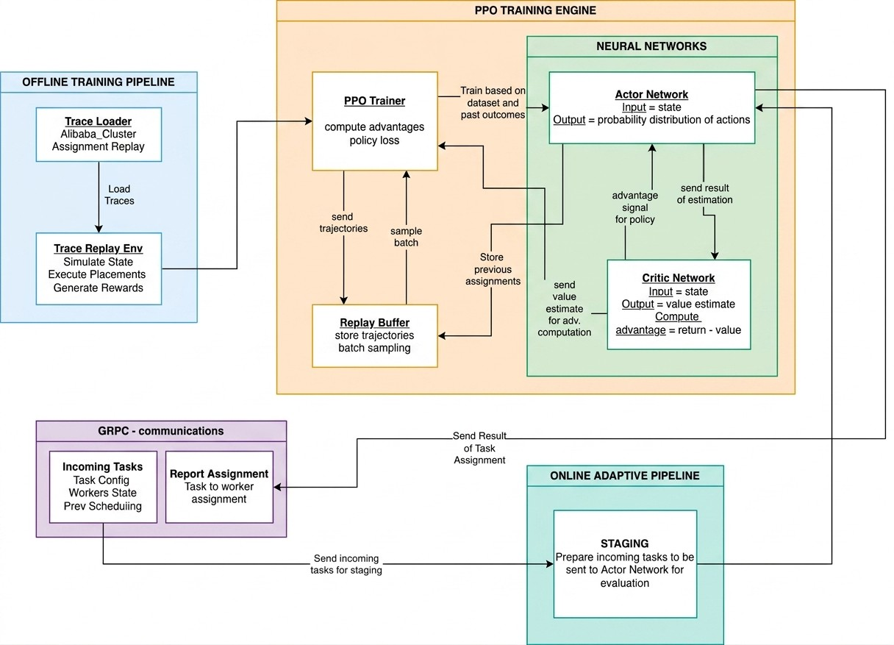
Figure 3.6.1: PPO scheduler architecture

Explanation of Figure 3.6.1: The PPO scheduler receives task features and worker features. These are encoded into pairwise task-worker inputs. The neural network produces policy logits for worker selection and a value estimate for the state. The policy head decides which worker should receive the task. The value head helps calculate advantages during training. The Go master calls the Python PPO service through gRPC, while the Python service loads the trained PyTorch checkpoint.

| Actor and Critic Network
The PPO model follows an actor-critic design, where both the actor and the critic use the same shared encoder. Whenever a scheduling request arrives, the task feature vector is copied once for each candidate worker and joined with that worker’s own feature vector. This produces one combined task-worker row for every possible placement choice.
The shared encoder has two fully connected layers with ReLU activation: task-worker features → Dense(128) → ReLU → Dense(128) → ReLU

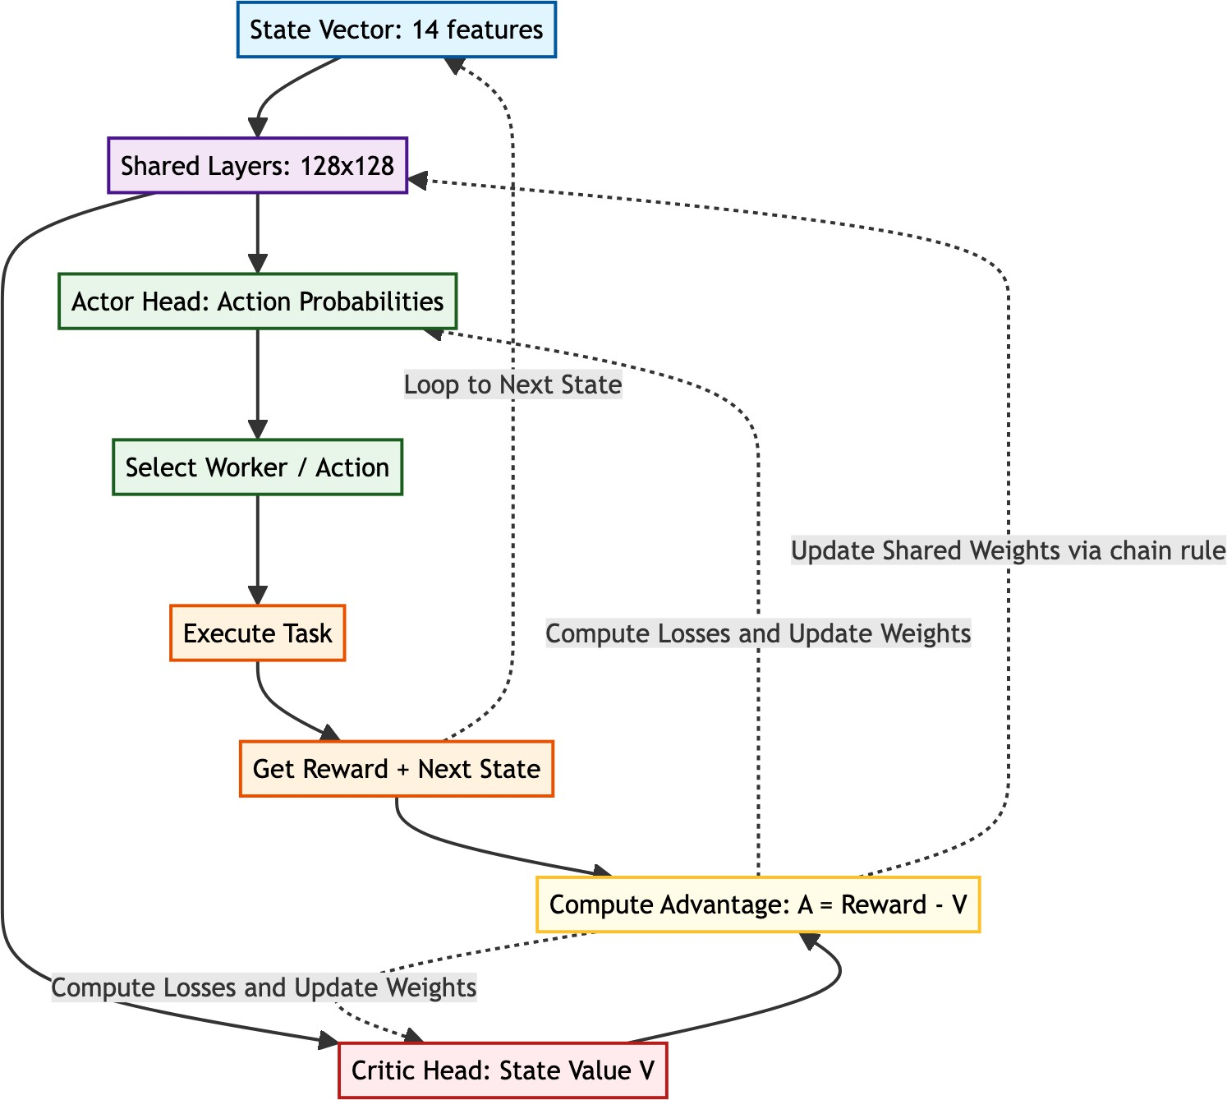
The actor-critic data path is shown in Figure 3.7.1, rendered directly from the project Mermaid specification.

Figure 3.7.1: Actor-critic data flow and PPO learning feedback loop After the shared encoder, the network splits into two heads:

- Actor / policy head: produces one logit per worker. After masking infeasible workers, these logits define the probability distribution π_{θ}(a|s).
- Critic / value head: produces a single value estimate V_{θ}(s), which predicts the expected future reward from the current cluster state [4].

The critic does not pick a worker itself. Its role is to evaluate how good the current situation looks. During training, it essentially answers: “Given this task and the available workers, how much reward should the scheduler expect on average?” PPO then checks the actual reward against that prediction. When the chosen action does better than the critic predicted, the advantage turns positive, and PPO makes similar choices more likely in the future. When the action does worse, the advantage turns negative, and PPO makes that choice less likely.

Formally, the critic estimates discounted return:

V_{θ}(s_{t}) =

E_{π}θ
∞

k=0
CØ

γ^{k}r

t+k -
s_{t}D .

In this scheduler, V_{θ}(s) is not a probability and does not have a fixed [0, 1] range.
Its size is based on the reward design and discount horizon. Single-step rewards are typically around a limited practical band (such as infeasible placements receive a reward of -1.8), with feasible low-pressure placements being allowed to remain positive because of the terms of 1.4 + 0.25H), but queue and tail-pressure penalties can push rewards down during congestion. Thus, in healthy and balanced conditions, under normal conditions, it is assumed that the equation V 0 -s (s) is positive, and under the conditions of stress, frequent requeues, or improper placement, the equation V 0 -s (s) can have a negative value. Effective horizon (which is approximately equal to 1 divided by 1- gamma)) increases magnitude since it is cumulative discounted reward.
In implementation, the value head is used following a pooling of the encoded worker representations. This implies that the critic will be viewing the entire set of candidates and not just the worker who has been chosen. This is important since a scheduling state is determined by the combination of all the available workers. A worker has 3 GB of free memory; it is good or bad depending on what the other workers look like.
The critic is trained in the form of a clipped loss of values:
LV F = max 1(Vθ − Vtarget)2, (Vclipped − Vtarget)22

In which case, V clipped is a limit to the extent to which the value estimate can vary across one update. This is a reflection of the conservative policy update by PPO. It does not allow the critic to suddenly shift its estimate too far which would render advantage estimates unstable.
The target value is borrowed out of the rollout return, it is not obtained by a fixed constant. Using standard PPO with GAE [16], we first compute
T −1
Ø
δ_{t} = r_{t} + γV_{θold}(s_{t+1}) − V_{θold}(s_{t}), Aˆt = (γλ)lδ_{t+l}.
l=0
Then the target of the critic is.
Vtarget,t = Aˆt + Vθold(st),
that is the bootstrapped return of the state at the parameter of that state, namely, 6.3. When a trajectory segment terminates in a terminal state, the bootstrap term in terms of which it appears, vold(s t + 1): is dropped (set to zero).
The overall PPO loss is made up of three parts: the policy loss, the value loss, and an entropy bonus:

L = L^{CLIP} + c₁L^{V} ^{F} − c₂H[π_{θ}]
As an example of a categorical policy over a set of workers, entropy is:

Nw
Ø
H[π_{θ}(·|s)] = − π_{θ}(a|s) log π_{θ}(a|s),
a=1

whereby N_{w} is the number of practicable worker actions following mask and that π_{θ}(a|s) is derived off the masked softmax probabilities. High entropy implies that the policy is distributed among a large number of workers (exploration), and low entropy implies that the policy is concentrated on a small number of workers (near-deterministic behavior). In this project, critic learning is weighted by the value coefficient c₁ and the entropy coefficient c₂ prevents premature determinism where the scheduler is repeatedly tempted to select one apparently strong worker too early. With more training and a more calibrated model, the entropy naturally decreases.

| State Representation
The PPO state is constructed based on the features of task and worker. There are five values in the task vector:
Table 3.8.1: Task feature vector

Feature Meaning

Required CPU CPU requested by the task. Required memory Memory requested by the task. Required storage Storage requested by the task.
SLA multiplier How much delay is acceptable compared to task runtime.
Task type Encoded task category, like CPU-intensive, memory-intensive or mixed.

Each worker is represented using nine values:
Table 3.8.2: Worker feature vector

Feature Meaning

available cpu ratio available CPU divided by total CPU. Available memory ratio Available memory divided by total memory. Available storage ratio Available storage divided by total storage. Total CPU Absolute CPU capacity.
Total memory Absolute memory capacity.
Total storage Absolute storage capacity.
Used CPU ratio Used CPU .
.

Used memory ratio
TUosteadl MCPemUory Total Memory

Used storage ratio Used Storage .
Total Storage

The model uses pairwise task-worker features. This is significant since it is not only what is the task? or what is the worker? but how suitable is this worker to this task?

| Action Space and Masking
The action is the index of the worker that is selected. The system develops an action mask before PPO makes a choice. Marking a worker feasible is only possible when it is active and has sufficient CPU, memory, and storage to carry out the task. The infeasible workers are disguised in such a way that the model does not have the option of picking the infeasible workers during normal operation.

| Reward Function
The reward was to teach PPO how to behave in practice, that is, to schedule:

R = 1.4 + 0.25H − 0.35Q_{p} − 0.55T_{p} − 0.20I_{p} − 0.40∆I − R_{q}
where:

- H is headroom bonus. It is rewarded by the selection of workers who have space vacant.
- Q_{p} is queue pressure. It punishes anticipated waiting.
- T_{p} is tail pressure. It penalizes likely SLA or tail-latency risk.
- I_{p} is imbalance penalty. It does not encourage overworking of already overworked workers.
- ∆I is change in imbalance. It punishes those behaviors that worsen cluster balance.
- R_{q} is requeue penalty. It discourages constantly dangerous placements.

The values are calculated with regard to the projected state upon the task being placed on the chosen worker. To begin with the system estimates the worker load as an average of the CPU, memory, and storage usage:
L = 1 A usedCPU_{w} + usedMem_{w} + usedStorage_{w} B .
^{w} 3 totalCPU totalMem totalStorage
w w
w
Once the requested resources of the new task are added to the available worker, it then becomes the projected load L_{selected}. The average load in the cluster is:

L = 1 Ø L
N
w
cluster N
w=1

Based on these values, the terms of the rewards are:
Table 3.10.1: Reward term computation

Term How it is computed and what it means

H 1 − L_{selected}. A lightly loaded selected worker gives a higher headroom bonus.
If the worker is almost full, this value becomes small.
Q_{p} min(queueWaitProxy/slaBudget, 3.0). The proxy is trace queue wait plus runtime × L_{selected}. It estimates how much waiting pressure the placement creates relative to the SLA budget.
T_{p} max(turnaroundProxy/slaBudget − 1, 0). Turnaround proxy is queue wait proxy plus runtime. This term becomes positive only when expected turnaround crosses the SLA budget.
I_{p} max(L_{selected} − L_{cluster}, 0). This is imbalance in the system. It means the selected worker is more loaded than the cluster average. If the selected worker is below or equal to average load, the penalty is zero.
∆I σ(loads_{after}) − σ(loads_{before}). This measures change in imbalance using the standard deviation of worker loads. Positive means the action made the cluster less balanced. Negative means it made the cluster more balanced.
R_{q} 0.05 × min(requeueCount, 4). A task that has already been requeued receives a small extra penalty so the scheduler avoids repeating risky placements.

For example, if one worker is already much busier than the others, its L_{w} will be above L_{cluster}. Placing another task there increases I_{p}, and it may also increase ∆I if the spread between worker loads becomes larger. In system terms, imbalance means a hot-spot: one worker is carrying more active resource load while other workers still have useful capacity. The reward therefore teaches PPO to avoid placing every task on the same apparently strong worker.
If a worker is infeasible, the reward is −1.8. This strong negative reward teaches the policy that violating hard resource limits is worse than merely making a slow but feasible placement.

| Training Data
The PPO model was trained using trace replay. The Alibaba cluster trace was used because it contains real production workload behavior [6]. The trace replay environment presents tasks in chronological order. When a task is placed, its resources are reserved on the selected worker. When its simulated runtime ends, resources are released.
Decision: Lifecycle-based resource tracking was used instead of simple exponential decay. This matters because many trace arrivals are simultaneous. A decay model can release or retain resources incorrectly, while lifecycle tracking matches the actual running period of each simulated task.

| Training Pipeline
The training pipeline is based on the following steps:

- Load trace tasks and worker information.
- Normalize task and worker features.
- Prepare the replay environment.
- Run PPO rollouts and receive actions, rewards, log probabilities, and values.
- Calculate returns and benefits.
- Update the policy using PPO clipping, value loss, entropy regularization, and gradient clipping.
- Save model checkpoints.
- Promote the best checkpoint for cluster use.

| Implementation in the Cluster
The Go master has a PPO scheduler wrapper. For each task, it builds a candidate worker list and sends it to the Python PPO service. The service encodes the request, applies the action mask, runs the policy, and returns the selected worker ID.

Task arrives at master
Build task and worker features
Create feasible worker mask
Query PPO service for worker
Fallback scheduler
if PPO invalid or down
invalid / unavailable
Validate returned worker

valid
Dispatch task to worker
retry cycle
Assignment successful?

yes

Run container on worker
no
Persist result status=failed
no
Recoverable failure or worker loss?
yes
no
Execution successful?
yes
Persist result status=completed
Mark attempt lost and requeue task
Return task to master queue
Figure 3.13.1: PPO scheduling flow inside the Go cluster with failover and requeue

Explanation of Figure 3.13.1: The flow starts in the Go master, not inside the neural network. After PPO returns a worker, the master validates that worker against the latest state. If PPO is unavailable or the choice is invalid, fallback scheduling is used. Assignment failures and recoverable runtime failures are not terminal: the current attempt is marked lost and the task is requeued for another scheduling cycle. Only non-recoverable execution failures are finalized as failed.
The implementation also includes fallback behavior:

- If the PPO service is down, use the fallback scheduler.
- In the event that PPO gives an empty response, then resort to fallback.
- When PPO provides a worker that no longer exists or cannot fit the task, use fallback.
- When the shadow mode is turned on, record the decision made by PPO but implement the decision made by fallback.

Decision: The learning model shall not be permitted to be the sole safety measure. The Go scheduler checks the output of PPO and only after checking the output, the Go scheduler assigns a task.

Chapter 4 Results

| Project Outcomes
This chapter documents the quantifiable results of the project and relates the results to the actual system behavior in the deployed cluster.

| Evaluation Setup
The system was tested in two aspects:

      - Offline PPO testing: the trained model was also tested on data formed by trace replay to gauge reward and feasibility.
      - End-to-end cluster campaigns: Go master and workers ran actual Docker tasks at various workload patterns and scheduler options.

The key schedulers compared were:
Table 4.1.1: Schedulers compared

Scheduler Description

Round-Robin Simple cyclic assignment baseline.
RTS Risk-aware heuristic scheduler using resource and risk scoring. PPO Reinforcement learning scheduler trained through trace replay.

| Training Convergence

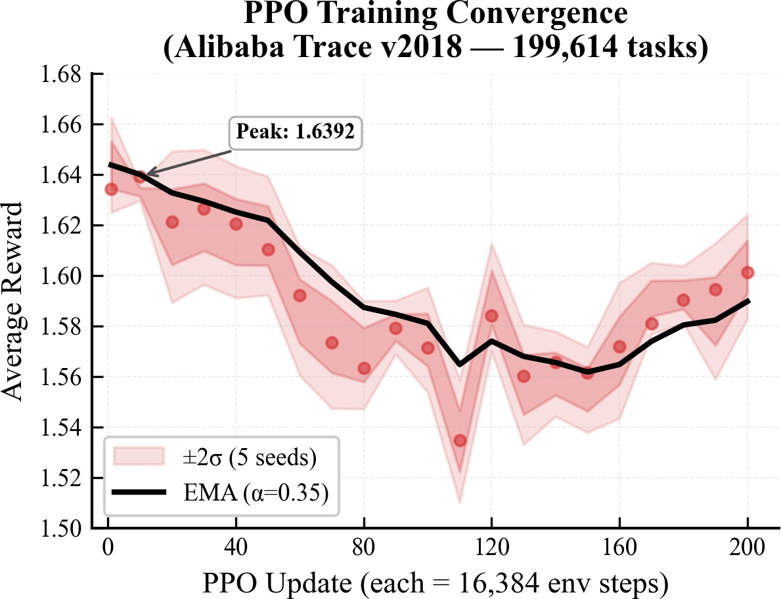
Figure 4.1.1: PPO training reward curve

Explanation of Figure 4.1.1: The curve shows how the average reward changed during training. Early training is exploratory because the policy is still testing placements. Later, the reward stabilizes, which indicates that the policy has learned a consistent placement strategy for the replayed cluster trace.
Average reward means the mean reward received per scheduling decision during a training window. From the DRL point of view, it is the signal that tells whether the actor is choosing actions that the environment considers better than before. A rising average reward means the policy is getting more positive feedback from the reward function. A flat reward means the policy has probably reached a stable behavior for the current trace and hyperparameters.
From the scheduling point of view, average reward is not a raw time measurement.
It is a composite measure of feasible practical placement quality: feasible placement, adequate worker headroom, reduced waiting pressure, reduced tail-risk pressure, and better cluster balance. Then when the average reward that PPO is learning to achieve is better, it does not imply that it is learning to make placements more likely to finish one task quickly, but rather to achieve a better average reward.

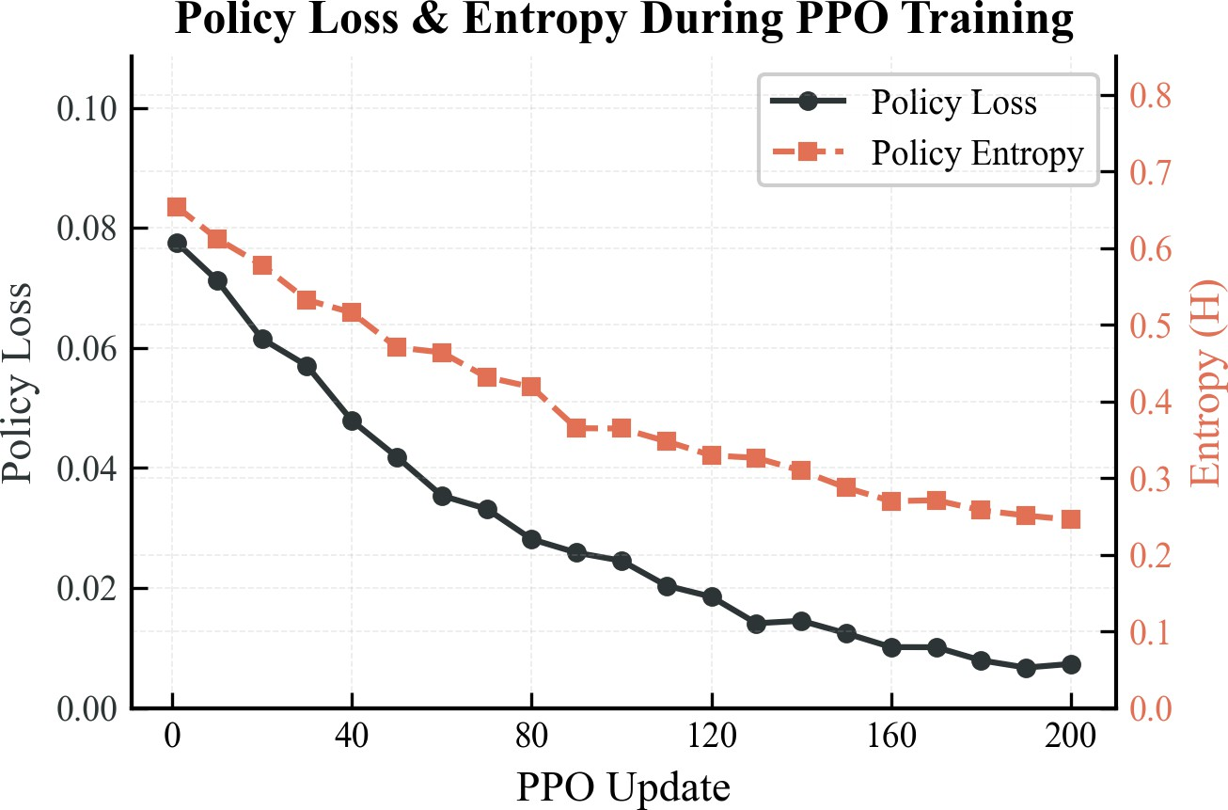
Figure 4.1.2: PPO policy loss and entropy

Explanation of Figure 4.1.2: This figure shows how the policy loss and entropy change over training. Policy loss is another name for the PPO actor loss. It captures how much the policy still needs to adjust so that it can favour actions with high advantage and avoid actions with low advantage. Put simply, it shows how much correction the actor still has left to do. When the policy loss shrinks, it means the updates are getting smaller because the scheduler is settling into a more stable placement rule.
Entropy is used to quantify the randomness in the policy distribution. In the DRL perspective, high entropy implies that the agent is searching a large number of actions; low entropy implies that the agent is very certain and deterministic. The scheduling perspective of high entropy would imply that PPO is still experimenting with various employees to perform similar jobs. A smaller entropy implies that it has acquired more robust preferences, such as a preference towards a worker with greater resource fit and with less tail risk.
The loss of values is not represented in this figure since the chart was retained at two axes to be readable, but it is included in the PPO update. Value loss is part of the critic network. It is a metric of the error between the predicted state value, V(s), and the observed return due to the rollout [4]. Under the point of view of scheduling, value loss informs whether the critic is learning to evaluate cluster states appropriately. When the loss of values decreases, then the critic is becoming more proficient in estimating whether the current task-worker situation will result in good future scheduling rewards.

| Results of the Offline PPO Model
The word trace in this section means a historical workload record. It holds the task arrivals, requested resources, run times and machine information. In trace replay, the environment submits these tasks to the scheduler in chronological order. The scheduler does not just copy the historical placement; it picks the workers in the simulated cluster, reserves the resources to the simulated runtime, releases the resources when the tasks finish, and is rewarded on each choice.
The PPO model that performed best scored a mean reward of about 0.8801 on the evaluation trace, and 0.8688 on the Round-Robin evaluation trace. The action rate of Round-Robin and PPO also improved, with Round-Robin having a better rate of 94.38
Table 4.2.1: Comparison of offline schedulers on trace replay

Policy | Mean Reward | Feasible Action Rate
Round-Robin | 0.8688 | 94.38%
First feasible | 0.8145 | 94.80%
Max available | 0.8800 | 94.84%
PPO best model | 0.8801 | 94.86%

The mean reward is obtained by dividing the value of rewards by all the scheduling choices made in the evaluation trace. It relies upon the same reward function as used in the methodology: feasibility, headroom, queue pressure, tail pressure, imbalance, change in imbalance, and requeue penalty. Calculation of feasible action rate is:

number of chosen workers that meet the task resources total scheduling decisions
Feasible Action Rate = × 100

In scheduling theory Feasible action rate is a measure of the frequency with which the scheduler selected a worker capable of actually executing the task without breaking the CPU, memory or storage constraints. Light-load trace replay does not make the improvement enormously large, but it is a meaningful improvement since PPO has now reached the level of a strong heuristic without compromise of the ability to learn by reward signals.

| Multi-Run Comparison

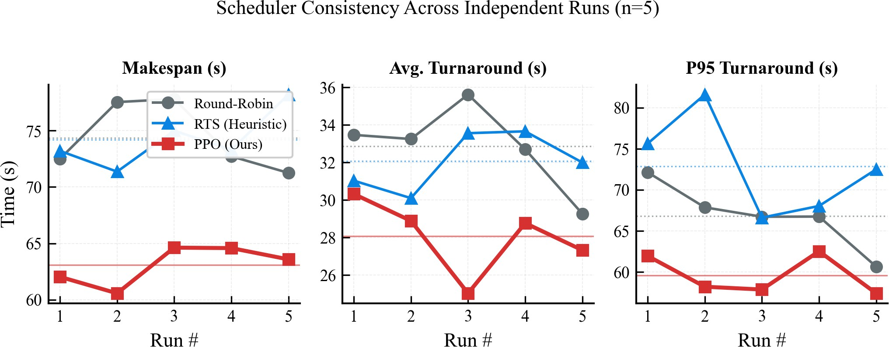

Figure 4.2.1: Multi-run scheduler comparison

Figure 1.1: Exploration: In a single run, timing of tasks, container start and worker state may be inaccurate. Multi-run plot is used to compare schedulers in the context of repeated runs. It indicates a consistent superiority of a scheduler or just a lucky event in a single campaign. This assisted in determining that the benefit of PPO is more evident under burst and overload conditions than under simple steady conditions.

| Cumulative Completion

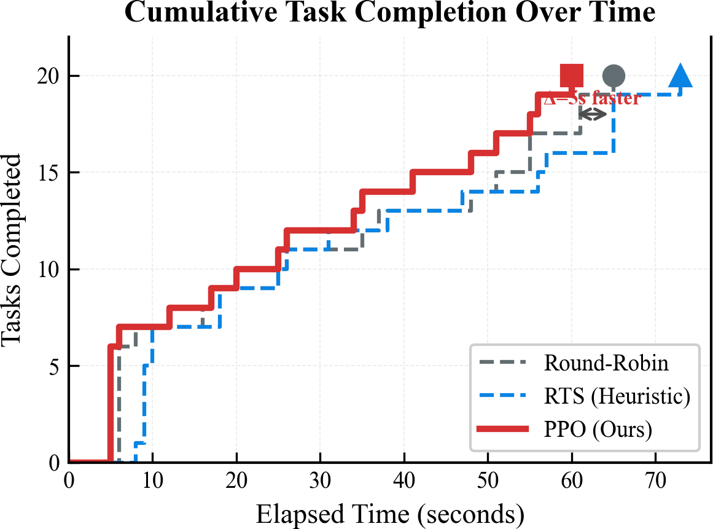
Figure 4.2.2: Cumulative number of tasks completed over time.

Description of Figure 1: This figure displays the rate at which each scheduler completes tasks with time. The steeper the curve, the faster tasks are being completed. The usefulness of this view is that the average duration by itself may conceal long-tail behavior. Tail behavior is important in cluster scheduling since just a handful of delayed tasks can block an entire workload.

| WebUI Operational Visuals
In live campaigns the WebUI served as operator-facing view to confirm that scheduler choices were consistent with observed system behavior. It is used to complement the numeric KPI tables displaying a real-time cluster state and workload progress.

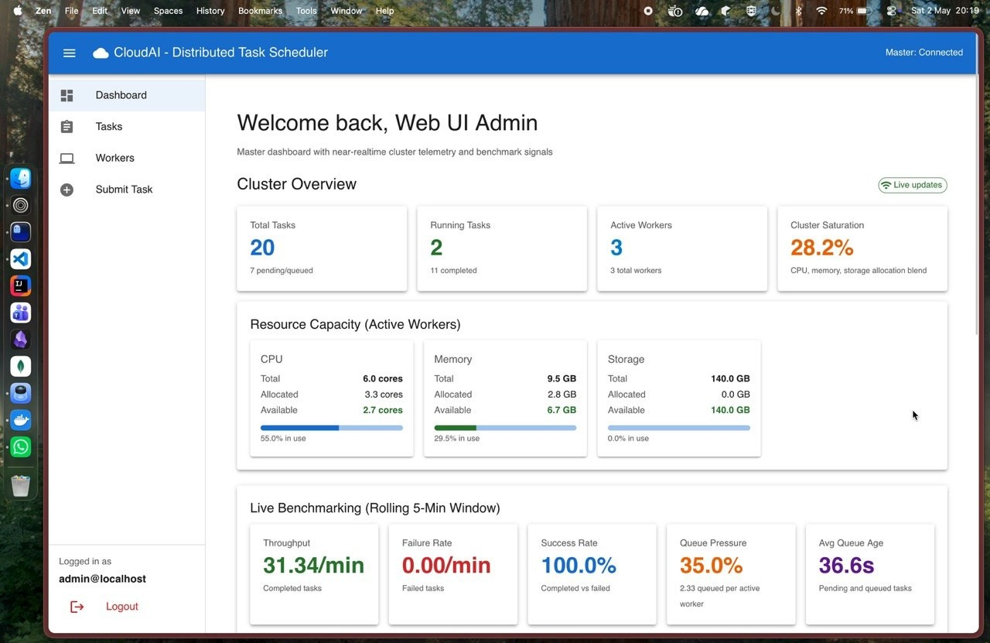
Figure 4.2.3: WebUI dashboard screen whilst running the campaign.

Description of Figure 4.2.3: The dashboard view gives an integrated status of the running scheduler, worker availability, and task lifecycle status. This served to confirm that the PPO placement decisions were not only better in the aggregate measures, but operationally consistent during the time that the workload was running.

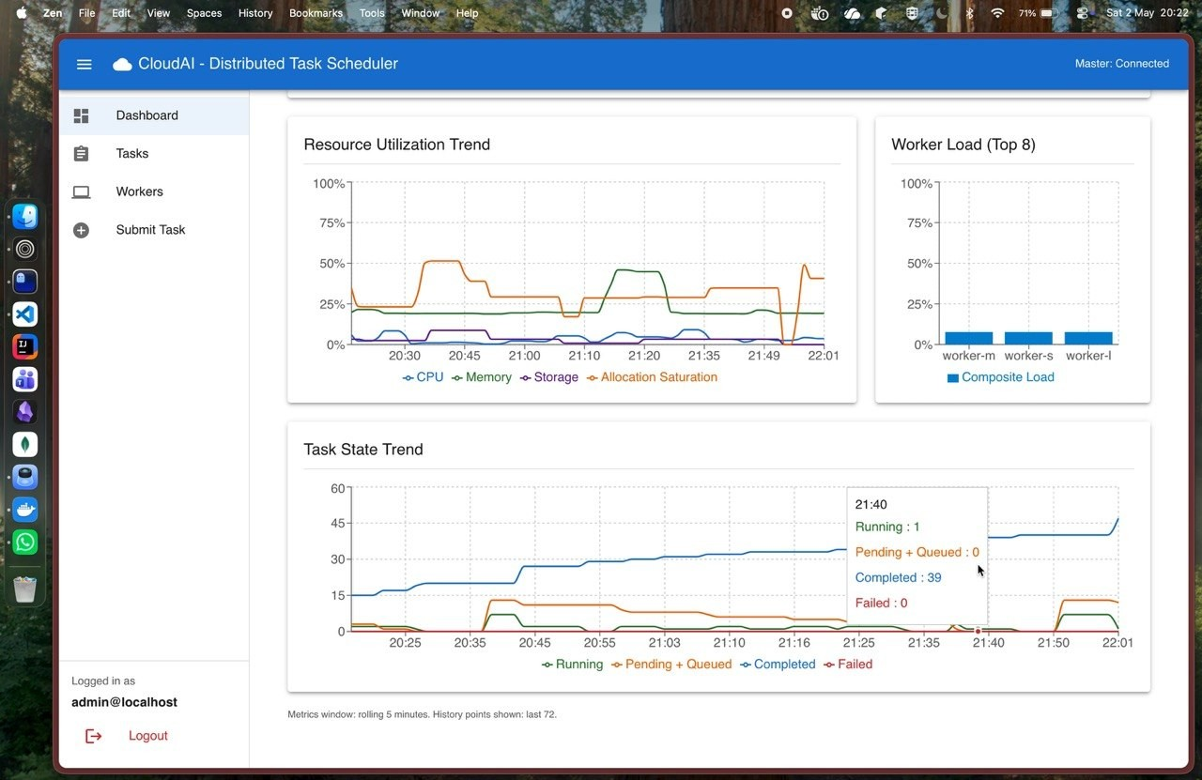
Figure 4.2.4: WebUI trend plot of scheduler performance monitoring.

Explanation of Figure 4.2.4: This trend plot visualizes the behavior of the runtime across the campaign window, which is easier to inspect response under pressure and detect tail effects that could be hidden in simple averages. This visual manifestation coincides with the quantitative aid in turnaround and P95 completion of PPO under contention-intensive situations.

| Latest Campaign Summary
The end-to-end evaluation harness of the project is the campaign testbench. It runs against the live Go master over HTTP, switches the active scheduler, submits a fixed workload, polls task status until tasks become terminal or the limit is reached, and then records the duration, success rate, queue wait, average turnaround, and P95 turnaround.
Table 4.2.2: New-model campaign scheduler summary

Scheduler | Tasks | Completed | Failed | Duration | Turnaround | P95
RR | 20 | 20 | 0 | 70.06 s | 33.80 s | 69.00 s
RTS | 20 | 20 | 0 | 76.20 s | 33.40 s | 74.00 s
PPO | 20 | 20 | 0 | 63.95 s | 27.75 s | 62.00 s

Table 4.2.3: New PPO improvement over baselines

Comparison | Duration Improvement | Turnaround Improvement
PPO vs RR | 8.7% faster | 17.9% lower
PPO vs RTS | 16.1% faster | 16.9% lower

The difference came from execution placement: PPO selected workers in a way that reduced total campaign duration and reduced the tail turnaround. Turnaround time means the time from task creation to task completion. Tail turnaround focuses on the slowest part of the workload, usually measured using a high percentile such as P95. In this campaign, P95 turnaround means that almost all tasks completed within that many seconds, except the slowest few tasks. PPO reducing P95 from 69.00 seconds for Round-Robin and 74.00 seconds for RTS to 62.00 seconds means the slowest tasks were less delayed. This is important because a cluster can look acceptable on average while still having a few tasks that finish very late.

| Pressure Scenarios
The pressure tests were developed in such a manner that scheduling was not going to be easy. The testbench is capable of running a baseline, burst and overload mode. When in the baseline mode, a single copy of the workload is sent and the runner waits up to 600 seconds to complete the workload. In burst mode (same workload) is submitted without a time delay between tasks again with a 600 second per-scenario time-out. When in an overload mode, the workload is tripled to overload the cluster and the timeout is extended to 1200 seconds.
The 20 deterministic Docker tasks in the resource-contention-ppo workload used in the final campaign. The set of tasks is intentionally mixed: five large CPU-heavy tasks, five memory-heavy tasks, five medium mixed CPU-memory tasks, and five small CPU-light tasks. The resource requests also vary. Large tasks request 2.5 CPU and 0.8 GB memory, memory-heavy tasks request 0.8 CPU and 2.0 GB memory, medium tasks request 1.5 CPU and 0.8 GB memory, and small tasks request 0.5 CPU and 0.4 GB memory. This gives a bin-packing problem since not all tasks are equally appropriate to all workers.
Previous extensive campaigns demonstrated the most evident PPO advantage in burst load. In one campaign, Round-Robin and RTS timed out on multiple burst workloads, while PPO completed a large percentage of burst tasks. This supports the original motivation: learned scheduling matters most when the placement decision is non-obvious.

Table 4.2.4: Burst scenario interpretation

Observation Interpretation

RR performs well under light load Simple cyclic placement is enough
when all workers have spare capacity.
RTS improves some resource-aware cases Heuristics help when they match the
workload pattern.
PPO improves under burst or overload pressure Learned placement can capture in-
teractions between task size, worker state, and tail risk.
PPO has overhead A learned scheduler must justify its cost by improving difficult cases.

| Important Engineering Decisions and Results

Table 4.2.5: Key project decisions and outcomes

Decision Reason Outcome

Use Go for master and worker

Use Docker for task ex-ecution

Use action masking in PPO
Use Lifecycle resource tracking during trace replay
Use fallback scheduler validation
The control plane needs effi-cient networking and concur-rency.
Tasks need portable execution environments.

Invalid workers must not be selected.
Decay-based resource release was incorrect when simultane-ous arrivals occurred.
A learned model can fail or be unavailable.
The cluster can run master-worker task execution with clear service boundaries.
Workers can run containerized workloads with resource re-quirements.
PPO decisions respect hard re-source constraints.
PPO is controlled towards less-ening hazardous placements.

Cluster safety is maintained even when PPO cannot make a decision.

| Delivered Components
The final project is one that provides:

- a working distributed task execution cluster,
- worker registration and heartbeat tracking,
- task assignment and report of results,
- scheduler comparison infrastructure,
- PPO trace replay training,

- PPO service integration with Go,
- offline and end-to-end evaluation artifacts.

| My Contribution to the Project
The key individual contributions were the design and development of the Go cluster framework, the scheduler integration boundary, the PPO scheduling pipeline, the training and evaluation workflow and the final benchmark interpretation. Much of the work, too, consisted of debugging practice system bugs: resource accounting, worker visibility, fallback behavior, and model loading.

| Learning Outcomes
The project served to bridge two topics which are frequently discussed independently: distributed systems and reinforcement learning.
The distributed systems aspect has helped me understand that a lot of correctness is determined by the state handling, retries, and clean boundaries. The RL component taught that the quality of models is susceptible to reward design, feature representation, and safe deployment. The greatest lesson here was that the learning-based scheduling must be introduced as a controlled enhancement and not as a replacement of the basic system reliability.

| Real World Applications
This project is applicable to small cloud platforms, internal batch execution systems, university lab cluster, CI workload runners, and clusters of the edge where machines have varying capabilities. The PPO scheduler is particularly applicable when the workloads are mixed and the rules of manual scheduling cannot be easily tuned.
The structure can be employed in a university or research laboratory to share a small number of machines with many users who may be running experiments. Experiments might be CPU-intensive, might be memory-intensive, and might be short utility tasks. An educated scheduler can minimize the likelihood that a small job will be blocked behind an improperly placed large job.
The framework can be used in CI and testing systems to schedule build, test, and benchmark jobs on workers with varying capacities. A basic Round-Robin scheduler can allocate a heavy integration test to a slow machine and PPO can learn what it has done and prefer to place it somewhere better.
Machines in edge computing tend to be heterogeneous and resource-constrained. A scheduler should make decisions on the placement of tasks without necessarily having all the nodes with the same capacity. The master-worker concept can be applied to direct the processing of video, filtering of data, or inference tasks to appropriate edge nodes.

In the case of a private cloud, the project may serve as a lightweight batch execution layer. It is not designed to compete with large orchestration platforms, but demonstrates how a focused scheduler can be constructed, tested, and trained with reinforcement learning and still maintain safe fallback behavior.

Chapter 5 Conclusion
The Agentic Cloud Cluster is a successful attempt to illustrate the distributed task execution framework based on Go with PPO-based scheduling. The practical necessity to distribute containerized jobs among heterogeneous workers grew into a full-fledged scheduling study. The last design isolates the cluster control plane and the learning service which ensures that the system is maintainable and safe.
The methodology demonstrated the reason why reinforcement learning is a viable choice to solve cluster scheduling [1]. Q-tables describe the fundamental concept, but do not work due to the large size of the state space [2]. DQN enhances generalization, and is less natural to dynamic sets of workers and masking of actions [3]. PPO was selected due to its ability to directly learn a worker-selection policy, support stable clipped updates and continuous resource capabilities [5].
The outcomes demonstrate a balanced image. It is not always the case that PPO is better. Simple schedulers are quick and efficient when the load is light. PPO is more useful when there is burst and overload pressure as far as it can use acquired relationships between task demand, worker state and risk. The general conclusion of the project is: learning-based scheduling can help when the decision space is complex, but must be implemented with checking and recovery.

| Future Work
The project can be enhanced in the future in the following ways:

    - Train on bigger and more varied traces.
    - Introduce cost, energy, and fairness multi-objective reward tuning.
    - Online adaptation by longer stable cluster runs.
    - Test using more physical or cloud machines.
    - Add more aggressive tests on failure injection of the workers loss and network delay.
    - Container Checkpoint/Restore In Userspace: Incorporate CRIU (Check-point/Restore In Userspace) to add functionality to enable faster container recovery

and task migration. CRIU offers kernel-level support of freezing process state, dump-ing it to disk, and restoring it on demand. This would allow making a number of improvements:
      - Quick Recovery of Failures: When a worker fails, it is possible to recover the worker in a much shorter time than to re-run tasks fresh to recover the worker.
      - Task Preemption: High-priority tasks could preempt lower-priority ones by checkpoint-saving the latter and restoring them when resources become available.
      - Container Migration: Checkpoints allow live migration of containers between workers without loss of state, better load balancing and maintenance operations.
      - Warm Starts: Container images with pre-established state can be checkpointed and restored, eliminating the need to reestablish state when stateful workloads are executed.
      - Predictive Scheduling: Risk modeling could involve the scheduler using CRIU-backed snapshots, which would enable the scheduler to trade-off immedi-ate completion against future availability of resources.
The difficulties of implementation are compatibility with the kernel, coordination between checkpoint timestamps and task state metadata in MongoDB, and dealing with network connections across migration boundaries.

On the whole, the project demonstrates that a distributed systems architecture and a reinforcement learning scheduler can be integrated in a practical and safe manner.

Bibliography

- R. S. Sutton and A. G. Barto, Reinforcement Learning: An Introduction. MIT Press, 2 ed., 2018. https://mitpress.mit.edu/9780262039246/reinforcement-learning/.
- C. J. C. H. Watkins and P. Dayan, “Q-learning,” Machine Learning, vol. 8, no. 3-4,
pp. 279–292, 1992. https://www.gatsby.ucl.ac.uk/∼dayan/papers/cjch.pdf.
- V. Mnih, K. Kavukcuoglu, D. Silver, A. Graves, I. Antonoglou, D. Wierstra, and
M. Riedmiller, “Playing Atari with deep reinforcement learning,” arXiv preprint arXiv:1312.5602, 2013. https://arxiv.org/abs/1312.5602.
- J. Schulman, F. Wolski, P. Dhariwal, A. Radford, and O. Klimov, “Proximal policy optimization algorithms,” arXiv preprint arXiv:1707.06347, July 2017. https://arxiv. org/abs/1707.06347.
- Y. Gu, Z. Liu, S. Dai, C. Liu, Y. Wang, S. Wang, G. Theodoropoulos, and L. Cheng, “Deep reinforcement learning for job scheduling and resource management in cloud computing: An algorithm-level review,” arXiv.org, jan 2025. https://arxiv.org/abs/ 2501.01007.
- Alibaba, “Alibaba cluster data.” https://github.com/alibaba/clusterdata, 2018. Cluster traces released for cluster management research.
- Kubernetes Authors, “What is Kubernetes?.” https://kubernetes.io/docs/concepts/ overview/, 2026. Accessed: 2026-05-03.
- K. Ma, K. Wang, et al., “Volcano: A cloud native batch system.” https://github.com
/volcano-sh/volcano, 2025.
- Apache Software Foundation, “Apache YuniKorn: A cloud native scheduler.” https:
//yunikorn.apache.org/, 2025.
- P. Moritz, R. Nishihara, S. Wang, A. Tumanov, R. Liaw, E. Liang, M. Elibol, Z. Yang,
W. Paul, M. I. Jordan, and I. Stoica, “Ray: A distributed framework for emerging AI applications,” in 13th USENIX Symposium on Operating Systems Design and Implementation (OSDI 18), 2018. https://arxiv.org/abs/1712.05889.
- T. Haarnoja, A. Zhou, P. Abbeel, and S. Levine, “Soft Actor-Critic: Off-policy maximum entropy deep reinforcement learning with a stochastic actor,” International Conference on Machine Learning (ICML), 2018. https://arxiv.org/abs/1712.05889.
- Docker Inc., “Docker documentation.” https://docs.docker.com/, 2026. Accessed May 2026.

- The Go Authors, “Documentation - the Go programming language.” https://go.dev
/doc/, 2026. Accessed May 2026.
- gRPC Authors, “Introduction to gRPC.” https://grpc.io/docs/what-is-grpc/introduc tion/, 2026. Accessed May 2026.
- MongoDB, “Introduction to MongoDB.” https://www.mongodb.com/docs/manual/ introduction/, 2026. Accessed May 2026.
- J. Schulman, P. Moritz, S. Levine, M. Jordan, and P. Abbeel, “High-dimensional continuous control using generalized advantage estimation,” arXiv preprint arXiv:1506.02438, 2015. https://arxiv.org/abs/1506.02438.

Appendix

| Repository Modules

Table .1.1: Main repository modules used in the project

Path Purpose

master/ Go master node, scheduler interface, task handling, worker handling, persistence hooks.
worker/ Go worker node, Docker task execution, heartbeat reporting, log streaming.
proto/ Protocol Buffer definitions for master-worker and PPO scheduler communication.
agenticscheduler/ Python PPO model, service, training code, trace replay environ-ment, checkpoints.
testbench/ Workload and campaign automation for end-to-end evaluation.
results/ Benchmark reports, campaign outputs, plots, and extracted result summaries.

| Representative PPO Configuration

Table .2.1: Representative PPO training configuration

Parameter Value / Meaning

Model Actor-critic neural network with two hidden layers.
Hidden size 128.
Task feature dimension 5.
Worker feature dimension 9.
Clip ratio 0.2.
Value coefficient 0.5.
Entropy coefficient Tuned during experiments, commonly around 0.01–0.02. Training source Alibaba trace replay and project campaign traces.


Agentic Cloud Cluster

| Ports and Service Mapping

Table .3.1: Ports used by the project

Component | Port / Address | Purpose
Master gRPC server | 0.0.0.0:50051 | Main worker-to-master commu-nication endpoint for registra-tion, task assignment coordina-tion, heartbeats, and result report-
ing.
Master HTTP API 0.0.0.0:8080 HTTP API used for task, worker,
file, auth, health, and metric end-points.
PPO scheduler service 127.0.0.1:50050 Python gRPC service used by
the Go PPO scheduler for Ping, model loading, worker selection, and outcome reporting.
Worker 1 gRPC 0.0.0.0:50052 Worker task execution endpoint. Worker 2 gRPC 0.0.0.0:50053 Worker task execution endpoint. Worker 3 gRPC 0.0.0.0:50054 Worker task execution endpoint.
Additional workers 0.0.0.0:5005N Extra worker nodes can use the
same pattern with unique ports. MongoDB localhost:27017 Persistent storage for tasks, work-
ers, assignments, attempts, re-sults, users, and scheduler model metadata.
Worker metrics 0.0.0.0:9101+ Per-worker metrics endpoint.
Each worker can use a unique metrics port when multiple workers run on the same host.
Docker daemon Host socket / Docker API Container execution backend used
by worker nodes. Exact access path depends on local Docker setup.

These mappings are the default local development mappings used by the project. In a multi-machine deployment, the same logical services remain, but the hostnames change from localhost to routable machine addresses.

