Amazon Sales - SQL Analysis Template
Ye DOCX template aapko Amazon sales data PostgreSQL/SQL me load karke analysis karne ke liye ready-made
CREATE TABLE, COPY command, aur commonly used KPI queries provide karta hai. Aap is document ko apne
CSV path aur schema ke hisaab se edit kar sakte ho.

1) Table schema (CREATE TABLE)
-- Create table for Amazon sales data
CREATE TABLE amazon_sales (
order_id VARCHAR(100) PRIMARY KEY,
order_date DATE,
status VARCHAR(50),
fulfilment VARCHAR(50),
sales_channel VARCHAR(100),
ship_service_level VARCHAR(100),
style VARCHAR(100),
sku VARCHAR(100),
category VARCHAR(150),
size VARCHAR(50),
asin VARCHAR(50),
courier_status VARCHAR(100),
qty INTEGER,
currency VARCHAR(10),
amount DECIMAL(12,2),
ship_city VARCHAR(100),
ship_state VARCHAR(100),
ship_postal_code VARCHAR(20),
ship_country VARCHAR(100),
promotion_ids VARCHAR(200),
b2b BOOLEAN,
fulfilled_by VARCHAR(100),
total_revenue DECIMAL(14,2)
);

2) Load data (COPY)
-- Adjust the file path to your CSV location and the column order if needed
COPY amazon_sales(order_id, order_date, status, fulfilment, sales_channel, ship_service_level,
style, sku, category, size, asin, courier_status, qty, currency, amount, ship_city, ship_state,
ship_postal_code, ship_country, promotion_ids, b2b, fulfilled_by, total_revenue)
FROM 'E:\path\to\Amazon Sale Report.csv' CSV HEADER;

3) Useful data-cleaning checks
-- 1) Check nulls and data types
SELECT
COUNT(*) AS total_rows,
COUNT(order_id) AS rows_with_order_id,
COUNT(order_date) AS rows_with_order_date,
SUM(CASE WHEN amount IS NULL THEN 1 ELSE 0 END) AS null_amount_count
FROM amazon_sales;
-- 2) Find malformed dates or negative quantities/amounts
SELECT * FROM amazon_sales WHERE qty < 0 OR amount < 0 LIMIT 50;

4) Key KPIs (SQL queries)
-- Total orders
SELECT COUNT(*) AS total_orders FROM amazon_sales;
Output : Total Orders = Rs . 120378
-- Total revenue (from amount or total_revenue column)
SELECT SUM(total_revenue) AS total_revenue, SUM(amount) AS sum_amount FROM amazon_sales;
Output : Total Revenue = Rs . 76034406.00
Output : Sum Amount = Rs . 78592678.00
-- Average order value (AOV)
SELECT ROUND(SUM(total_revenue) / NULLIF(COUNT(*),0), 2) AS avg_order_value FROM amazon_sales;
Output : avg_order_value = Rs . 631.63

-- Revenue and orders by month
SELECT DATE_TRUNC('month', order_date) AS month,
TO_CHAR(DATE_TRUNC('month', order_date),'YYYY-MM') AS month_name,
COUNT(*) AS orders,
ROUND(SUM(total_revenue),2) AS revenue,
ROUND(SUM(total_revenue) / NULLIF(COUNT(*),0),2) AS aov
FROM amazon_sales
GROUP BY DATE_TRUNC('month', order_date)
ORDER BY month;
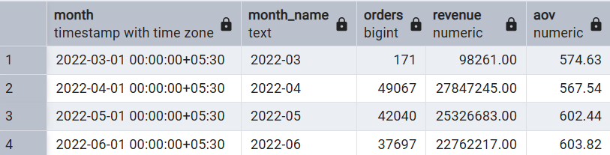
-- Top 10 products by revenue (by SKU or ASIN)
SELECT sku, asin, SUM(total_revenue) AS revenue, SUM(qty) AS total_qty
FROM amazon_sales
GROUP BY sku, asin
ORDER BY revenue DESC LIMIT 10;
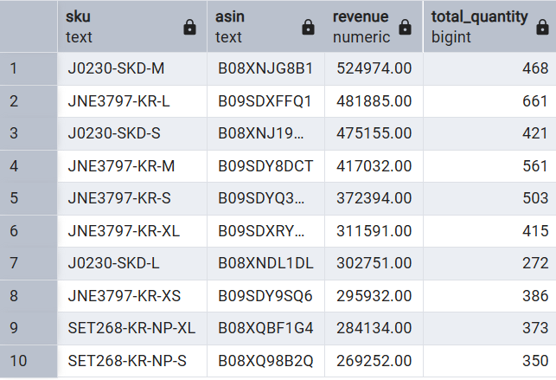
-- Top categories by revenue
SELECT category, SUM(total_revenue) AS revenue, SUM(qty) AS total_qty
FROM amazon_sales
GROUP BY category ORDER BY revenue DESC;
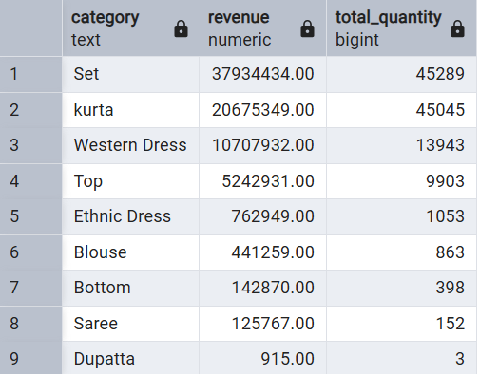
-- B2B vs B2C revenue split
SELECT b2b, COUNT(*) AS orders, SUM(total_revenue) AS revenue
FROM amazon_sales GROUP BY b2b;
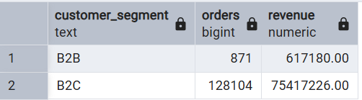
-- Fulfilment channel performance (e.g., FBA vs Seller Fulfilled)
SELECT fulfilled_by, COUNT(*) AS orders, SUM(total_revenue) AS revenue
FROM amazon_sales GROUP BY fulfilled_by ORDER BY revenue DESC;
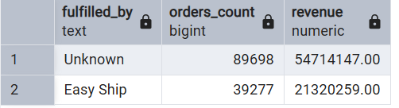
-- Order status distribution (Delivered, Returned, Cancelled etc.)
SELECT status, COUNT(*) AS count_orders, SUM(total_revenue) AS revenue
FROM amazon_sales GROUP BY status ORDER BY count_orders DESC;
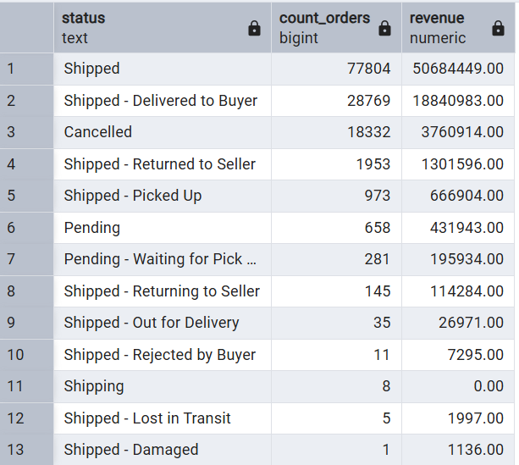
-- Average items per order
SELECT ROUND(AVG(qty),2) AS avg_items_per_order FROM amazon_sales;
Output : avg_items_per_order = 0.90
-- Revenue per city (top 20)
SELECT ship_city, ship_state, SUM(total_revenue) AS revenue, SUM(qty) AS qty
FROM amazon_sales GROUP BY ship_city, ship_state ORDER BY revenue DESC LIMIT 20;
