The Problem
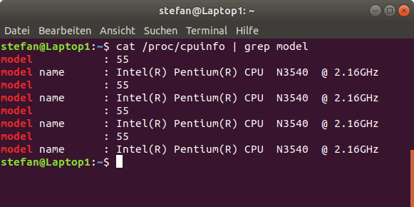
I got an Ubuntu 18.04 (same problem with 16.04 after kernelupdates) running on a N3540 witch freezes by random.

This is a known issue with baytrail cpus in combination of newer kernels.

The easy solution
An easy workarround is, to add „intel_idle.max_cstate=1“
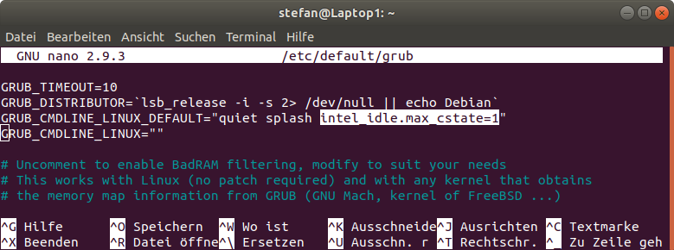
sudo nano /etc/default/grub

update grub afterwards:

sudo update-grub

Disadvantage: more powerconsumption / less time on battery

The smart solution

cstateInfo.sh is to verify the script has worked. The "Disabled" Column will show a "1" for disabled states (or you take a look before running
the script and after to check whether the offending C6* states have not been used [ie no change in 'time'])
c6off+c7on.sh is the script which will actually disable the C6* states. And enable C7

This will not work if you have booted with any cstate parameters. (remove intel_idle.max_cstate=1)
The script should be run at boot. If it works, make the change permanent by adding it to startup.

If all is well, you should probably also benefit from better power savings than originally. :smiley:

A quick walkthrough here - on systemd you're gonna want to create a service.

Drop the script at "/usr/bin/c6off+c7on.sh"

Make sure it can run with following command

sudo chmod 755 /usr/bin/c6off+c7on.sh

Then create a file "/etc/systemd/system/cstatefix.service"
with following contents:

[Unit]
Description=My script

[Service]
ExecStart=/usr/bin/c6off+c7on.sh

[Install]
WantedBy=multi-user.target

Then enable service with command

systemctl enable cstatefix.service

When you restart, use the info script to see if all is well.
You should get output similar to this:

cpu0 State Name Disabled Latency Residency Time Usage
0 POLL 0 0 0 40996149 15951
1 C1-BYT 0 1 1 18934852616 17313916
2 C6N-BYT 1 300 275 75736 138
3 C6S-BYT 1 500 560 319588 235
4 C7-BYT 0 1200 4000 4756954535 1000102
5 C7S-BYT 0 10000 20000 1638046880 82461

..with 1's in Disabled row for C6*, and the news C7 states available.

c6off+c7on.sh
#!/bin/sh

#title: c6off+c7on.sh
#description: Disables all C6 and enables all C7 core states for Baytrail CPUs
#author: Wolfgang Reimer <linuxball (at) gmail.com>
#date: 2016014
#version: 1.0
#usage: sudo <path>/c6off+c7on.sh
#notes: Intended as test script to verify whether erratum VLP52 (see
# [1]) is the root cause for kernel bug 109051 (see [2]). In order
# for this to work you must _NOT_ use boot parameter
# intel_idle.max_cstate=<number>.
#
# [1] http://www.intel.com/content/dam/www/public/us/en/documents/specification-updates/pentium-n3520-j2850-celeron-n2920-n2820-n2815-n2806-j1850-j1750-spec-update.pdf
# [2] https://bugzilla.kernel.org/show_bug.cgi?id=109051

# Disable ($1 == 1) or enable ($1 == 0) core state, if not yet done.
disable() {
local action
read disabled <disable
test "$disabled" = $1 && return
echo $1 >disable || return
action=ENABLED; test "$1" = 0 || action=DISABLED
printf "%-8s state %7s for %s.\n" $action "$name" $cpu
}

# Iterate through each core state and for Baytrail (BYT) disable all C6
# and enable all C7 states.
cd /sys/devices/system/cpu
for cpu in cpu[0-9]*; do
for dir in $cpu/cpuidle/state*; do
cd "$dir"
read name <name
case $name in
C6*) disable 1;;
C6*-BYT) disable 1;;
C7*) disable 0;;
C7*-BYT) disable 0;;
esac
cd ../../..
done
done

Cstateinfo.sh
#!/bin/sh

#title: cstateInfo.sh
#description: Shows all core states + some related info as a formatted table
#author: Wolfgang Reimer <linuxball (at) gmail.com>
#date: 2016014
#version: 1.0
#usage: <path>/cstateInfo.sh
#notes: The intel_idle.max_cstate boot parameter refers to enumeration
# done by the linux kernel (number in column State) and not to
# the Intel notation of core states C0, C1, C2, C3, C6, C7, etc.
# Latency, Residency, and Time units are microseconds.

ns=State nn=Name nd=Disabled nl=Latency nr=Residency nt=Time nu=Usage
lc=3 ls=${#ns} ln=${#nn} ld=${#nd} ll=${#nl} lr=${#nr} lt=${#nt} lu=${#nu}

# set l<$1> to max of $l<$1> and string length of $<$1>
max () { eval test \${#$1} -gt \$l$1 && eval l$1=\${#$1}; }

get () {
cd /sys/devices/system/cpu
for c in cpu[0-9]*; do
cd $c/cpuidle
max c
printf "$1" "$c" "$ns" "$nn" "$nd" "$nl" "$nr" "$nt" "$nu"
for i in state*; do
cd $i
s=${i#state}; max s
read n <name; max n
read d <disable; max d
read l <latency; max l
read r <residency; max r
read t <time; max t
read u <usage; max u
printf "$1" "" "$s" "$n" "$d" "$l" "$r" "$t" "$u"
cd ..
done
cd ../..
done
}

get '' # 1st run with empty output to set string lengths.
max () { :; } # We don't need max for the 2nd run.
get "%-${lc}s %${ls}s %-${ln}s %${ld}s %${ll}s %${lr}s %${lt}s %${lu}s\n"

References
https://bugzilla.kernel.org/show_bug.cgi?id=109051#c434
https://www.heise.de/newsticker/meldung/Patch-stabilisiert-Linux-auf-Atom-Celerons-3337456.html
https://forum.manjaro.org/t/intel-bay-trail-freezes-the-linux-kernel/1931/10

