# **Requirements: Interactive Maps**

**CS4900/CS4910 - Soft Sys Dev: Design Document**

Client: Dustin Ian Black​

Group Members: ​

Bhargav, Praveen, Brandon

**Purpose:**

The purpose of this Design Document is to outline the specific technical details and design considerations for the development of a bike routing application. This application is designed for cyclists in Kalamazoo and Portage, Michigan, aiming to enhance their biking experience by offering personalized route recommendations.

**Resources:**

Flutter Official Documentation: <https://flutter.dev/docs>

Dart Programming Language: <https://dart.dev/guides/language/language-tour>

Flutter Widgets: <https://flutter.dev/docs/development/ui/widgets>

MapBox Official Documentation: <https://docs.mapbox.com/>

MapBox API Overview: <https://docs.mapbox.com/api/overview/>

MapBox - GeoJSON: <https://docs.mapbox.com/help/glossary/geojson/>

Flutter and MapBox Integration: <https://pub.dev/packages/mapbox_gl>

GeoJSON Specification: <https://geojson.org/>

GeoJSON.io: <http://geojson.io/>

Overpass Turbo: [A web-based data mining tool for OpenStreetMap.](https://overpass-turbo.eu/)

Extracting Data with Overpass API: [Overpass API](https://wiki.openstreetmap.org/wiki/Overpass_API)

OpenStreetMap (OSM): [The main site for OSM. OpenStreetMap](https://www.openstreetmap.org/)

Creating RESTful APIs:<https://developer.mozilla.org/en-US/docs/Learn/Server-side/Express_Nodejs/routes>

GraphHooper: <https://pub.dev/packages/graphhooper_route_navigation>

**Flutter GUI:**

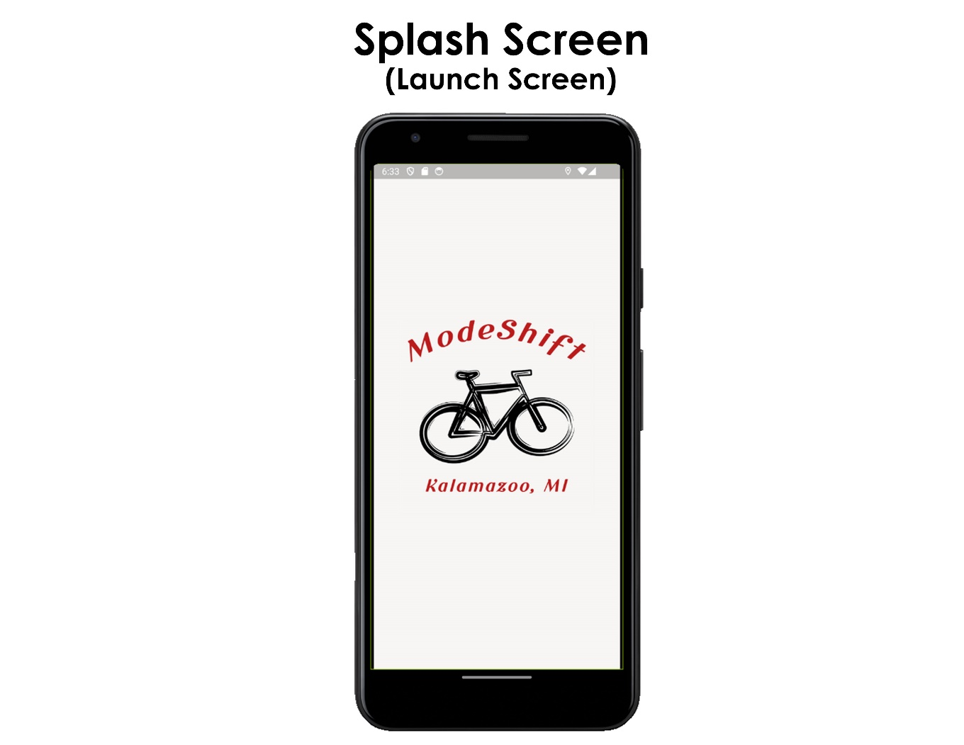

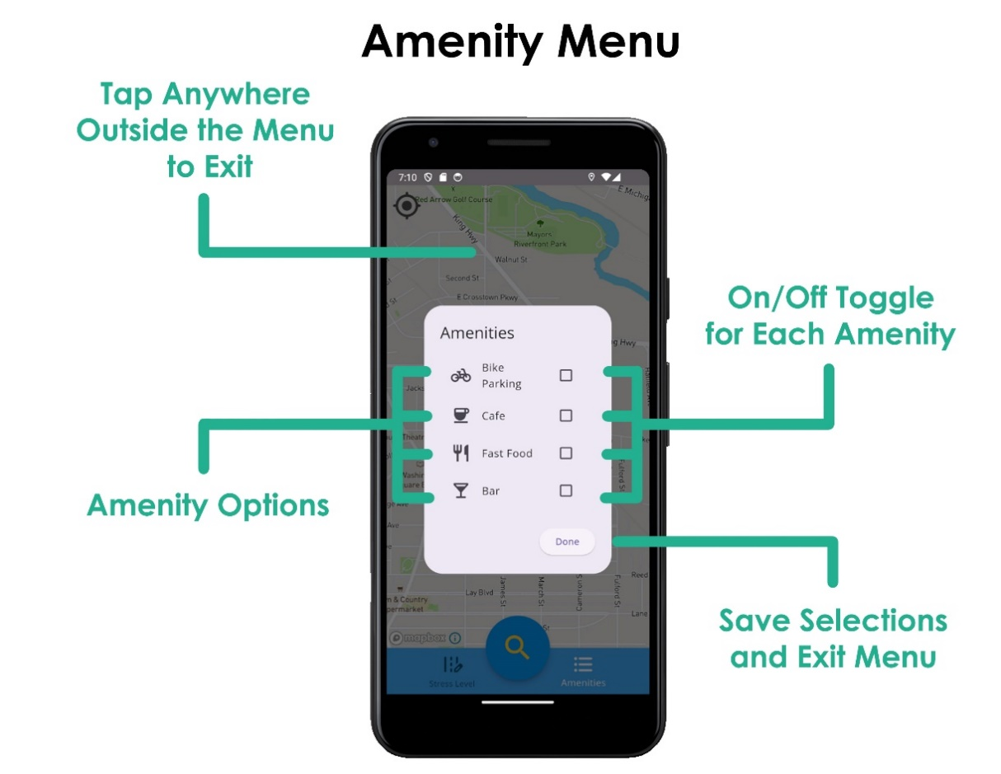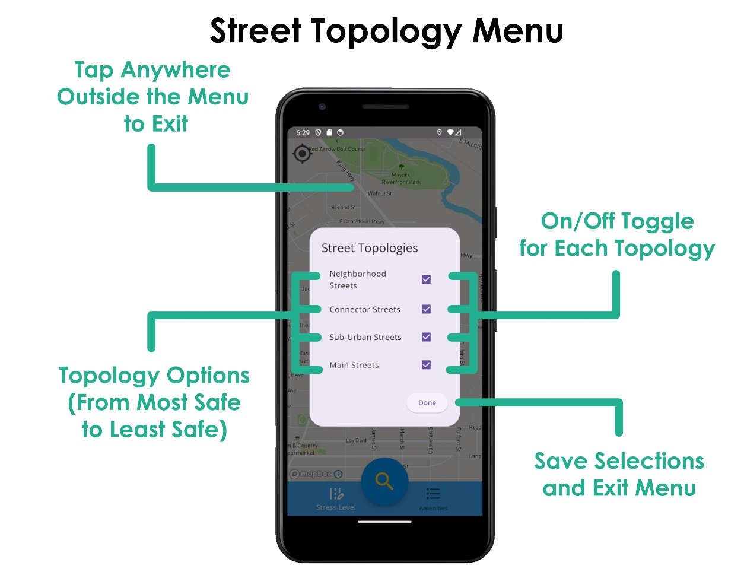

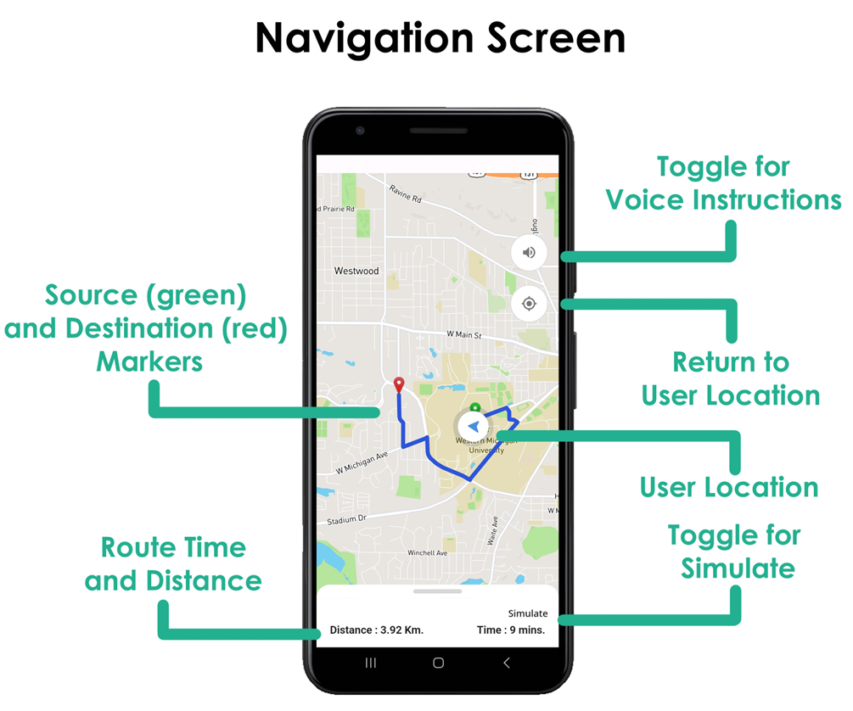

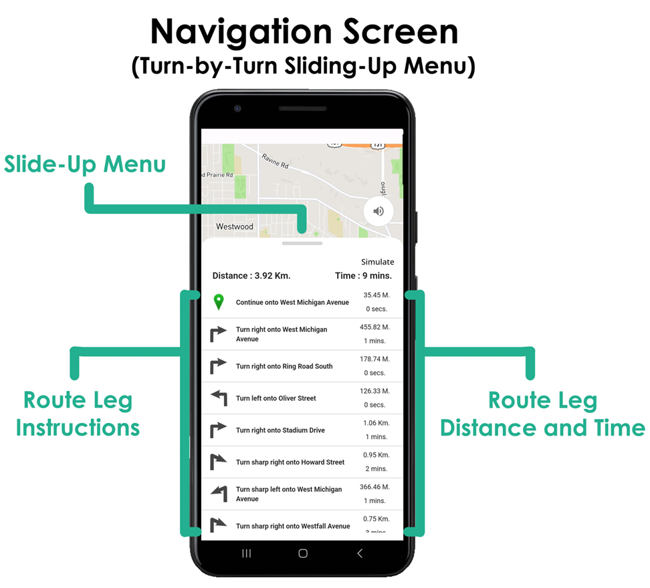

**2.1 Usability Requirements:**

* The application shall be compatibility with all mobile devices of different screen sizes (2.1.1).
* The application shall allow users to enter starting and destination points in a text field for preparing the route (2.1.2).
* The application shall be able to switch between different road topologies preferences using checkboxes (2.1.3).
* The application shall have a menu to select amenities (2.1.4).
* The application shall have the zoom in and out functionality (2.1.5).

**Functional Requirements:**

* The application will feature a user-friendly destination entry including suggestions of addresses during typing (2.2.1).
* The application shall provide auto-fill functionality for the starting address using GPS if enabled (2.2.2).
* The application shall take into account users preferred street topologies when producing the route (2.2.3).
* The application shall show amenities on the map when they are toggled from the amenities menu (2.2.4).
* The application shall provide voice-guided navigation and turn-by-turn directions using GraphHooper (2.2.5).

**Interface Requirements:**

* The application shall have a user interface with a map-centric design. (2.3.1).
* The application shall have a user-friendly map control mechanism (2.3.2).
* The application shall take GeoJSON data from the MapBox API request and use it to display a polyline of the route on the map (2.3.3).
* The application shall take current location data (latitude and longitude) from the user's device that will be used for routing and returning the camera position to the user's location on the map (2.3.4).

**Capability Requirements:**

* The application shall allow users to input origin and destination points via text or GPS, which will be used as starting and ending locations for the route until other locations are specified by the user. (2.4.1).
* The application shall store user current location within the shared preferences, so that they can be accessed at any point during application runtime (2.4.2).
* The application shall compare returned route data against road stress levels and return the best-fitting route of those provided by MapBox API (2.4.3).
* The application shall maintain a responsive user interface with less than 2 seconds of load time. (2.4.4).

**Traceability to system requirements:**

