Create a Local VM and Auto-Scale It to Any Public Cloud Platform When Resource Usage Exceeds 75% in Local VM

Name: Megha Pandey
Roll. No: G25AI1028
Course: Virtualization and Cloud Computing
Professor: Sumit Kalra

1. Objective
The objective of this assignment is to:
- Create a local virtual machine (VM)
- Monitor system resource usage (CPU)
- Automatically trigger scaling to a public cloud platform (Google Cloud Platform)
- Deploy a mechanism that creates a new cloud VM when resource usage exceeds 75%

2. Tools and Technologies Used
- Oracle VirtualBox
- Ubuntu 24.04 LTS
- Python
- psutil library
- Google Cloud Platform (GCP)
- gcloud CLI

3. Step-by-Step Implementation

3.1 Local VM Creation
A virtual machine was created using Oracle VirtualBox with the following configuration:
- VM Name: Megha_Local_VM
- OS: Ubuntu 24.04 LTS
- RAM: 2 GB
- CPU: 2 cores
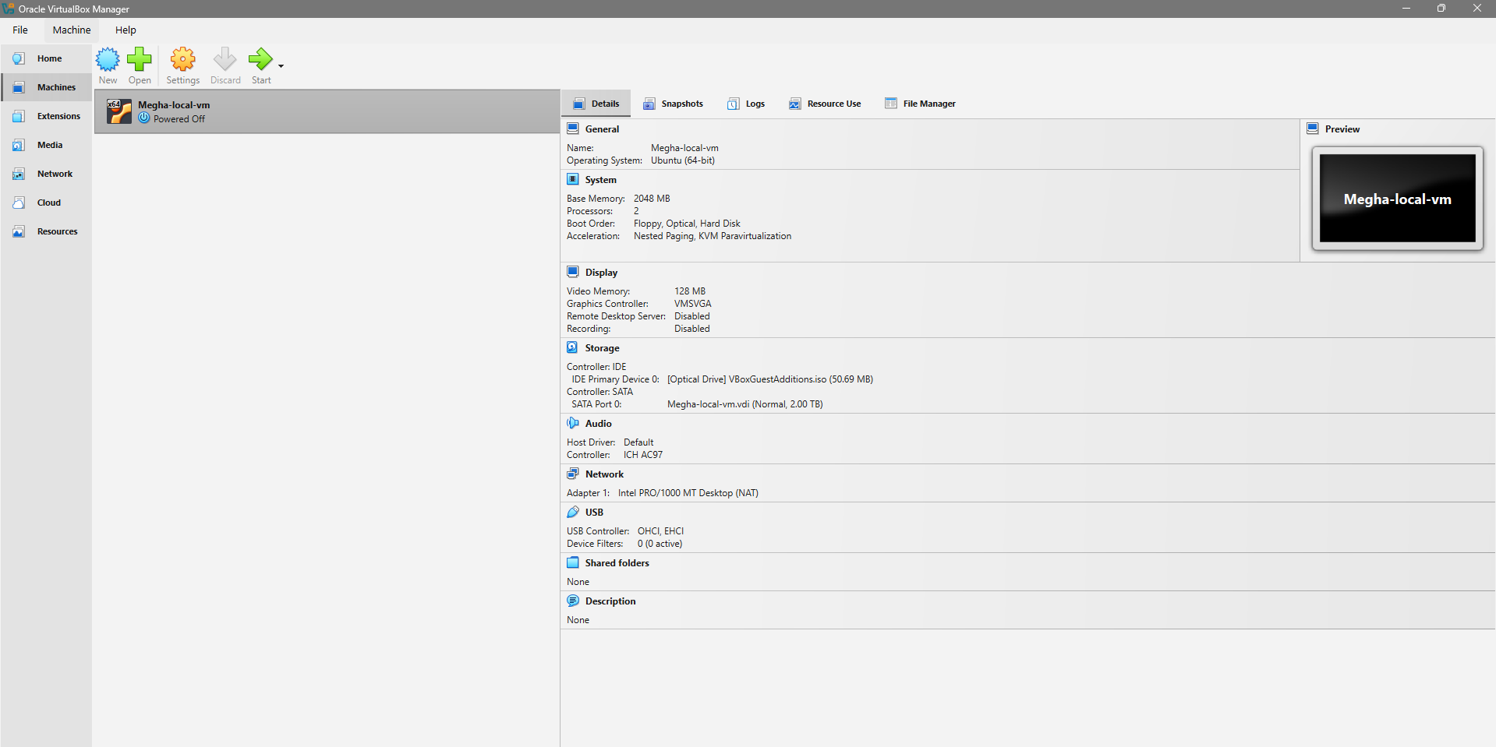
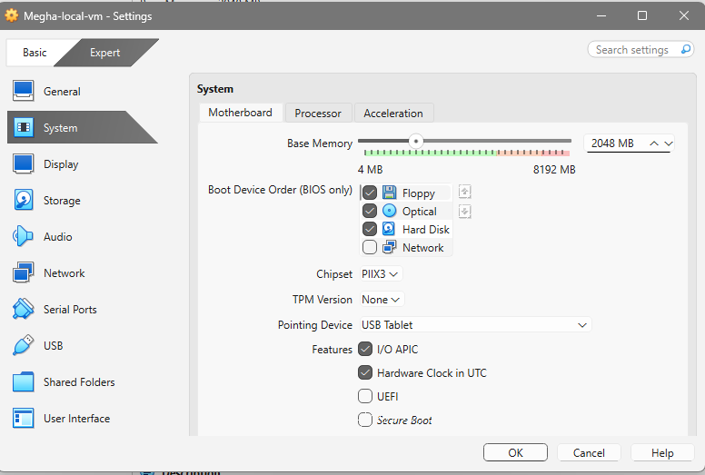
3.2 Resource Monitoring Setup
Python and required libraries were installed with below command
sudo apt install python3-psutil
sudo systemctl start docker
sudo systemctl enable docker

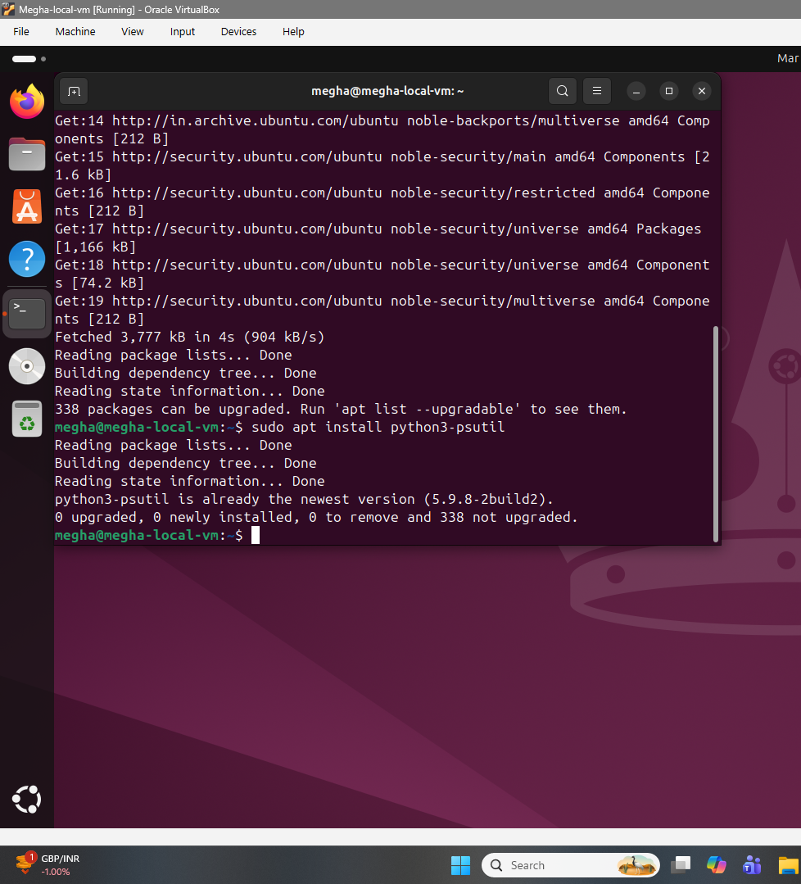

A Python script (monitor.py) was created to monitor CPU usage.

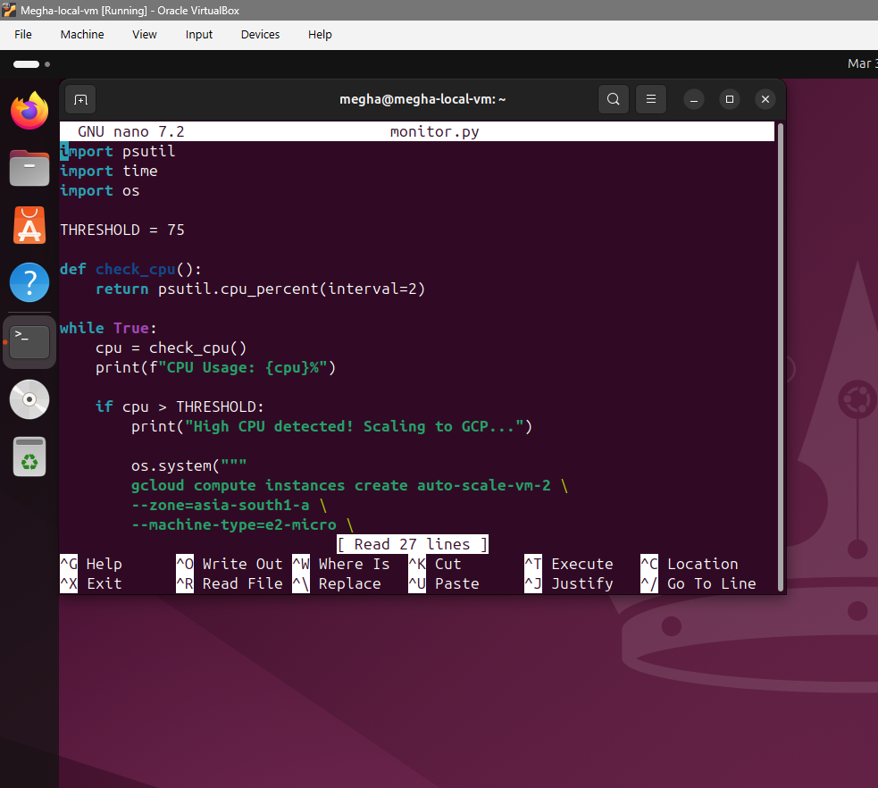

import psutil
import time
import os

THRESHOLD = 75

def check_cpu():
return psutil.cpu_percent(interval=2)

while True:
cpu = check_cpu()
print(f"CPU Usage: {cpu}%")

if cpu > THRESHOLD:
print("High CPU detected! Scaling to GCP...")

os.system("""
gcloud compute instances create auto-scale-vm-2 \
--zone=asia-south1-a \
--machine-type=e2-micro \
--image-family=debian-11 \
--image-project=debian-cloud
""")

break

time.sleep(5)

Create Auto-Scaling Script
Create file:
nano scale_to_gcp.py

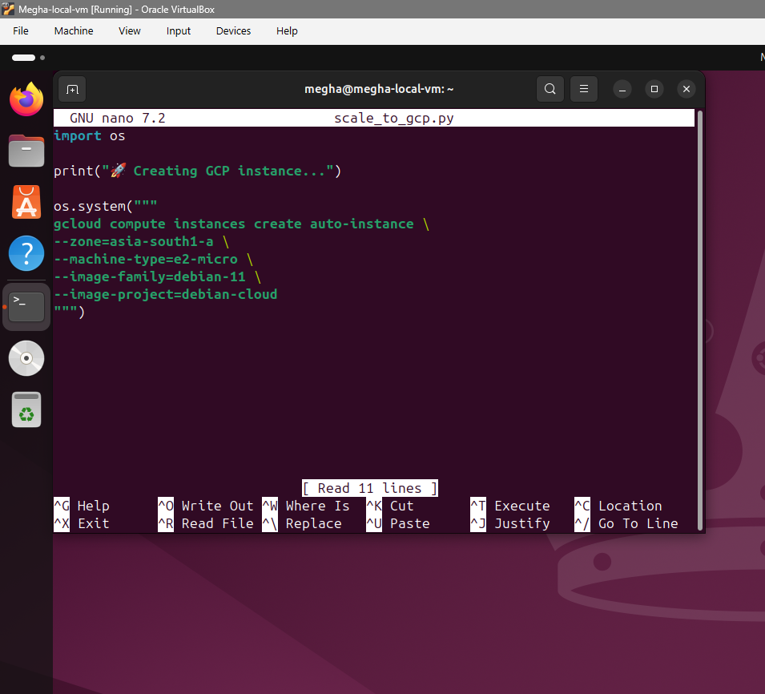

3.3 GCP Setup
Install GCP CLI
Step 1: Update system
sudo apt update
Step 2: Install required packages
sudo apt install apt-transport-https ca-certificates gnupg curl -y
Step 3: Add Google Cloud GPG key
curl https://packages.cloud.google.com/apt/doc/apt-key.gpg | sudo gpg --dearmor -o /usr/share/keyrings/cloud.google.gpg
Step 4: Add GCP repository
echo "deb [signed-by=/usr/share/keyrings/cloud.google.gpg] http://packages.cloud.google.com/apt cloud-sdk main" | sudo tee /etc/apt/sources.list.d/google-cloud-sdk.list
Step 5: Install gcloud CLI
sudo apt update
sudo apt install google-cloud-cli -y
STEP 6: Initialize GCP
gcloud init

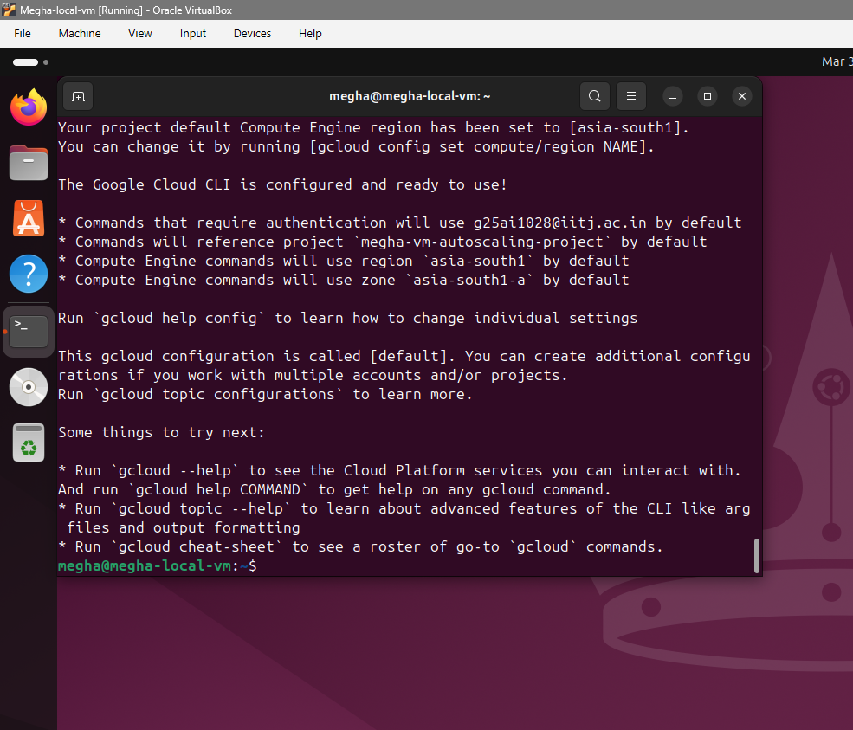
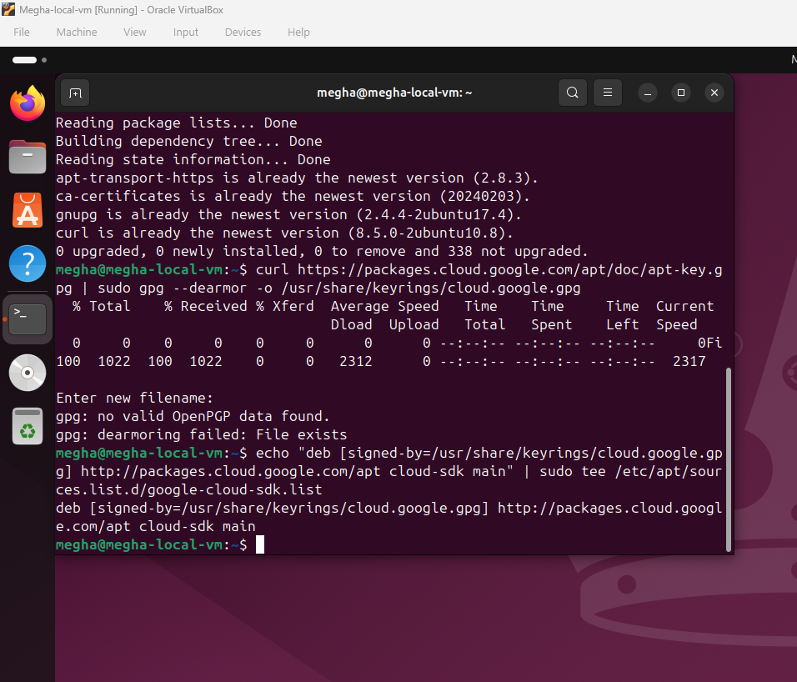

Google Cloud CLI was installed and configured.
- Project created: megha-vm-autoscaling-project
- Region: asia-south1
- Zone: asia-south1-a

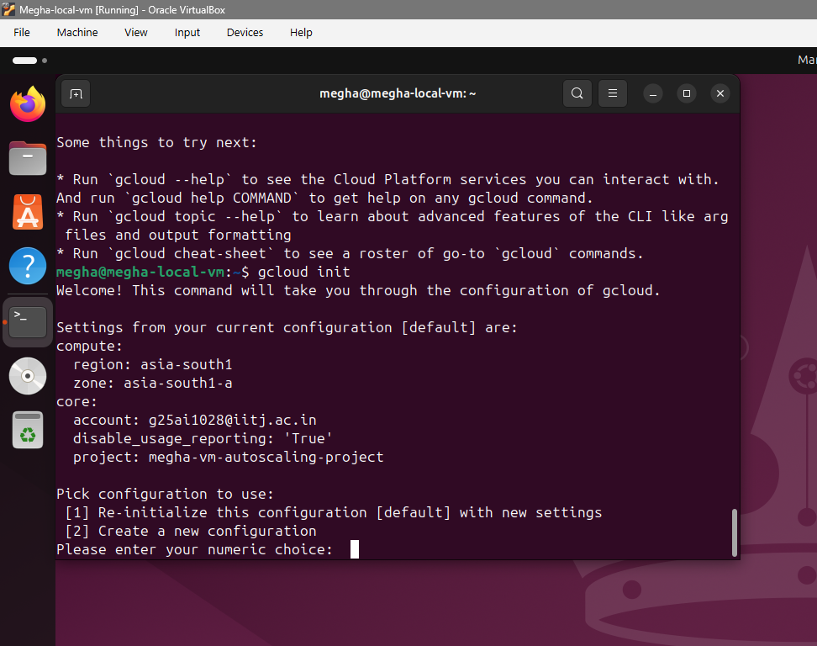

3.4 Monitoring Execution
The monitoring script was executed:
python3 monitor.py
Load Simulation
CPU load was increased artificially:
yes > /dev/null &

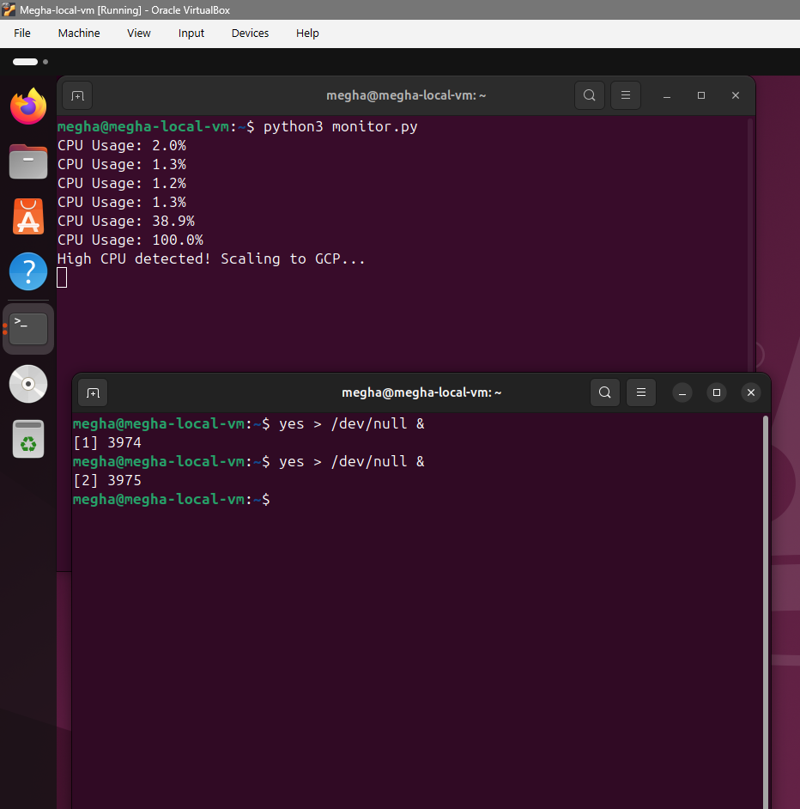
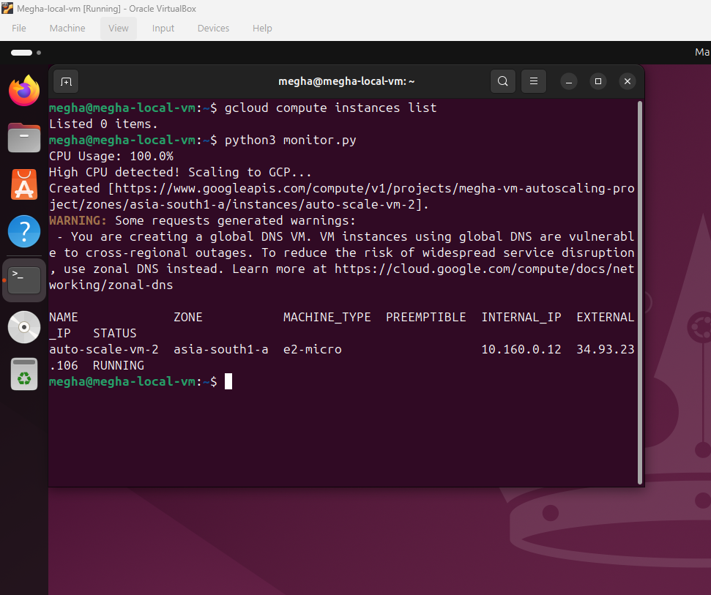

A new VM (auto-scale-vm-2) was successfully created.

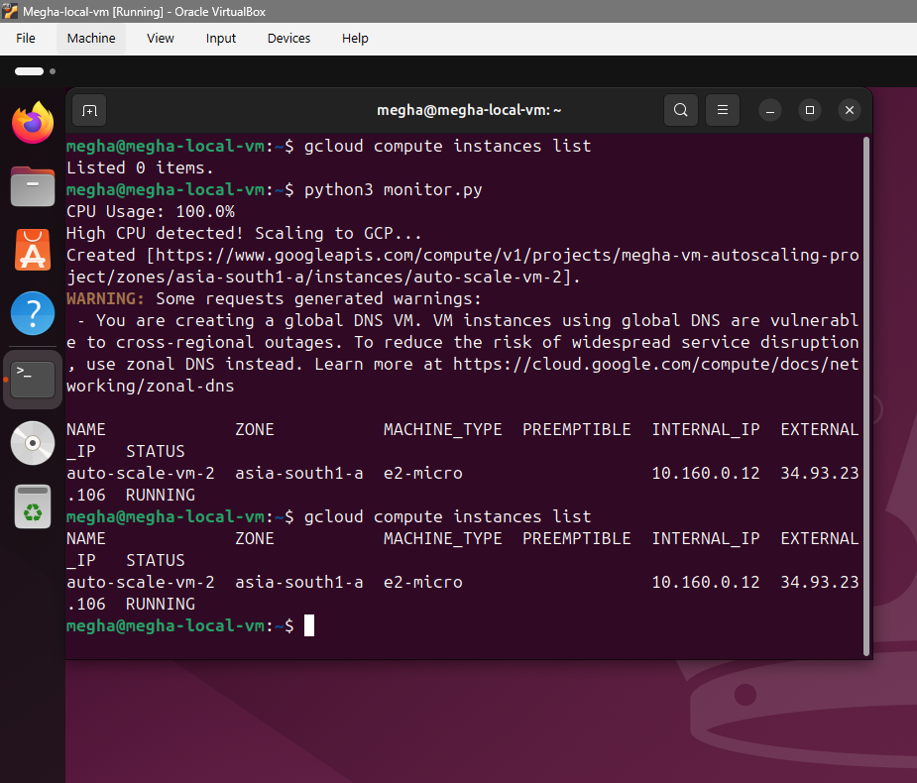

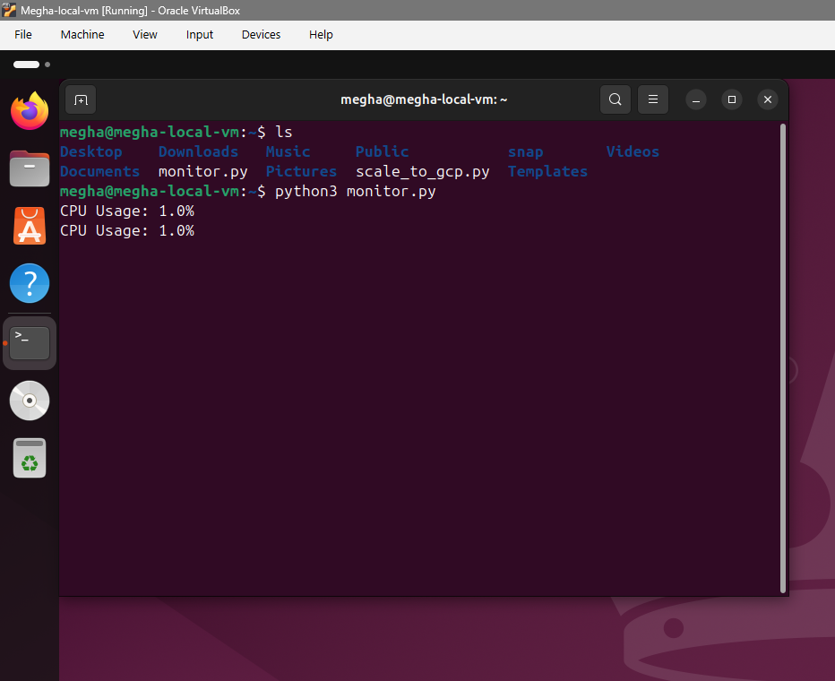

5. Source Code Repository
GitHub Repository Link:
https://github.com/Codewith-Megha/-Create-a-Local-VM-and-Auto-Scale-It-to-Any-Public-Cloud-Platform/tree/main

6. Video Demonstration
Video Link:

https://drive.google.com/file/d/13uWFhU-lR0_KvpbsoRj6kYOMy7iuGarS/view?usp=sharing

7. Conclusion
This project successfully demonstrates auto-scaling from a local VM to Google Cloud Platform based on CPU usage. When the CPU exceeded 75%, a new VM was automatically created, validating the implementation.

