Virtual Machine Networking and Microservice Deployment using VirtualBox
Name: Megha Pandey
Roll. No: G25AI1028
Course: Virtualization and Cloud Computing
Professor: Sumit Kalra
Tools Used: Oracle VirtualBox, Ubuntu Linux, Node.js, Express.js

1. Objective
The objective of this assignment is to create and configure multiple Virtual Machines (VMs) using Oracle VirtualBox, establish a private network between them, and deploy a simple microservice-based application. One VM hosts a Node.js REST API, while the second VM acts as a client that communicates with the API over the configured network.

2. Environment Setup
2.1 VirtualBox Installation
Oracle VirtualBox is installed on the host machine to create and manage virtual machines. Ubuntu (64-bit) ISO was used as the guest operating system.
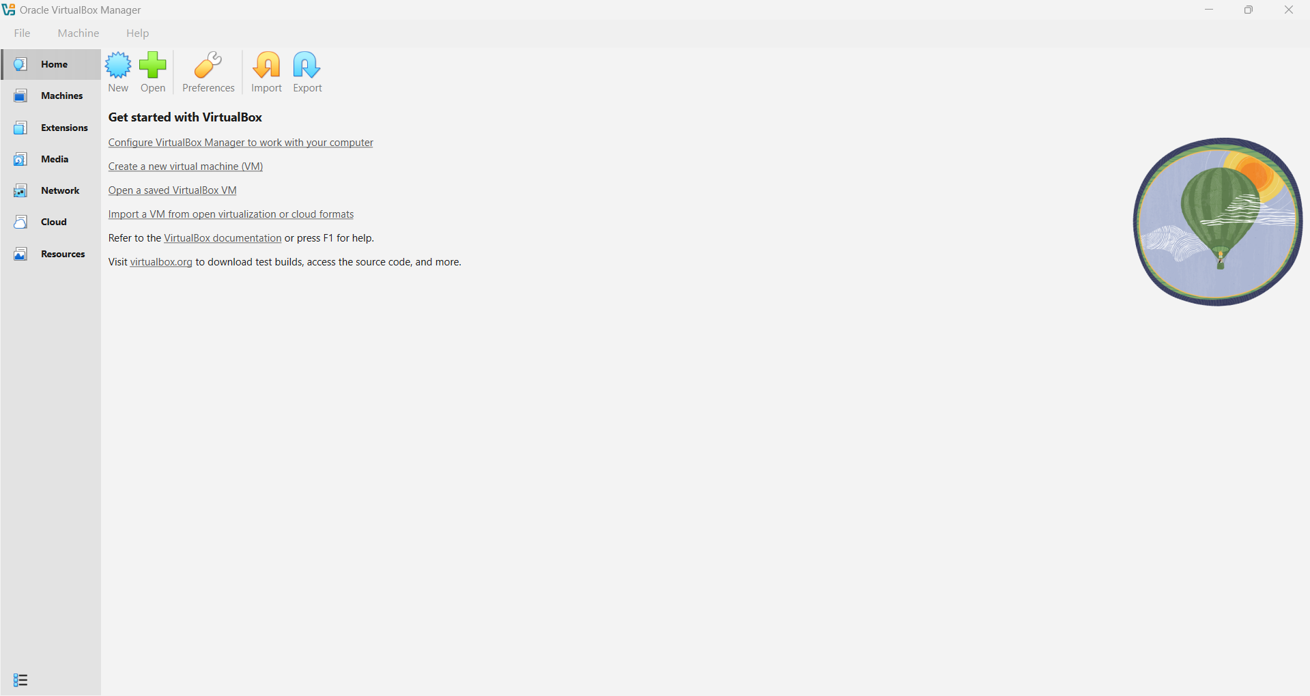

3. Virtual Machine Configuration
Two Ubuntu-based virtual machines are created.
3.1 VM 1 – API Server
VM Name: Megha_microservice_api
Role: Hosts the microservice (Node.js REST API)
System Configuration
- Operating System: Ubuntu (64-bit)
- Base Memory: 2048 MB
- CPUs: 2
- Storage: Virtual Hard Disk (VDI)
Network Configuration
- Adapter 1: Host-only Adapter
- Network Name: VirtualBox Host-Only Ethernet Adapter
- Adapter Type: Intel PRO/1000 MT Desktop
- IP Address (assigned via DHCP): 192.168.56.101
- Purpose: Enables private communication with the client VM

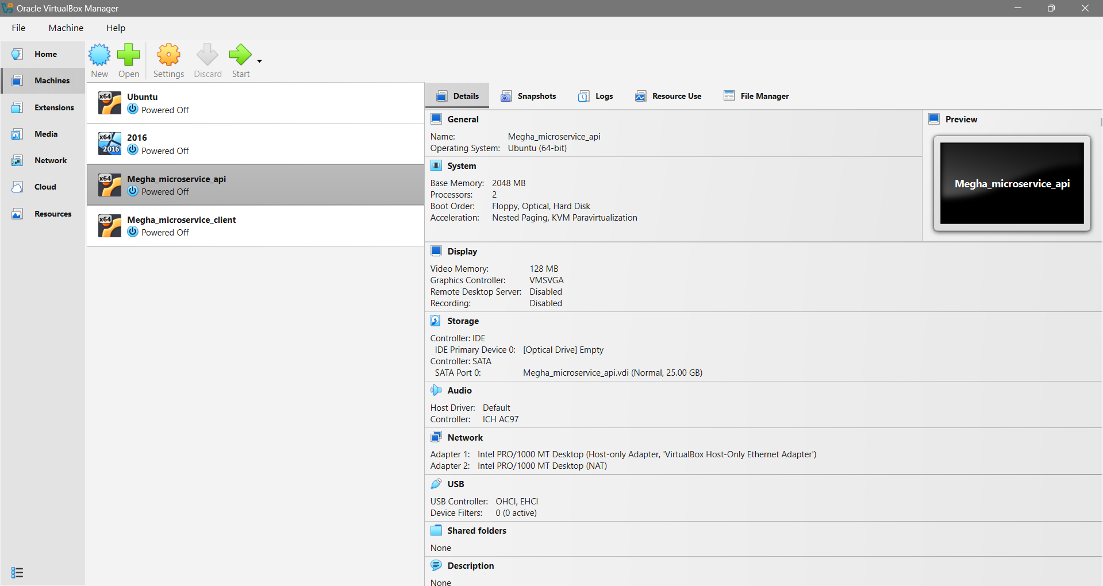

3.2 VM 2 – Client Machine
VM Name: Megha_microservice_client
Role: Acts as the consumer of the microservice
System Configuration
- Operating System: Ubuntu (64-bit)
- Base Memory: 2048 MB
- CPUs: 2
- Storage: Virtual Hard Disk (VDI)
Network Configuration
- Adapter 1: Host-only Adapter
- Network Name: VirtualBox Host-Only Ethernet Adapter
- Adapter Type: Intel PRO/1000 MT Desktop
- IP Address (assigned via DHCP): 192.168.56.102

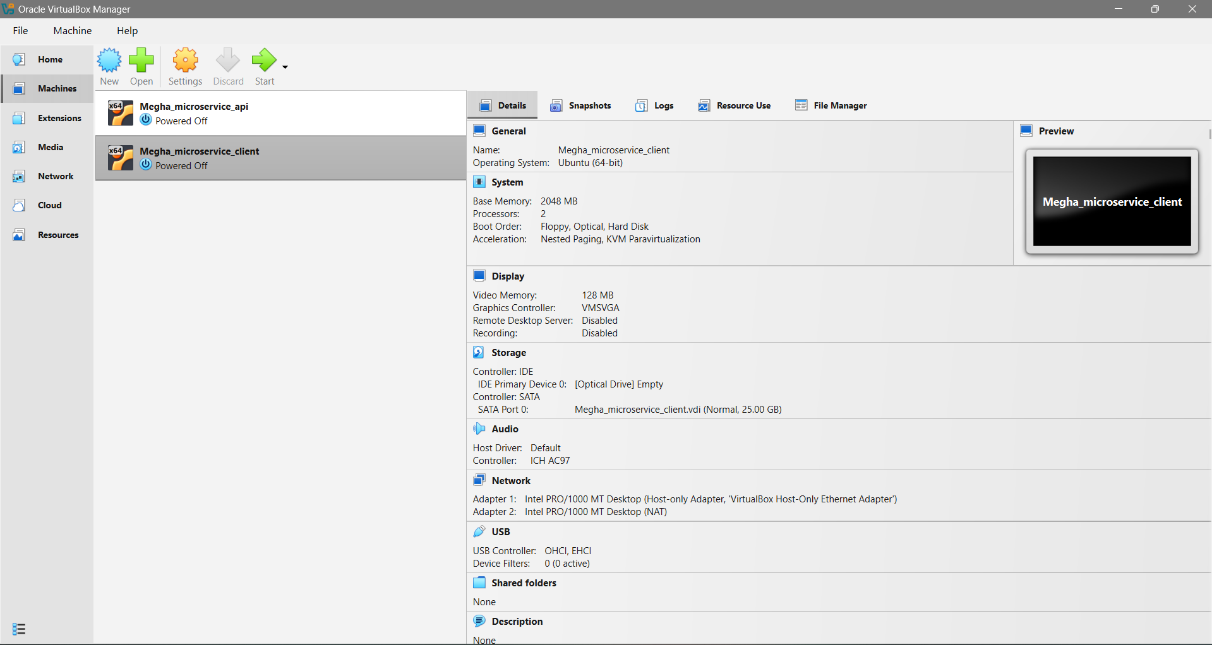

4. Network Connectivity Verification
To verify connectivity between the two VMs, ICMP ping tests were performed.
From Client VM to API VM
ping 192.168.56.101
From API VM to Client VM
ping 192.168.56.102
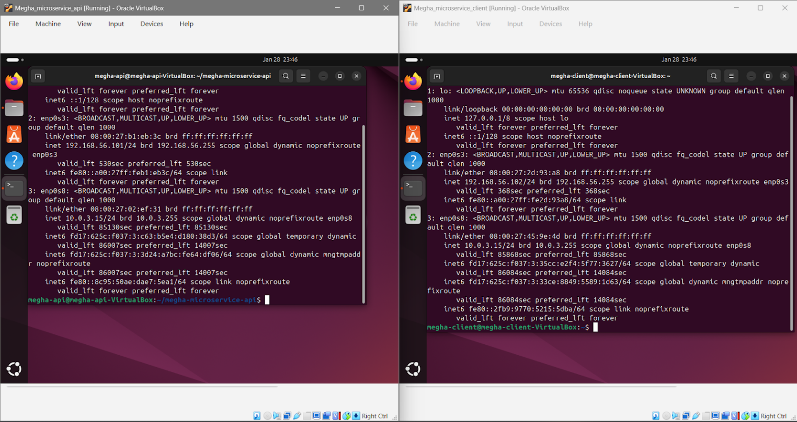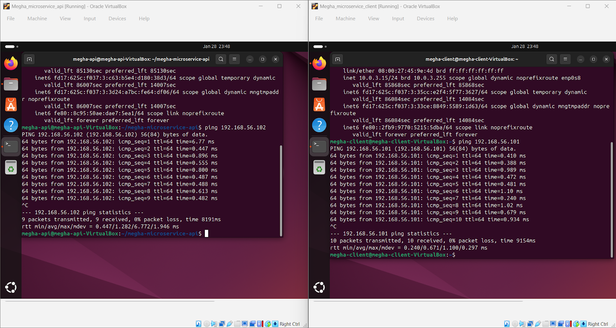
Both VMs successfully communicated with each other with 0% packet loss, confirming correct network configuration.

5. Microservice Deployment
5.1 Technology Stack
- Node.js (v18.19.1)
- npm (9.2.0)
- Express.js
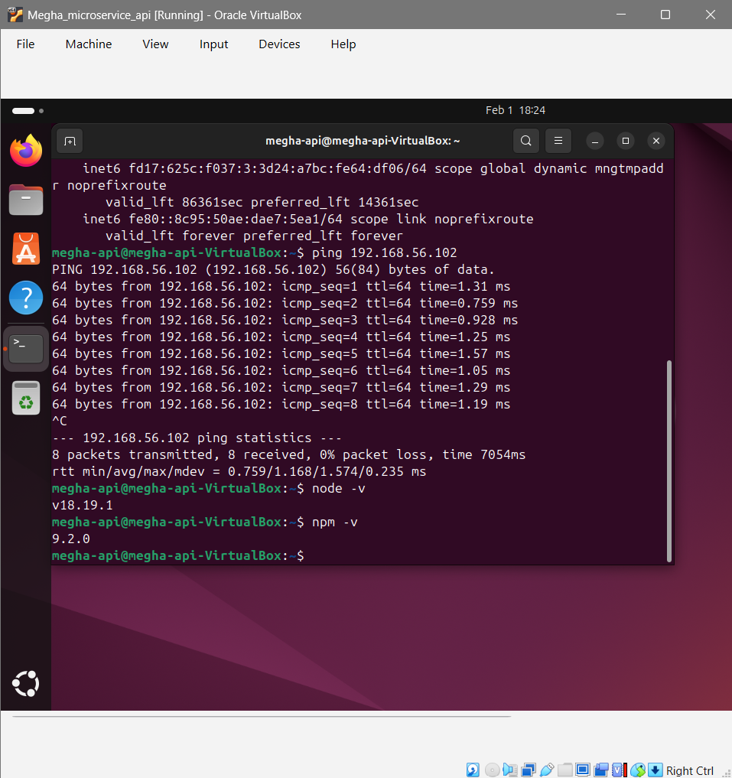
5.2 Microservice Source Code
const express = require('express');
const app = express();
app.get('/api/hello', (req, res) => {
res.json({
message: "Hello from Megha's Microservice API",
vm: "Megha_microservice_api",
status: "success"
});
});
app.listen(3000, '0.0.0.0', () => {
console.log("Microservice API running on port 3000");
});
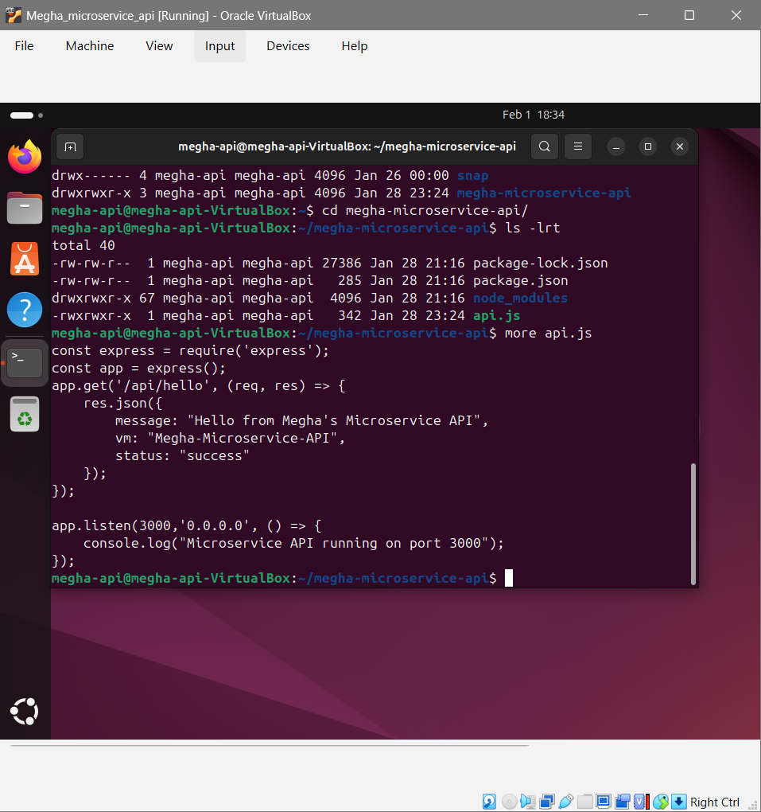

5.4 Running the Microservice
On the API VM:
node api.js
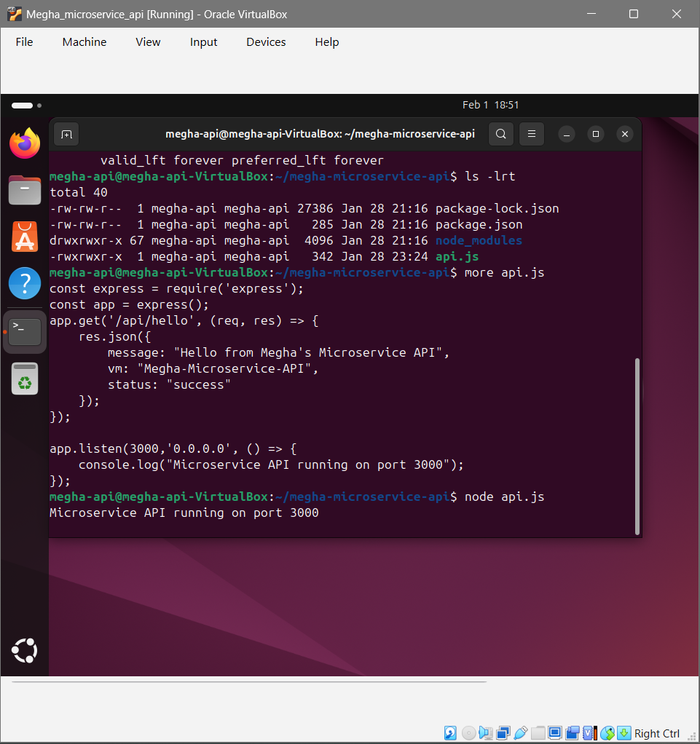

6. Accessing the Microservice from Client VM
Since both VMs are on the same Host-only network, the client accesses the API using the API VM’s IP address.

Request from Client VM
curl http://192.168.56.101:3000/api/hello

Response
{
"message": "Hello from Megha's Microservice API",
"vm": "Megha_microservice_api",
"status": "success"
}
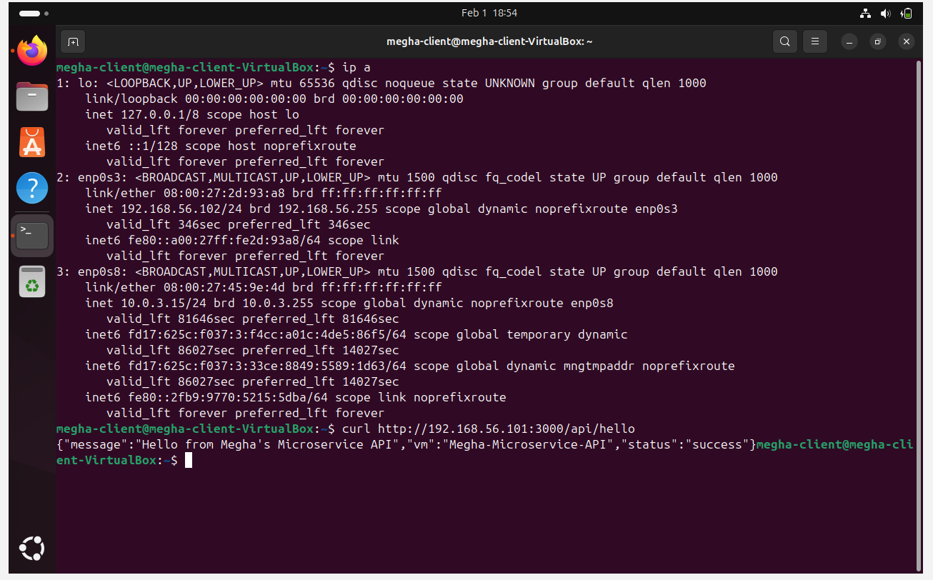
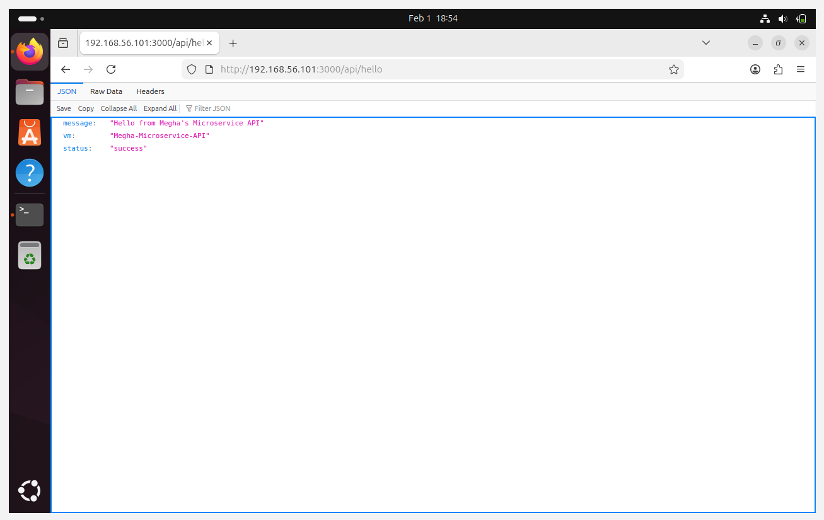
7. Architecture Design
System Architecture Description
- Two Ubuntu VMs running on Oracle VirtualBox
- Connected via a Host-only private network
- API VM hosts the Node.js microservice
- Client VM consumes the REST API using HTTP
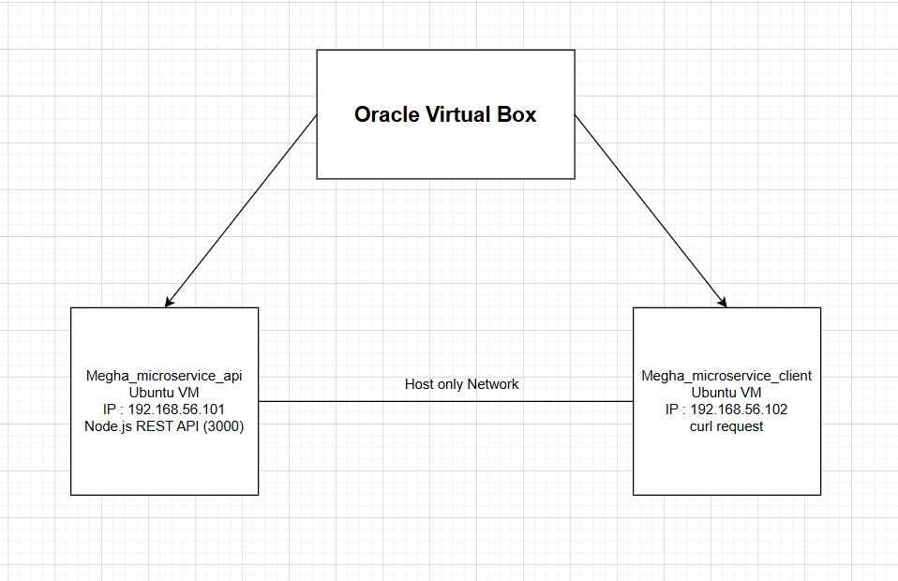

8. Source Code Repository
GitHub Repository:
(Upload your project and paste the link here)
Example:
https://github.com/megha/microservice-vm-assignment

9. Video Demonstration
🔗 Recorded Video Link:
(Upload to Google Drive / YouTube – unlisted)
The video demonstrates:
- VM creation
- Network configuration
- Ping test
- Node.js API execution
- Client accessing the API

10. Plagiarism Declaration
Plagiarism Clause
I hereby declare that this assignment is my original work. The implementation, code, configuration, and documentation have been created solely by me. I understand that any form of plagiarism in implementation, source code, or documentation will result in disqualification as per academic regulations.
Student Signature: Megha
Date: (Add date)

