LandSetu: An AI-Powered Policy Intelligence Platform for Evidence-Based Land Governance
[Author Name(s)]
Department of Computer Science (Data Science)
Noida Institute of Engineering and Technology, Greater Noida, India
[email@example.com] | [Contact Number]
Abstract—India's land governance ecosystem is characterized by fragmented and non-interoperable data systems. Land records, public grievances, and policy decisions are managed independently by disparate authorities — state land departments, the Department of Land Resources (DoLR), and municipal bodies — resulting in limited visibility into ground-level land issues at the policy-making level. This research addresses the absence of a unified, intelligence-driven decision-support system that integrates land data, public grievances, and policy simulation into a single accessible platform. We propose LandSetu, an AI-powered platform for land governance and policy intelligence that integrates land records, complaint data, and legal/policy information across administrative silos, applies GIS-based spatial analysis to identify dispute and encroachment patterns, and employs a machine-learning-based delay-risk prediction module to help evaluate the potential impact of proposed land policy interventions. The proposed architecture uses a three-layer design (Input, Processing, Output) combining OCR/NLP for document digitization, spatial analysis for geospatial patterns, and a HistGradientBoosting-based classifier for predicting delay risk in land-related projects. A synthetic pilot dataset (n=600) modeled on project characteristics, historical dispute indices, and geospatial features was used to validate the delay-risk prediction module, achieving 74.0% accuracy and a ROC-AUC of 0.767, with the historical dispute index emerging as the most influential predictor. These preliminary results demonstrate the technical feasibility of the proposed pipeline; field validation on real government datasets remains necessary before deployment. This work contributes toward a scalable, evidence-based model for land governance in India, with potential applicability to similar public-sector data integration challenges.
Keywords—Land Governance, Policy Intelligence, Artificial Intelligence, GIS, Evidence-Based Decision Making, Machine Learning, Risk Prediction
1. INTRODUCTION
Land is not only a source of livelihood in India but also an essential element of social identity and economic security. Land administration has historically been plagued by inefficiencies, with records maintained across disconnected registries — land revenue departments, survey and settlement records, geospatial datasets, and citizen grievance forums, among others [1], [2]. Because these registries are siloed, they cannot provide the holistic view needed to identify patterns such as clusters of land disputes, persistent delays in mutation or title regularization, or regions with disproportionately high concentrations of grievances.
The Government of India has launched large-scale efforts to digitize land records through initiatives such as the Digital India Land Records Modernization Programme (DILRMP), promising greater transparency and more efficient service delivery [7]. However, digitization alone does not resolve the deeper structural problem: digitized data still resides in disconnected systems, and no unified analytical layer exists to convert this data into actionable policy insight. Recent advances in artificial intelligence — including optical character recognition (OCR), natural language processing (NLP), and machine learning — create a technically credible path to address this problem structurally, by consolidating fragmented land governance data into a single evidence-based decision-support platform.
This paper presents LandSetu, an AI-powered policy intelligence platform for land governance. The paper makes the following contributions: (i) it formally defines the fragmentation problem in Indian land governance and situates it within existing literature; (ii) it proposes a three-layer system architecture combining data integration, AI/spatial analytics, and policy dashboards; (iii) it describes a machine-learning pipeline for predicting land-dispute delay risk; and (iv) it reports preliminary validation results on a synthetic pilot dataset constructed to reflect realistic project, dispute, and geospatial characteristics.
2. PROBLEM STATEMENT
Land governance in India suffers from a structural absence of interoperability. Decisions made by one authority — for instance, a state land department reclassifying land use — are frequently invisible to other stakeholders such as municipal grievance cells or the judiciary, until a dispute forces reconciliation. Existing digitization efforts capture information within individual systems but do not address the problem of information travelling between them.
Formally, the problem this paper addresses is: how can artificial intelligence, geospatial analysis, and natural language processing be leveraged to consolidate fragmented land governance data — state land records, scanned document archives, and citizen grievance channels — into a unified, evidence-based framework that supports proactive, informed policy-making and enables early prediction of land-dispute-related delays?
3. RESEARCH GAP
Existing decision-support systems (DSS) for land and rural resource governance fall into three broad categories, none of which fully addresses the problem above. First, geospatial governance frameworks such as the Geospatial Governance Decision Support Framework (GG-DSF) [6] demonstrate that GIS-based rule engines and optimization can produce auditable, budget-aware resource allocation plans, but are focused on soil and water conservation rather than land-dispute and grievance data. Second, secondary-research studies on land digitization [7] establish the governance importance of digitized land records but rely purely on literature synthesis, without proposing or testing a technical system. Third, AI-GIS integration studies in adjacent domains (e.g., groundwater quality estimation [9]) demonstrate the feasibility of combining machine learning with spatial data, but have not been applied to land dispute or grievance prediction.
None of these bodies of work integrates (a) multi-source land governance data ingestion via OCR/NLP, (b) spatial dispute-pattern analysis, and (c) predictive risk scoring for land-related project delays, within a single, policy-facing platform. LandSetu is positioned to address this gap.
4. OBJECTIVES
- To design a unified data-integration pipeline that ingests state land records, OCR-scanned legal documents, and public grievance data into a common analytical framework.
- To apply spatial and geospatial analysis techniques to identify land dispute clusters, encroachment patterns, and regions of concentrated grievance activity.
- To develop and evaluate a machine-learning model for predicting the delay risk associated with land-related projects, based on project, historical-dispute, and geospatial features.
- To validate the proposed pipeline on a representative pilot dataset and report quantitative performance metrics for the delay-risk prediction module.
5. LITERATURE REVIEW
A. Land Governance and Digitization
Deininger and Feder [1] argue that secure and reliable land records are essential for reducing disputes and supporting economic development, establishing the foundational case for land-record reform. Banerjee and Iyer [2] show that historical land tenure systems in India created long-term governance challenges rooted in colonial-era administrative fragmentation, underscoring that today's data silos have deep institutional origins rather than purely technical causes. The World Bank [4] reports that countries adopting digital land records have seen measurable reductions in land disputes and faster public service delivery, suggesting similar potential for India. However, Nielsen [3] cautions that digitization without adequate accessibility safeguards can exclude vulnerable groups, particularly citizens with limited digital literacy — a risk that any policy intelligence platform, including LandSetu, must account for in its interface design. Mukherjee [5] similarly argues that governance reforms must prioritize citizen-centric, inclusive design rather than efficiency alone.
B. Geospatial Decision Support Systems
Rajankar et al. [6] propose a Geospatial Governance Decision Support Framework (GG-DSF) that combines spatial data mining, GIS-based overlay analysis, and integer linear programming (ILP) to generate auditable, budget-constrained resource allocation plans for soil and water conservation, validated on a village-scale case study with measurable improvements (+24.3% water storage efficiency, +24.4% land utilization). This work demonstrates that rule-based, spatially explicit decision support can be made both auditable and policy-relevant — a design principle LandSetu adopts for its own rule engine and dashboard outputs. Jeihouni et al. [9] similarly combine decision-tree-based data mining with GIS to identify high-quality groundwater zones, demonstrating the broader feasibility of hybrid AI-GIS pipelines in natural-resource governance contexts, though not applied to land dispute prediction specifically.
C. Retrieval and Knowledge-Grounded AI
Lewis et al. [8] introduce retrieval-augmented generation (RAG), demonstrating that language model outputs can be grounded in external knowledge stores to reduce hallucination and reflect current, verifiable information. This principle motivates LandSetu's use of a legal knowledge-retrieval component (Section VI) to ground policy recommendations in actual statutes and prior rulings rather than unverified model output.
D. Summary
The reviewed literature establishes that (i) land governance fragmentation has deep institutional roots, (ii) geospatial rule-based decision support is technically feasible and policy-relevant, and (iii) AI-GIS integration is an active and productive research direction. However, no reviewed work combines multi-source land governance data ingestion, spatial dispute analysis, and predictive delay-risk modeling into a single evidence-based platform — the gap this paper addresses.
6. PROPOSED SYSTEM ARCHITECTURE
LandSetu is structured as a three-layer architecture, illustrated in Fig. 1: an Input Layer, a Processing Layer, and an Output Layer.
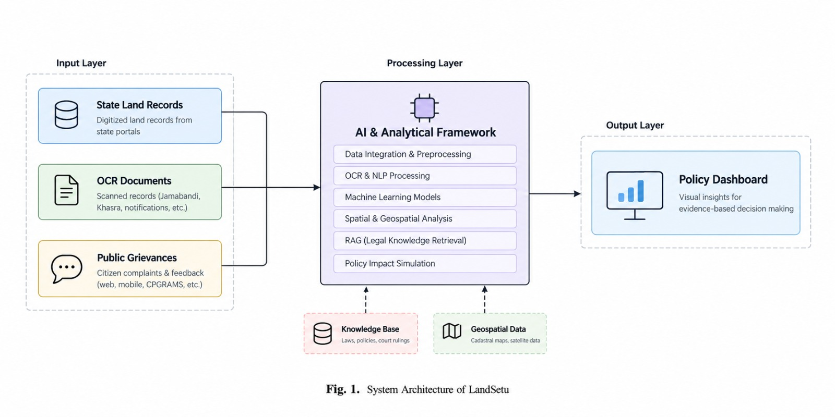
Fig. 1. System architecture of LandSetu. The Input Layer ingests state land records, OCR-scanned documents, and public grievances. The Processing Layer applies data integration, OCR/NLP, machine learning, spatial analysis, retrieval-augmented legal knowledge lookup, and policy impact simulation. The Output Layer presents results via a policy dashboard.
A. Input Layer
- State Land Records: digitized land records retrieved from state land-record portals.
- OCR Documents: scanned legacy records such as Jamabandi and Khasra registers, and government notifications.
- Public Grievances: citizen complaints and feedback collected via web, mobile, and platforms such as CPGRAMS.
B. Processing Layer
The processing layer performs six functions: data integration and preprocessing; OCR and NLP processing of scanned and unstructured text; machine-learning-based prediction (Section VII); spatial and geospatial analysis of dispute and encroachment patterns; retrieval-augmented generation (RAG) over a legal knowledge base of statutes, policies, and court rulings, following the grounding approach of [8]; and policy impact simulation to estimate the effect of proposed interventions before implementation.
C. Output Layer
Processed insights are surfaced through a policy dashboard providing visual, evidence-based summaries for decision-makers, including risk maps, prioritized case lists, and simulation outputs.
D. Real-Time Data Synchronization
Fig. 3 illustrates the real-time interaction between external stakeholders and the AI Risk Engine at the core of LandSetu. Citizens submit grievances and documents through a Citizen Portal, which receives acknowledgement and status updates in return. Government databases (state land records, litigation data, and policy/regulatory data) are synchronized with the AI Risk Engine in real time. The engine performs data processing, applies machine-learning models, and computes risk scores, forwarding processed insights and risk flags back to the government database and to an Officer Dashboard, where officials visualize risk maps, prioritize cases, and monitor action taken.
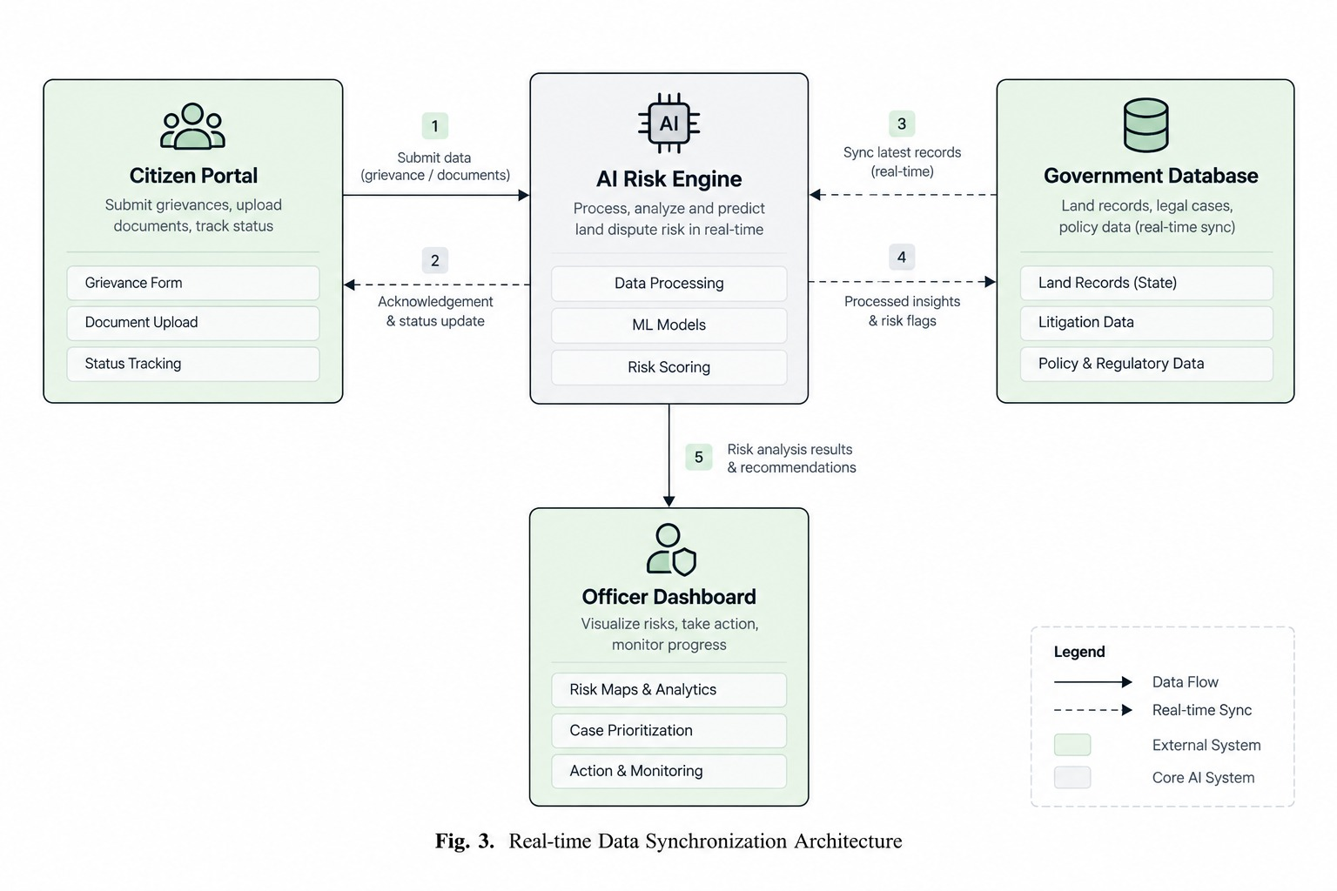
Fig. 3. Real-time data synchronization architecture connecting the Citizen Portal, AI Risk Engine, Government Database, and Officer Dashboard.
7. DELAY-RISK PREDICTION PIPELINE
A central module of LandSetu's processing layer is a machine-learning pipeline for predicting the delay risk of land-related projects, illustrated in Fig. 2. The pipeline consists of four stages: data preprocessing (cleaning, missing-value handling, normalization, and data integration), feature engineering, model training, and prediction.
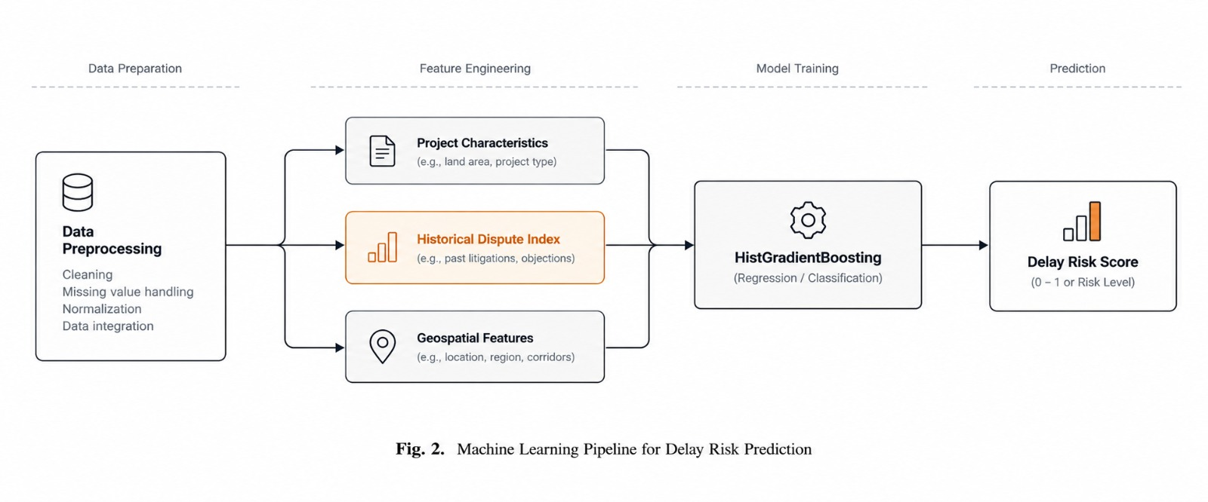
Fig. 2. Machine learning pipeline for delay risk prediction, from data preprocessing through feature engineering, model training, and prediction of a delay risk score.
Three feature groups are engineered: project characteristics (e.g., land area, project type), the historical dispute index (e.g., past litigations and objections associated with the parcel or region), and geospatial features (e.g., location, region, and infrastructure corridors). These features are passed to a Histogram-based Gradient Boosting (HistGradientBoosting) model, chosen for its native handling of missing values and its efficiency on tabular data with mixed feature types, to produce a delay risk score.
8. DATASET AND EXPERIMENTAL SETUP
Because integrated, de-identified government land-dispute datasets are not yet publicly accessible for external validation, the delay-risk prediction module was evaluated on a synthetic pilot dataset constructed to reflect the feature distributions described in Fig. 2. This approach follows an established practice in early-stage geospatial and policy decision-support research, where pilot or simulated data is used to demonstrate technical feasibility ahead of field-scale deployment [6].
The synthetic dataset (n = 600 records) was generated with the following fields: land area (hectares, gamma-distributed), project type (residential, agricultural, infrastructure, or commercial), historical dispute index (0–10 scale, beta-distributed), number of past litigations (Poisson-distributed, correlated with the dispute index), distance to the nearest urban center (kilometers), and a region risk score (0–10 scale). A binary delay-risk label (high/low) was generated from a weighted combination of these features plus stochastic noise, so that the historical dispute index and past litigations were the dominant — but not sole — drivers of delay risk, reflecting a realistic, imperfectly separable classification problem.
The dataset was split into training (75%, n = 450) and test (25%, n = 150) subsets using stratified sampling. A HistGradientBoostingClassifier (scikit-learn) was trained with a maximum depth of 4 and a learning rate of 0.08.
9. RESULTS
Table I summarizes the classification performance of the delay-risk prediction model on the held-out test set (n = 150).
TABLE I. DELAY-RISK PREDICTION PERFORMANCE (TEST SET, N=150)
Metric | Value
Accuracy | 0.740
Precision | 0.725
Recall | 0.773
F1-score | 0.748
ROC-AUC | 0.767

The confusion matrix (Fig. 4) shows that the model correctly classified 111 of 150 test instances (74.0%), with a relatively balanced error distribution between false positives (22) and false negatives (17), indicating no strong bias toward either class.
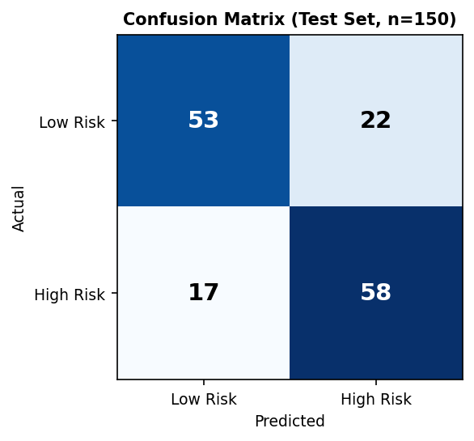
Fig. 4. Confusion matrix for the delay-risk classifier on the test set (n=150).
Permutation feature importance (Fig. 5) confirms that the historical dispute index is the strongest predictor of delay risk (importance = 0.137), followed by past litigations (0.067) and region risk score (0.054), while land area and project type contributed minimally. This is consistent with the intuitive expectation that prior dispute activity is the most informative signal for anticipating future delay, and supports the design decision to weight historical-dispute features heavily in LandSetu's risk engine.
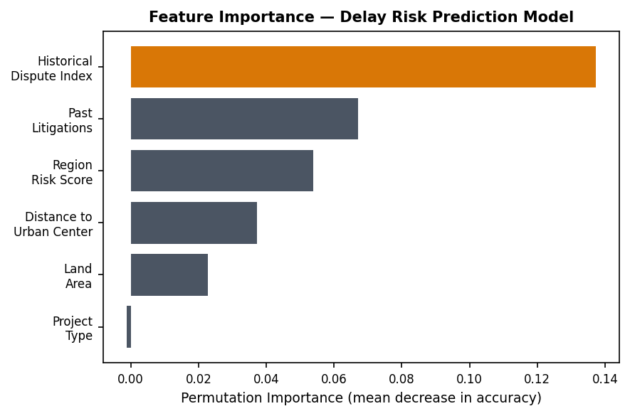
Fig. 5. Permutation feature importance for the delay-risk prediction model.
10. LIMITATIONS
- Synthetic validation: the reported performance metrics are based on a synthetically generated pilot dataset, not real government land records or litigation data. Field validation on de-identified, real land-dispute datasets is required before the delay-risk model can be considered reliable for operational deployment.
- OCR and NLP accuracy on legacy records: the accuracy of the Input Layer is dependent on the quality of scanned legacy documents (e.g., Jamabandi, Khasra), which vary considerably in condition and handwriting legibility across regions.
- Data privacy and access control: centralizing land, litigation, and grievance data in a single memory layer concentrates sensitive personal and legal information, requiring careful access-control design before deployment.
- Digital accessibility: consistent with the concerns raised by Nielsen [3], a purely digital citizen portal risks excluding citizens with limited digital literacy or connectivity, particularly in rural areas.
11. FUTURE SCOPE
- Validation on real, de-identified land-dispute and grievance datasets obtained through appropriate government data-sharing agreements.
- Integration of the RAG-based legal knowledge retrieval module with a live, versioned repository of statutes and court rulings.
- Extension of the spatial analysis module to support multi-district and multi-state deployments.
- Design and usability testing of the Citizen Portal with rural and low-digital-literacy user groups, to address the accessibility risks identified in Section X.
12. CONCLUSION
This paper presented LandSetu, an AI-powered policy intelligence platform designed to address the structural fragmentation of land governance data in India. The proposed three-layer architecture integrates state land records, OCR-processed legal documents, and citizen grievances into a unified analytical framework, combining spatial dispute analysis with a machine-learning-based delay-risk prediction module. A pilot evaluation on a synthetic dataset demonstrated the technical feasibility of the delay-risk prediction pipeline, achieving 74.0% accuracy and a ROC-AUC of 0.767, with the historical dispute index identified as the most influential predictor. While these results are preliminary and require validation on real government data, they demonstrate that the proposed architecture is technically sound and that its central hypothesis — that historical dispute and litigation patterns carry strong predictive signal for future land-related delays — is well supported by the pilot evidence. This work contributes toward a scalable, evidence-based model for land governance in India, with potential applicability to comparable public-sector data-integration challenges.
REFERENCES
[1] K. Deininger and G. Feder, "Land registration, governance, and development: Evidence and implications for policy," World Bank Research Observer, vol. 24, no. 2, pp. 233–266, 2009.
[2] A. Banerjee and L. Iyer, "History, institutions, and economic performance: The legacy of colonial land tenure systems in India," American Economic Review, vol. 95, no. 4, pp. 1190–1213, 2005.
[3] M. Nielsen, "Digital divides and social exclusion: Implications for e-governance reforms," Information Systems Journal, vol. 26, no. 3, pp. 213–232, 2016.
[4] World Bank, "Harnessing digital technologies for land governance," Washington, DC: World Bank, 2019.
[5] R. Mukherjee, "Citizen-centric governance in the digital age: Challenges and opportunities," Journal of Public Administration and Policy Research, vol. 12, no. 3, pp. 45–55, 2020.
[6] S. Rajankar, S. Chaturvedi, Y. Dhale, and V. Parihar, "A geospatial governance framework for smart villages using rule-based spatial decision support for soil and water resource management," SSRG International Journal of Civil Engineering, vol. 12, no. 11, pp. 211–228, 2025.
[7] Y. Mishra, "Land records digitization and good governance: A study of transparency, accountability, and service delivery in India," International Research Journal of Modernization in Engineering Technology and Science, vol. 7, no. 9, pp. 455–456, 2025.
[8] P. Lewis et al., "Retrieval-augmented generation for knowledge-intensive NLP tasks," in Advances in Neural Information Processing Systems, vol. 33, pp. 9459–9474, 2020.
[9] M. Jeihouni, A. Toomanian, and A. Mansourian, "Decision tree-based data mining and rule induction for identifying high quality groundwater zones: A novel hybrid use of data mining and GIS," Water Resources Management, vol. 34, pp. 139–154, 2020.

