LAB # 7
Open-Ended Lab

Objective:
A company has hired a data analyst to develop a database system for tracking customer orders andinventory. The data analyst will need to use SQL to create a database schema, design and implement a data model, write SQL queries to retrieve, update, and delete data, and develop user-defined functions to perform complex calculations. The data analyst will need to create a databaseschema that includes tables for customers, orders, products, and inventory. The schemashould incorporatevarious data types, such as integers, strings, and dates. The schema should alsoincludeconstraints to ensure data integrity, such as primary keys, foreign keys, and check constraints. Think about the possible views and use cases which the client can demand and writequeries for them. You may create multiple views for the analysis of data, stored procedures or functions whichneed to take parameters. Following are some key points and examples to divideyour task accordingly.
Theory:
- Describe your database schema which includes names and number of tables, namesandnumber of columns for each table, their primary keys and foreign keys.
Schema Design:
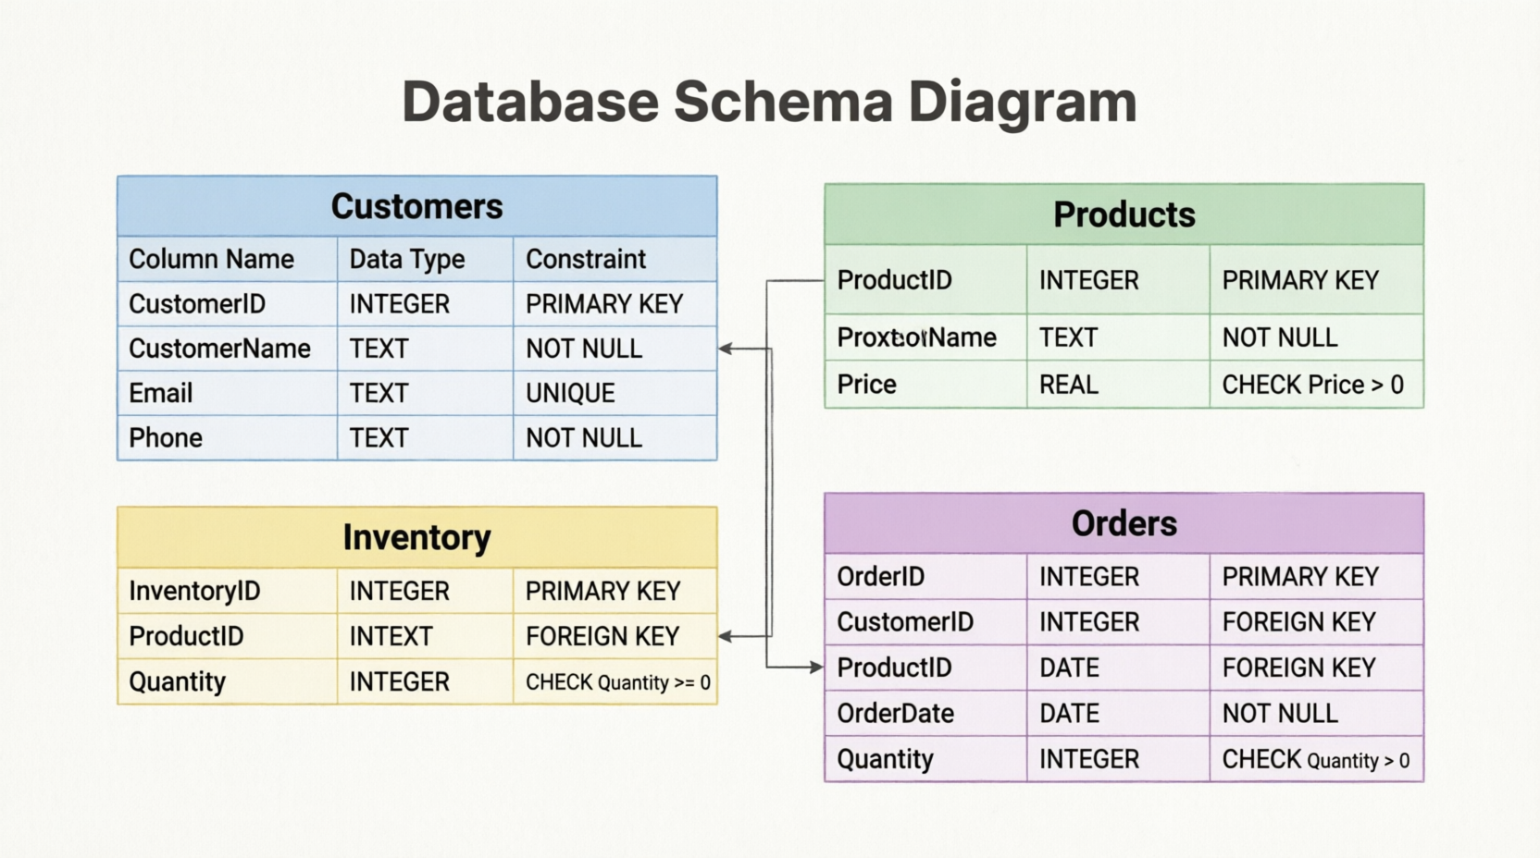

SQLSCRIPT:
CREATE TABLE Customers (
CustomerID INTEGER PRIMARY KEY,
CustomerName TEXT NOT NULL,
Email TEXT UNIQUE,
Phone TEXT NOT NULL
);

CREATE TABLE Products (
ProductID INTEGER PRIMARY KEY,
ProductName TEXT NOT NULL,
Price REAL CHECK(Price > 0)
);

CREATE TABLE Inventory (
InventoryID INTEGER PRIMARY KEY,
ProductID INTEGER,
Quantity INTEGER CHECK(Quantity >= 0),
FOREIGN KEY(ProductID) REFERENCES Products(ProductID)
);

CREATE TABLE Orders (
OrderID INTEGER PRIMARY KEY,
CustomerID INTEGER,
ProductID INTEGER,
OrderDate DATE NOT NULL,
Quantity INTEGER CHECK(Quantity > 0),
FOREIGN KEY(CustomerID) REFERENCES Customers(CustomerID),
FOREIGN KEY(ProductID) REFERENCES Products(ProductID)
);

INSERT INTO Customers VALUES
(1,'Ali Khan','ali@gmail.com','03001234567'),
(2,'Sara Ahmed','sara@gmail.com','03111234567');

INSERT INTO Products VALUES
(1,'Laptop',100000),
(2,'Mouse',1500);

INSERT INTO Inventory VALUES
(1,1,20),
(2,2,100);

INSERT INTO Orders VALUES
(1,1,1,'2025-05-01',1),
(2,2,2,'2025-05-03',2);

CREATE VIEW CustomerOrders AS
SELECT
Customers.CustomerName,
Products.ProductName,
Orders.Quantity,
Orders.OrderDate
FROM Orders
JOIN Customers ON Orders.CustomerID = Customers.CustomerID
JOIN Products ON Orders.ProductID = Products.ProductID;

CREATE VIEW InventoryStatus AS
SELECT
Products.ProductName,
Inventory.Quantity
FROM Products
JOIN Inventory
ON Products.ProductID = Inventory.ProductID;

SELECT * FROM CustomerOrders;

SELECT
Orders.OrderID,
Products.ProductName,
Orders.Quantity,
Products.Price,
(Orders.Quantity * Products.Price) AS TotalAmount
FROM Orders
JOIN Products
ON Orders.ProductID = Products.ProductID;

SELECT name
FROM sqlite_master
WHERE type='table';

SELECT * FROM CustomerOrders;

SELECT * FROM InventoryStatus;

SELECT
Orders.OrderID,
Products.ProductName,
Orders.Quantity,
Products.Price,
(Orders.Quantity * Products.Price) AS TotalAmount
FROM Orders
JOIN Products
ON Orders.ProductID = Products.ProductID;

Screenshot 01:
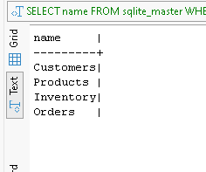

ScreenShot02:
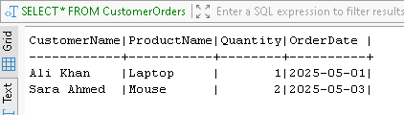

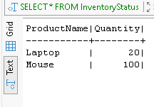
ScreenShot03:

ScreenShot04:
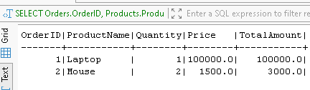

4. Conclusion
A database system for customer orders and inventory management was successfully designed and implemented using SQLite. Four tables (Customers, Products, Inventory, and Orders) were created with primary keys, foreign keys, and check constraints to maintain data integrity. Views were developed for customer order analysis and inventory tracking. SQL queries were used to insert, retrieve, update, and delete data, demonstrating effective database management.

