LAB#08
DATA CONTROL LANGUAGE (DCL) AND
TRANSACTION CONTROL LANGUAGE (TCL)
OBJECTIVES:
- To implement Server Authentication
- To learn and implement DCL (Grant and Revoke Commands).
- To learn and implement exception handling in SQL.
- To learn and implement TCL (Commit, Rollback and Save point)
LAB TASKS:
1. Create a Login with your name as User name and set the password accordingly. Perform the SQL server authentication with the created login.
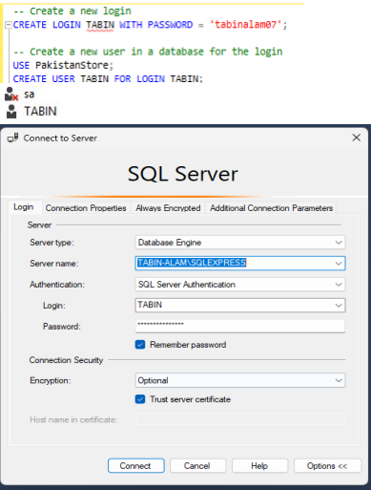
2. Create a role for the above login named “junior data base engineer” and grant all the rights. Now create a user for this role and perform some simple database operations.
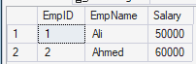
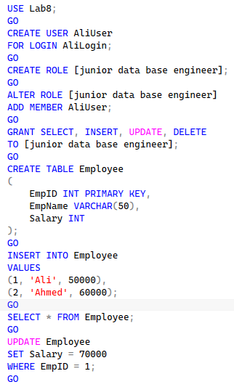

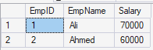

3. Revoke the right for updating the record from the above role and now try to update any record and observe the result.
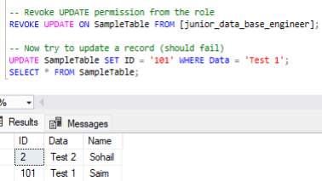

4. Suppose you are performing a credit debit transaction in your table. The table is based on the following schema. ( User_id (Primary Key), name, Account#, Balance ).
- Begin a transaction and insert some records.
- Deduct an amount of 5000 from the user id 1.
- Credit the amount to user Id 10 (which does not exist).
- Rollback the deduction transaction.
- Apply save points where necessary.
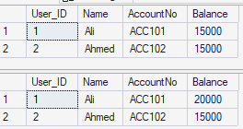
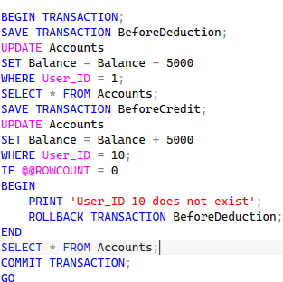
5. Answer the following questions:
- What have you learned from the lab task?
I learned how to create logins, users, and roles in Microsoft SQL Server. I also learned how to give and remove permissions from users. Besides this, I learned how transactions, rollback, and save points help keep database data safe.
- What was the most challenging task and how did you overcome that challenge?
The hardest part was revoking the UPDATE permission because the update query was still working. I found out that I was logged in as the admin user, which has all permissions. I fixed the problem by logging in with the created user account and using the correct REVOKE command

