LAB # 3
JOIN OPERATIONS IN SQL
- To learn and apply different types of Join Operations in SQL.
- To understand and implement foreign key.

LAB TASKS:
  - Consider the following schema: Sailors (sid(PK), sname, rating, age) Boats (bid(PK), bname, color)
Reserves (sid (FK), bid(FK), day(date)). Find all information of sailors who have reserved boat number 101.
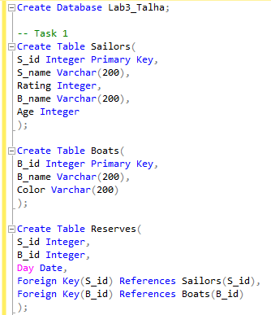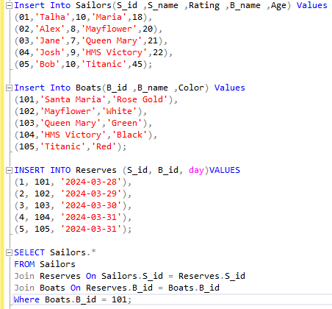

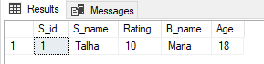
Output:

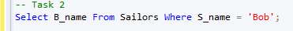
  - Write a query to find and display the name of boat reserved by Bob.

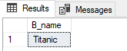
Output:

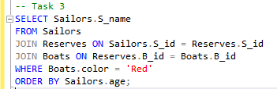
  - Find the names of sailors who have reserved a red boat, and list in the order of age.

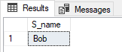
Output:

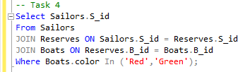
  - Find the ids of sailors who have reserved a red boat or a green boat.

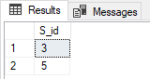
Output:

  - Create a table Projects with the following schema. (P_id, Pro_name, Dep_id). Now write a query to show which projects have been assigned to the ‘HR’ department.
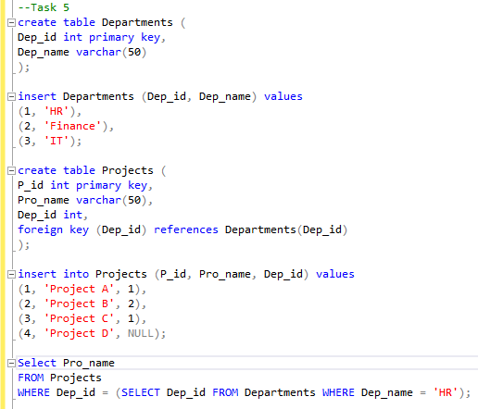

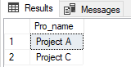
Output:

  - Write a query to display project names along with their allocated department names.
Also display the names of those projects which have not been assigned to any department yet.
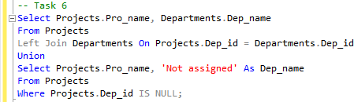

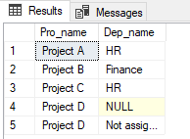
Output:

  - Create tables for the student, teacher and course scenario as shown in the manual. Write a query to display the course name along with the allocated teacher’s name for that
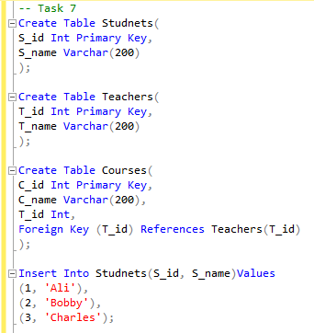
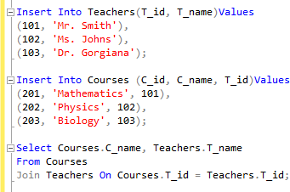
course.

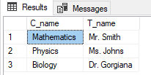
Output:

  - Write a query to display the id, name and course name of those students who are enrolled in DBMS course.
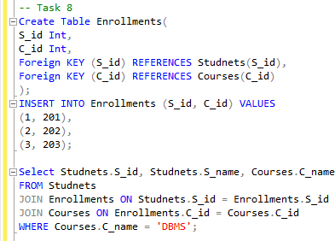

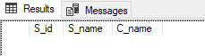

  - Write a query to display student id, student name, course name (in which the student has been enrolled) and teacher name (who has been assigned that course). (Hint: it will
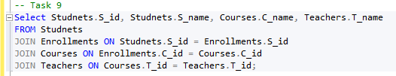
require more than two tables).

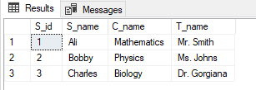
Output:

  - Create a table for teachers and their co-ordinators with the following schema: (t_id, t_name,c co-ordinator_id). The table should look like the following:
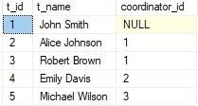
Now write a query to display the teacher names whose coordinator is John Smith along with the coordinator’s name.
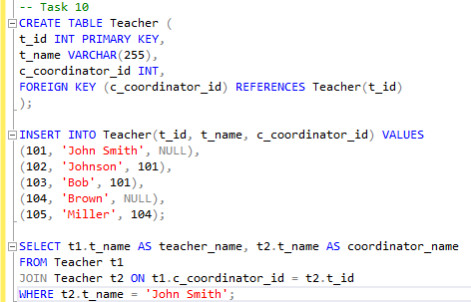

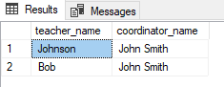

  - Answer the following questions:
    - What have you learned from the lab task?
I have learned thorough this lab task that how the functionality of the join operation works in SQL and what are the different kinds of join.

    - What was the most challenging task and how did you overcome that challenge?
The most challenging task was to identify which join operation to be used in which situation.

