LAB # 01
Introduction to Linux Operating System

Objective
To study the Execution of various file/directory handling commands.

Theory of Linux
- Operating system for several types of computer platforms, primarily INTEL based PC’s.
- Goal has been to create a UNIX clone.
- Free of any commercially copy righted software.
- It has all the features of a modern fully fledged UNIX, like;
  - Multitasking
  - Multi-user
  - Programmable Shells
  - Device independence
  - Open system portability
  - Virtual memory
  - Shared libraries
  - Demand loading
  - Proper memory management
  - TCP/IP networking

Hardware Support

For Ubuntu
    - 2 GHz dual core processor or better
    - 4 GB system memory
    - 25 GB of free hard drive space
    - Either a DVD drive or a USB port for the installer media
    - Internet access is helpful

For Redhat Linux
    - 2 GB of RAM, plus additional RAM for virtual machines.
    - 6 GB disk space for the host, plus the required disk space for the virtual machine(s).
    - Either a DVD drive or a USB port for the installer media
    - Internet access is helpful

For Fedora (A Red Hat Community Project)
    - 1GHz or faster processor
    - 1GB System Memory
    - 10GB unallocated drive space
    - Either a DVD drive or a USB port for the installer media
    - Internet access is helpful

Ubuntu Installation Steps

Follow the steps to install Ubuntu 20.04 LTS iso on Virtual Box.
Assumption: VirtualBox already installed

- Download iso file
https://ubuntu.com/download/desktop
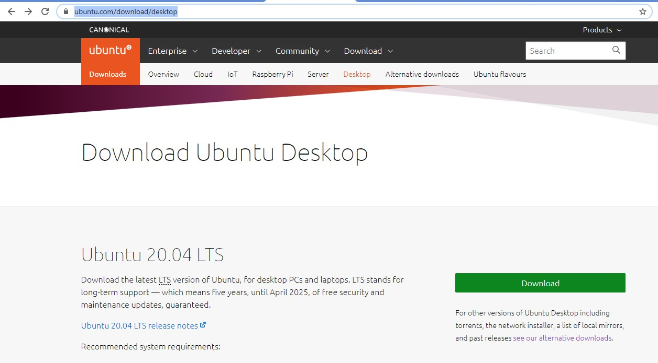
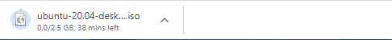

- Open Virtual Box and click on New.
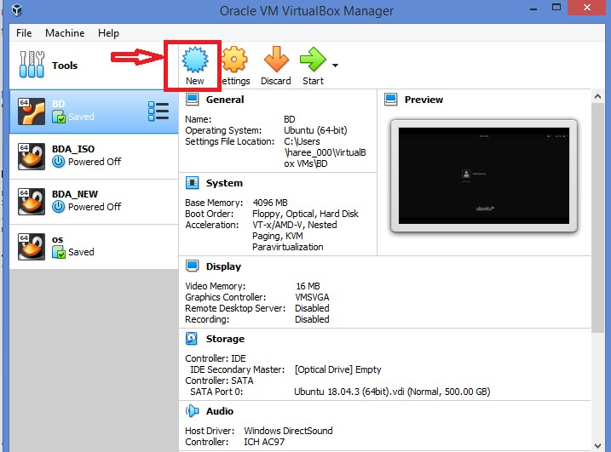

- Write name for your VM, specify folder, Select ‘Linux’ in Type and version.

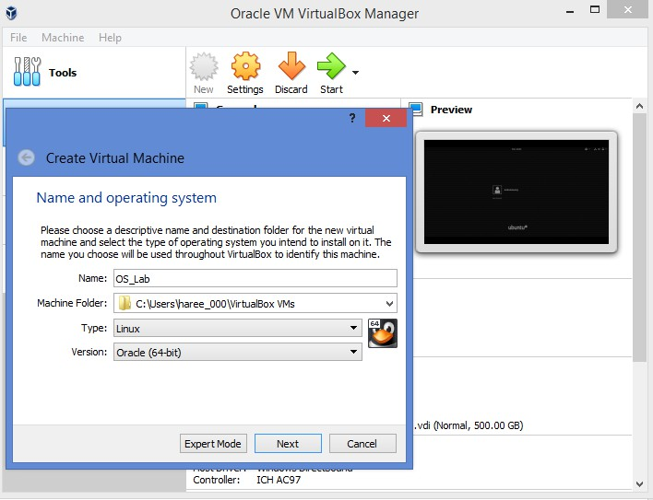

- Set RAM size (Ideally half of your system’s RAM. Works better if assigned size for RAM is 2 GB and above)
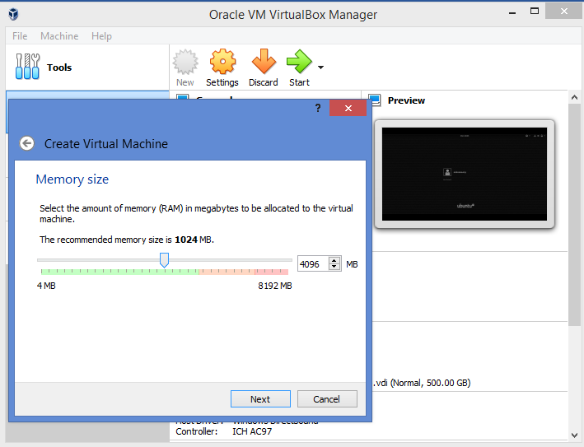

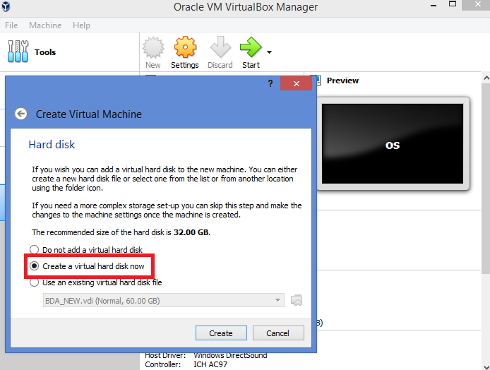
- Select 2nd option and click create

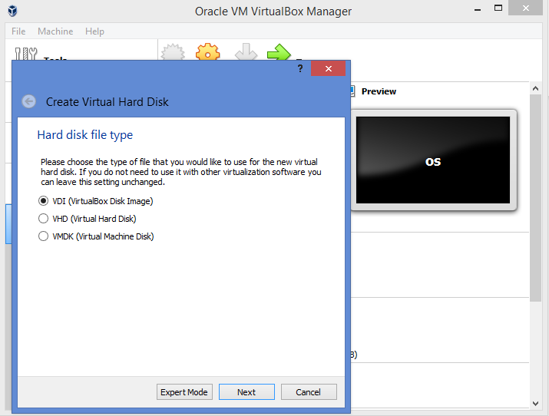
- Select VDI and Enter next

- Select Dynamically allocated and tap next
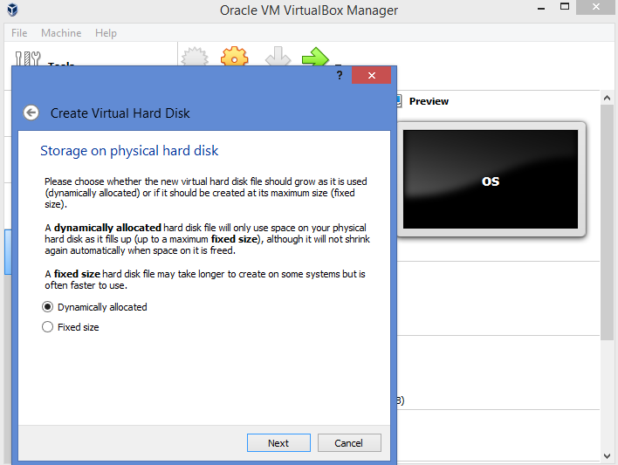

- Set hard disk size (10GB and above is recommended). Create.
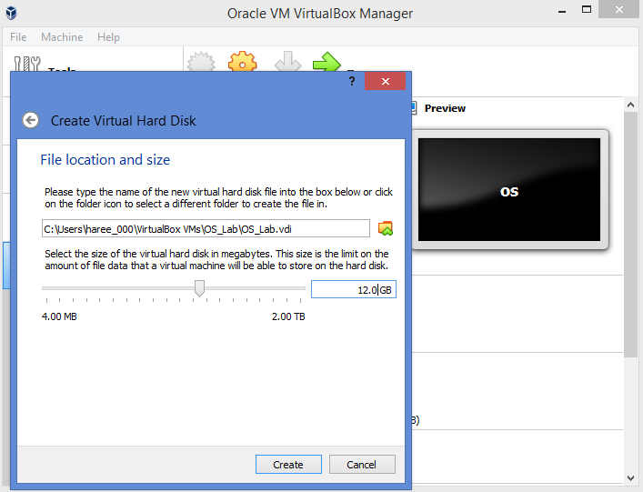

- Select your VM in left window pane and open its settings
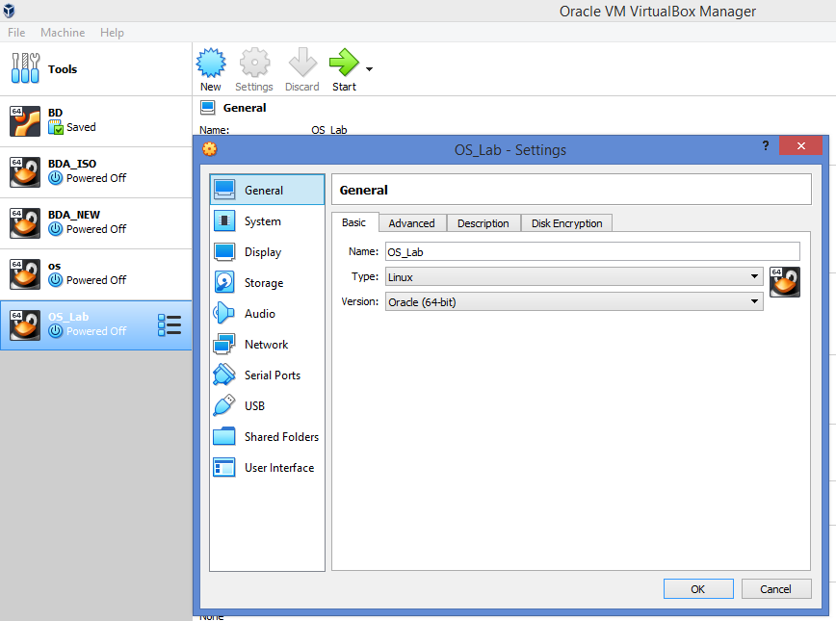

- Go to Storage, then tap on empty, then click on small disk and select choose virtual optical disk file to select iso file from your system
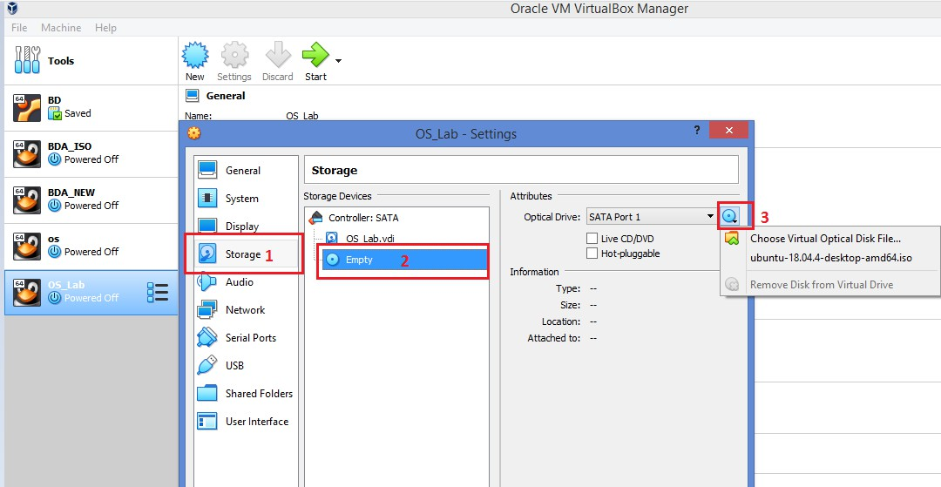

- Select iso file from your system
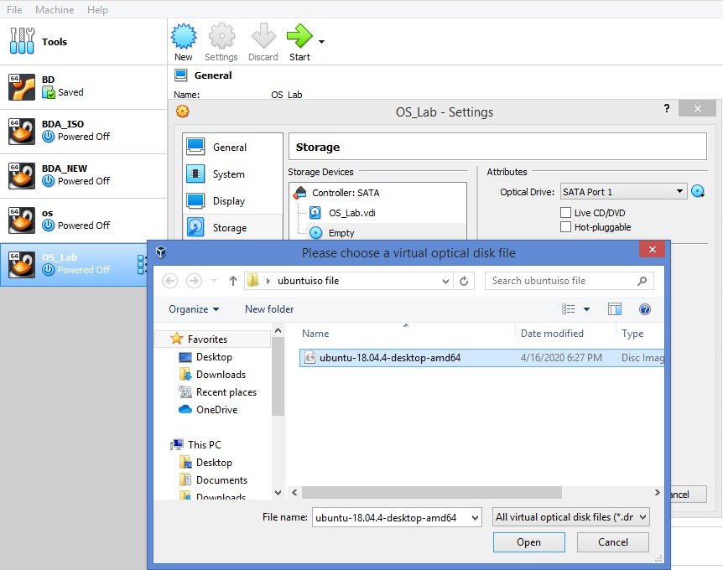

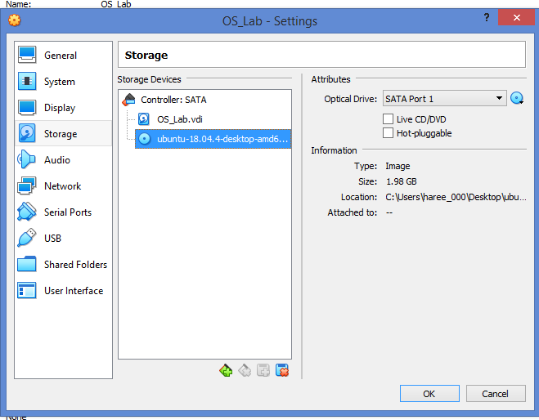
- Tap ok

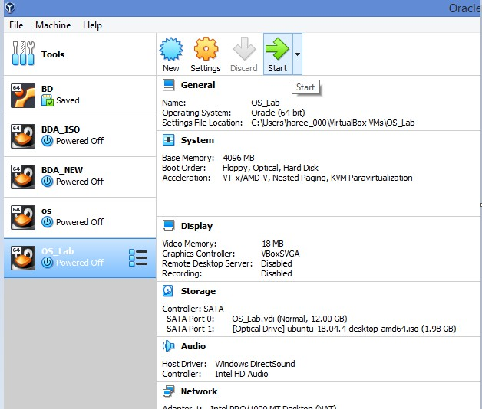
- Start the VM

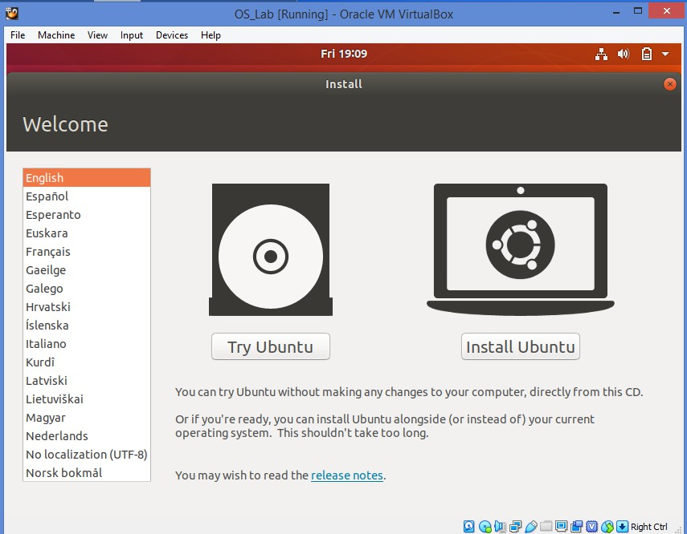
- Install Ubuntu

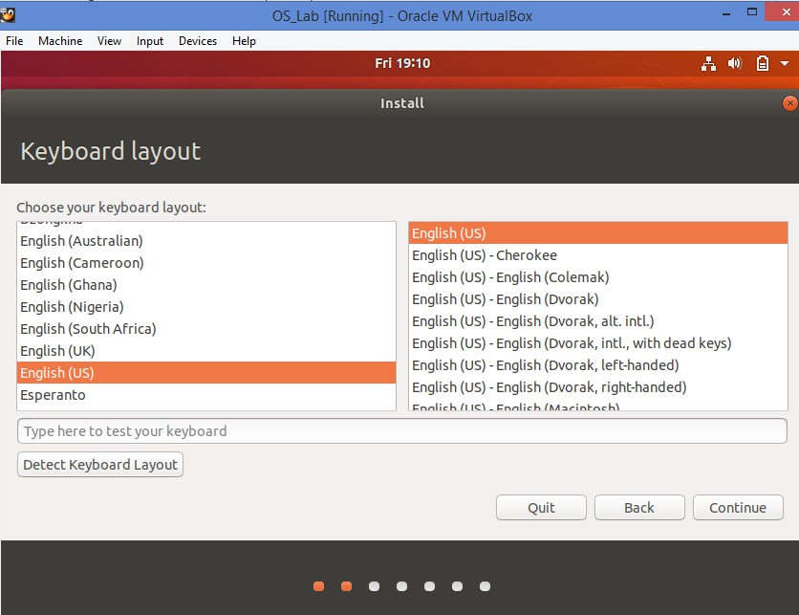
- Continue

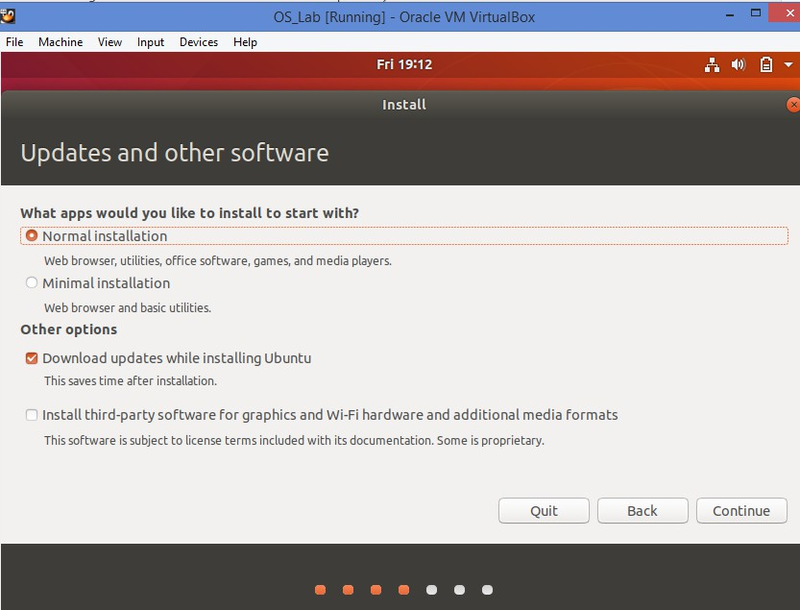
- Continue after selecting the settings shown in the picture below

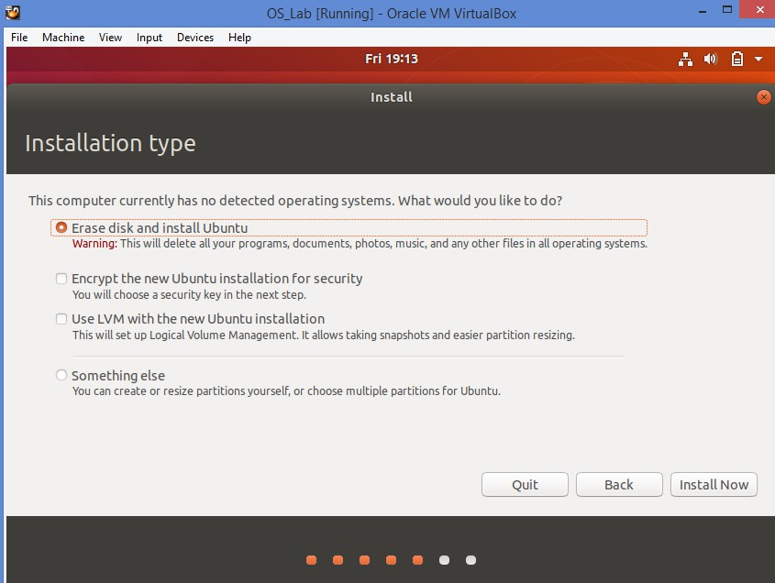
- Select first option and then Enter ‘Install’

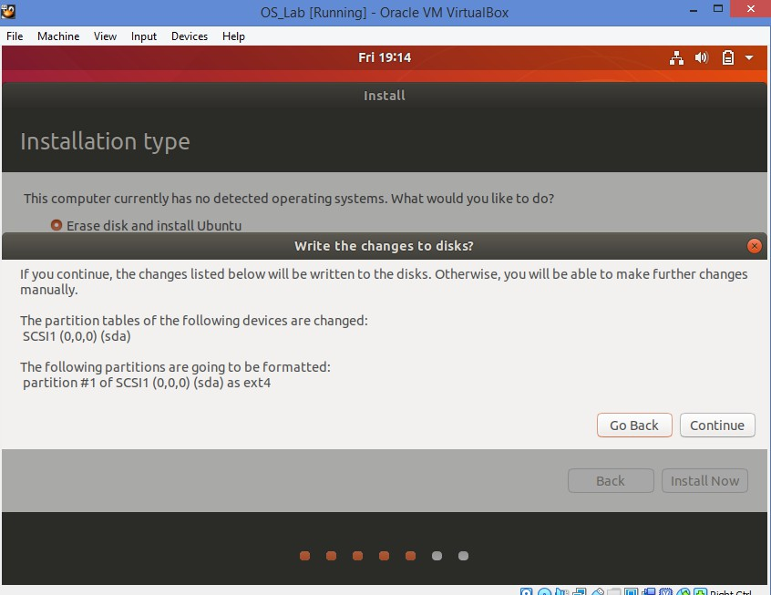
- Continue

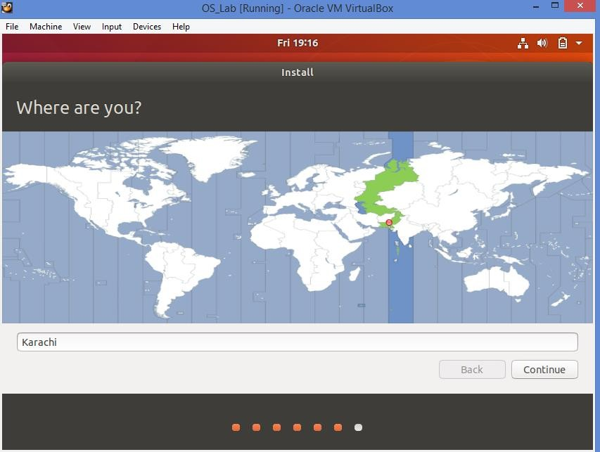
- Continue

System will load files and ask to setup user name and password
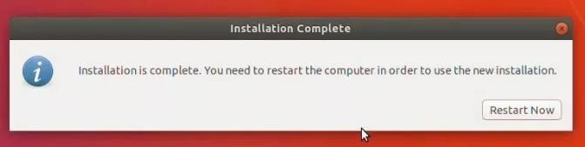
- Reinstall VM after install finishes

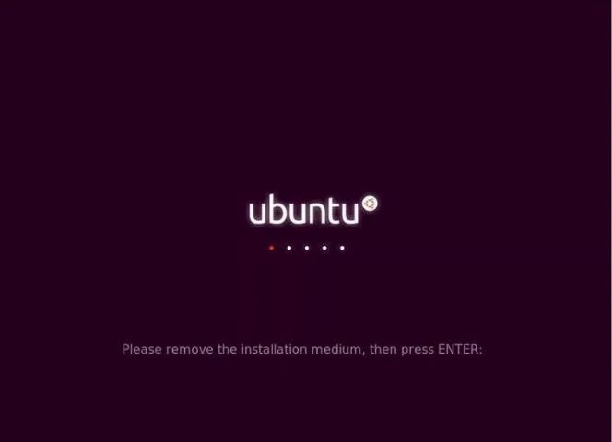
- If you see this screen, then just press Enter

Linux File System
- Linux is committed to the Filesystem Hierarchy Standard (FHS) a collaborative document that defines the names and locations of many files and directories.
- Inverted tree structure, with the root at the top. The top directory, /, known as Root Directory.
- Linux operating system resides on two file system: the root file system known as /, and a file system mounted under /usr.
/
/var /bin /sbin /usr /etc /lib
adam gwenl

mail news text data temp
Inverted Tree structure

/var (variable data files)
  - Any program that write log files or need spool or lock directories probably should write them to the /var directory."…. This includes spool directories and files, administrative and logging data, and transient and temporary files."
  - The /var/spool directory hold data that is of transitory nature, such as mail and news that is recently received from or queued for transmission to another site.

/bin
  - The /bin directory contains executable programs, know as binaries. Many Linux commands such as ls, arch, cat, cpio etc are actually programs found in this directory.

/sbin
  - The /sbin directory is also used to store system binary files. Most files (fdisk, halt, hdparm, shutdown etc.) These files are used for system administration purpose.

/usr
  - The /usr directory and its sub-directories are very important to the operation of your Linux system contains several directories with some of the most important programs.
  - Sub-directories of /usr contains large software packages.
  - The /usr directory usually has its own partition, and it should be mountable read-only.

/etc
  - The /etc directory is reserved for configuration files that are local to your machine.
  - The password file, startup scripts for Linux, list of IP addresses and many other types of configuration information stored in this directory.

/lib

- The /lib directory should contain only those libraries that are needed to execute the binaries in /bin
and /sbin.

/home
  - The /home directory is the base for user home directories.

/dev
  - The /dev directory contains filesystem entries which represent devices that are attached to the system. These files are essential for the system to function properly. The dev/mouse file is for reading input for mouse.

Logging on to Linux
  - To use the Linux operating system, you must first gain access to it by logging in. when you are log in; you are placed in your home directory.
  - login [name | option]

  - Enter your Login Name and press ENTER. LOGIN:

  - Enter your PASSWORD and press ENTER. Login:
Password:

  - Once you have entered all the correct information, the “prompt character” appears on the screen. This is a dollar sign($) for Bourne shell users and a percent sign(%) for C-shell users.
  - The man command
man [option] [section] [title]

Displays information from the online reference manuals. man locates and prints the named title from the designated reference section.

Example
man date (display the usage and syntax of date command)

Creating Directories
A directory is a collection of files. It can be thought of as a “folder” that contains many different files. Directories are given names, with which you can identify them. Furthermore, directories are maintained in a tree-like structure; that is, directories may contain other directories.

mkdir
Use mkdir command to create new directories and thereby organize files in a filing cabanet. This is an incredibly simple command. You specify the name of the directory to create.

Example:

$ mkdir lab1
$ ls Command for listing

Deleting Directories

Directories are deleted with rmdir command. This command deletes only empty directories. If the directory contains any file or directory, first that file or directory must be deleted.
- rmdir <Directory Name>
- cd (Change Directory)
Use the cd command to open your new created Directory.

Example:
$ cd ssuet
/ssuet/ $ ls
/ssuet/ $
Note: If you want to go one step back use cd .. Command you are now at your previous location.

pwd
You need a way to determine your current directory location. The pwd command, for print working directory, can do this for you.
Example:
$ pwd
/ssuet /Labs

Lab Task:
- Create multiple directories and subdirectories.
- Using man command(manual), explore atleast 5 extensions of each command i.e. rmdir, mkdir, ls and pwd. Implement them in any directory and insert screenshots

