Objective
LAB # 2

File Access Permission in LINUX

To study the various File Access Permission and different types users in LINUX.

Lab task

- Create multiple files and perform all commands.
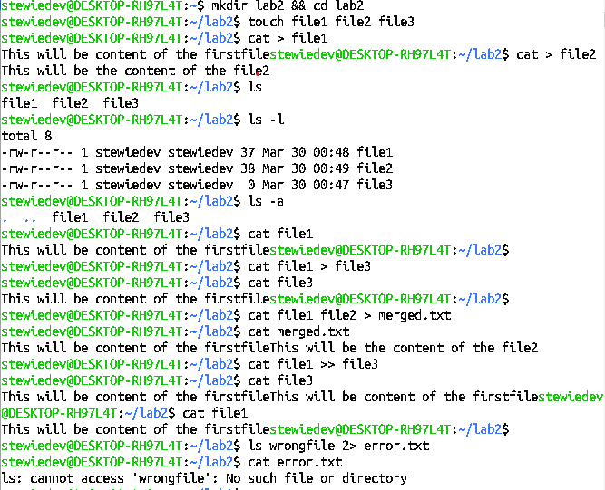
- Remove non empty directory.
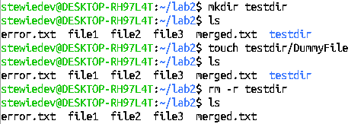

3,4,5.date (for Current Date). ps(running processes),finger,Display calendar and date
simultaneously.

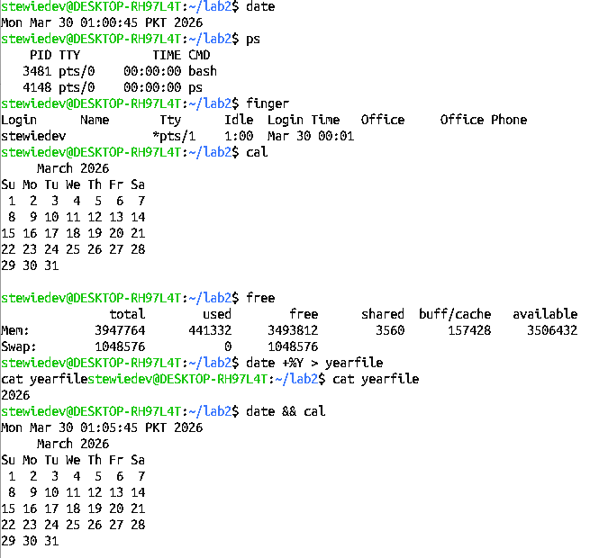

- df./
- df –k./
- du –s*
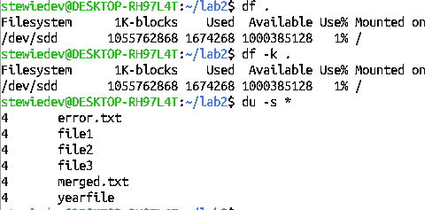

Displaying dat and cal simutanously,
Free command

