LAB # 3

Process Management

Objective
Implementation of process management using the following system calls of LINUX operating system: fork, getpid, getppid.

Example programs

Program#01 | Program#02
#include <stdio.h> #include <stdlib.h> #include <unistd.h> int main()  {  int pid;  pid = getpid( );  printf("Process ID is %d \n",pid);  } | #include <stdio.h> #include <stdlib.h> #include <unistd.h> int main()  {  int ppid;  ppid = getppid( );  printf("Parent Process ID is %d\n",ppid);  }
Program#03 | Program#04
#include <stdio.h> #include <stdlib.h> #include <unistd.h> int main()  {  fork( );  printf("Hello World\n");  } | #include <stdio.h> #include <stdlib.h> #include <unistd.h> int main()  {  int pid;  pid = fork( ); if(pid>0)  printf("Parent process PID is %d\n",pid);  }

Program#05 | Program#06
#include <stdio.h> #include <stdlib.h> #include <unistd.h> int main()  {  int pid;  pid = fork( ); if (pid == 0)  printf("Child Process\n");  } | #include <stdio.h> #include <stdlib.h> #include <unistd.h> int main()  {  int pid; pid=fork( ); if(pid==0)  {  printf("I am the child, my process ID is  %d\n",getpid( ));  printf("The child’s parent process ID is  %d\n",getppid( ));  }  else  {  printf("I am the parent, my process ID is  %d\n",getpid( ));  printf("The parents parent process ID is  %d\n",getppid( ));  }  }

Lab Task:
- Execute all the above programs (example program) and attach the screenshots of the output.
PROGRAM#1
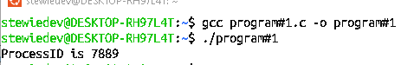

PROGRAM#2
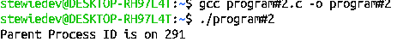

PROGRAM#3
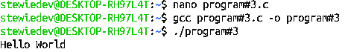

PROGRAM#4
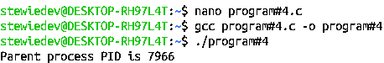

PROGRAM#5
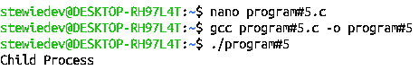

PROGRAM#6
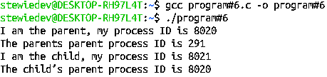

- Write a program to get Process Id and Parent Process Id in one program also attach the screenshot of output.
CODE:
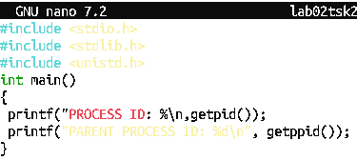

OUTPUT:
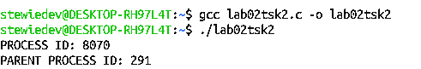

- Show the output of the given code and justify in your own words that why this output is occurring?

Program
#include <stdio.h> #include <unistd.h>
int main()
{
fork( );
fork( );
fork( ); printf("hello\n");
}
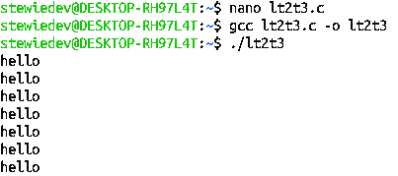
Output:

