Objective
LAB #5
CPU Scheduling Algorithms-1

To simulate CPU Scheduling Algorithms. (First Come First Serve, Shortest Job First).

Exercise
- Write a program which takes as an argument at least 10 CPU Brust time. Calculate CPU utilization, average waiting time, turnaround time and response time using SJF(Non-Preemptive) and SJF(Preemptive). Display a text-based Gantt chat on the screen.

Ouput:
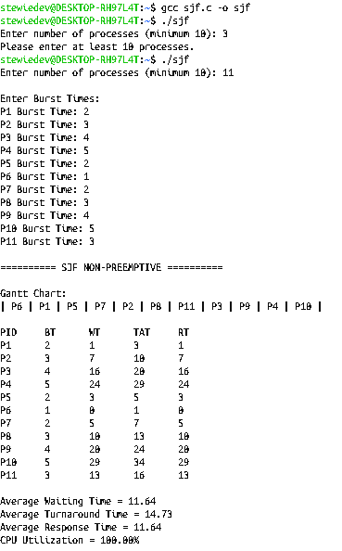

- Write a program which takes as an argument at least 15 CPU Brust time. Calculate CPU utilization, average waiting time, turnaround time and response time using FCFS. Display a text-based Gantt chat on the screen.

