Objective
LAB #14
OPEN ENDED LAB 2

Scenario 01:A college administration is developing a small utility for students to practice basic mathematics. The utility should allow a user to enter a number and automatically determine whether the entered value is even or odd. This helps students understand conditional statements and arithmetic operations in Shell scripting while providing immediate feedback to the user.
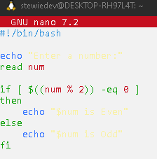
Script:

Output:

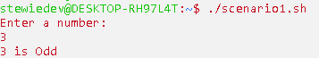

Scenario 02:A system administrator is responsible for monitoring multiple directories on a Linux server. To quickly assess storage usage and organization, the administrator needs a script that counts the total number of files and folders present in a specified directory. Automating this task reduces manual effort and provides useful information for system management and maintenance.
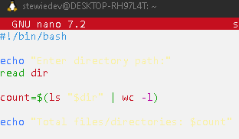
Script:

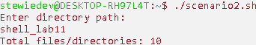
Output:

Scenario03:A school wants to automate the process of assigning grades to students based on their examination marks. Instead of manually checking marks against grading criteria, a Perl program should accept a student's marks as input and display the corresponding grade. This application demonstrates the use of conditional statements and user input handling in Perl programming

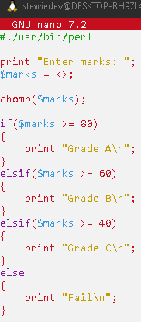
Script:

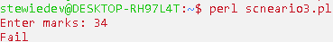
output:

Scenario04:A small retail shop wants a simple billing system to calculate the total cost of purchased items. The shopkeeper enters the prices of two products, and the system automatically calculates and displays the final bill amount. This task demonstrates the use of scalar variables, arithmetic operators, and user input in Perl scripting

Script:

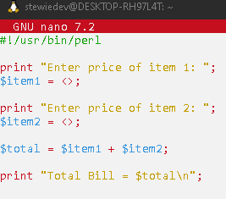

Output:
