Linkora — Developer Code Guide
Generated from the actual source in C:\Users\IT\Documents\Linkora · Expo SDK 57.0.20 · React Native 0.86.3 · Firebase JS SDK 12.18.0
Everything here is taken from code that exists in this project. Features with no code are marked NOT IMPLEMENTED rather than described.

A. Project overview

What Linkora is
Linkora is a professional-networking mobile app. A user registers with an email and password, fills in a profile, posts updates, likes and comments on other people's posts, and sends connection requests. It runs on Android and iOS from one codebase.

Why React Native
- One codebase, two platforms. The same TypeScript runs on Android and iOS.
- Real native UI. React Native renders actual platform widgets, not a web page in a wrapper.
- Expo removes the setup barrier. With Expo you run the app on a real phone through the Expo Go app — no Android Studio, no Xcode, no JDK. That matters here: this development machine has no Java and no Android SDK installed, and the app still runs.

Why Firebase
- No server to write or host. Linkora has no Node/Express backend. The app talks straight to Google's services over HTTPS.
- Authentication is solved. Passwords are hashed and stored by Google. Linkora never sees or stores a password.
- Realtime by default. Firestore listeners push changes to the app, so the feed updates without a refresh button.
- Security lives on the server. Firestore rules run on Google's machines, so they cannot be bypassed by editing the app.

How the frontend and backend communicate
There is no REST API and no custom endpoint. Screens call functions in src/services/; those functions call the Firebase SDK; the SDK makes the HTTPS request. The single file that opens any connection is src/firebase/app.ts.
User
↓
React Native UI src/screens/ , src/components/
↓
Navigation src/navigation/
↓
Context / Services src/context/AuthContext.tsx , src/services/*.service.ts
↓
Firebase SDK src/firebase/app.ts ← the ONLY network entry point
↓
Firebase Auth · Firestore · Storage
↓
Firebase project: linkora-a274a
The one rule that makes this codebase auditable: no screen and no component imports the Firebase SDK directly. They import functions from src/services/. Those services import auth, db and storage from src/firebase/app.ts. So to see every network destination the app can reach, you read one file.

Architecture in layers
Layer | Folder | Job | May import
UI | src/components/ | Dumb, reusable pieces (Button, Avatar, PostCard) | theme, utils, types
Screens | src/screens/ | One screen each; holds screen state | services, context, components
Navigation | src/navigation/ | Which screen shows when | screens, context
State | src/context/ | Current user + profile, app-wide | services
Data | src/services/ | All reads and writes | src/firebase/app.ts
Connection | src/firebase/ | Starts Firebase. Only network entry point. | config
Config | src/config/ | Reads .env, validates, blocks wrong project | —
Dependencies point downward only. A service never imports a screen. That is what keeps the data layer testable and the network surface small.

B. Complete folder guide
Linkora/ ├── App.tsx Entry: providers + navigator ├── index.ts Registers App.tsx with React Native ├── app.json Expo config (name, icons, permissions) ├── package.json Dependencies + npm scripts ├── tsconfig.json TypeScript settings ├── .env.example Env template (committed) ├── .env Real values (NOT committed — you create it) ├── .gitignore Blocks secrets from Git ├── firebase.json Points Firebase CLI at the rule files ├── firestore.rules Firestore security rules ├── firestore.indexes.json Composite index definition ├── storage.rules Storage security rules ├── assets/ Icons and splash image └── src/ ├── components/ 6 reusable UI pieces ├── config/ env.ts ├── context/ AuthContext.tsx ├── firebase/ app.ts ├── navigation/ 4 files ├── screens/ 10 screens (2 under auth/) ├── services/ 7 service files ├── theme/ colours, spacing, font sizes ├── types/ shared Firestore document types └── utils/ errors.ts, format.ts
Folders that do NOT exist (you will see them in tutorials, but documenting them here would be wrong):
- src/hooks/ — the only hook, useAuth, is exported from src/context/AuthContext.tsx.
- android/ and ios/ — Expo generates these only if you run npx expo prebuild. Not needed.
- __tests__/ — there is no test runner configured.

What each folder is for
src/firebase/ — the connection
Contains: app.ts only.
Why it exists: to give the whole app exactly one place where a backend connection is created. Everything else imports auth, db, storage from here.
Depended on by: all seven service files. Nothing else.
src/services/ — all data access
Contains: auth.service.ts, users.service.ts, posts.service.ts, comments.service.ts, connections.service.ts, notifications.service.ts, storage.service.ts.
Why it exists: screens should describe what they want, not how Firestore works. If the database changed, only this folder would change.
Depends on: src/firebase/app.ts, src/types/. Used by: screens and AuthContext.
src/screens/ — one file per screen
10 screens. auth/LoginScreen.tsx and auth/RegisterScreen.tsx are shown when signed out; the other eight when signed in.
Screens hold their own loading/error state and call services. They never touch Firestore directly.
src/navigation/ — routing
RootNavigator.tsx chooses between signed-out and signed-in. AuthNavigator.tsx is the login stack. MainTabs.tsx is the four bottom tabs. types.ts types every route name and its parameters so a typo is a compile error.
src/context/ — app-wide state
AuthContext.tsx holds the Firebase Auth user and the Firestore profile, and exports the useAuth() hook. Nearly every signed-in screen calls it.
src/config/, src/types/, src/utils/, src/theme/
- config/env.ts — reads .env, validates it, and refuses to start on the wrong Firebase project.
- types/index.ts — TypeScript shapes mirroring the Firestore documents, plus the connectionIdFor() helper.
- utils/errors.ts — maps Firebase error codes to readable sentences. utils/format.ts — timeAgo(), initials(), looksLikeEmail().
- theme/index.ts — colours, spacing, radius, font sizes.

What it looks like — screen to file

Real screenshots — the app actually running
These two are genuine screenshots, captured from the web build with a temporary throwaway Firebase config. The jump from Login to Register was done by an automated click, and the browser console reported zero errors.
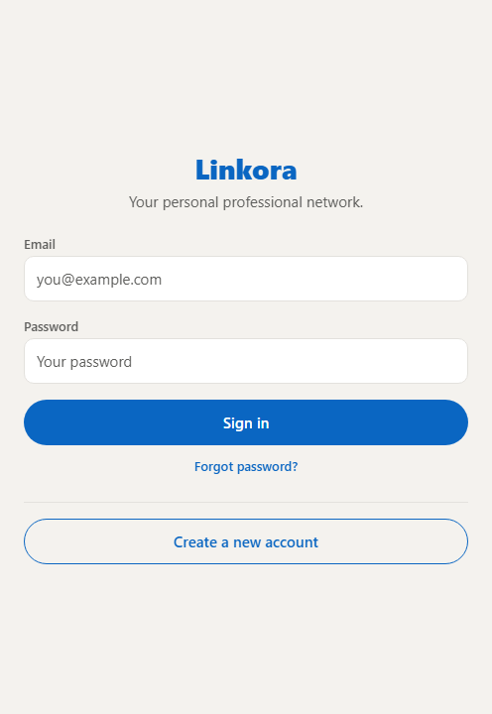  Login — real  screens/auth/LoginScreen.tsx | 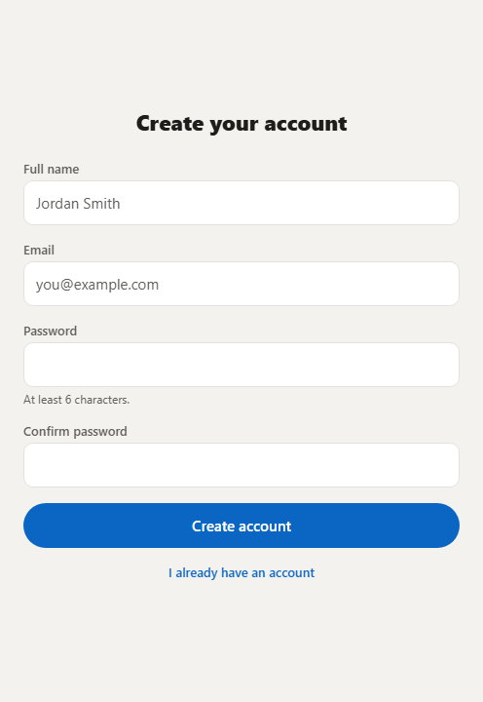  Register — real  screens/auth/RegisterScreen.tsx
What this proves: the app boots, the config guard passes, Firebase initialises, AuthContext resolves, React Navigation works, and both auth screens render. What it does not prove: real sign-in or any Firestore read/write — those need your real Firebase keys. It is also the web render; a phone uses the same components with native spacing.

Mockups — the remaining screens
These are mockups, not screenshots. The signed-in screens need a real account, so they could not be captured. Each image is drawn from the real values in src/theme/index.ts and each screen's StyleSheet, so the colours, spacing and button text match the code. Replace them with real screenshots once you run the app.
Use this section to connect what you see on the phone to the file that draws it — that is usually the first thing you need when a question starts with "show me where…".
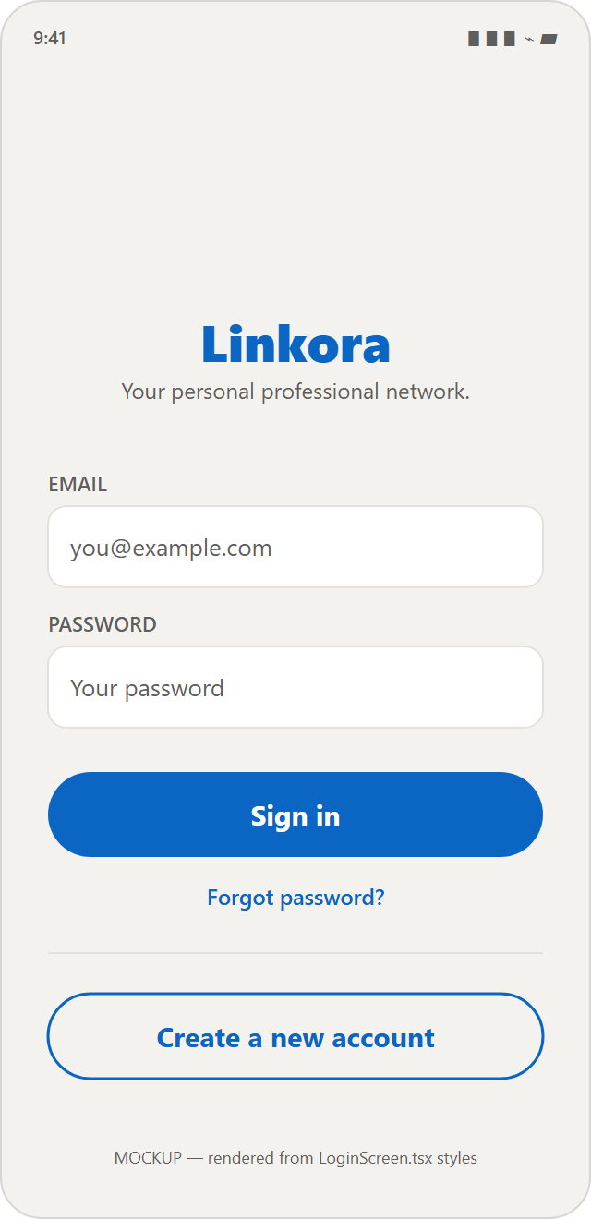  Login  screens/auth/LoginScreen.tsx | 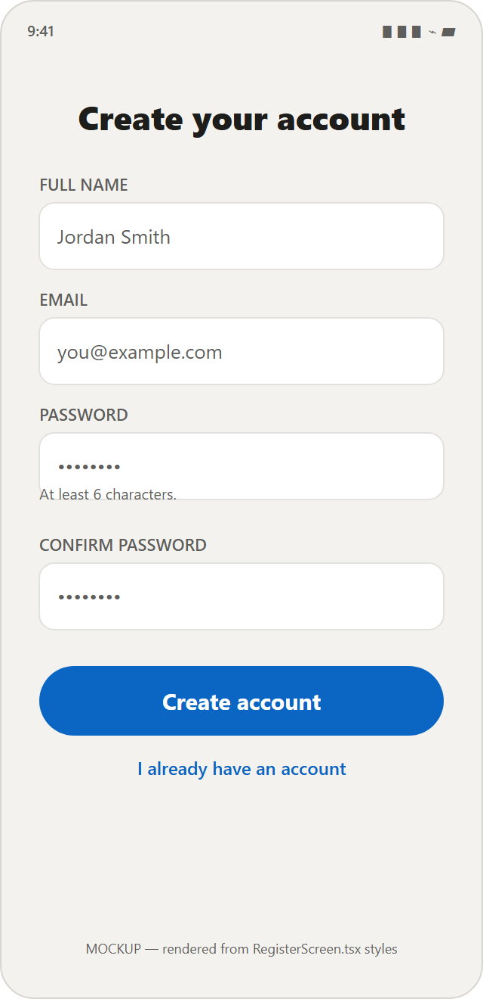  Register  screens/auth/RegisterScreen.tsx | 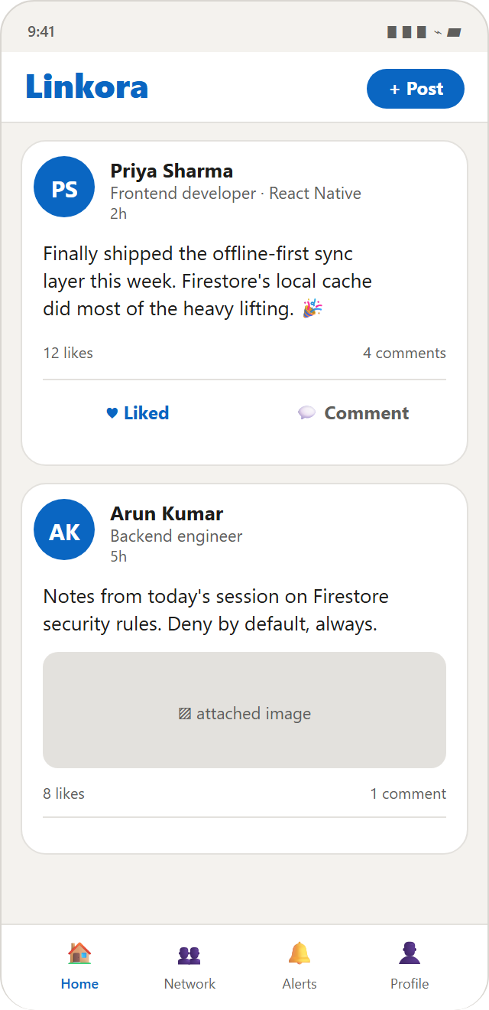  Home feed  screens/HomeScreen.tsx + PostCard.tsx
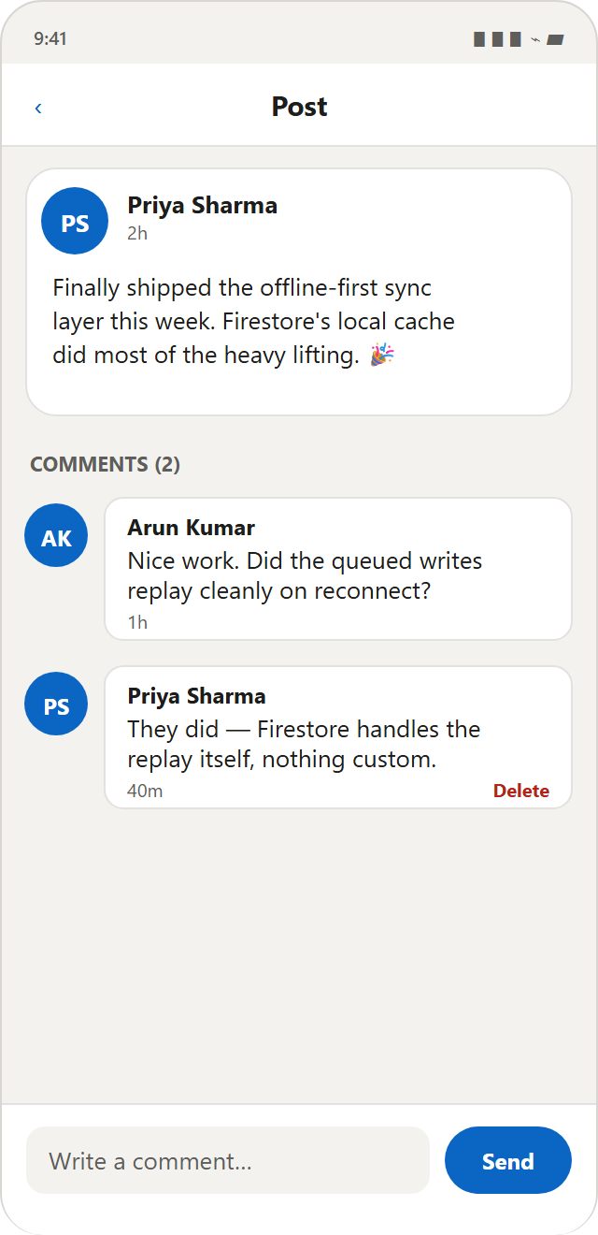  Post & comments  screens/PostDetailScreen.tsx | 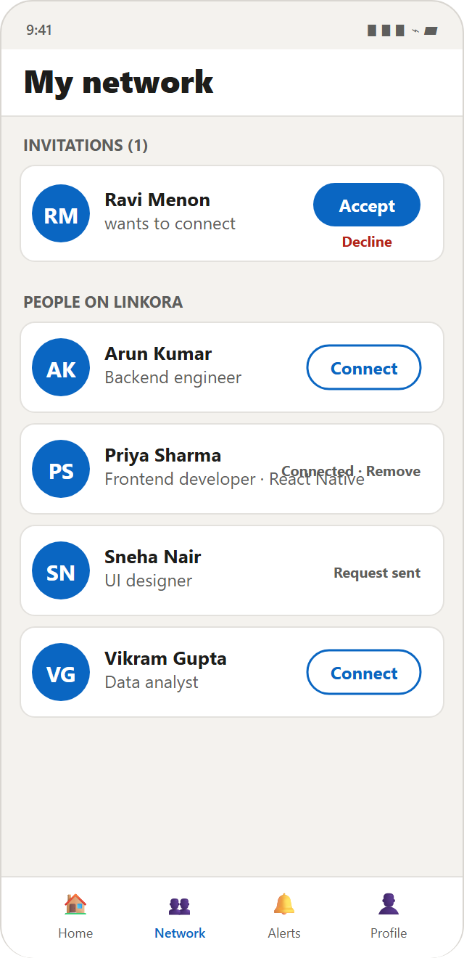  My network  screens/NetworkScreen.tsx | 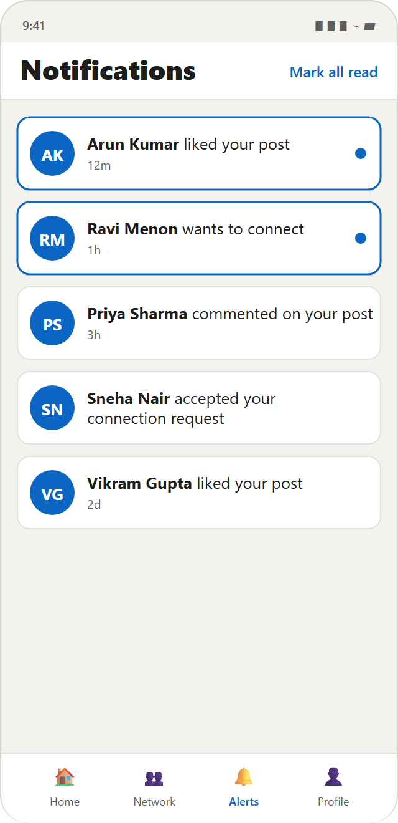  Notifications  screens/NotificationsScreen.tsx
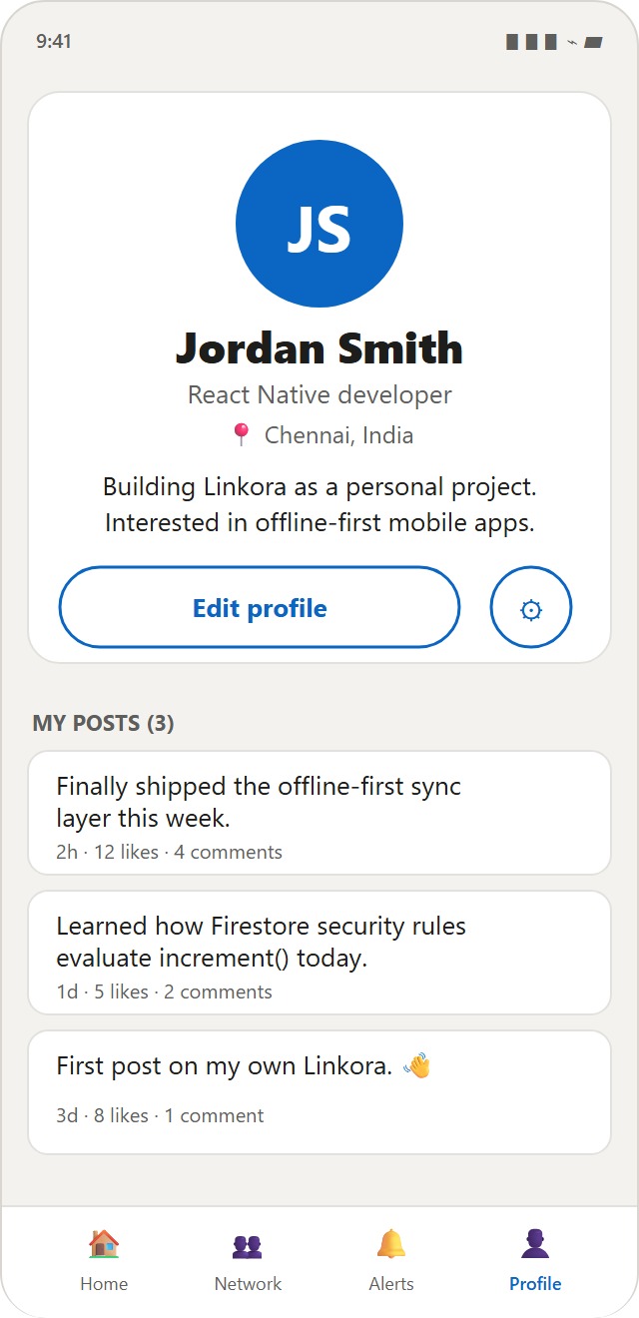  Profile  screens/ProfileScreen.tsx | 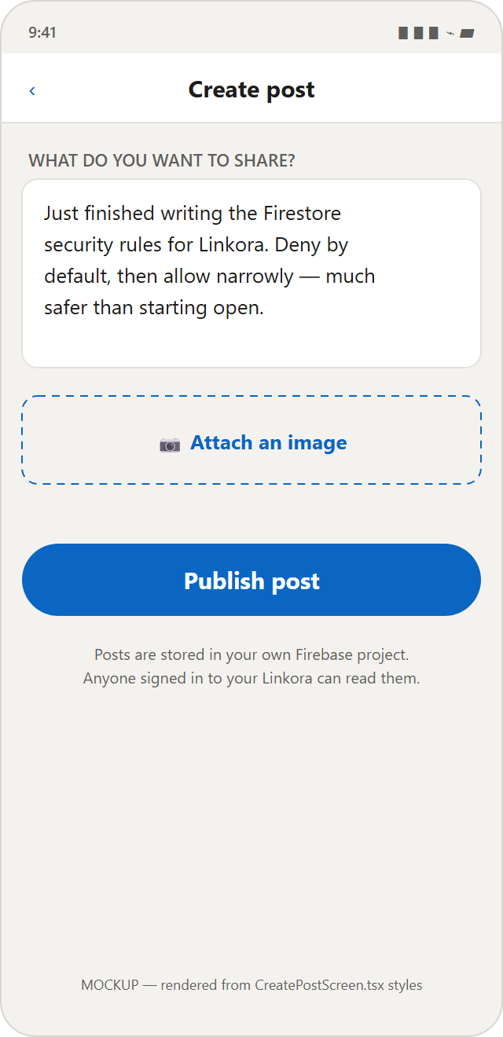  Create post  screens/CreatePostScreen.tsx | 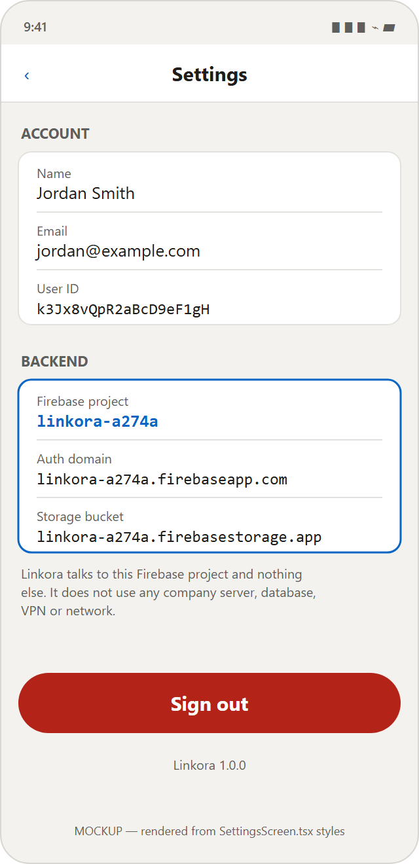  Settings  screens/SettingsScreen.tsx

Which service feeds which screen
Screen | Draws it | Gets data from
Login | auth/LoginScreen.tsx | login(), requestPasswordReset()
Register | auth/RegisterScreen.tsx | register()
Home feed | HomeScreen.tsx | subscribeToFeed(), likePost(), unlikePost()
Post & comments | PostDetailScreen.tsx | getPost(), subscribeToComments(), addComment()
My network | NetworkScreen.tsx | listOtherUsers(), subscribeToMyConnections()
Notifications | NotificationsScreen.tsx | subscribeToNotifications()
Profile | ProfileScreen.tsx | useAuth(), subscribeToUserPosts()
Create post | CreatePostScreen.tsx | uploadPostImage(), createPost()
Settings | SettingsScreen.tsx | useAuth(), firebaseConfig, logout()
The Settings screen is your isolation proof. It prints the live Firebase project ID straight from firebaseConfig. If someone asks "how do you know it only talks to your own backend?", you open Settings on the phone and show them linkora-a274a.

Where the colours come from
Every screen imports one token file, which is why the whole app looks consistent:
src/theme/index.ts
export const colors = {
background: '#F4F2EE', // page behind the cards
surface: '#FFFFFF', // cards, headers, tab bar
border: '#E3E1DD', // hairlines
primary: '#0A66C2', // buttons, links, active tab
text: '#1D1D1B',
textMuted: '#5E5E5C',
danger: '#B42318', // delete, sign out
success: '#0E7C3A',
} as const;
Change a value here and it changes everywhere. That is the whole point of a token file — there are no hardcoded colour strings scattered through the screens.

C. File-by-file explanation
File | Purpose | Firebase service
src/config/env.ts | Read + validate env, project tripwire | —
src/firebase/app.ts | Initialise Firebase | Auth, Firestore, Storage
src/services/auth.service.ts | Register, login, logout, reset | Auth
src/services/users.service.ts | Profile CRUD, people list | Firestore
src/services/posts.service.ts | Feed, create/delete post, likes | Firestore
src/services/comments.service.ts | Comments | Firestore
src/services/connections.service.ts | Requests, accept, remove | Firestore
src/services/notifications.service.ts | In-app notifications | Firestore
src/services/storage.service.ts | Image upload | Storage
src/context/AuthContext.tsx | Current user + profile | via services
src/navigation/RootNavigator.tsx | Signed-in vs signed-out | —

Firebase configuration and initialisation
Note on naming: many tutorials call this file src/firebase/config.ts. In Linkora it is src/firebase/app.ts, and the environment reading is split out into src/config/env.ts.

File 1 — src/config/env.ts
Purpose: read the Firebase settings out of .env, prove they are present and real, and refuse to run against any project except linkora-a274a.
src/config/env.ts
export const firebaseConfig = {
apiKey: required('EXPO_PUBLIC_FIREBASE_API_KEY', process.env.EXPO_PUBLIC_FIREBASE_API_KEY),
authDomain: required('EXPO_PUBLIC_FIREBASE_AUTH_DOMAIN', process.env.EXPO_PUBLIC_FIREBASE_AUTH_DOMAIN),
projectId: required('EXPO_PUBLIC_FIREBASE_PROJECT_ID', process.env.EXPO_PUBLIC_FIREBASE_PROJECT_ID),
storageBucket: required('EXPO_PUBLIC_FIREBASE_STORAGE_BUCKET', process.env.EXPO_PUBLIC_FIREBASE_STORAGE_BUCKET),
messagingSenderId: required('EXPO_PUBLIC_FIREBASE_MESSAGING_SENDER_ID', process.env.EXPO_PUBLIC_FIREBASE_MESSAGING_SENDER_ID),
appId: required('EXPO_PUBLIC_FIREBASE_APP_ID', process.env.EXPO_PUBLIC_FIREBASE_APP_ID),
} as const;

export const ALLOWED_FIREBASE_PROJECT_ID = 'linkora-a274a';

export function assertPersonalFirebaseProject(): void {
if (firebaseConfig.projectId !== ALLOWED_FIREBASE_PROJECT_ID) {
throw new Error('[Linkora] Refusing to start…');
}
}

Explanation, piece by piece
Code | What it does
process.env.EXPO_PUBLIC_* | Expo replaces this with the literal value from .env when the app is bundled. Only names starting EXPO_PUBLIC_ are exposed.
required(name, value) | Throws a readable error if the value is missing, empty, or still a your_…_here placeholder.
ALLOWED_FIREBASE_PROJECT_ID | A hard-coded tripwire. Linkora is personal, so exactly one project is legal.
assertPersonalFirebaseProject() | Called at import time in app.ts. If .env ever points elsewhere, the app stops instead of silently writing to the wrong database.

File 2 — src/firebase/app.ts
Purpose: create the three Firebase objects the whole app shares.
src/firebase/app.ts
// Fail fast if .env points anywhere other than the personal project.
assertPersonalFirebaseProject();

export const firebaseApp: FirebaseApp =
getApps().length > 0 ? getApp() : initializeApp(firebaseConfig);

function createAuth(app: FirebaseApp): Auth {
try {
const { getReactNativePersistence } = require('firebase/auth');
if (typeof getReactNativePersistence === 'function') {
return initializeAuth(app, {
persistence: getReactNativePersistence(AsyncStorage),
});
}
} catch { /* already initialised, or not React Native */ }
return getAuth(app);
}

export const auth: Auth = createAuth(firebaseApp);
export const db: Firestore = getFirestore(firebaseApp);
export const storage: FirebaseStorage = getStorage(firebaseApp);
Code | What it does
initializeApp(firebaseConfig) | Connects the app to the Firebase project. This is the moment Linkora becomes bound to linkora-a274a.
getApps().length > 0 ? getApp() : … | Metro's fast refresh can re-run this file while you are editing. Calling initializeApp twice throws, so an existing instance is reused.
initializeAuth(app, { persistence }) | Creates the Auth instance with a storage backend.
getReactNativePersistence(AsyncStorage) | Tells Firebase to save the login token in the phone's own local storage. Without it the user is signed out every time the app restarts.
getFirestore(app) | Creates the database handle. Every query in the app starts from this db.
getStorage(app) | Creates the file-storage handle, used only for images.
The require inside try/catch is deliberate. getReactNativePersistence exists only in the SDK's React Native build. Under Metro it resolves; under plain Node (a lint or script run) it does not, and the app falls back to in-memory auth instead of crashing.

Authentication
File that handles authentication: src/services/auth.service.ts. Email + password only — no company SSO, no LDAP, no Google/Facebook sign-in.

Registration
src/services/auth.service.ts → register()
export async function register(params: {
email: string; password: string; displayName: string;
}): Promise<User> {
const { email, password, displayName } = params;

const credential = await createUserWithEmailAndPassword(auth, email.trim(), password);

// Set the name on the Auth record so it is available immediately.
await updateProfile(credential.user, { displayName: displayName.trim() });

// Then create the Firestore profile the rest of the app reads from.
await createUserProfile({
uid: credential.user.uid,
email: credential.user.email ?? email.trim(),
displayName: displayName.trim(),
});

return credential.user;
}

Step by step
- createUserWithEmailAndPassword sends the email and password to Firebase Auth. Google hashes and stores the password. Linkora never sees or stores it.
- updateProfile writes the display name onto the Auth record.
- createUserProfile (in users.service.ts) writes the Firestore document at users/{uid} with empty headline, bio, location and photo.
- Firebase fires onAuthStateChanged. AuthContext picks it up and RootNavigator swaps to the signed-in app. No navigation code runs.
Why two records? Firebase Auth stores identity only (uid, email, password hash). It cannot store a headline or a bio. So Linkora keeps a matching Firestore document at users/{uid} for everything else. The uid is the link between them.

Login and logout
src/services/auth.service.ts
export async function login(email: string, password: string): Promise<User> {
const credential = await signInWithEmailAndPassword(auth, email.trim(), password);
return credential.user;
}

export async function logout(): Promise<void> {
await signOut(auth);
}

export function subscribeToAuthState(callback: (user: User | null) => void): () => void {
return onAuthStateChanged(auth, callback);
}
- signInWithEmailAndPassword — Firebase verifies the credentials and returns a token, which is written to AsyncStorage by the persistence layer.
- signOut — clears the stored token. onAuthStateChanged fires with null, and the UI returns to Login on its own.
- onAuthStateChanged — the event that drives the whole app. It returns an unsubscribe function, which AuthContext returns from its useEffect so the listener is closed when the provider unmounts.

How the logged-in user is identified
src/context/AuthContext.tsx (condensed)
const [user, setUser] = useState<User | null>(null);
const [profile, setProfile] = useState<UserProfile | null>(null);
const [initialising, setInitialising] = useState(true);

// 1. Watch login / logout
useEffect(() => {
const unsubscribe = subscribeToAuthState((nextUser) => {
setUser(nextUser);
setInitialising(false);
if (!nextUser) setProfile(null);
});
return unsubscribe;
}, []);

// 2. Watch that user's profile document, live
useEffect(() => {
if (!user) return;
const unsubscribe = subscribeToUserProfile(user.uid, setProfile, (e) => setError(…));
return unsubscribe;
}, [user]);
Any screen then does:
const { user, profile } = useAuth();
// user.uid → the Firebase identity
// profile → the live Firestore document (name, headline, photo)
Two separate pieces of state on purpose. user answers "who is signed in?"; profile answers "what do we display?". The profile uses a live listener, so editing your name updates every screen instantly without a refresh.

G. Firestore database guide
users/{uid}
└── notifications/{notificationId}

posts/{postId}
├── likes/{likerUid}
└── comments/{commentId}

connections/{connectionId} id = both UIDs sorted, joined with "_"

users/{uid}
Field | Type | Meaning
uid | string | Same as the document ID
email | string | Sign-in email
displayName | string | Full name
headline | string | One-line description
bio | string | Longer "about" text
location | string | City / country
photoURL | string | Storage download URL, or ''
createdAt, updatedAt | timestamp | Set by serverTimestamp()
- Created by createUserProfile(), once, at registration.
- Read by any signed-in member — that is what makes the people directory work.
- Updated by the owner only, and only the presentation fields. email and uid cannot be rewritten from the app.
- Deleted by the owner. No screen calls this today.

posts/{postId}
Field | Type | Meaning
authorId | string | Author's UID
authorName, authorHeadline, authorPhotoURL | string | Copied at write time (denormalised)
text | string | Body, max 3000 chars (enforced by rules)
imageUrl | string | Storage URL, or ''
likeCount, commentCount | number | Running totals
createdAt | timestamp | Server time
Why copy the author's name onto every post? This is called denormalisation. Firestore charges per document read and has no JOIN. If the feed stored only authorId, showing 50 posts would need 50 extra reads to fetch each author. Copying the name and photo makes the feed one query. The trade-off: if someone renames themselves, their old posts keep the old name until rewritten. For a personal app that is the right trade.

posts/{postId}/likes/{likerUid}
Fields: uid (string), createdAt (timestamp).
The document ID is the liker's UID. That single design decision means a user physically cannot like a post twice — a second like overwrites the same document — and the security rule becomes one line. No "check if already liked" query is needed before writing.

posts/{postId}/comments/{commentId}
Fields: authorId, authorName, authorPhotoURL, text (1–1000 chars), createdAt. Auto-generated ID from addDoc.
Deleted by the comment's author or the post's author (basic moderation).

connections/{connectionId}
Field | Type | Meaning
members | array of 2 strings | Both UIDs, sorted
requesterId | string | Who asked
recipientId | string | Who was asked
status | string | 'pending' or 'accepted'
createdAt, updatedAt | timestamp | Server time
src/types/index.ts
export function connectionIdFor(uidA: string, uidB: string): string {
return [uidA, uidB].sort().join('_');
}
Why a deterministic ID? Sorting the two UIDs means A→B and B→A produce the same document ID. So a pair of users can only ever have one connection document. Duplicate requests are impossible by construction, and checking "are we connected?" is a direct document read instead of a query.

users/{uid}/notifications/{notificationId}
Fields: recipientId, actorId, actorName, actorPhotoURL, type, targetPostId, read, createdAt.
type is one of 'like', 'comment', 'connection_request', 'connection_accepted'.
A subcollection, not a top-level collection, so "only I can read my notifications" is a path rule rather than a field filter. Other users may still create one in your subcollection — that is how "X liked your post" reaches you.

Firebase Storage & image upload
File: src/services/storage.service.ts. Two upload paths only.
src/services/storage.service.ts
async function uriToBlob(localUri: string): Promise<Blob> {
const response = await fetch(localUri);
if (!response.ok) throw new Error('Could not read the selected image…');
return await response.blob();
}

export async function uploadAvatar(uid: string, localUri: string): Promise<string> {
const blob = await uriToBlob(localUri);
const target = ref(storage, `users/${uid}/avatar.jpg`);
await uploadBytes(target, blob, { contentType: 'image/jpeg' });
return await getDownloadURL(target);
}

export async function uploadPostImage(uid: string, localUri: string): Promise<string> {
const blob = await uriToBlob(localUri);
const target = ref(storage, `posts/${uid}/${Date.now()}.jpg`);
await uploadBytes(target, blob, { contentType: 'image/jpeg' });
return await getDownloadURL(target);
}
Code | What it does
fetch(localUri) | The image picker returns a local path like file:///…/IMG_001.jpg. In React Native, fetch is the standard way to read it. This is a device-local read, not a network request. It is the only fetch in the whole app.
.blob() | Turns the file into binary data, which is what Storage accepts.
ref(storage, path) | Points at a location in the bucket. Both paths start with the uploader's UID, which is what lets the rules say "you may only write in your own folder".
uploadBytes(...) | Performs the upload.
getDownloadURL(target) | Returns a public HTTPS URL. That string is what gets saved into the Firestore document.
Date.now() in the post path | Gives each post image a unique name so a second upload does not overwrite the first. The avatar deliberately uses a fixed name so a new photo replaces the old one.

Order of operations matters
Pick image → Upload to Storage → get URL → write Firestore document
↑
the post is only created once the image URL exists,
so a post can never point at a missing image

Posts, likes and comments

Creating a post
src/services/posts.service.ts → createPost()
export async function createPost(params: {
author: UserProfile; text: string; imageUrl?: string;
}): Promise<string> {
const created = await addDoc(collection(db, POSTS), {
authorId: params.author.uid,
authorName: params.author.displayName,
authorHeadline: params.author.headline,
authorPhotoURL: params.author.photoURL,
text: params.text.trim(),
imageUrl: params.imageUrl ?? '',
likeCount: 0,
commentCount: 0,
createdAt: serverTimestamp(),
});
return created.id;
}
- collection(db, 'posts') — points at the posts collection.
- addDoc(...) — creates a document with an auto-generated ID. (Compare with setDoc, used for likes and connections, where we choose the ID.)
- serverTimestamp() — Google's clock fills this in, not the phone's. A phone with the wrong date cannot corrupt the feed order.

Fetching posts — the live feed
src/services/posts.service.ts → subscribeToFeed()
export function subscribeToFeed(
callback: (posts: Post[]) => void,
onError?: (error: Error) => void,
max: number = 50,
): () => void {
return onSnapshot(
query(collection(db, POSTS), orderBy('createdAt', 'desc'), fsLimit(max)),
(snapshot) => callback(snapshot.docs.map((d) => toPost(d.id, d.data()))),
(error) => onError?.(error),
);
}
Code | What it does
query(collection, orderBy, limit) | Builds the query: newest first, at most 50.
onSnapshot(...) | The key line. Not a one-off read — it opens a live listener. Firestore pushes an update whenever a matching document changes anywhere, so a post from another phone appears without a refresh.
snapshot.docs.map(...) | Converts raw documents into typed Post objects.
the return value | onSnapshot returns an unsubscribe function. The screen returns it from useEffect, so leaving the screen closes the connection. Forgetting this is the classic React Native memory leak.
src/screens/HomeScreen.tsx — how the screen consumes it
useEffect(() => {
const unsubscribe = subscribeToFeed(
(nextPosts) => { setPosts(nextPosts); setLoading(false); setError(null); },
(listenerError) => { setError(describeError(listenerError)); setLoading(false); },
);
return unsubscribe; // ← cleanup: closes the listener
}, []);

How a like works
src/services/posts.service.ts → likePost()
export async function likePost(params: { post: Post; actor: UserProfile }): Promise<void> {
const { post, actor } = params;

const batch = writeBatch(db);
batch.set(doc(db, POSTS, post.id, 'likes', actor.uid), {
uid: actor.uid, createdAt: serverTimestamp(),
});
batch.update(doc(db, POSTS, post.id), { likeCount: increment(1) });
await batch.commit();

// Do not notify yourself about your own like.
if (post.authorId !== actor.uid) {
await createNotification({ recipientId: post.authorId, actor, type: 'like', targetPostId: post.id });
}
}
Code | What it does
writeBatch(db) | Groups writes so they succeed or fail together. Without it, the like could save while the counter failed, and the number would drift out of sync forever.
doc(db, 'posts', post.id, 'likes', actor.uid) | Points at the like document. The last segment is the liker's UID — that is the anti-double-like design.
increment(1) | A server-side atomic operation. Two people liking at the same instant both count. Reading the number and writing n+1 would lose one of them.
batch.commit() | Sends both writes as one atomic request.

Optimistic UI in HomeScreen
src/screens/HomeScreen.tsx → handleToggleLike (condensed)
// 1. Flip the heart immediately so the tap feels instant
setLikedIds((previous) => { const next = new Set(previous);
alreadyLiked ? next.delete(post.id) : next.add(post.id); return next; });

try {
alreadyLiked ? await unlikePost({ postId: post.id, uid: profile.uid })
: await likePost({ post, actor: profile });
} catch (caught) {
// 2. Roll the heart back if the write failed
setLikedIds(/* …reverse the change… */);
setError(describeError(caught));
}
This is the optimistic update pattern: change the UI first, undo it if the server refuses. The post's likeCount number itself needs no manual update — the feed listener pushes the new value automatically.

How commenting works
src/services/comments.service.ts → addComment()
const created = await addDoc(collection(db, 'posts', post.id, 'comments'), {
authorId: author.uid, authorName: author.displayName,
authorPhotoURL: author.photoURL, text: text.trim(), createdAt: serverTimestamp(),
});

await updateDoc(doc(db, 'posts', post.id), { commentCount: increment(1) });

if (post.authorId !== author.uid) {
await createNotification({ recipientId: post.authorId, actor: author,
type: 'comment', targetPostId: post.id });
}
Why not a batch here? The comment uses addDoc, which asks the server to generate the ID, so it cannot be part of a batch built in advance. If the counter update fails, the comment still exists — the safer of the two failure modes.

Connections

Sending a request
src/services/connections.service.ts → sendConnectionRequest()
const id = connectionIdFor(requester.uid, recipientId);

await setDoc(doc(db, CONNECTIONS, id), {
members: [requester.uid, recipientId].sort(),
requesterId: requester.uid,
recipientId,
status: 'pending',
createdAt: serverTimestamp(),
updatedAt: serverTimestamp(),
});

await createNotification({ recipientId, actor: requester,
type: 'connection_request', targetPostId: '' });
- setDoc (not addDoc) because we choose the ID — the sorted pair.
- members is sorted and stored as an array so the "show me all my connections" query can use array-contains.

Accepting
src/services/connections.service.ts → acceptConnectionRequest()
await updateDoc(doc(db, CONNECTIONS, connection.id), {
status: 'accepted', updatedAt: serverTimestamp(),
});

await createNotification({ recipientId: connection.requesterId, actor: accepter,
type: 'connection_accepted', targetPostId: '' });
The security rule permits this only for recipientId, and only for the exact transition pending → accepted. The requester cannot accept their own request.

Listing my connections
onSnapshot(
query(collection(db, CONNECTIONS), where('members', 'array-contains', uid)),
(snapshot) => callback(snapshot.docs.map(…)),
);
array-contains matches any document whose members array holds your UID — so one query returns every connection you are part of, on either side. NetworkScreen then splits pending from accepted locally with useMemo.

Notifications
IMPLEMENTED in-app only NOT IMPLEMENTED push / FCM
src/services/notifications.service.ts → createNotification()
await addDoc(notificationsOf(recipientId), {
recipientId,
actorId: actor.uid,
actorName: actor.displayName,
actorPhotoURL: actor.photoURL,
type, // 'like' | 'comment' | 'connection_request' | 'connection_accepted'
targetPostId,
read: false,
createdAt: serverTimestamp(),
});
notificationsOf(uid) is just collection(db, 'users', uid, 'notifications').
You write into someone else's subcollection. That sounds dangerous, so the rule constrains it: the new document's actorId must equal request.auth.uid. You can tell someone you liked their post; you cannot forge a notification that appears to come from a third person.
Notifications are created from three services — posts.service.ts (like), comments.service.ts (comment) and connections.service.ts (request, accepted). Each one checks if (post.authorId !== actor.uid) first, so you never get notified about your own action.

Why there are no push notifications
Firebase Cloud Messaging needs native code, which does not run inside Expo Go. Adding it would require expo-notifications, a custom development build, and a server component to send the messages. Linkora's notifications are read from Firestore while the app is open.

Navigation and protected screens
Where the navigation code is: src/navigation/ — four files.
src/navigation/RootNavigator.tsx (the important part)
const { user, initialising } = useAuth();

// Brief splash while Firebase restores any saved session from AsyncStorage.
if (initialising) {
return <View style={styles.splash}><ActivityIndicator … /></View>;
}

return (
<NavigationContainer>
{user ? (
<Stack.Navigator>
<Stack.Screen name="Tabs" component={MainTabs} … />
<Stack.Screen name="CreatePost" component={CreatePostScreen} … />
<Stack.Screen name="PostDetail" component={PostDetailScreen} … />
<Stack.Screen name="EditProfile" component={EditProfileScreen} … />
<Stack.Screen name="Settings" component={SettingsScreen} … />
<Stack.Screen name="UserProfile" component={UserProfileScreen} … />
</Stack.Navigator>
) : (
<AuthNavigator />
)}
</NavigationContainer>
);

How protected screens work — this is the answer to give
There is no route guard, no redirect, and no "if not logged in, navigate to Login" code anywhere. The signed-in screens are simply not mounted when user is null. They do not exist in the navigation tree, so they cannot be reached — not by a back gesture, not by a deep link.
When Firebase reports a login or logout, user changes, React re-renders, and the entire half of the app swaps. That is why LoginScreen has this comment after a successful sign-in:
await login(email, password);
// No navigation call needed — RootNavigator swaps automatically on login.

The three navigators
File | Type | Screens
RootNavigator.tsx | Native stack | Tabs, CreatePost, PostDetail, EditProfile, Settings, UserProfile
AuthNavigator.tsx | Native stack | Login, Register
MainTabs.tsx | Bottom tabs | Home 🏠, Network 👥, Notifications 🔔, Profile 👤

Type-safe routes
src/navigation/types.ts
export type MainStackParamList = {
Tabs: undefined;
CreatePost: undefined;
PostDetail: { postId: string };
EditProfile: undefined;
Settings: undefined;
UserProfile: { uid: string };
};
Because routes are typed, navigation.navigate('PostDetail', { postId }) is checked at compile time. Misspelling the route, or forgetting postId, is a TypeScript error rather than a crash on the phone.

H. Firebase Security Rules explained
The single most important idea: these rules run on Google's servers, not in the app. Someone could modify the app, or call the Firestore API directly with a script — the rules still apply. This, not the app code, is what actually protects the data.

Rule 1 — deny everything by default
firestore.rules (end of file)
match /{document=**} {
allow read, write: if false;
}
Meaning: any path not explicitly allowed above is refused. The default answer is "no", and each collection has to earn a "yes". There is no allow read, write: if true anywhere in the file, and no time-limited test mode.

Rule 2 — you can only edit your own profile
firestore.rules → users/{uid}
function isSelf(uid) {
return isSignedIn() && request.auth.uid == uid;
}

allow read: if isSignedIn();

allow update: if isSelf(uid)
&& onlyChanges(['displayName', 'headline', 'bio',
'location', 'photoURL', 'updatedAt']);
Expression | In plain English
request.auth | Who is calling. null if signed out.
request.auth.uid == uid | "The person calling has the same UID as the document they are editing." Since the document ID is the user's UID, this means you can only write your own profile.
allow read: if isSignedIn() | Any signed-in member may read any profile — needed for the people directory. A signed-out request reads nothing.
onlyChanges([...]) | The write may touch only those fields. email and uid are absent from the list, so they cannot be rewritten from the app.
firestore.rules → the helper
function changedKeys() {
return request.resource.data.diff(resource.data).affectedKeys();
}
function onlyChanges(allowed) {
return changedKeys().hasOnly(allowed);
}
- resource.data — the document as it is now.
- request.resource.data — the document as it would be after the write.
- .diff(...).affectedKeys() — the set of field names that actually change.
- .hasOnly([...]) — true if that set contains nothing outside the allowed list.

Rule 3 — the counter rule (the interesting one)
firestore.rules → posts/{postId}
allow update: if isSignedIn()
&& onlyChanges(['likeCount'])
&& (
request.resource.data.likeCount == resource.data.likeCount + 1
|| request.resource.data.likeCount == resource.data.likeCount - 1
);
The problem: anyone must be able to like anyone's post, so non-authors need write access to likeCount. But naive permission would let a member set a post to a million likes.
The fix: the write may change only likeCount, and only by exactly ±1. Firestore evaluates the result of increment() here, so these comparisons see the final number.

Rule 4 — one like per person
match /likes/{likerUid} {
allow create: if isSelf(likerUid) && request.resource.data.uid == likerUid;
allow delete: if isSelf(likerUid);
allow update: if false;
}
The document ID is the liker's UID, so isSelf(likerUid) means "you can only create or remove your own like". allow update: if false because a like has no mutable fields.

Rule 5 — only the recipient may accept
allow update: if isSignedIn()
&& request.auth.uid == resource.data.recipientId
&& resource.data.status == 'pending'
&& request.resource.data.status == 'accepted'
&& onlyChanges(['status', 'updatedAt']);
Four conditions at once: you must be the recipient; it must currently be pending; it must become accepted; and nothing else may change. The requester cannot accept their own request.

Rule 6 — unfinished features are locked, not left open
match /jobs/{jobId} { allow read, write: if false; }
match /companies/{companyId} { allow read, write: if false; }
match /applications/{applicationId} { allow read, write: if false; }
match /conversations/{conversationId} {
allow read, write: if false;
match /messages/{messageId} { allow read, write: if false; }
}
These collections are designed but have no app code. Denying them explicitly means an unfinished feature can never quietly become an unsecured collection.

Storage rules
storage.rules
match /users/{uid}/{fileName} {
allow read: if isSignedIn();
allow write: if isSelf(uid) && isImage() && isReasonableSize();
}

function isImage() { return request.resource.contentType.matches('image/.*'); }
function isReasonableSize() { return request.resource.size < 5 * 1024 * 1024; }
Because every writable path starts with the uploader's UID, "you may only write into your own folder" is one comparison. The size cap stops a mistake running up a bill; the content-type check stops the bucket being used to host arbitrary files.

F. Data flow diagrams

Registration
RegisterScreen.tsx
↓ validates name / email / password locally
register() src/services/auth.service.ts
↓
createUserWithEmailAndPassword() Firebase Auth
↓
updateProfile({ displayName }) Firebase Auth
↓
createUserProfile() src/services/users.service.ts
↓
setDoc(users/{uid}) Firestore
↓
onAuthStateChanged fires
↓
AuthContext sets user, then listens to users/{uid}
↓
RootNavigator renders MainTabs → HomeScreen

Login
LoginScreen.tsx → login() → signInWithEmailAndPassword()
↓
token saved to AsyncStorage (getReactNativePersistence)
↓
onAuthStateChanged → AuthContext → RootNavigator → MainTabs

Profile update
EditProfileScreen.tsx
↓ (if photo changed) uploadAvatar() → Storage users/{uid}/avatar.jpg → download URL
↓
updateUserProfile(uid, { displayName, headline, location, bio, photoURL })
↓
updateDoc(users/{uid}) Firestore
↓
subscribeToUserProfile listener fires (already open in AuthContext)
↓
profile updates everywhere at once — ProfileScreen, SettingsScreen, new posts

Create post
CreatePostScreen.tsx
↓ text + optional image
(if image) uploadPostImage() → Storage posts/{uid}/{timestamp}.jpg → download URL
↓
createPost({ author, text, imageUrl })
↓
addDoc(posts) Firestore
↓
subscribeToFeed listener fires on every device
↓
HomeScreen setPosts → FlatList → PostCard → user sees post

Fetch posts
HomeScreen useEffect
↓
subscribeToFeed(callback)
↓
onSnapshot( posts, orderBy createdAt desc, limit 50 )
↓ live push whenever anything changes
snapshot.docs.map(toPost)
↓
setPosts([...]) → FlatList → PostCard

on unmount: useEffect returns unsubscribe() → listener closed

Like
PostCard onToggleLike
↓
HomeScreen: setLikedIds(...) ← optimistic, heart fills instantly
↓
likePost({ post, actor })
↓
writeBatch: set(posts/{id}/likes/{uid}) + update(posts/{id}, likeCount +1)
↓ commit() — both or neither
createNotification(type: 'like') → users/{authorId}/notifications
↓
feed listener pushes the new likeCount → number updates by itself

on failure: setLikedIds rolls back + ErrorBanner shows the reason

Comment
PostDetailScreen composer → handleSend()
↓
addComment({ post, author, text })
↓
addDoc(posts/{id}/comments) Firestore
↓
updateDoc(posts/{id}, commentCount +1)
↓
createNotification(type: 'comment')
↓
subscribeToComments listener fires → comment appears in the list

Connection
NetworkScreen "Connect"
↓
sendConnectionRequest({ requester, recipientId })
↓
setDoc(connections/{sortedPairId}, status 'pending')
↓
createNotification(type: 'connection_request')
↓
recipient's subscribeToMyConnections listener fires
↓
invitation appears at the top of their Network screen
↓
"Accept" → acceptConnectionRequest() → updateDoc(status 'accepted')
↓
createNotification(type: 'connection_accepted') → back to the requester

Image upload
ImagePicker.requestMediaLibraryPermissionsAsync() ← OS permission dialog
↓ granted
ImagePicker.launchImageLibraryAsync({ quality: 0.7 })
↓ returns file:///…/IMG_0001.jpg
uriToBlob(): fetch(localUri).blob() ← device-local read, NOT network
↓
uploadBytes(ref(storage, 'posts/{uid}/{ts}.jpg'), blob)
↓
getDownloadURL() → https://firebasestorage.googleapis.com/…
↓
that URL string is stored in the Firestore document

I. React Native concepts used in Linkora
Concept | What it is | Where it is used here
Component | A function returning UI | Button, Avatar, PostCard, Input, EmptyState, ErrorBanner
Props | Inputs passed into a component | <Avatar name={…} photoURL={…} size={44} />
State | Data that changes and re-renders the UI | posts, likedIds, error, busy in HomeScreen
useState | Creates one piece of state | Every screen; e.g. const [email, setEmail] = useState('')
useEffect | Runs code after render; returns a cleanup function | Opening every Firestore listener, and closing it on unmount
useContext | Reads shared state without prop-drilling | useAuth() in AuthContext.tsx
useMemo | Caches a computed value | incoming and byId in NetworkScreen
useCallback | Keeps a function identity stable | handleToggleLike, handleDelete in HomeScreen
Custom hook | Reusable stateful logic | useAuth() — the only one
Navigation | Moving between screens | React Navigation 7: native stack + bottom tabs
FlatList | Efficient scrolling list; renders only visible rows | Feed, comments, people, notifications, profile posts
Forms | Controlled text inputs | Input.tsx + value/onChangeText pairs
async / await | Readable asynchronous code | Every service function
Promise | A value that arrives later | Promise.all() in getLikedPostIds and markAllNotificationsRead
Firebase listener | Live server push | onSnapshot (6 places), onAuthStateChanged
Error handling | try/catch + user-facing message | describeError() + <ErrorBanner />

The most important pattern in the codebase
useEffect(() => {
const unsubscribe = subscribeToSomething(setData, setError);
return unsubscribe; // ← cleanup runs when the screen unmounts
}, [dependency]);
Every Firestore listener follows exactly this shape. Returning unsubscribe from useEffect is what closes the connection. Omitting it leaves listeners running after the screen closes — the classic React Native memory leak, and it costs real money in Firestore reads.

Controlled input
const [email, setEmail] = useState('');

<Input label="Email" value={email} onChangeText={setEmail}
autoCapitalize="none" keyboardType="email-address" />
React state is the single source of truth: the field displays email, and typing calls setEmail, which re-renders with the new value.

D. "How does this work?" — 25 questions
1. How does React Native connect to Firebase?
Answer: through the Firebase JS SDK, initialised once in src/firebase/app.ts. initializeApp(firebaseConfig) binds the app to project linkora-a274a; getAuth, getFirestore and getStorage create the three service handles that everything else imports.
Location: src/firebase/app.ts, config from src/config/env.ts.
Flow: .env → env.ts validates → app.ts initialises → services import auth/db/storage → screens call services.
2. How does Firebase Authentication work?
Google stores the email and a hash of the password. On sign-in the app sends the credentials, Firebase verifies them and returns an ID token. The token is saved to AsyncStorage so the session survives a restart, and it is attached automatically to every Firestore and Storage request — which is how the rules know who request.auth.uid is.
Location: src/services/auth.service.ts.
3. How does registration work?
createUserWithEmailAndPassword → updateProfile for the name → createUserProfile writes users/{uid} → onAuthStateChanged fires → the app swaps to the signed-in navigator. See the Authentication section for the code.
4. How does login work?
signInWithEmailAndPassword(auth, email, password) in auth.service.ts. On success the token is persisted and onAuthStateChanged drives the UI change. LoginScreen makes no navigation call at all.
5. How does logout work?
signOut(auth), called from SettingsScreen behind an Alert.alert confirmation. The stored token is cleared, onAuthStateChanged fires with null, and RootNavigator renders AuthNavigator again.
6. How is the logged-in user identified?
By user.uid from Firebase Auth, held in AuthContext and read anywhere via const { user, profile } = useAuth(). The same UID is the document ID of users/{uid}, which is what ties identity to profile data.
7. How is a user profile stored?
As a Firestore document at users/{uid}, created once by createUserProfile() at registration and updated by updateUserProfile(). AuthContext keeps a live onSnapshot listener on it.
8. How do you create a post?
CreatePostScreen collects text and an optional image. If there is an image it is uploaded to Storage first, then createPost() calls addDoc(collection(db, 'posts'), {...}) with the returned URL, both counters at 0 and serverTimestamp().
9. How do you retrieve posts?
subscribeToFeed() uses onSnapshot with orderBy('createdAt','desc') and limit(50) — a live listener, not a one-off read, so new posts arrive by themselves.
10. How does a like work?
A writeBatch creates posts/{postId}/likes/{yourUid} and applies increment(1) to likeCount atomically. The document ID being your UID makes double-liking impossible. The heart updates optimistically and rolls back on failure.
11. How does a comment work?
addComment() adds a document under posts/{postId}/comments, increments commentCount, and creates a notification for the post author. subscribeToComments keeps the list live.
12. How does a connection request work?
setDoc at connections/{sortedPairId} with status: 'pending'. The ID comes from connectionIdFor(), which sorts the two UIDs — so the pair can only ever have one document.
13. How do you accept a connection?
acceptConnectionRequest() updates status to 'accepted'. The rule allows this only when request.auth.uid == resource.data.recipientId and only for the exact pending → accepted transition.
14. How does messaging work?
NOT IMPLEMENTED
There is no messaging code in Linkora. conversations and messages exist in the planned data model and are explicitly denied in firestore.rules (allow read, write: if false) so the unbuilt feature cannot become an unsecured collection. There is no Messages screen, no service file and no navigation route.
15. How are messages stored?
NOT IMPLEMENTED — nothing is stored. The intended design would be conversations/{id} with a messages subcollection and a members array, mirroring how connections works, but none of it is built.
16. How are images uploaded?
Permission → launchImageLibraryAsync → local file:// URI → fetch(uri).blob() → uploadBytes → getDownloadURL → the URL is saved in the Firestore document. See the Storage section.
17. How does Firebase Storage work?
A file bucket addressed by path. Linkora writes only users/{uid}/avatar.jpg and posts/{uid}/{timestamp}.jpg. Because every writable path starts with the uploader's UID, the rules enforce "your own folder only" with one comparison, plus an image-type check and a 5 MB cap.
18. How are notifications handled?
In-app only. createNotification() writes into users/{recipientId}/notifications; NotificationsScreen reads them with a live listener. Push/FCM is NOT IMPLEMENTED because it needs native code that does not run in Expo Go.
19. How does navigation work?
React Navigation 7. RootNavigator picks between AuthNavigator and the signed-in stack based on user; MainTabs provides four bottom tabs. Routes and their parameters are typed in src/navigation/types.ts.
20. How do protected screens work?
By not mounting them. When user is null the signed-in stack is not rendered at all, so its screens do not exist in the navigation tree and cannot be reached. There is no redirect and no route guard anywhere in the codebase.
21. How do Firestore Security Rules protect data?
They execute on Google's servers on every request, so they apply even if the app is modified or the API is called directly. Linkora denies everything by default, requires sign-in everywhere, ties writes to request.auth.uid, and restricts which fields a write may touch. See the Security section for line-by-line explanations.
22. How does the app handle Firebase errors?
src/utils/errors.ts maps raw codes such as auth/invalid-credential and permission-denied to readable sentences; screens catch the error, call describeError() and render <ErrorBanner />. Nothing fails silently and nothing shows a raw error code.
23. How does the app handle no internet?
Firestore's offline cache serves recently-read data and queues writes until the connection returns. Listener failures reach onError, which sets a message rather than crashing. auth/network-request-failed and unavailable both have friendly mappings in errors.ts.
24. How is data validated?
In two places, deliberately. Client-side for fast feedback: looksLikeEmail(), password ≥ 6, passwords match, name ≥ 2 characters, post not empty. Server-side in the rules, which is the part that actually matters: text is string, length caps of 3000 (posts) and 1000 (comments), counters must start at 0, authorId == request.auth.uid. Client checks can be bypassed; rules cannot.
25. How does the app prevent unauthorised access?
Four layers: (1) unauthenticated users cannot read anything — every rule requires isSignedIn(); (2) writes are tied to request.auth.uid; (3) field-level restrictions limit even permitted writes; (4) the signed-out UI never mounts the signed-in screens. Layers 1–3 are enforced by Google and cannot be bypassed by editing the app.

J. "Sir asked me" — quick revision
Short answer first, then where the code lives, then the fuller explanation.
Q1 · How does your app connect to Firebase?
Short: Through the Firebase JS SDK. initializeApp() connects the app to my personal project linkora-a274a, and the app then uses Authentication, Firestore and Storage through their SDK APIs.
Code: src/firebase/app.ts — initializeApp(firebaseConfig), getAuth, getFirestore, getStorage.
Long: The configuration is read from .env through src/config/env.ts, which validates it and refuses to start if it points at any project other than linkora-a274a. app.ts then exports auth, db and storage, and it is the only file in the project that opens a network connection.
Q2 · Why did you use Expo instead of bare React Native?
Short: So it runs on a real phone with no Android Studio, no Xcode and no JDK.
Long: Expo Go loads the app over Wi-Fi from the development server. My development machine has no Java and no Android SDK installed, and the app still runs on a physical device. The trade-off is that native-only modules — including Firebase Cloud Messaging — are unavailable, which is exactly why push notifications are not implemented.
Q3 · Why the Firebase JS SDK and not @react-native-firebase?
Short: @react-native-firebase needs native code, which does not run in Expo Go.
Long: Choosing the JS SDK keeps the whole project runnable with just Node.js and a phone. The cost is losing FCM and some native performance. For a personal project where setup friction was the main risk, that was the right trade.
Q4 · Where is Firebase initialised, and why only in one file?
Short: src/firebase/app.ts — so the app's entire network surface can be audited by reading one file.
Long: No screen or component imports the Firebase SDK. Screens call src/services/, and only those services import auth, db and storage. If that one file points only at linkora-a274a, the app cannot be talking to anything else.
Q5 · How do you keep a user logged in after closing the app?
Short: getReactNativePersistence(AsyncStorage) passed to initializeAuth.
Long: By default the JS SDK keeps the session in memory only, so the user would be signed out on every restart. AsyncStorage is the phone's own local storage; the token is written there and restored at launch. AuthContext shows a spinner (initialising) while that restore happens.
Q6 · Why store a user in Firestore when Firebase Auth already has them?
Short: Auth stores identity only. It cannot store a headline, bio, location or photo.
Long: Firebase Auth holds uid, email and the password hash. Everything the app displays lives in users/{uid}. The uid is the link. It also means other users can read a profile without any access to the Auth system.
Q7 · Why is the author's name copied onto every post?
Short: Denormalisation — it makes the feed one query instead of 51.
Long: Firestore has no JOIN and charges per document read. Storing only authorId would mean 50 extra reads to display 50 posts. The trade-off is that renaming yourself does not retroactively rename your old posts.
Q8 · How do you stop a user liking the same post twice?
Short: The like document's ID is the liker's UID.
Code: doc(db, 'posts', postId, 'likes', actor.uid)
Long: A second like writes to the same document ID, so there is nothing to duplicate. It also makes the rule one line — isSelf(likerUid) — and removes the need for a "have I already liked this?" query before every write.
Q9 · What is a writeBatch and why did you use one?
Short: It makes several writes succeed or fail together.
Long: Liking a post writes two documents: the like, and the incremented counter. Without a batch, one could succeed while the other failed and likeCount would be permanently wrong. batch.commit() sends them as one atomic operation.
Q10 · What does increment() do that a normal update cannot?
Short: It adds on the server, atomically.
Long: Reading likeCount and writing n+1 is a race: two simultaneous likes both read the same number and one is lost. increment(1) is applied by Firestore itself, so concurrent likes all count.
Q11 · Why is the connection document ID two sorted UIDs?
Short: So A→B and B→A are the same document.
Code: connectionIdFor() in src/types/index.ts.
Long: A deterministic ID makes duplicate requests impossible by construction, and turns "are we connected?" into a direct document read rather than a query.
Q12 · What is onSnapshot and how is it different from getDoc?
Short: getDoc reads once; onSnapshot keeps listening.
Long: onSnapshot opens a live channel — Firestore pushes an update whenever a matching document changes on any device. It returns an unsubscribe function which must be returned from useEffect, otherwise the listener keeps running (and billing) after the screen closes. Linkora uses onSnapshot in six places and getDoc where a one-off read is enough.
Q13 · How are protected screens implemented?
Short: They are not rendered at all when nobody is signed in.
Long: RootNavigator returns <AuthNavigator /> when user is null. The signed-in screens are not in the navigation tree, so they cannot be reached by a back gesture or a deep link. No guard code exists.
Q14 · How do Firestore Security Rules work?
Short: They run on Google's servers and are checked on every request.
Long: Rules cannot be bypassed by editing the app, because they are not in the app. Linkora's file denies everything by default, requires authentication everywhere, compares request.auth.uid to the document being written, and limits which fields a write may change using diff().affectedKeys().hasOnly([...]).
Q15 · What does request.auth.uid == userId mean?
Short: Only the authenticated user whose UID matches the document may modify it.
Long: request.auth is who is calling, filled in by Firebase from the ID token. Because the profile document ID is the user's UID, this comparison means "you can only write your own profile". Everyone else gets permission-denied.
Q16 · Anyone can like a post — how do you stop them faking a million likes?
Short: The rule allows a change of exactly ±1, and only to that field.
Long: Non-authors must be able to write likeCount, so the rule restricts how much it may change rather than whether it may. Honest limitation: a determined user could repeat the ±1 write in a loop. Fully preventing that needs a Cloud Function, which requires the paid Blaze plan.
Q17 · Is your Firebase API key a secret? Isn't it exposed?
Short: It is public by design and is not a password.
Long: Firebase client config identifies the project — like a postal address. It ships inside every copy of every Firebase app and grants no access on its own. Access is decided by the security rules. The variables use an EXPO_PUBLIC_ prefix precisely as a reminder that they are visible. Real secrets — service-account keys — are never placed in a mobile app, because anyone can unpack the bundle.
Q18 · Where do you store secrets then?
Short: Nowhere in the app — a mobile app cannot keep a secret.
Long: There is no Admin SDK and no service-account file in this project. .gitignore blocks .env, serviceAccount*.json, firebase-adminsdk*.json, keystores and every certificate format. Anything genuinely secret would have to live on a server.
Q19 · How does your app handle errors?
Short: describeError() converts Firebase codes into sentences, shown in <ErrorBanner />.
Long: src/utils/errors.ts maps roughly 15 codes across Auth, Firestore and Storage. Every service call in a screen is inside try/catch, and listeners pass an onError callback. The user sees "Wrong email or password", not auth/invalid-credential.
Q20 · What happens with no internet?
Short: Firestore's offline cache serves recent data and queues writes.
Long: Reads come from the local cache; writes are stored and sent when connectivity returns. Listener errors surface as a banner. The app does not crash and does not lose the user's input.
Q21 · Why is there no backend server?
Short: Firebase provides authentication, database and storage directly to the client, with authorisation enforced server-side by rules.
Long: A traditional backend exists largely to hold credentials and enforce authorisation. Firestore rules do the authorisation on Google's servers, so a middle tier would add hosting cost, deployment work and a second thing to secure without adding safety. The limitation is that logic needing true trust — like server-authoritative counters — would require Cloud Functions.
Q22 · What is the difference between addDoc and setDoc? You use both.
Short: addDoc lets Firestore generate the ID; setDoc is used when I choose the ID.
Long: Posts and comments use addDoc — the ID is meaningless. Likes use setDoc with the liker's UID, and connections use setDoc with the sorted pair. In both of those the ID carries meaning and enforces uniqueness.
Q23 · Why serverTimestamp() instead of new Date()?
Short: So the ordering uses Google's clock, not the phone's.
Long: A device with the wrong date could otherwise pin its post to the top of the feed forever. One consequence: createdAt is briefly null in the local snapshot before the server value arrives, which is why timeAgo() returns "just now" for null.
Q24 · What is optimistic UI and where did you use it?
Short: Update the screen first, undo it if the server refuses. Used for likes.
Long: In HomeScreen.handleToggleLike the heart fills immediately, then the write runs. If it throws, the state change is reversed and an error banner appears. Without this the button would feel laggy on a slow connection.
Q25 · Why is there a composite index, and what happens without it?
Short: Because one query both filters and sorts.
Long: subscribeToUserPosts uses where('authorId','==',uid) plus orderBy('createdAt','desc'). Firestore needs a composite index on (authorId ASC, createdAt DESC), defined in firestore.indexes.json. Without it the query fails with failed-precondition, and the error contains a link that creates the index.
Q26 · How do you prevent forged notifications?
Short: The rule requires actorId == request.auth.uid.
Long: Writing into another user's notifications subcollection is allowed — that is how "X liked your post" arrives — but the notification must name you as the actor. You cannot create one that appears to come from somebody else.
Q27 · What is TypeScript giving you here?
Short: Compile-time checking of Firestore shapes and navigation routes.
Long: src/types/index.ts defines UserProfile, Post, Comment, Connection, AppNotification. src/navigation/types.ts types every route and its parameters, so navigate('PostDetail') without a postId fails to compile rather than crashing on the phone. npm run typecheck currently passes with zero errors.
Q28 · How would you add messaging?
Short: A conversations collection with a messages subcollection, mirroring how connections work.
Long: Give the conversation a deterministic ID from the two sorted UIDs and a members array; rules allow read/write only if request.auth.uid in resource.data.members. Add messages.service.ts, a ConversationsScreen and a ChatScreen with an onSnapshot listener. The placeholders are already denied in the rules, so I would replace if false with the real conditions.
Q29 · What are the limitations of the current build?
Short: No messaging, no jobs, no push notifications, no automated tests, and counters are only partly protected.
Long: Every signed-in member can read every profile and post — intended for a network app, but there is no private content. Registration is open. Deleting a post removes its likes and comments in a client-side loop, which could be interrupted for a very popular post. See the "Not implemented" section for the full list.
Q30 · How do you know the app only talks to your own Firebase project?
Short: One network entry point, a hard-coded project tripwire, and I checked the compiled bundle.
Long: src/firebase/app.ts is the only file that opens a connection, and assertPersonalFirebaseProject() throws if .env names any project other than linkora-a274a. There is exactly one fetch in the codebase and it reads a local file:// image. Building the Android bundle and searching it for hostnames returns only Google's Firebase endpoints. The Settings screen also displays the live project ID on the device.

Not implemented — be honest about these
Feature | Status | Reality
Messaging / conversations | NOT IMPLEMENTED | No screen, no service, no route. Denied in rules.
Jobs | NOT IMPLEMENTED | Collection designed and denied in rules; no code.
Companies | NOT IMPLEMENTED | Same.
Job applications | NOT IMPLEMENTED | Same.
Push notifications (FCM) | NOT IMPLEMENTED | Needs native code; unavailable in Expo Go.
Search | NOT IMPLEMENTED | No search UI. NetworkScreen lists up to 50 people ordered by name.
Automated tests | NOT IMPLEMENTED | No test runner; npm test does not exist.
Editing a post after publishing | NOT IMPLEMENTED | Rules allow it; no UI calls it.
Account deletion | NOT IMPLEMENTED | Rules allow it; no UI calls it.

Written but not wired to any screen
These functions exist and compile, but no screen calls them. Say so if asked rather than claiming the feature works:
Function | File | Status
findUserByEmail() | users.service.ts | UNUSED — would power a "find by email" search
deleteNotification() | notifications.service.ts | UNUSED — no delete button in the UI
currentUser() | auth.service.ts | UNUSED — screens use useAuth() instead

Troubleshooting
"Missing environment variable EXPO_PUBLIC_FIREBASE_…"
.env is missing, still has placeholders, or the bundler cached old values. Environment values are baked in at bundle time, so restart with npx expo start --clear.
"Refusing to start. EXPO_PUBLIC_FIREBASE_PROJECT_ID is …"
The isolation tripwire fired. .env names a Firebase project other than linkora-a274a. Fix .env; only edit ALLOWED_FIREBASE_PROJECT_ID if you genuinely renamed your own project.
Firestore "permission denied"
The rules refused the operation — that is them working. Check: are the rules published? Are you signed in? Are you writing your own document? Use Firebase console → Firestore → Rules → Rules Playground to see which line denies it.
Never "fix" this with allow read, write: if true. That opens the entire database to the internet.
"The query requires an index" / failed-precondition
A filter-plus-sort query needs a composite index. The error contains a console link — open it and click Create index, or run firebase deploy --only firestore:indexes.
Storage "unauthorized"
Check storage.rules are published, Storage is enabled, the file is an image under 5 MB, and EXPO_PUBLIC_FIREBASE_STORAGE_BUCKET matches the console exactly — newer projects use .firebasestorage.app, older ones .appspot.com.
Phone will not connect to the dev server
Both devices must be on the same Wi-Fi. Many office networks block device-to-device traffic — use a mobile hotspot or npx expo start --tunnel. Also allow Node.js through Windows Firewall on Private networks.
Metro error / "Unable to resolve module"
npx expo start --clear first. If that fails, delete node_modules and run npm install again.
Generated from the Linkora source tree. If you change the code, update this guide — a document that drifts from the code is worse than no document.

