L

LINKORA
Professional Networking & Career Platform
"Connect. Grow. Succeed."
React Native (Expo) + Firebase
Project | Linkora
Version | 1.0.0
Date | 5 September 2026
Developer | [Your name]
Institution / Guide | [To be filled in]
Platforms | Android · iOS
Backend | Firebase — project linkora-a274a

Contents
- Executive summary
- Problem statement
- Objectives
- Proposed solution
- Features
- Technology stack
- System architecture
- Application workflow
- Database design
- Authentication design
- Security
- UI / UX — screens
- Firebase services used
- Data flow
- Testing
- Error handling
- Performance
- Infrastructure independence
- Installation guide
- Running the application
- Deployment
- Future enhancements
- Conclusion
- Viva / presentation questions

1.Executive summary
Linkora is a cross-platform mobile application for professional networking. A user creates an account, maintains a professional profile, publishes updates to a shared feed, engages with other members' content through likes and comments, and builds a network through connection requests.
The application is built with React Native using the Expo toolchain, and uses Firebase as a complete serverless backend. There is no custom API server: the mobile client communicates directly with Firebase Authentication, Cloud Firestore and Firebase Storage over HTTPS, with all authorisation enforced server-side by Firebase Security Rules.
The current build implements authentication, profiles, the feed, posts with images, likes, comments, connections, in-app notifications and settings. Jobs, job applications, direct messaging and push notifications are designed but not implemented; they are documented as such throughout rather than presented as working features.
A defining constraint of this project is infrastructure independence: Linkora is a personal application, architected so that it cannot depend on any employer or organisational infrastructure. This is enforced in code, not merely stated as policy — see §18.

2.Problem statement
Professional networking platforms are centralised. A user's profile, posts, connections and message history are held by a third-party company under terms the user does not control.
- No data ownership. The user cannot export, inspect or delete their own data on their own terms.
- Opaque ranking. Feed content is decided by an algorithm optimised for the platform's engagement metrics.
- Advertising and profiling. Professional data is monetised for targeted advertising.
- Platform dependency. If the account is suspended, the professional network is lost.
A secondary problem motivated the specific architecture. When a personal application is developed on a workstation that also has access to organisational systems, there is a real risk of accidental infrastructure coupling — a hardcoded internal URL, a shared connection string, a corporate proxy setting, or a service account committed to the repository. Such coupling creates both a security exposure for the organisation and a functional dependency that breaks the personal application the moment it leaves the corporate network.

3.Objectives

Primary
- Build a functional cross-platform networking application from a single codebase.
- Implement secure authentication where the application never stores or handles passwords.
- Design a Firestore model for profiles, posts, likes, comments, connections and notifications.
- Enforce authorisation on the server through Security Rules, not in client code.
- Provide realtime updates so content appears without manual refresh.
- Support image upload with server-enforced type and size limits.

Architectural
- Confine all network access to a single auditable module.
- Guarantee the application connects to exactly one Firebase project, verifiably.
- Ensure it runs on any personal device and ordinary internet connection, with no dependency on organisational network, VPN, servers, databases or credentials.

Engineering
- Use TypeScript so data shapes and navigation routes are checked at compile time.
- Keep the toolchain minimal enough to run without Android Studio, Xcode or a JDK.

4.Proposed solution
Linkora addresses the problem through a serverless, client-direct architecture on infrastructure owned by the individual developer.
Problem | How Linkora addresses it
No data ownership | All data resides in a Firebase project owned by the developer's personal Google account.
Opaque ranking | The feed is strictly reverse-chronological (orderBy('createdAt','desc')). No ranking algorithm exists.
Advertising and profiling | No analytics SDK, crash reporter, advertising library or third-party tracker is present in the dependency tree.
Platform dependency | The owner controls the project; no external moderator can suspend the account.
Accidental infrastructure coupling | Enforced in code: a single network entry point, a hardcoded project allow-list that halts the app on mismatch, and a verifiable bundle.

Why serverless
A conventional three-tier design exists largely to hold credentials and enforce authorisation away from the client. Firebase Security Rules perform authorisation on Google's servers on every request. A middle tier would therefore add hosting cost, deployment complexity and an additional attack surface without adding a guarantee the rules do not already provide.

5.Features

5.1 Implemented WORKING
Feature | Description | Implementation
Registration | Email + password sign-up; creates Auth record and Firestore profile | auth.service.ts → register()
Login | Email + password authentication | auth.service.ts → login()
Persistent session | User stays signed in after closing the app | getReactNativePersistence(AsyncStorage)
Password reset | Reset email sent by Firebase | requestPasswordReset()
Logout | With confirmation dialog | SettingsScreen → logout()
User profile | Name, headline, location, bio, photo | users.service.ts, Profile/EditProfile screens
Profile photo upload | Gallery image stored in Firebase Storage | uploadAvatar()
Home feed | Realtime reverse-chronological, 50 most recent | subscribeToFeed()
Create post | Text (≤3000 chars) with optional image | createPost()
Delete post | Author only; removes likes and comments first | deletePostCompletely()
Likes | One per user per post, atomic counter | likePost() / unlikePost()
Comments | Realtime thread per post | comments.service.ts
Delete comment | Comment author or post author | deleteComment()
Connections | Send / accept / remove requests | connections.service.ts
People directory | Up to 50 members, ordered by name | listOtherUsers()
In-app notifications | Like, comment, request, accepted | notifications.service.ts
Other user profiles | View any member and their posts | UserProfileScreen
Settings | Account details plus live backend identification | SettingsScreen

5.2 Not implemented
Feature | Status | Reason
Direct messaging | NOT IMPLEMENTED | No screen, service or route. conversations/messages denied in rules.
Jobs | NOT IMPLEMENTED | Collection designed and denied in rules; no code.
Companies | NOT IMPLEMENTED | As above.
Job applications | NOT IMPLEMENTED | As above.
Push notifications (FCM) | NOT IMPLEMENTED | Needs native modules unavailable in Expo Go, plus a server to send messages.
Search | NOT IMPLEMENTED | No search UI. findUserByEmail() exists but no screen calls it.
Post editing | NOT IMPLEMENTED | Permitted by rules; no UI.
Account deletion | NOT IMPLEMENTED | Permitted by rules; no UI.
Automated tests | NOT IMPLEMENTED | No test runner; npm test does not exist.
Unused code, stated honestly. Three functions are defined but called by no screen: findUserByEmail(), deleteNotification() and currentUser(). They compile and are typed, but they do not represent working features.

6.Technology stack
Layer | Technology | Version | Purpose
Language | TypeScript | 6.0.3 | Typed application code
UI framework | React | 19.2.3 | Component model
Mobile framework | React Native | 0.86.3 | Native rendering on Android and iOS
Toolchain | Expo SDK | 57.0.20 | Build, run and device delivery without native IDEs
Backend SDK | Firebase JS SDK | 12.18.0 | Auth, Firestore, Storage clients
Authentication | Firebase Authentication | — | Email/password identity
Database | Cloud Firestore | — | Document database with realtime listeners
File storage | Firebase Storage | — | Profile and post images
Navigation | React Navigation | 7.x | Native stack + bottom tabs
Local storage | AsyncStorage | 2.2.0 | Session persistence
Media | expo-image-picker | 57.0.16 | Gallery access
Screen primitives | react-native-screens | 4.26.0 | Native screen containers
Safe areas | react-native-safe-area-context | 5.7.0 | Notch / home-indicator insets
Notably absent by design: no analytics SDK, no crash reporting, no advertising library, no HTTP client such as axios, no state-management library, no backend framework, and no SQL or NoSQL server other than Firestore.

Justification of key choices
React Native + Expo. One codebase targets both platforms. Expo was chosen over bare React Native because it allows the application to run on a physical device through Expo Go without Android Studio, Xcode or a JDK — the development machine used for this project has none of these installed.
Firebase JS SDK over @react-native-firebase. The React Native Firebase library requires native modules and therefore a custom development build. The JS SDK runs inside Expo Go. The accepted trade-off is the loss of Firebase Cloud Messaging, which is the direct reason push notifications are not implemented.

7.System architecture

7.1 Layered architecture
┌──────────────────────────────────────────────────────────┐
│ PRESENTATION │
│ src/screens/ (10) src/components/ (6) │
└───────────────────────────┬──────────────────────────────┘
┌───────────────────────────▼──────────────────────────────┐
│ NAVIGATION │
│ RootNavigator · AuthNavigator · MainTabs · types.ts │
└───────────────────────────┬──────────────────────────────┘
┌───────────────────────────▼──────────────────────────────┐
│ STATE │
│ src/context/AuthContext.tsx → useAuth() │
└───────────────────────────┬──────────────────────────────┘
┌───────────────────────────▼──────────────────────────────┐
│ SERVICE / DATA ACCESS │
│ auth · users · posts · comments · connections · │
│ notifications · storage │
└───────────────────────────┬──────────────────────────────┘
┌───────────────────────────▼──────────────────────────────┐
│ BACKEND CONNECTION ← the ONLY network entry point │
│ src/firebase/app.ts · src/config/env.ts │
└───────────────────────────┬──────────────────────────────┘
│ HTTPS
┌───────────────────────────▼──────────────────────────────┐
│ FIREBASE — project linkora-a274a │
│ Authentication · Cloud Firestore · Storage │
└──────────────────────────────────────────────────────────┘
Dependencies point downward only. No service imports a screen; no screen imports the Firebase SDK.

7.2 Client–backend communication
User
↓
React Native UI
↓
Navigation
↓
Services / Context
↓
Firebase SDK
↓
Firebase Authentication / Firestore / Storage
↓
Linkora Firebase project (linkora-a274a)
There is no REST API, no GraphQL endpoint and no custom server. Every operation is an SDK call that becomes an authenticated HTTPS request to a Google endpoint, carrying the user's Firebase ID token. That token is what populates request.auth in the security rules.

7.3 Project structure
Linkora/
├── App.tsx · index.ts · app.json · package.json · tsconfig.json
├── .env.example · .gitignore
├── firebase.json · firestore.rules · firestore.indexes.json · storage.rules
├── assets/ · docs/
└── src/
├── components/ Avatar · Button · EmptyState · ErrorBanner · Input · PostCard
├── config/ env.ts
├── context/ AuthContext.tsx
├── firebase/ app.ts
├── navigation/ RootNavigator · AuthNavigator · MainTabs · types.ts
├── screens/ 10 screens (2 under auth/)
├── services/ 7 service modules
├── theme/ · types/ · utils/

8.Application workflow

First launch
App.tsx
→ SafeAreaProvider
→ AuthProvider subscribes to onAuthStateChanged
→ RootNavigator shows a spinner while initialising

├── no saved session → AuthNavigator → LoginScreen
└── saved session → MainTabs → HomeScreen

Registration
RegisterScreen
→ client validation (name ≥ 2, valid email, password ≥ 6, passwords match)
→ register()
→ createUserWithEmailAndPassword() Firebase Auth
→ updateProfile({ displayName }) Firebase Auth
→ createUserProfile() Firestore users/{uid}
→ onAuthStateChanged fires
→ AuthProvider sets user, opens profile listener
→ RootNavigator renders MainTabs

Posting
HomeScreen "+ Post" → CreatePostScreen
→ (optional) permission → launchImageLibraryAsync
→ (optional) uploadPostImage() → Storage → download URL
→ createPost() → addDoc(posts)
→ feed listener pushes the new post to every signed-in device

Engagement
Like → writeBatch{ set(likes/{uid}), update(likeCount +1) } → notification
Comment → addDoc(comments) → update(commentCount +1) → notification
Connect → setDoc(connections/{sortedPair}, 'pending') → notification
Accept → updateDoc(status 'accepted') → notification

9.Database design
users/{uid}
└── notifications/{notificationId}

posts/{postId}
├── likes/{likerUid}
└── comments/{commentId}

connections/{connectionId} id = sorted(uidA, uidB).join('_')

── designed but NOT IMPLEMENTED ──
jobs/{jobId} · companies/{companyId} · applications/{applicationId}
conversations/{conversationId}/messages/{messageId}

9.1 users/{uid}
Field | Type | Description
uid | string | Equals the document ID
email | string | Sign-in address
displayName | string | Full name
headline | string | One-line professional description
bio | string | Extended description
location | string | City / country
photoURL | string | Storage download URL, or empty
createdAt / updatedAt | timestamp | serverTimestamp()
Create: owner, at registration. Read: any authenticated user. Update: owner only, restricted to presentation fields — email and uid are immutable from the client. Delete: owner (no UI).

9.2 posts/{postId}
Field | Type | Description
authorId | string | Author UID
authorName / authorHeadline / authorPhotoURL | string | Denormalised author data
text | string | Body, ≤ 3000 characters
imageUrl | string | Storage URL, or empty
likeCount / commentCount | number | Maintained by increment()
createdAt | timestamp | serverTimestamp()

Design note — denormalisation
Author name, headline and photo are copied onto each post. Firestore has no join operation and bills per document read; storing only authorId would require 50 additional reads to render a 50-post feed. The cost is that a renamed user's historical posts retain the previous name.

9.3 posts/{postId}/likes/{likerUid}
Fields: uid (string), createdAt (timestamp).

Design note — identity as key
The document ID is the liker's UID. This makes duplicate likes structurally impossible, removes the need for a pre-write existence query, and reduces the authorisation rule to a single identity comparison.

9.4 posts/{postId}/comments/{commentId}
Fields: authorId, authorName, authorPhotoURL, text (1–1000 characters), createdAt. Deletable by the comment author or the post author.

9.5 connections/{connectionId}
Field | Type | Description
members | array[2] string | Both UIDs, sorted
requesterId | string | Initiator
recipientId | string | Recipient
status | string | 'pending' | 'accepted'
createdAt / updatedAt | timestamp | serverTimestamp()

Design note — deterministic identifier
connectionIdFor(a, b) sorts the two UIDs and joins them with _. Because A→B and B→A produce the same identifier, a duplicate connection cannot be created, and relationship lookup is a direct document read rather than a query.

9.6 users/{uid}/notifications/{notificationId}
Fields: recipientId, actorId, actorName, actorPhotoURL, type (like | comment | connection_request | connection_accepted), targetPostId, read, createdAt.
Modelled as a subcollection so ownership is expressed by path. Other users may create documents here — that is how notifications are delivered — but the rule requires actorId == request.auth.uid, preventing forged notifications.

9.7 Index
Collection | Fields | Required by
posts | authorId ASC, createdAt DESC | subscribeToUserPosts()
All other queries are satisfied by Firestore's automatic single-field indexes.

10.Authentication design
Method: Firebase Authentication, email + password only. Deliberately excluded: organisational SSO, LDAP, Active Directory, SAML and third-party social providers — an isolation requirement as much as a scope decision.
Store | Holds | Managed by
Firebase Authentication | UID, email, password hash | Google
Firestore users/{uid} | Name, headline, bio, location, photo | The application
The application never receives, stores or transmits a password to its own storage. Credentials pass directly from the client SDK to Google's authentication endpoint.

Session management
initializeAuth() is configured with getReactNativePersistence(AsyncStorage). Firebase writes the ID token to the device's local storage and restores it at launch. AuthContext exposes an initialising flag so the UI shows a spinner rather than briefly flashing the login screen during restore.
onAuthStateChanged → AuthContext.user
↓
RootNavigator re-renders
↓
signed in → main stack | signed out → AuthNavigator
No screen performs manual navigation after login or logout.

11.Security

The central principle
Authorisation is enforced on Google's servers by Firebase Security Rules. They apply to every request regardless of whether it originates from the official application, a modified build, or a direct API call from a script. Client-side checks in Linkora exist only for feedback speed; they are not a security control.

11.1 Principles applied
Principle | Implementation
Deny by default | File terminates with match /{document=**} { allow read, write: if false; }
No test mode | allow read, write: if true appears nowhere in the file
Authentication required | Every rule requires isSignedIn()
Ownership | Writes compare request.auth.uid to the document ID or authorId
Field-level restriction | diff(resource.data).affectedKeys().hasOnly([...])
Value-level restriction | Counter updates constrained to exactly ±1
Unbuilt features locked | jobs, companies, applications, conversations, messages explicitly denied

11.2 Representative rules

Profile ownership
allow update: if isSelf(uid)
&& onlyChanges(['displayName','headline','bio',
'location','photoURL','updatedAt']);
Only the owner may write, and only presentation fields. email and uid are absent from the allow-list and therefore immutable from the client.

Counter integrity
allow update: if isSignedIn()
&& onlyChanges(['likeCount'])
&& ( request.resource.data.likeCount == resource.data.likeCount + 1
|| request.resource.data.likeCount == resource.data.likeCount - 1 );
Non-authors must be able to like a post, so the rule restricts magnitude rather than access.

Connection acceptance
allow update: if isSignedIn()
&& request.auth.uid == resource.data.recipientId
&& resource.data.status == 'pending'
&& request.resource.data.status == 'accepted'
&& onlyChanges(['status','updatedAt']);
Four simultaneous conditions; a requester cannot accept their own request.

Notification authenticity
allow create: if isSignedIn()
&& request.resource.data.actorId == request.auth.uid
&& request.resource.data.recipientId == uid
&& request.resource.data.read == false;
Cross-user writes are permitted but must be attributed truthfully.

11.3 Storage rules
match /users/{uid}/{fileName} {
allow read: if isSignedIn();
allow write: if isSelf(uid) && isImage() && isReasonableSize();
}
Every writable path is prefixed with the uploader's UID, reducing folder isolation to a single comparison. Uploads must match image/* and be under 5 MB.

11.4 Secret management
Item | Handling
Firebase client config | In .env, injected via EXPO_PUBLIC_*. Public by design — an identifier, not a credential.
.env | Git-ignored. Template .env.example holds placeholders only.
Service-account keys | Not present. No Admin SDK. Blocked by .gitignore.
Signing keystores | Blocked by .gitignore (*.jks, *.keystore, *.p8, *.p12, *.key, *.pem).
A mobile application cannot hold a secret — any embedded value can be extracted from the bundle. The architecture therefore assumes the client is untrusted and places all trust decisions in the security rules.

11.5 Known limitations
- Counter manipulation is limited, not prevented. A user could repeat a permitted ±1 write. Full prevention requires a Cloud Function (Blaze plan).
- All content is visible to all members. Intended for a network application, but there is no private content tier.
- Registration is open. Anyone with the application can create an account.
- Post deletion uses a client-side loop and could be interrupted for a very large post.
- 17 moderate npm advisories, all transitive (decode-uri-component, uuid) via Expo and React Navigation. No clean remediation exists — versions are pinned upstream and npm audit fix --force would break SDK alignment. Neither advisory is reachable through Linkora's usage.

12.UI / UX — screens

12.1 Verified screenshots
The two images below are genuine screenshots of the application running. They were captured from the web build (npx expo export --platform web, rendered through react-native-web) using a temporary throwaway Firebase configuration. The transition from Login to Register was performed by an automated click through the Chrome DevTools Protocol, and the browser console reported zero errors or exceptions throughout.
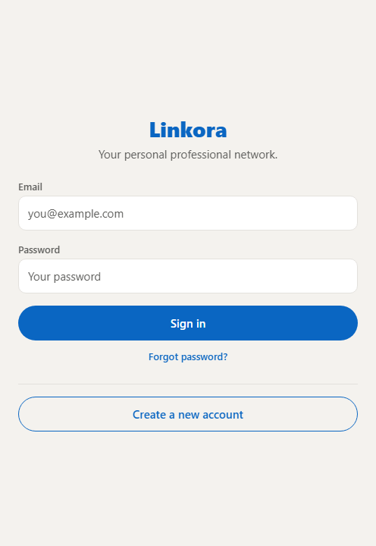  Login — real render | 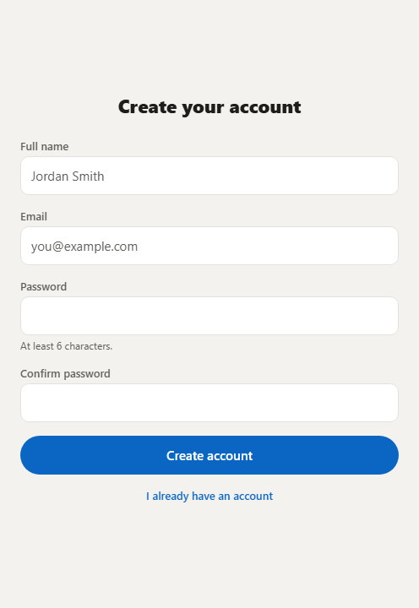  Register — real render

What this evidences
All of the following is platform-independent and therefore transferable to a device: successful application boot, the environment guard accepting a valid configuration, Firebase SDK initialisation, AuthContext resolving its loading state, React Navigation performing a screen transition, and correct rendering of both authentication screens.
What it does not evidence. The capture is the web render via react-native-web, not a physical device. Three code paths are platform-specific and were not exercised.
Unexercised path | Location | Failure symptom on a device
getReactNativePersistence(AsyncStorage) | src/firebase/app.ts | Session does not survive an app restart
expo-image-picker native module | CreatePostScreen, EditProfileScreen | Gallery does not open, or no permission prompt
fetch('file://…') → Blob | src/services/storage.service.ts | Upload fails after an image is selected
Real authentication and all Firestore reads and writes also remain unevidenced, as they require live credentials and published security rules. The Android bundle compiles successfully (903 modules), but compilation is not execution.

12.2 Interface mockups
Statement of accuracy. The images below are mockups, not screenshots. The signed-in screens require an authenticated account against live Firebase credentials, so they could not be captured. Each mockup is drawn directly from the design tokens in src/theme/index.ts and from each screen's StyleSheet, so colours, spacing, control shapes and label text correspond to the implemented code. They are presented as design references, not as evidence of a running build.
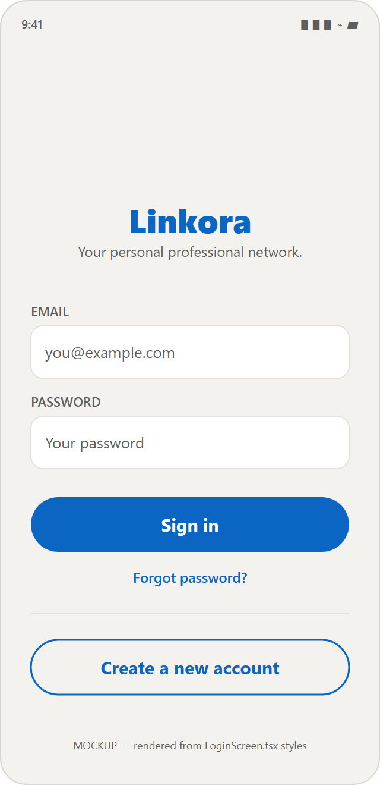  Login | 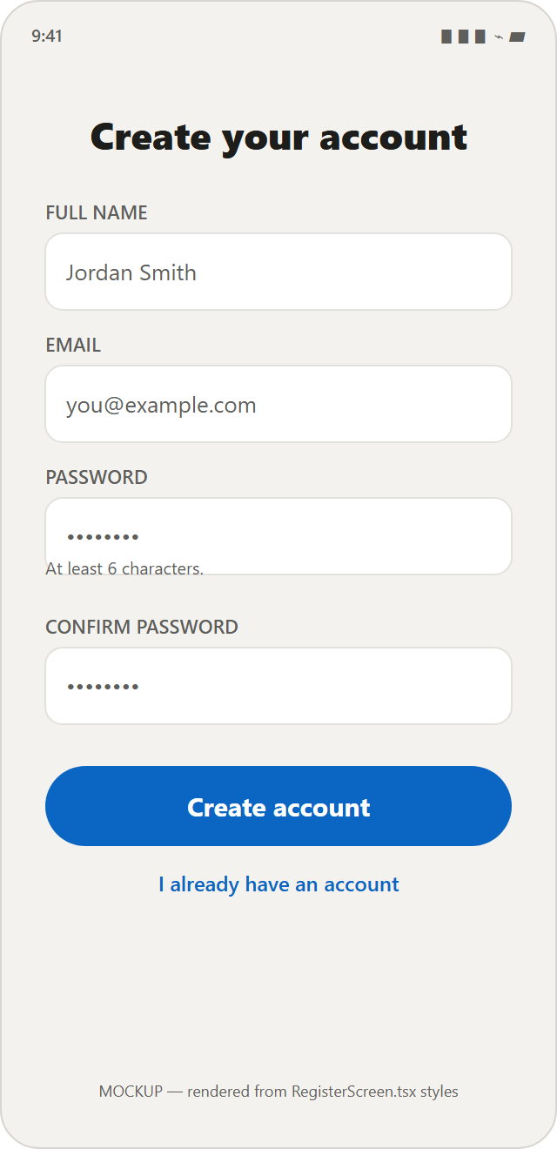  Register | 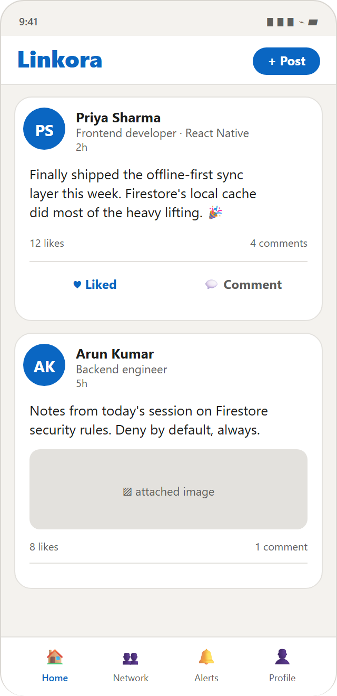  Home feed
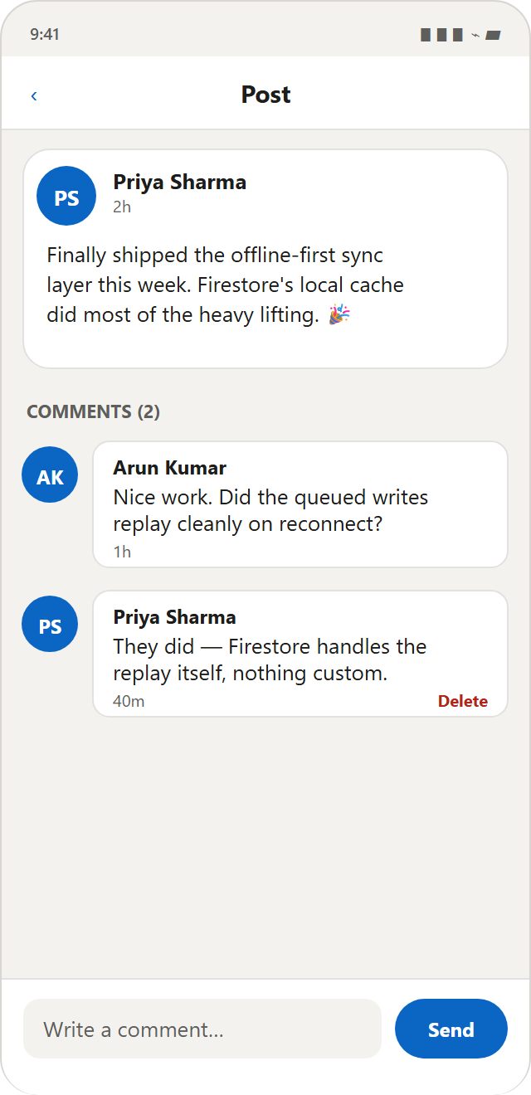  Post & comments | 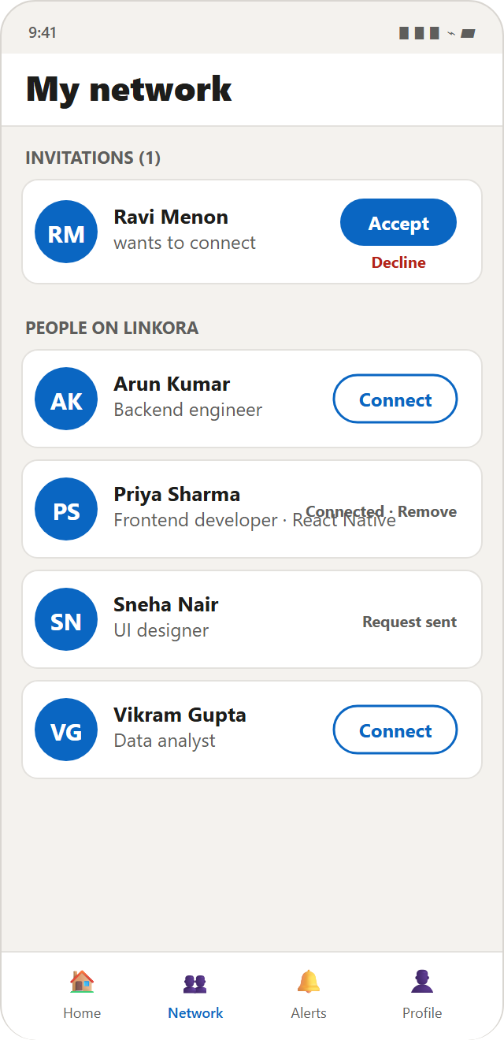  My network | 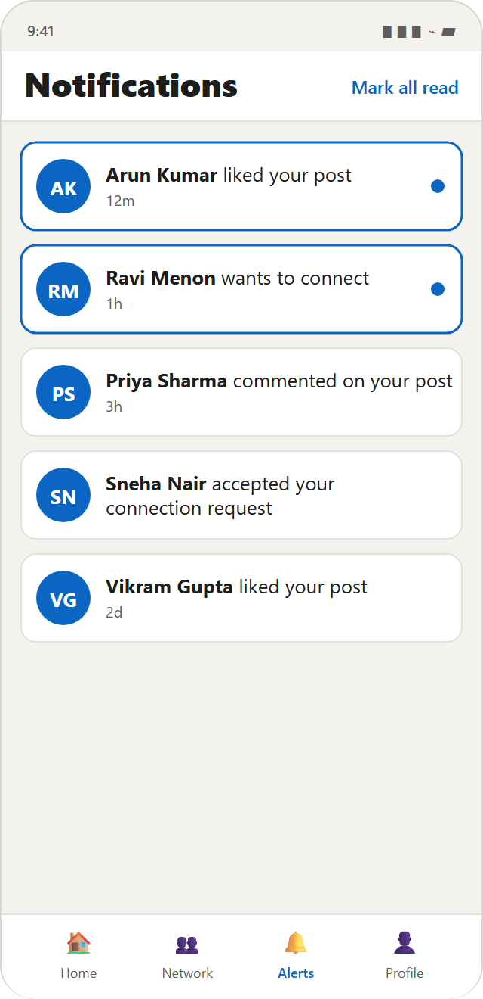  Notifications
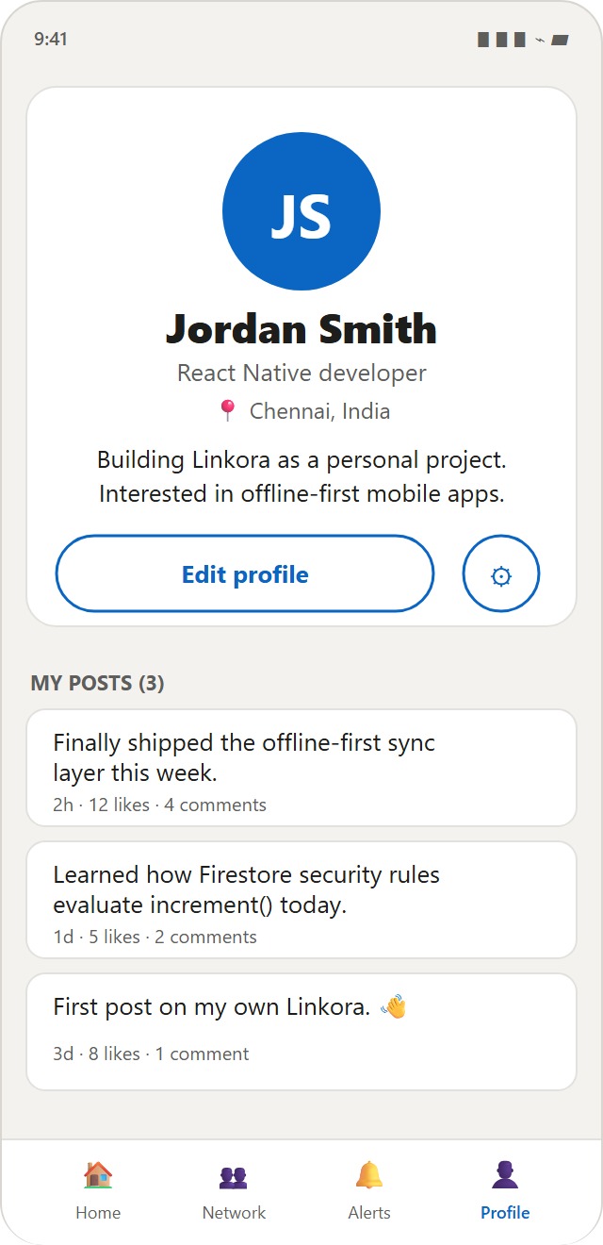  Profile | 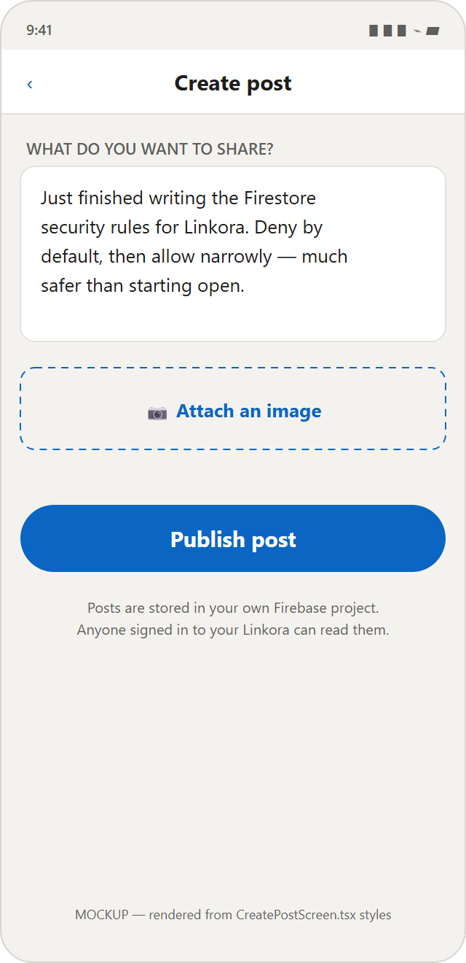  Create post | 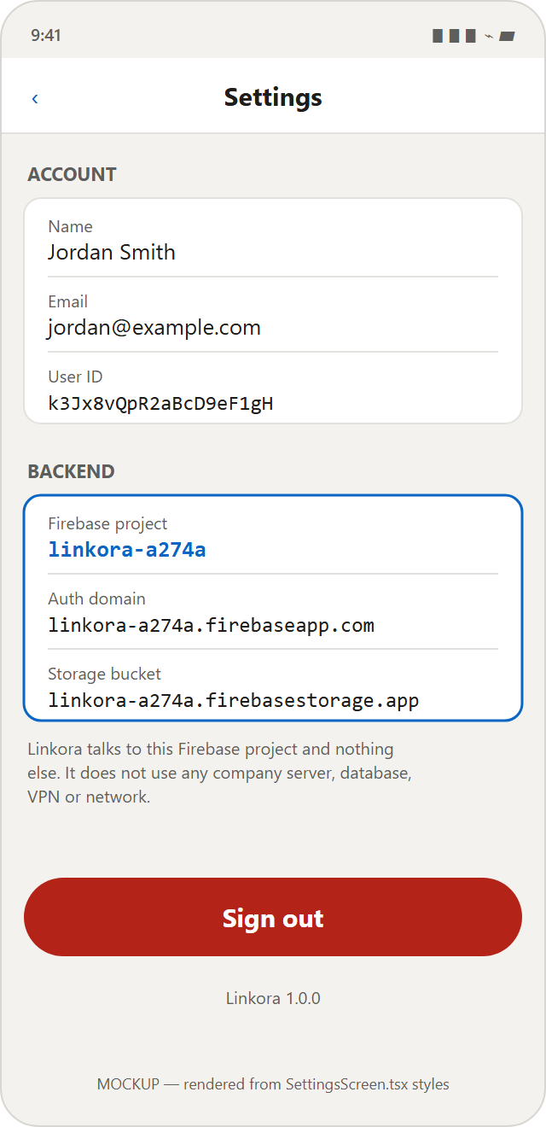  Settings

Design language
A single token file (src/theme/index.ts) defines the palette — primary #0A66C2, background #F4F2EE, surface #FFFFFF, border #E3E1DD, text #1D1D1B — together with a spacing scale, corner radii and font sizes. Every screen imports from it, which is why the mockups above can be generated from the source with confidence.

12.3 Screen inventory

Signed out
Screen | File | Purpose | Actions | Data source
Login | auth/LoginScreen.tsx | Sign in | Sign in, reset password, go to Register | Firebase Auth
Register | auth/RegisterScreen.tsx | Create account | Create account, return to Login | Auth + Firestore

Signed in — tabs
Screen | File | Purpose | Actions | Data source
Home | HomeScreen.tsx | Realtime feed | Like, comment, open author, delete own post, new post | subscribeToFeed()
Network | NetworkScreen.tsx | People and invitations | Connect, accept, decline, remove | listOtherUsers(), subscribeToMyConnections()
Notifications | NotificationsScreen.tsx | Activity list | Open target, mark all read | subscribeToNotifications()
Profile | ProfileScreen.tsx | Own profile and posts | Edit profile, settings | useAuth(), subscribeToUserPosts()

Signed in — stack
Screen | File | Purpose | Actions | Data source
Create post | CreatePostScreen.tsx | Compose | Attach/remove image, publish | createPost(), uploadPostImage()
Post detail | PostDetailScreen.tsx | Post + comments | Add comment, delete own comment | getPost(), subscribeToComments()
Edit profile | EditProfileScreen.tsx | Edit own profile | Change photo, save | updateUserProfile(), uploadAvatar()
User profile | UserProfileScreen.tsx | Another member | Connect, accept, remove | getUserProfile(), subscribeToUserPosts()
Settings | SettingsScreen.tsx | Account and backend info | Sign out | useAuth(), firebaseConfig

Notable UX decision — the Settings backend card
Settings displays the live Firebase project ID, auth domain and storage bucket. This turns the isolation guarantee into something verifiable on the device itself rather than a claim in documentation.

13.Firebase services used
Linkora consumes no REST APIs. All backend interaction is through the Firebase SDK.

Authentication
SDK function | Purpose
createUserWithEmailAndPassword | Registration
signInWithEmailAndPassword | Login
signOut | Logout
updateProfile | Set display name on the Auth record
sendPasswordResetEmail | Password reset
onAuthStateChanged | Session state listener
initializeAuth / getAuth | Instance creation with persistence

Cloud Firestore
SDK function | Purpose
collection, doc | Path references
getDoc, getDocs | One-off reads
onSnapshot | Realtime listeners (6 sites)
setDoc | Write with a chosen ID (users, likes, connections)
addDoc | Write with a generated ID (posts, comments, notifications)
updateDoc | Partial update
deleteDoc | Delete
writeBatch | Atomic multi-write (like / unlike)
increment | Atomic counter
serverTimestamp | Server-side time
query, where, orderBy, limit | Query construction

Storage
ref · uploadBytes · getDownloadURL

Cloud Messaging
NOT IMPLEMENTED — no FCM code exists. EXPO_PUBLIC_FIREBASE_MESSAGING_SENDER_ID is present because it is part of the standard Firebase config block, not because messaging is in use.

14.Data flow

Registration
RegisterScreen → register()
→ createUserWithEmailAndPassword() Firebase Auth
→ updateProfile({ displayName }) Firebase Auth
→ createUserProfile() → setDoc() Firestore users/{uid}
→ onAuthStateChanged → AuthContext → RootNavigator → MainTabs

Create post
CreatePostScreen
→ (optional) uploadPostImage() → Storage → download URL
→ createPost() → addDoc(posts)
→ subscribeToFeed listener fires on all devices
→ HomeScreen → FlatList → PostCard

Fetch posts
HomeScreen useEffect
→ subscribeToFeed()
→ onSnapshot(posts, orderBy createdAt desc, limit 50)
→ snapshot.docs.map(toPost) → setPosts
→ unmount: unsubscribe()

Like
PostCard onToggleLike
→ optimistic setLikedIds()
→ likePost()
→ writeBatch: set(likes/{uid}) + update(likeCount +1) → commit()
→ createNotification('like')
→ feed listener pushes the new count
→ on failure: state rolled back, ErrorBanner shown

Connection
NetworkScreen "Connect" → sendConnectionRequest()
→ setDoc(connections/{sortedPair}, 'pending') → notification
→ recipient's subscribeToMyConnections fires
→ "Accept" → acceptConnectionRequest() → updateDoc('accepted') → notification

Image upload
requestMediaLibraryPermissionsAsync()
→ launchImageLibraryAsync({ quality: 0.7 })
→ file:// URI
→ fetch(uri).blob() device-local read, NOT a network request
→ uploadBytes(ref(...)) Firebase Storage
→ getDownloadURL()
→ URL saved into the Firestore document

15.Testing
Accuracy statement. This section reports only what was actually executed. Items marked PENDING have not been run.

15.1 Automated verification — PERFORMED
Check | Command | Result
TypeScript compilation | npm run typecheck | Pass — zero errors
Metro production bundle (Android) | npm run bundle-check | Pass — 903 modules, no resolution errors
Dependency audit | npm audit | 17 moderate, 0 high, 0 critical — all transitive

15.2 Static and bundle analysis — PERFORMED
Check | Result
Network entry points (fetch, axios, XMLHttpRequest, WebSocket) | 1 result — local file:// read in storage.service.ts
Hardcoded URLs / IPs in source | Only documentation links; no live endpoints
Private IP literals in compiled bundle | None
Database drivers (MongoDB, MySQL, PostgreSQL, Redis, MSSQL, Oracle) | None
Directory / SSO clients (LDAP, Kerberos, SAML) | None
Telemetry SDKs (Sentry, Segment, Amplitude, Mixpanel, Bugsnag, Datadog) | None
Embedded private keys | None
Admin SDK / service accounts | None
Outbound hostnames in compiled bundle | Only Google Firebase endpoints

15.3 Runtime boot test — PERFORMED
The application was executed as a web build with a temporary throwaway Firebase configuration and driven automatically through the Chrome DevTools Protocol.
Check | Method | Result
Application boots | Load exported web bundle | Pass — renders within 3 s
Environment guard accepts valid config | .env with correct projectId | Pass — no error thrown
Firebase SDK initialises | initializeApp in src/firebase/app.ts | Pass — no exception
AuthContext resolves loading state | onAuthStateChanged fires | Pass — Login replaces the splash spinner
Login screen renders | DOM text assertion | Pass — all fields and buttons present
Navigation works | Automated click on "Create a new account" | Pass — Register screen rendered
Register screen renders | DOM text assertion | Pass — all four fields present
Console errors / exceptions | CDP Runtime.exceptionThrown | Zero
Additionally, onAuthStateChanged was probed directly in Node with a deliberately invalid API key and fired in 1 ms with user = null, confirming the auth listener resolves even when the backend is unreachable.

15.4 Functional testing — PENDING
Testing against live data requires real Firebase credentials and completed console setup, which were not performed. No end-to-end functional test has been executed. The list below is the intended plan, not a record of results.
[ ] Registration creates an Auth user and users/{uid}
[ ] Login and logout
[ ] Session persists across app restart
[ ] Password reset email delivered
[ ] Profile edit persists
[ ] Avatar upload appears in Storage
[ ] Post creation (text, and text + image)
[ ] Feed updates in realtime on a second device
[ ] Like increments and de-duplicates; unlike decrements
[ ] Comment adds and increments counter
[ ] Comment deletion by author and by post owner
[ ] Post deletion removes subcollections
[ ] Connection request, accept, remove
[ ] Notifications generated for all four types; no self-notification

15.5 Security-rule testing — PENDING
Planned via Firebase Console → Firestore → Rules Playground:
[ ] Unauthenticated read of users/{uid} expect DENY
[ ] Authenticated read of another user's profile expect ALLOW
[ ] Write to another user's profile expect DENY
[ ] Write email field on own profile expect DENY
[ ] likeCount change of +1 expect ALLOW
[ ] likeCount change of +50 expect DENY
[ ] Create like with another user's UID as docId expect DENY
[ ] Requester accepting own request expect DENY
[ ] Notification with forged actorId expect DENY
[ ] Any read of jobs / conversations expect DENY

15.6 Isolation testing — partially performed
Test | Status
Source and bundle scan for organisational references | PERFORMED — CLEAN
Verification that only Firebase endpoints appear in the bundle | PERFORMED — CONFIRMED
Run on personal Wi-Fi with organisational network unreachable | PENDING
Run with VPN disconnected | PENDING

16.Error handling

Strategy — three layers
- Client validation — immediate feedback before a network call (looksLikeEmail(), password length, matching passwords, non-empty post).
- Service-layer propagation — services do not swallow errors; they let them reach the caller.
- Screen-level presentation — screens catch, translate via describeError(), and render <ErrorBanner />.

Translation examples
Code | Message shown
auth/email-already-in-use | That email address already has a Linkora account. Try signing in.
auth/invalid-credential | Wrong email or password.
auth/network-request-failed | Could not reach Firebase. Check that this device has internet access.
permission-denied | Firestore refused this operation. Your security rules do not allow it…
failed-precondition | Firestore needs an index for this query. Open the link in the terminal error.
storage/unauthorized | Firebase Storage refused this upload…
Unmapped errors fall back to the raw message, then to a generic sentence — the user never sees a bare error code.

Deliberate non-failures
Operation | Rationale
getLikedPostIds() in HomeScreen | A failure only means heart icons are not pre-filled. It must not break the feed.
markNotificationRead() on tap | Navigation should proceed even if the read flag fails to write.
Both are commented in the source to record the intent.

Offline behaviour
Firestore's local cache serves recently-read data and queues writes for replay. unavailable and auth/network-request-failed have explicit user-facing messages. The application does not crash and does not discard user input.

17.Performance
Technique | Implementation | Effect
Denormalisation | Author data copied onto each post | 50-post feed is 1 query, not 51
Query limits | limit(50) on feed, user posts, notifications | Bounded read cost and memory
List virtualisation | FlatList throughout | Only visible rows rendered
Atomic increments | increment() not read-modify-write | Removes a round trip and a race
Batched writes | writeBatch for like + counter | One round trip instead of two
Optimistic UI | Like state updates before the write completes | Perceived latency ≈ 0
Deterministic IDs | Likes by UID, connections by sorted pair | Eliminates pre-write queries
Listener cleanup | Every useEffect returns its unsubscribe | Prevents leaks and billed reads
Image compression | quality: 0.7 in the picker | Smaller uploads, faster feed
Memoisation | useMemo / useCallback | Avoids recomputation per render
Composite index | authorId + createdAt | Server-side filtered sort
Single Firebase init | getApps().length > 0 ? getApp() : … | No duplicate instances under fast refresh
Measured artefact. The Android production bundle is 3.7 MB (Hermes bytecode) across 903 modules.

18.Security & privacy — infrastructure independence

Statement
Linkora is a personal application. It operates exclusively on the personal Firebase project linkora-a274a and is designed so that it does not require or depend on organisational servers, databases, APIs, VPN, credentials or network infrastructure.

Enforcement in code
Control | Location | Effect
Single network entry point | src/firebase/app.ts | Only file that opens a backend connection
No HTTP client | Whole project | No axios; exactly one fetch, reading a local file:// image
Project allow-list | config/env.ts → ALLOWED_FIREBASE_PROJECT_ID | Application throws and halts if .env names any other project
Placeholder rejection | config/env.ts → required() | Refuses to start on unconfigured values
On-device disclosure | SettingsScreen | Displays live project ID, auth domain, storage bucket
Secret exclusion | .gitignore | Blocks .env, service-account JSON, keystores, certificates
No Admin SDK | Dependency tree | No privileged credential can exist in the client

External network dependencies — complete list
Service | Domain | Purpose | Ownership | Runtime?
Firebase Authentication | identitytoolkit.googleapis.com | Sign-in, registration, reset | Personal | Yes
Firebase token refresh | securetoken.googleapis.com | Session token renewal | Personal | Yes
Cloud Firestore | firestore.googleapis.com | All application data | Personal | Yes
Firebase Storage (write) | firebasestorage.googleapis.com | Image upload | Personal | Yes
Firebase Storage (read) | storage.googleapis.com | Image download | Personal | Yes
Firebase auth domain | linkora-a274a.firebaseapp.com | Auth handler | Personal | Yes
npm registry | registry.npmjs.org | Dependency installation | Public | No — build only
Expo dev server | Local machine, port 8081 | Code delivery to Expo Go | Local | No — development only
Organisational infrastructure referenced: none.
Caveat on verification scope. The scans above cover source code, configuration and the compiled Android bundle. They do not constitute a runtime network capture. A definitive runtime verification would require running the configured application behind a network monitor, which has not been performed. The static and bundle-level evidence is strong but is not a substitute for that test.

19.Installation guide
Requirement | Necessity | Verify with
Node.js 20+ | Required | node --version
npm | Required | npm --version
Expo Go on a phone | Required | Play Store / App Store
Personal Google account | Required | —
Git | Recommended | git --version
Android Studio / JDK / Xcode | Not required | —

Steps
cd C:\Users\IT\Documents\Linkora
npm install
Copy-Item .env.example .env # then fill in the Firebase values
npm run typecheck

Firebase console setup
- Project settings → Your apps → register a Web app (the JS SDK requires a Web app even on mobile). Copy the config into .env.
- Build → Authentication → Sign-in method → enable Email/Password.
- Build → Firestore Database → create in production mode.
- Build → Storage → enable in production mode; copy the bucket into .env.
- Firestore → Rules → paste firestore.rules, publish.
- Storage → Rules → paste storage.rules, publish.
- Create the composite index via firebase deploy --only firestore:indexes or the link in the runtime error.
google-services.json and GoogleService-Info.plist are not required. The JS SDK uses the Web app configuration on all platforms.

20.Running the application
Command | Purpose
npm start | Start the Expo development server
npm run android | Open on a connected Android device or emulator
npm run ios | Open in the iOS simulator (macOS only)
npm run web | Open in a browser
npm run typecheck | TypeScript check
npm run bundle-check | Produce a production bundle
npx expo start --clear | Start with cleared cache (required after editing .env)
npx expo start --tunnel | Tunnel mode when the local network blocks device-to-device traffic
On a physical device: run npm start, connect the phone to the same Wi-Fi, and scan the QR code with Expo Go (Android) or the Camera app (iOS).
Version control note. This project is not currently a Git repository — Git is not installed on the development machine. When initialising it, use a personal Git identity and a private personal remote, and confirm .env is absent from git status --porcelain before the first commit.

21.Deployment
Linkora has no server component. Deployment consists of publishing security rules and distributing the application binary.

Rules deployment
npm install -g firebase-tools
firebase login
firebase use linkora-a274a
firebase deploy --only firestore:rules,firestore:indexes,storage
Rules must be deployed before distributing an application version that depends on them.

Android — cloud build
npm install -g eas-cli
eas login
eas build:configure
eas build --platform android --profile preview # APK
eas build --platform android # AAB for Play Store
EAS Build uploads source to Expo's servers — the only third-party service in this project's lifecycle. For a personal project with no embedded secrets the exposure is low, but it should be a conscious choice. EXPO_PUBLIC_* variables must be configured in eas.json or the EAS dashboard, as the build server has no access to the local .env.

Android — local build
Requires JDK 17 and Android Studio, neither installed on the development machine:
npx expo prebuild --platform android
cd android
./gradlew assembleRelease # APK
./gradlew bundleRelease # AAB
A release keystore is required and must be backed up outside version control — losing it prevents publishing further updates to the same application identity.

iOS
eas build --platform ios requires a paid Apple Developer account (USD 99/year). For personal use, Expo Go on a physical iPhone is sufficient.

22.Future enhancements
These are proposals, not implemented functionality.

Completing the designed model
Enhancement | Notes
Direct messaging | conversations/{id}/messages/{id} with a members array, mirroring the connections pattern. Rule placeholders already exist.
Jobs and applications | jobs, companies, applications collections. Rule placeholders already exist.
Push notifications | Requires a development build plus expo-notifications and a Cloud Function to dispatch messages.
Search | findUserByEmail() already exists and needs only a UI. Substring search would require an external index.
Post editing / account deletion | Both already permitted by the rules; only UI is missing.

Engineering improvements
Enhancement | Rationale
Automated tests | jest-expo + @testing-library/react-native; rules tests via the Firebase emulator
Cloud Functions | Server-authoritative counters, cascading deletes, notification fan-out
Pagination | Cursor-based infinite scroll to replace the fixed limit(50)
Image caching | expo-image for disk caching and progressive loading
Offline indicator | Explicit UI state for queued writes
CI pipeline | Automated typecheck and bundle-check on every commit

Product ideas
Advanced job recommendations · improved search ranking · profile verification · AI-assisted career guidance · richer notification preferences · usage analytics on personally-owned infrastructure.

23.Conclusion
Linkora demonstrates that a functional, secure, cross-platform social application can be built without operating any server infrastructure. By using Firebase as a serverless backend and enforcing authorisation through server-side security rules, the project achieves a security posture that does not depend on the client being trustworthy — a property a naive client-validated design cannot claim.
The implemented feature set — authentication, profiles, a realtime feed, posts with images, likes, comments, connections and notifications — covers the core interaction loop of a professional network. Features that were designed but not built are documented as such throughout, and their Firestore collections are explicitly denied in the security rules so that incomplete work cannot become an unsecured surface.
The architectural constraint that shaped this project most is infrastructure independence. Confining all network access to a single module, hardcoding a project allow-list that halts the application on mismatch, and surfacing the live backend identity on the Settings screen together turn a policy statement into a verifiable property. Static analysis of both source and the compiled bundle confirms that the application's only network destinations are the Firebase endpoints of one personally-owned project.
The principal limitations are honest ones: no automated test suite, counter integrity that is bounded rather than guaranteed without Cloud Functions, and several designed features still unimplemented. Each is documented with the specific work required to address it.

24.Viva / presentation questions
Q1.What is React Native?
A framework for building mobile applications in JavaScript or TypeScript that render as genuine native platform widgets, rather than as a web page inside a wrapper. One codebase targets both Android and iOS.
Q2.Why did you choose React Native?
A single codebase for both platforms, a large ecosystem, and — combined with Expo — the ability to develop and run on a physical device without Android Studio, Xcode or a JDK. The development machine used for this project has none of those installed.
Q3.What is Expo and why use it?
A toolchain and runtime around React Native. Expo Go loads the application over Wi-Fi from the development server, removing the entire native build setup. The trade-off is that native-only modules — including Firebase Cloud Messaging — are unavailable, which is directly why push notifications are not implemented.
Q4.Why Firebase?
It provides authentication, a realtime database and file storage as managed services, with authorisation enforced server-side by security rules. This removes the need to write, host and secure a backend, while still keeping trust decisions off the client.
Q5.What is Firestore?
A NoSQL document database. Data is stored as documents containing fields, grouped into collections, which may in turn contain subcollections. It supports realtime listeners that push changes to connected clients.
Q6.How does authentication work in your app?
Firebase Authentication with email and password — createUserWithEmailAndPassword and signInWithEmailAndPassword in src/services/auth.service.ts. Google stores the password hash; the application never sees or stores a password. The returned ID token is persisted to AsyncStorage and attached to every subsequent request, which is what populates request.auth in the rules.
Q7.How does your app store data?
In Cloud Firestore: users, posts (with likes and comments subcollections), connections, and notifications as a subcollection of users. Images live in Firebase Storage and are referenced from Firestore by download URL.
Q8.How do users connect?
A document at connections/{id} where the ID is the two user IDs sorted and joined with an underscore. The requester creates it with status pending; only the recipient may change it to accepted. The deterministic ID makes duplicate connections structurally impossible.
Q9.How does messaging work?
It is not implemented. There is no messaging screen, service or route. The conversations and messages collections exist in the planned data model and are explicitly denied in the security rules so the unbuilt feature cannot become an unsecured collection.
Q10.How do Security Rules work?
They are a declarative policy evaluated on Google's servers for every request. Because they are not part of the application, they apply even to a modified client or a direct API call. Linkora denies everything by default, requires authentication throughout, compares request.auth.uid against the target document, and restricts which fields — and for counters, which values — a write may produce.
Q11.How is the application secured?
Four layers. Authentication is required for every operation. Ownership is enforced by comparing the caller's UID to the document. Field-level rules limit even permitted writes. And the signed-out UI never mounts the signed-in screens. The first three are server-enforced and cannot be bypassed by editing the app.
Q12.Is your Firebase API key exposed? Is that a problem?
It is embedded in the bundle, and that is expected. Firebase client configuration is a public project identifier, comparable to a postal address — it grants no access by itself. Access is decided entirely by the security rules. The EXPO_PUBLIC_ prefix exists precisely to signal that the value is visible. Genuine secrets, such as service-account keys, are never placed in a mobile application because any embedded value can be extracted.
Q13.How does your app handle errors?
src/utils/errors.ts translates Firebase error codes into actionable sentences; screens catch errors and render a consistent ErrorBanner. Listeners receive an onError callback. Two operations deliberately swallow errors — pre-filling like icons and marking a notification read on tap — because failing loudly there would degrade the experience more than failing silently.
Q14.How does your application communicate with Firebase?
Through the Firebase JS SDK only. There is no REST API and no custom endpoint. Screens call service functions, services use the SDK, and the SDK issues authenticated HTTPS requests — all flowing through one initialisation module, src/firebase/app.ts.
Q15.Why didn't you use a traditional backend?
A conventional API tier exists mainly to hold credentials and enforce authorisation away from the client. Firebase Security Rules perform that authorisation on Google's servers. A middle tier would add hosting cost, deployment work and another attack surface without adding a guarantee the rules do not already provide. The genuine limitation is that server-authoritative logic — such as tamper-proof counters — would require Cloud Functions.
Q16.What are the limitations of your project?
No messaging, jobs or push notifications. No automated tests. Like and comment counters are bounded to ±1 per write but not fully tamper-proof without Cloud Functions. All content is visible to all signed-in members. Registration is open. Post deletion iterates subcollections from the client and could be interrupted for a very large post.
Q17.What would you improve in future?
Implement messaging and jobs using the collection placeholders already reserved in the rules; add Cloud Functions for authoritative counters and cascading deletes; add a test suite with the Firebase emulator; replace the fixed feed limit with cursor pagination; and migrate to a development build to enable push notifications.
Q18.What is the difference between addDoc and setDoc?
addDoc lets Firestore generate the document ID, used for posts, comments and notifications where the ID carries no meaning. setDoc is used where the ID is meaningful and enforces uniqueness — likes keyed by the liker's UID, and connections keyed by the sorted user pair.
Q19.Why serverTimestamp() rather than new Date()?
So ordering uses Google's clock rather than the device's. A phone with an incorrect date could otherwise pin its post permanently to the top of the feed. A consequence is that createdAt is briefly null in the local snapshot before the server value arrives, which is why timeAgo() returns "just now" for a null value.
Q20.What is a writeBatch and why is it necessary?
It groups writes so they succeed or fail together. Liking a post writes two documents — the like and the incremented counter. Without a batch, one could succeed while the other failed, leaving likeCount permanently wrong.
Q21.How do you prevent a user liking a post twice?
The like document's ID is the liker's UID: posts/{postId}/likes/{uid}. A second like overwrites the same document, so duplication is structurally impossible. It also reduces the rule to a single identity comparison and removes the need for a check query before writing.
Q22.How do you know the app only talks to your own Firebase project?
Four ways. All network access is confined to src/firebase/app.ts. assertPersonalFirebaseProject() halts the application if .env names any project other than linkora-a274a. The Settings screen displays the live project ID on the device. And extracting hostnames from the compiled Android bundle returns only Google's Firebase endpoints.
Q23.What did you actually test, and what did you not?
Verified by execution: TypeScript compiles with zero errors; the Android bundle builds successfully (903 modules); the dependency audit shows 17 moderate transitive advisories and no high or critical ones; and static plus bundle analysis found no organisational infrastructure, no database drivers, no telemetry SDKs and no embedded keys. Not yet performed: functional testing on a device and security-rule simulation, both of which require a configured .env and completed Firebase console setup.
LINKORA · Version 1.0.0 · 5 September 2026
Firebase project linkora-a274a · React Native 0.86.3 · Expo SDK 57.0.20
This document describes the project as implemented. Features not built are marked NOT IMPLEMENTED rather than described.

