**Synopsis on University Management System**

* **Introduction**

In today’s rapidly evolving digital era, universities are facing tremendous challenges in managing their academic and administrative activities effectively. With the growing number of students, faculty, and departments, traditional manual systems often prove inefficient, time-consuming, and prone to errors. A University Management System (UMS) is designed as a comprehensive software solution to address these issues by centralizing and automating processes such as admissions, student data management, faculty allocation, fee collection, examinations, and report generation.   
  
The introduction of a UMS eliminates paperwork, reduces redundancy, and ensures transparency in academic institutions. It supports administrators in making data-driven decisions while providing students with quick and easy access to academic information. Moreover, faculty can efficiently manage course materials, attendance, and student performance through an integrated platform.   
  
The adoption of digital systems in universities not only improves productivity but also enhances communication among all stakeholders. In an age where educational institutions are expanding and competing globally, an effective UMS becomes essential for ensuring academic excellence, maintaining operational efficiency, and meeting modern educational standards.

* **Problem Definition**

Universities today face multiple challenges in managing diverse academic and administrative tasks. Student admissions, attendance tracking, examination schedules, faculty records, and financial transactions are often maintained using manual systems or isolated tools. This leads to a lack of integration, inefficiencies, and errors in data management.   
  
Some of the key problems include duplication of student records, delays in communication, inaccurate reporting, and difficulty in accessing information. For example, students may experience delays in obtaining examination results, while administrators struggle to consolidate data across departments. Faculty members may find it challenging to keep track of student performance or attendance accurately.   
  
Such issues result in wasted time, decreased productivity, and frustration for both staff and students. A centralized University Management System can address these problems by providing a unified platform that ensures accuracy, reduces manual workload, and supports secure data management. Thus, the problem definition highlights the pressing need for an integrated system that brings together all stakeholders under one digital environment

* **Aim and Objectives**
* **Aim:**  
  The primary aim of the University Management System is to design and implement a comprehensive and integrated platform that automates academic and administrative processes while ensuring efficiency, accuracy, and accessibility for all stakeholders.
* **Objectives:**1. Develop a responsive and user-friendly platform to manage students, faculty, courses, and departments seamlessly.  
  2. Provide online admission facilities that simplify the application and enrollment process, reducing paperwork and delays.  
  3. Automate attendance and examination management, ensuring transparency and accuracy in records.  
  4. Enable secure fee collection and issue digital receipts to minimize financial discrepancies.  
  5. Offer dashboards and analytical reports that help administrators and faculty in decision-making.  
  6. Ensure scalability for integration with mobile applications and future modules, keeping pace with technological advancements.  
  7. Improve communication between students, faculty, and administration through a centralized notification and alert system.
* **Key Features**

The University Management System is designed with several essential features that make it a robust and comprehensive solution for universities. Each feature is tailored to address specific needs of students, faculty, and administrators:  
  
**1. Student Management:** Enables registration, attendance tracking, grade management, and personal record maintenance. Students can access their data easily without administrative delays.  
  
**2. Faculty Management:** Simplifies faculty allocation, course scheduling, and performance monitoring. Faculty members can update student records, upload study materials, and communicate directly with students.  
  
**3. Course and Department Management:** Supports curriculum design, department-level activities, and course allocation. It ensures smooth coordination between departments.  
  
**4. Examination and Result Processing:** Automates exam scheduling, question paper setting, evaluation, and result publishing, reducing errors and delays.  
  
**5. Fee Management and Online Payments:** Provides students with secure fee payment gateways, digital receipts, and financial transparency for administrators.  
  
**6. Dashboards and Analytics:** Administrators can view real-time insights, generate reports, and monitor student and faculty performance effectively.  
  
**7. Secure Authentication:** Ensures data privacy and system security through user authentication, role-based access, and encryption.  
  
Together, these features make the UMS a powerful tool that enhances efficiency and promotes a digitally advanced learning environment.

* **Tools and Technologies**

|  |  |
| --- | --- |
| Category | Tools / Technologies |
| Frontend | HTML5, CSS3, JavaScript, React.js / Angular |
| Backend | Node.js / Java (Spring Boot) . |
| Database | MySQL / MongoDB |
| Hosting | AWS / Heroku / Azure |
| Authentication | JWT, OAuth 2.0 |
| Version Control | Git & GitHub |
| Testing | Postman, Jest |
| Project Management | Trello, Jira |

**Project Phases**

|  |  |  |
| --- | --- | --- |
| **Phase** | **Tasks** | **Output** |
| 1. Planning & Requirement | Gather requirements, define roles, identify modules. | Requirement Document |
| 2. Technology Selection | Decide frontend, backend, database, APIs | Tech Stack Finalized |
| 3. UI/UX Design | Wireframes, mockups, responsive layouts | UI Designs |
| 4. Backend Development | Develop APIs for students, faculty, exams, fees | Working Backend |
| 5. Frontend Development | Build student, faculty, admin dashboards | Functional Web Interface |
| 6. Integration & Testing | Integrate modules, conduct testing | Bug-Free System |
| 7. Deployment | Deploy system to server/cloud | Live System |
| 8. Training & Maintenance | Train users, fix bugs, add updates | Operational System |

* **Workflow**

The workflow of the University Management System begins with a requirement analysis phase, where system needs and user roles are identified. This is followed by system design, which includes ER diagrams, UI wireframes, and database schema creation. The backend is then developed to handle APIs and business logic, followed by frontend development for user interfaces. After both ends are integrated, rigorous testing is performed to ensure system stability and correctness. Finally, the project is deployed on a server or cloud environment, and periodic maintenance and updates are carried out to ensure long-term usability.

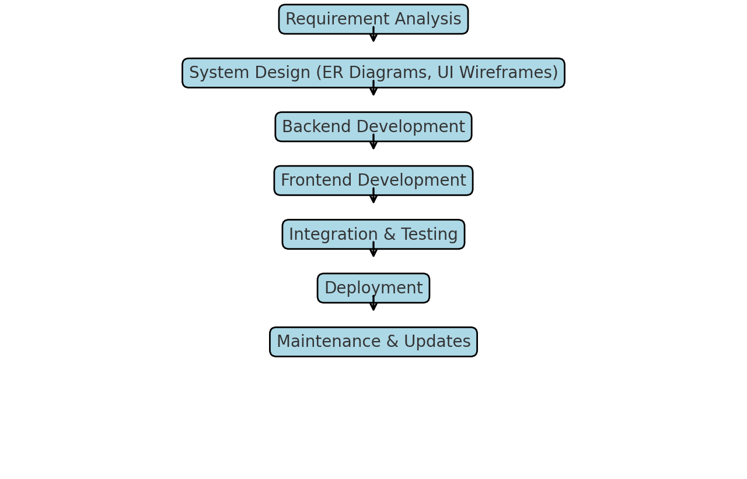

* + - **Conclusion**

The University Management System (UMS) is a practical and future-oriented solution to digitalize university operations and overcome the challenges of manual processes. By integrating various academic and administrative functions into a single platform, the UMS ensures efficiency, transparency, and convenience for all stakeholders.   
  
For students, it provides quick access to academic information, online fee payment options, and real-time updates. For faculty, it simplifies course management, attendance tracking, and student performance evaluation. For administrators, it delivers powerful dashboards, reporting tools, and streamlined communication channels.   
  
In addition, the system is designed with scalability in mind, allowing future integration with mobile applications and additional modules. By adopting such a solution, universities can significantly reduce paperwork, save time, and improve productivity. Ultimately, the UMS strengthens the educational ecosystem and positions institutions to compete effectively in the digital age.

* **Team Members**

1) Tushar Kalugade  
2) Swapnil Kalambe  
3) Vrushali Khavle  
4) Makrand Sawant  
5) Deven Hande

**Prof. Roshni Mukadam. Dr. Praveen Gupta.**

**Guide** **H.O.D**

CS/IT Department CS/IT Department