Smart Meter Data Reconciliation & Audit Engine
  - Technical Specification & Deep Architecture Reference
1. Executive Summary
Business problem: The application was built to eliminate a critical operational bottleneck in power utility management. Previously, teams spent up to six hours manually downloading millions of smart meter records into large Excel spreadsheets, chaining fragile VLOOKUP formulas, and handling repeated spreadsheet crashes while unpivoting date matrices and calculating completion ratios.
Operational challenge: This manual workflow was time-consuming, prone to human error, and affected by operating system file-path conflicts across multiple datasets. These issues made the audit process slow, fragile, and difficult to scale for high-volume smart meter data.
Solution approach: To solve this, the workflow was automated through a high-performance, web-based audit engine built with FastAPI, DuckDB, and HTMX. Operators can trigger background ingestion pipelines directly from a web dashboard while the system processes data in the background.
Processing engine: DuckDB performs vectorized, in-memory SQL transformations to merge baseline records, filter out pre-tested devices, and validate consumer-meter links against master registries. The engine also removes hardware serial prefixes using regex and unpivots time-series date columns to calculate expected versus received interval reading counts.
Final outcome: Real-time HTMX polling streams execution progress to the user, and the engine completes the process by exporting clean, ready-to-use report files: final_lp.csv, final_dp.csv, and final_bp.csv. This reduces a lengthy manual process into a faster, more reliable, and easier-to-monitor audit workflow.

2. Deep Architecture & Tech Stack Details
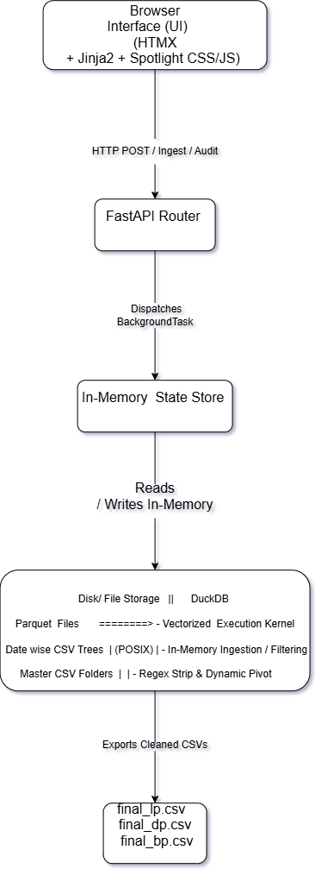
A. In-Memory Analytical Execution Kernel (DuckDB)
- Vectorized Execution: Uses vectorized columnar query processing, executing SQL operations in CPU-friendly batches (vectors) rather than row-by-row iteration.
- On-the-Fly Schema Inference & Unioning: Uses read_csv_auto() combined with union_by_name=true to parse heterogeneous CSVs with varying column orders or schema drift.
- In-Memory Volatility: Uses DuckDB connected in non-persistent in-memory mode (duckdb.connect(":memory:")), delegating persistence strictly to final file export routines (COPY ... TO ...).
B. Asynchronous Event-Driven Loop (FastAPI + HTMX Polling)
- Non-Blocking Requests: Ingestion and audit tasks execute inside FastAPI’s BackgroundTasks thread pool, allowing immediate HTTP 200 responses containing an initial HTMX target block.
- State Polling Mechanism: The client initiates an HTMX poll (hx-trigger="every 50ms") targeting /progress/{task_id}. The server queries the global PROGRESS_STORE map and streams back updated progress bar HTML.
- Out-Of-Band (OOB) DOM Mutation: Upon task completion, responses contain hx-swap-oob="true" DOM payloads, updating UI elements (such as updating card status dots from neutral to active) without reloading the page.
C. Platform-Agnostic Path Engine
To prevent execution failures across mixed operating systems (e.g., Windows backslashes vs. Linux forward slashes), path strings undergo POSIX normalization:
Python
def normalize_path(raw_path: Union[str, Path]) -> str:
if not raw_path:
return ""
clean_path = str(raw_path).strip('\'" ').strip()
return Path(clean_path).as_posix()
All system I/O references (read_parquet, read_csv_auto, COPY TO) execute strictly through this POSIX normalization layer.
3. File System & Subsystem Breakdown
Subsystem Responsibilities
- app.py: Main entry point. Configures static mounts, instantiates in-memory DuckDB connections, defines dataset schemas, manages the PROGRESS_STORE, and implements background ingestion and reconciliation pipelines.
- routes_debug.py: Debugging router exposing /debug/view-table/{table_name}. Interrogates DuckDB metadata (DESCRIBE) and fetches raw row slices as JSON objects.
- styles.css: Implements UI elements including custom progress bars (.vc-progress-fill), status indicators (.vc-dot-ok), typography, and sticky tables (.vc-th, .vc-td).
- spotlight.js: Listens for mousemove events across UI elements class-tagged with .glow-card. Calculates local mouse bounding boxes and updates CSS variables (--x, --y) to render dynamic radial background gradients.
4. Comprehensive Deep-Dive: 8-Stage Audit Pipeline
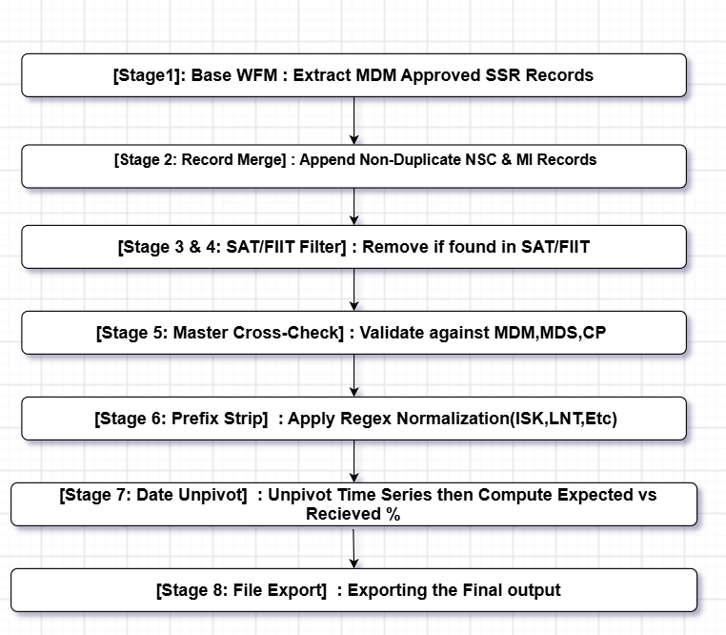
Stage 1: Base Workforce Management (WFM) Table Construction
Objective: Construct the foundational baseline of installed devices using Smart-to-Smart Replacement (SSR) datasets approved by MDM.
Detailed SQL Logic:
SQL
CREATE OR REPLACE TABLE WFM AS
SELECT
"Consumer Number" AS CONSUMER_NUMBER,
"SSR_New Meter Number" AS METER_NUMBER,
"Installation Date" AS INSTALLATION_DATE,
'SSR' AS Source
FROM SSR
WHERE "MDM Status" = 'Approve';
- Execution Details: Filters SSR records to retain only entries marked 'Approve' in MDM Status. Standardizes heterogeneous column names (Consumer Number $→$ CONSUMER_NUMBER).
Stage 2: Incremental Record Merging (NSC & MI Data)
Objective: Expand the WFM baseline by merging approved New Service Connections (NSC) and Meter Installation (MI) records, enforcing uniqueness constraints across Consumer-Meter pairs.
Detailed SQL Logic:
SQL
-- Merge New Service Connections
INSERT INTO WFM (CONSUMER_NUMBER, METER_NUMBER, INSTALLATION_DATE, Source)
SELECT NSC.PERMANENT_CONSUMER_NUMBER, NSC.NEW_METER_NUMBER, NSC.INSTALLATION_DATE, 'NSC'
FROM NSC
WHERE NOT EXISTS (
SELECT 1 FROM WFM
WHERE WFM.CONSUMER_NUMBER = NSC.PERMANENT_CONSUMER_NUMBER
AND WFM.METER_NUMBER = NSC.NEW_METER_NUMBER
AND api_MDM_status = 'Approve'
);

-- Merge Meter Installations
INSERT INTO WFM (CONSUMER_NUMBER, METER_NUMBER, INSTALLATION_DATE, Source)
SELECT MI."Consumer Number", MI."New Meter Number", MI."Installation Date", 'MI'
FROM MI
WHERE NOT EXISTS (
SELECT 1 FROM WFM
WHERE WFM.CONSUMER_NUMBER = MI."Consumer Number"
AND WFM.METER_NUMBER = MI."New Meter Number"
AND "API MDM Status" = 'Approve'
);
- Execution Details: Uses NOT EXISTS subqueries to verify that incoming NSC/MI consumer and meter pairs do not duplicate existing approved entries in the WFM baseline.
Stages 3 & 4: Site Acceptance & Field Inspection Exclusion Filtering
Objective: Filter out meters already processed, tested, or accepted via Site Acceptance Testing (SAT) or Field Inspection Testing (FIT) workflows.
Detailed SQL Logic:
SQL
-- Indexing SAT and removing matched records
CREATE INDEX IF NOT EXISTS idx_sat_consumer ON sat ("consumer number");
CREATE INDEX IF NOT EXISTS idx_sat_meter ON sat ("meter no");

DELETE FROM WFM w
WHERE EXISTS (SELECT 1 FROM sat s WHERE s."consumer number" = w.CONSUMER_NUMBER)
OR EXISTS (SELECT 1 FROM sat s WHERE s."meter no" = w.METER_NUMBER);

-- Indexing FIT and removing matched records
CREATE INDEX IF NOT EXISTS idx_fit_consumer ON fit ("consumer number");
CREATE INDEX IF NOT EXISTS idx_fit_meter ON fit ("meter no");

DELETE FROM WFM w
WHERE EXISTS (SELECT 1 FROM fit s WHERE s."consumer number" = w.CONSUMER_NUMBER)
OR EXISTS (SELECT 1 FROM fit s WHERE s."meter no" = w.METER_NUMBER);
- Execution Details: Creates secondary B-Tree indexes on consumer number and meter no in the sat and fit tables. Matches are deleted from WFM to ensure downstream steps operate only on active operational records.
Stage 5: Master List Cross-Validation (MDM, MDS, CP)
Objective: Validate remaining candidate devices against master system repositories (MDM, MDS, CP). Any candidate missing from any master repository is excluded.
Detailed SQL Logic:
SQL
-- MDM Master Validation
CREATE INDEX IF NOT EXISTS idx_MDM_consumer ON MDM ("ConsumerNumber");
CREATE INDEX IF NOT EXISTS idx_MDM_meter ON MDM ("DeviceSerialNumber");
DELETE FROM WFM w WHERE NOT EXISTS (
SELECT 1 FROM MDM s
WHERE s."ConsumerNumber" = w.CONSUMER_NUMBER
AND s."DeviceSerialNumber" = w.METER_NUMBER
);

-- MDS Master Validation
CREATE INDEX IF NOT EXISTS idx_MDS_consumer ON MDS ("Consumer No");
CREATE INDEX IF NOT EXISTS idx_MDS_meter ON MDS ("Meter No");
DELETE FROM WFM w WHERE NOT EXISTS (
SELECT 1 FROM MDS s
WHERE s."Consumer No" = w.CONSUMER_NUMBER
AND s."Meter No" = w.METER_NUMBER
);

-- CP Master Validation
CREATE INDEX IF NOT EXISTS idx_CP_consumer ON CP ("consumer_no");
CREATE INDEX IF NOT EXISTS idx_CP_meter ON CP ("meter_no");
DELETE FROM WFM w WHERE NOT EXISTS (
SELECT 1 FROM CP s
WHERE s."consumer_no" = w.CONSUMER_NUMBER
AND s."meter_no" = w.METER_NUMBER
);
- Execution Details: Performs strict relational integrity checks. Ensures that candidates match across all three core operational data sources.
Stage 6: Device Serial Number Normalization
Objective: Normalize hardware serial numbers by stripping vendor-specific prefixes (ISK_, LNT-, etc.) using DuckDB regex functions.
Detailed SQL Logic:
SQL
CREATE OR REPLACE TABLE LP_clean AS
SELECT *, REGEXP_REPLACE(devicename, '^(ISK|LNT)[-_]?', '', 'i') AS meter_no FROM lp;

CREATE OR REPLACE TABLE DP_clean AS
SELECT *, REGEXP_REPLACE(devicename, '^(ISK|LNT)[-_]?', '', 'i') AS meter_no FROM dp;

CREATE OR REPLACE TABLE BP_clean AS
SELECT *, REGEXP_REPLACE(devicename, '^(ISK|LNT)[-_]?', '', 'i') AS meter_no FROM bp;
- Execution Details: Evaluates regex pattern ^(ISK|LNT)[-_]? case-insensitively ('i'). Extracts standardized serial numbers (e.g., converting ISK_12345 or LNT-12345 to 12345) to enable accurate joins against master lists.
Stage 7: Matrix Unpivoting, Interval Aggregation & Metric Calculation
Objective: Transform wide time-series matrix formats into unpivoted relational rows, calculate expected versus received reading counts, and enrich records with network and communication hardware metadata.
A. Unpivoting & Aggregate Metrics Generation
SQL
-- Final Daily Profile (DP) Calculation
CREATE OR REPLACE TABLE Final_DP AS
WITH dp_unpivoted AS (
UNPIVOT DP_clean
ON COLUMNS('^\d{4}-\d{2}-\d{2}$')
INTO NAME date_col VALUE val
),
dp_aggregated AS (
SELECT meter_no, type, COUNT(DISTINCT date_col) AS EXPECTED, SUM(TRY_CAST(val AS INTEGER)) AS RECIEVED
FROM dp_unpivoted GROUP BY meter_no, type
)
SELECT dp.* EXCLUDE (meter_no),
COALESCE(a.RECIEVED, 0) AS RECIEVED,
COALESCE(a.EXPECTED, 0) AS EXPECTED,
ROUND((COALESCE(a.RECIEVED, 0) * 100) / NULLIF(a.EXPECTED, 0)) AS PERCENTAGE,
w.INSTALLATION_DATE, w.Source,
w.consumer_number AS WFM_CONSUMER,
w.consumer_number AS MDM_CONSUMER,
w.consumer_number AS MDS_CONSUMER
FROM WFM w
LEFT JOIN DP_clean dp ON w.METER_NUMBER = dp.meter_no
LEFT JOIN dp_aggregated a ON dp.meter_no = a.meter_no AND dp.type IS NOT DISTINCT FROM a.type;
SQL
-- Final Load Profile (LP) Calculation (48 Intervals per Day)
CREATE OR REPLACE TABLE raw_lp AS
WITH lp_unpivoted AS (
UNPIVOT LP_clean
ON COLUMNS('^\d{4}-\d{2}-\d{2}$')
INTO NAME date_col VALUE val
),
lp_aggregated AS (
SELECT meter_no, COUNT(DISTINCT date_col) * 48 AS EXPECTED, SUM(TRY_CAST(val AS INTEGER)) AS RECIEVED
FROM lp_unpivoted GROUP BY meter_no
)
SELECT lp.*,
COALESCE(a.RECIEVED, 0) AS RECIEVED,
COALESCE(a.EXPECTED, 0) AS EXPECTED,
ROUND((COALESCE(a.RECIEVED, 0) * 100) / NULLIF(a.EXPECTED, 0)) AS PERCENTAGE,
w.INSTALLATION_DATE, w.Source,
w.consumer_number AS WFM_CONSUMER,
w.consumer_number AS MDM_CONSUMER,
w.consumer_number AS MDS_CONSUMER
FROM WFM w
LEFT JOIN LP_clean lp ON w.METER_NUMBER = lp.meter_no
LEFT JOIN lp_aggregated a ON lp.meter_no = a.meter_no;
B. Metadata Enrichment & Tariff Classification
SQL
-- Join Tariff & Cycle Codes from MDS
CREATE OR REPLACE TABLE LP_1 AS
SELECT raw_lp.*, MDS."Tariff Code", MDS."Cycle No"
FROM raw_lp
LEFT JOIN MDS ON raw_lp.WFM_CONSUMER = MDS."Consumer No"
AND raw_lp.meter_no = MDS."Meter No";

-- Communication Type & Phase Hardware Classification
CREATE OR REPLACE TABLE Final_LP AS
SELECT LP_1.*,
CASE WHEN LP_1.meter_no = rf."meter_serial_number" THEN 'RF' ELSE 'Cellular'
END AS "Communication Type",
CASE
WHEN LP_1.meter_no LIKE 'US%' THEN '1 Phase'
WHEN LP_1.meter_no LIKE 'UT%' THEN '3 Phase'
WHEN LP_1.meter_no LIKE 'UC%' THEN 'LTCT Consumers'
ELSE 'Unknown'
END AS "Type"
FROM LP_1
LEFT JOIN rf ON LP_1.meter_no = rf."meter_serial_number"
ORDER BY cluster, WFM_CONSUMER, meter_no;
- Math Metrics:
  - $\text{Expected Days}=\text{COUNT}\left(\text{DISTINCT date_col}\right)$
  - $\text{Expected LP Intervals}=\text{Expected Days}×48$
  - $\text{Completion Percentage}=\left\lfloor \frac{\text{Received Interval Count}}{\text{Expected Interval Count}}×100\right\rfloor$
Stage 8: Output Streaming, Index Dropping & Vacuuming
Objective: Stream finalized tables to disk as standardized CSVs, release secondary memory indexes, drop intermediary transformation tables, and run garbage collection.
Detailed SQL Logic:
SQL
-- Streaming tables to CSV files on disk
COPY Final_LP TO '.../final_lp.csv' (HEADER, DELIMITER ',');
COPY Final_BP TO '.../final_bp.csv' (HEADER, DELIMITER ',');
COPY Final_DP TO '.../final_dp.csv' (HEADER, DELIMITER ',');

-- Releasing memory resources
DROP INDEX IF EXISTS idx_sat_consumer;
DROP TABLE IF EXISTS LP_clean;
DROP TABLE IF EXISTS DP_clean;
DROP TABLE IF EXISTS BP_clean;
DROP TABLE IF EXISTS WFM;

-- Forcing DuckDB Memory Checkpoint Allocation Cleanup
CHECKPOINT;
5. Dataset Dictionary & Schema Catalog
Dataset Key | Technical Name | Input Format | Ingestion Path Wildcard | Primary Key / Joins | Functional Description
MI | Meter Installation | Parquet | Exact File Path | New Meter Number, Consumer Number | Field logs of new meter replacements.
NSC | New Service Connection | Parquet | Exact File Path | NEW_METER_NUMBER, PERMANENT_CONSUMER_NUMBER | Records for newly connected power utility accounts.
SSR | Smart to Smart Replacement | Parquet | Exact File Path | SSR_New Meter Number, Consumer Number | Replacement logs used to seed base WFM tables.
sat_combined | Site Acceptance | Parquet | Exact File Path | meter no, consumer number | Verified site testing logs used for exclusion filtering.
fit_combined | Field Inspection | Parquet | Exact File Path | meter no, consumer number | Field inspection testing logs used for exclusion filtering.
MDM | Master Data Mgmt | CSV Folder | folder/*.csv | DeviceSerialNumber, ConsumerNumber | Core utility billing repository.
MDS | Meter Data System | CSV Folder | folder/*.csv | Meter No, Consumer No | Secondary operational validation registry.
CP | Consumer Portal | CSV Folder | folder/*.csv | meter_no, consumer_no | Consumer database registry.
lp | Load Profile | Datewise CSVs | folder/**/*.csv | devicename $→$ meter_no | 30-min interval readings (48 intervals/day).
dp | Daily Profile | Datewise CSVs | folder/**/*.csv | devicename $→$ meter_no | Daily operational summary snapshots.
bp | Billing Profile | Datewise CSVs | folder/**/*.csv | devicename $→$ meter_no | Monthly billing interval data.
rf | Radio Frequency | CSV Folder | folder/*.csv | meter_serial_number | RF communication module hardware lookup table.
6. Configuration & Endpoint Reference
Primary Route Map
- GET /
  - Description: Renders the main dashboard (index.html) containing dataset upload cards and control buttons.
- POST /ingest/{dataset_key}
  - Payload: file_path OR folder_path (Form-encoded).
  - Behavior: Spawns bg_ingest_file_or_folder in a background thread. Returns an HTMX polling placeholder.
- GET /progress/{task_id}
  - Behavior: Called by HTMX polling (every 50ms). Queries PROGRESS_STORE and returns status updates or rendered preview tables.
- POST /run-audit
  - Behavior: Triggers bg_build_reconciliation_output. Runs the 8-Stage Audit Pipeline, writes output CSVs, and renders a dataset preview in the UI.
- GET /download-csv/{table_key}
  - Params: table_key (lp, dp, bp).
  - Behavior: Returns a FileResponse to stream final_lp.csv, final_dp.csv, or final_bp.csv.
- GET /debug/view-table/{table_name}
  - Behavior: Debugging endpoint. Returns schema descriptions and the first $N$ rows of any DuckDB table as JSON.
7. Deployment, Environment Setup & Operational Runbook
Prerequisites
- Python Runtime: Python 3.9+.
- System Memory: 8 GB RAM minimum (16 GB+ recommended for multi-gigabyte datewise CSV datasets).
Setup
Bash
# 1. Clone/Extract the application directory
cd project-root

# 2. Instantiate a virtual environment
python -m venv venv
source venv/bin/activate # On Windows use: venv\Scripts\activate

# 3. Install required packages
pip install -r requirements.txt
Production Execution (Uvicorn / Gunicorn)
Run using Uvicorn with single-worker allocation to ensure unified in-memory DuckDB state management:
Bash
uvicorn app:app --host 0.0.0.0 --port 8000 --workers 1
For dockerized deployments, run:
Dockerfile
FROM python:3.10-slim
WORKDIR /app
COPY requirements.txt .
RUN pip install --no-cache-dir -r requirements.txt
COPY . .
EXPOSE 8000
CMD ["uvicorn", "app:app", "--host", "0.0.0.0", "--port", "8000", "--workers", "1"]

