A Report On
Comparative Analysis of Machine Translation Models
Subject: Artificial Intelligence
Submitted by:
Aarogya Parajuli
Roll No: ACE080BCT003
Submitted to:
Department of Electronics and Computer Engineering

Abstract
This report presents a controlled experimental comparison of four sequence-to-sequence neural network architectures for English-to-Korean machine translation: a vanilla RNN encoder-decoder, a GRU-based encoder-decoder, and two attention-augmented variants using Bahdanau (additive) and Luong (multiplicative) attention mechanisms. All four models were trained from scratch on the same parallel corpus, under identical data splits, hyperparameters, and hardware, so that any difference in performance could be attributed to the architecture itself rather than to confounding experimental factors. The models were evaluated using BLEU score, perplexity, and inference latency. The results show that models without attention perform poorly on this dataset, with the vanilla RNN essentially failing to produce any meaningful overlap with reference translations. Introducing attention produced a substantial improvement in translation quality, with the Bahdanau attention model achieving the best BLEU score and the lowest perplexity among all four models, though at the cost of higher inference latency. These findings support the well-established claim in the literature that attention mechanisms address the fixed-length context bottleneck of classical encoder-decoder models, particularly for small and medium-sized datasets.

Table of Contents
1. Introduction 3
2. Related Work 3
3. Methodology 4
3.1 Dataset 4
3.2 Data Preprocessing 4
3.3 Model Architectures 5
3.4 Experimental Setup 6
3.5 Evaluation Metrics 6
4. Results 7
4.1 Quantitative Results 7
4.2 Training and Validation Behaviour 8
4.3 Accuracy Comparison 9
4.4 Inference Latency Comparison 10
4.5 Accuracy versus Latency Trade-off 11
4.6 Qualitative Analysis 11
5. Discussion 12
6. Limitations 13
7. Conclusion 13
References 14

1. Introduction
Machine translation is one of the oldest and most widely studied problems in natural language processing. Over the last decade, the field has moved from statistical phrase-based systems to neural approaches built on encoder-decoder architectures. The core idea of a neural machine translation (NMT) system is simple: an encoder reads a source sentence and compresses it into a vector representation, and a decoder generates the target sentence one token at a time based on that representation. In its earliest form, this representation was a single fixed-length vector, which created a bottleneck for longer or more complex sentences. Attention mechanisms were later introduced to remove this bottleneck by allowing the decoder to refer back to all encoder hidden states at every decoding step, rather than relying on a single summary vector.
This project implements and compares four such architectures on the same English-to-Korean translation task, under matched experimental conditions. The objective is not to build a state-of-the-art translation system, but to isolate and measure the effect of architectural choices, specifically the presence and type of attention mechanism, on translation quality, training behaviour, and inference cost. The comparison is intended to reproduce, on a small scale, the improvements originally reported by Bahdanau et al. (2015) and Luong et al. (2015) when attention was first introduced into NMT.
The specific objectives of this study are:
- To implement four encoder-decoder architectures (vanilla RNN, GRU, Bahdanau attention, Luong attention) under a single shared codebase and training pipeline.
- To train and evaluate all four models on identical data splits and hyperparameters, so that differences in results can be attributed to architecture rather than experimental inconsistency.
- To quantitatively compare the models using BLEU score, perplexity, and inference latency.
- To qualitatively examine sample translations to understand the practical differences between the models.

2. Related Work
Sutskever, Vinyals and Le (2014) introduced the sequence-to-sequence (Seq2Seq) framework, in which an encoder RNN reads a source sentence and produces a fixed-length context vector, which a decoder RNN then uses to generate the target sentence. While effective for short sentences, this design forces the entire meaning of a sentence into one vector, which becomes increasingly difficult as sentence length grows.
Bahdanau, Cho and Bengio (2015) addressed this limitation by proposing an additive attention mechanism, which allows the decoder to compute a weighted combination of all encoder hidden states at each decoding step, rather than depending on a single vector. This weighting is learned jointly with the rest of the network and allows the model to align each output word with the relevant part of the input sentence.
Luong, Pham and Manning (2015) proposed a simpler and computationally cheaper family of attention mechanisms, including a multiplicative (general) scoring function that computes alignment scores using a bilinear transformation between decoder and encoder states. Their work also introduced the distinction between global and local attention. This study implements the general (multiplicative) variant of Luong attention.
The models implemented in this project follow the original formulations of these three works closely, with the same core recurrent architecture used across all four models so that attention itself is the primary variable under study.

3. Methodology

3.1 Dataset
The experiment uses an English-Korean parallel sentence corpus obtained from the ManyThings/Tatoeba project. The dataset consists of short, everyday sentence pairs, which is a standard resource for small-scale NMT experimentation. Table 1 summarizes the dataset statistics after preprocessing.
Property | Value
Language pair | English to Korean
Raw usable sentence pairs | 6,394
Pairs after sequence-length filtering (<=30 tokens) | 6,392
Training set | 5,113 pairs (80%)
Validation set | 639 pairs (10%)
Test set | 640 pairs (10%)
Source (English) vocabulary size | 2,044 tokens
Target (Korean) vocabulary size | 2,363 tokens
Table 1: Dataset statistics after preprocessing.

3.2 Data Preprocessing
The following preprocessing pipeline was applied uniformly before training:
- Lowercasing of English text and stripping of leading and trailing whitespace.
- Normalization of Unicode punctuation marks (curly quotes and apostrophes) to their standard ASCII equivalents.
- Collapsing of repeated whitespace into single spaces.
- Whitespace-based tokenization, chosen deliberately over a subword tokenizer to keep the experimental setup simple, deterministic, and easy to reproduce.
- Filtering of sentence pairs exceeding 30 tokens (including the start-of-sequence and end-of-sequence markers) in either language.
- Deterministic, seeded sampling and an 80/10/10 train/validation/test split, so that every model was trained and evaluated on exactly the same data.
- Construction of source and target vocabularies with four special tokens: padding, start-of-sequence, end-of-sequence, and unknown-word tokens.

3.3 Model Architectures
All four models share the same general encoder-decoder skeleton, embedding dimension, and hidden state size. They differ only in the recurrent unit used and in whether, and how, an attention mechanism is applied. This design keeps the comparison fair, since the only variables that change between models are the ones under study.
- Vanilla RNN Seq2Seq: A plain Elman RNN encoder processes the source sentence and passes its final hidden state to a plain RNN decoder. No attention is used, so the decoder must rely entirely on this single hidden state to generate the full target sentence.
- GRU Seq2Seq: Identical in structure to the vanilla RNN model, but the recurrent unit is replaced with a Gated Recurrent Unit (GRU). GRUs use gating mechanisms to control the flow of information through time, which generally improves the modelling of longer-range dependencies compared to a plain RNN.
- Bahdanau Attention: Built on a GRU encoder-decoder, with an additive attention layer inserted between them. At each decoding step, an alignment score is computed between the current decoder state and every encoder hidden state using a learned feed-forward network, and these scores are normalized with a softmax function to produce attention weights. The weighted sum of encoder states forms a context vector that is combined with the decoder input at every step.
- Luong Attention: Also built on a GRU encoder-decoder, but the alignment score between the decoder state and each encoder state is computed using a bilinear (multiplicative) function instead of a feed-forward network. This is computationally cheaper than the Bahdanau formulation, since it avoids an additional non-linear transformation.

3.4 Experimental Setup
To ensure a fair comparison, all four models were trained using identical hyperparameters, shown in Table 2. Model weights were reinitialized using a fixed random seed before each training run, so that differences in results could not be attributed to differing initialization.
Hyperparameter | Value
Random seed | 3
Embedding dimension | 256
Hidden state dimension | 256
Maximum sequence length | 30 tokens
Batch size | 64
Optimizer | Adam
Learning rate | 0.001
Loss function | Cross-entropy (padding ignored)
Gradient clipping | 1.0
Number of epochs | 10
Teacher forcing ratio | Linearly annealed from 1.0 to 0.5
Decoding strategy at inference | Greedy decoding
Table 2: Shared hyperparameters used to train all four models.

3.5 Evaluation Metrics
Each model was evaluated on the held-out test set using the following metrics:
- BLEU-4 score (corpus-level and sentence-level), computed using NLTK with smoothing, to measure n-gram overlap between generated and reference translations.
- Perplexity, computed as the exponential of the average test-set cross-entropy loss, as a measure of how well each model predicts the target sequence.
- Inference latency (mean, median, and 95th percentile), measured in milliseconds per sentence, to quantify the computational cost of each architecture at prediction time.

4. Results

4.1 Quantitative Results
Table 3 summarizes the test-set performance of all four models. Bahdanau attention achieved the best result on every accuracy metric, while the two non-attention models performed considerably worse, with the vanilla RNN failing to produce any meaningful 4-gram overlap with the reference sentences.
Model | Parameters | BLEU-4 | Sentence BLEU | Perplexity | Mean Latency (ms)
Vanilla RNN | 1,998,651 | ~0.00 | 0.28 | 213.49 | 13.6
GRU Seq2Seq | 2,524,987 | 0.20 | 0.59 | 100.30 | 14.5
Bahdanau Attention | 4,062,779 | 0.75 | 1.16 | 49.60 | 38.7
Luong Attention | 3,996,987 | 0.48 | 0.90 | 59.11 | 27.6
Table 3: Test-set results for all four models.

4.2 Training and Validation Behaviour
Figure 1 shows the training and validation loss curves for all four models over ten epochs. The vanilla RNN and GRU models show validation loss plateauing early, while training loss continues to decrease, indicating that these models reach the limit of what the fixed-length context vector can represent and begin to overfit to the training set beyond that point. In contrast, both attention-based models show a validation loss that continues to decrease for a larger portion of training and settles at a substantially lower value, indicating that they are able to make better use of the additional training epochs.
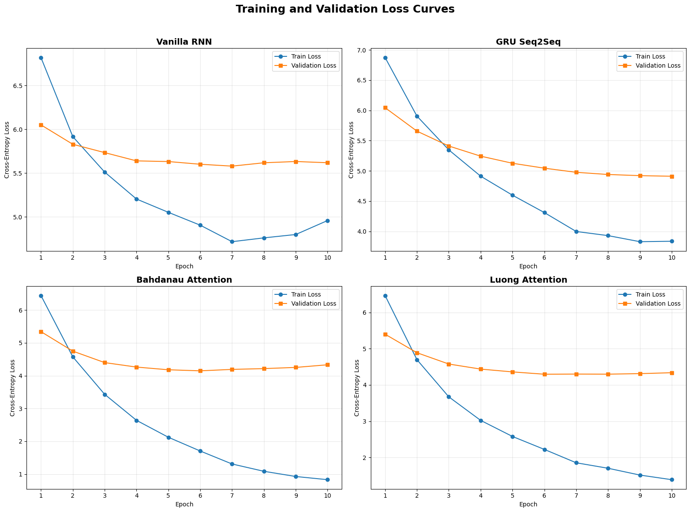
Figure 1: Training and validation cross-entropy loss curves for all four models.

4.3 Accuracy Comparison
Figure 2 presents the test BLEU-4 score achieved by each model. The gap between the non-attention models and the attention-based models is large: the vanilla RNN scores close to zero, the GRU model reaches a modest score of 0.20, while Bahdanau and Luong attention reach 0.75 and 0.48 respectively. This is consistent with the theoretical motivation for attention, namely that a single fixed-length vector is insufficient to represent longer or more complex source sentences.
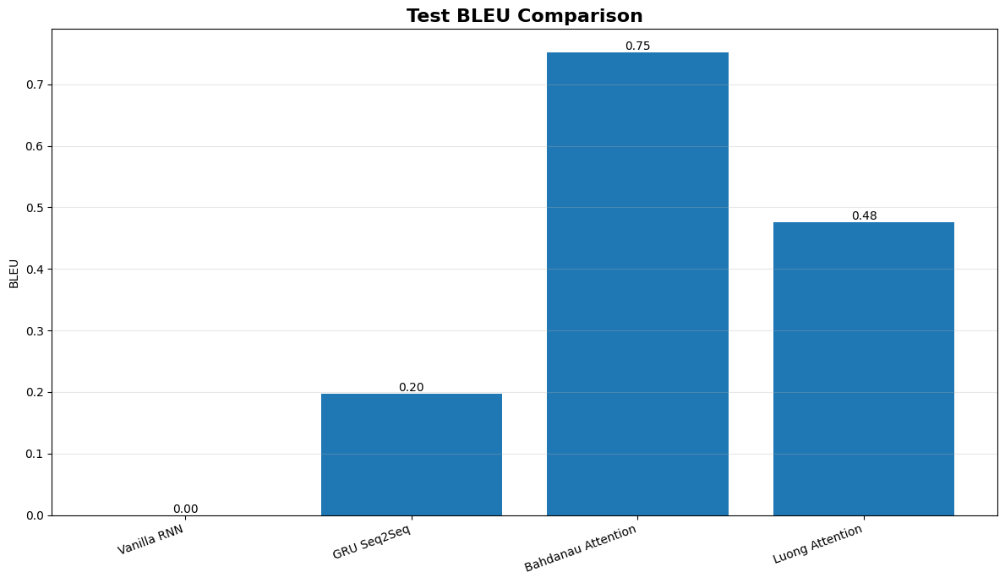
Figure 2: Test BLEU-4 score comparison across the four models.

4.4 Inference Latency Comparison
Figure 3 shows the mean inference latency per sentence for each model. Attention introduces a clear computational overhead, since the decoder must compute alignment scores against every encoder hidden state at every decoding step. The Bahdanau model, which uses a feed-forward alignment function, is the slowest of the four, while the Luong model, which uses a simpler bilinear scoring function, is comparatively faster while still benefiting from attention.
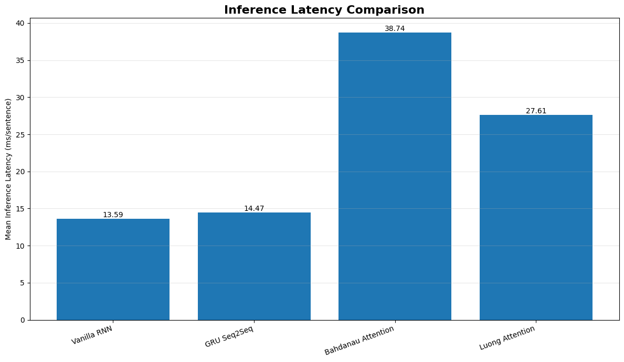
Figure 3: Mean inference latency (milliseconds per sentence) across the four models.

4.5 Accuracy versus Latency Trade-off
Figure 4 plots BLEU score against mean inference latency for each model, illustrating the accuracy-speed trade-off directly. The vanilla RNN and GRU models occupy the fast but inaccurate region of the plot, while Bahdanau attention occupies the accurate but slow region. Luong attention sits between the two extremes, offering a substantial accuracy improvement over the non-attention models at a lower latency cost than Bahdanau attention, and therefore represents a reasonable compromise where inference speed is a constraint.
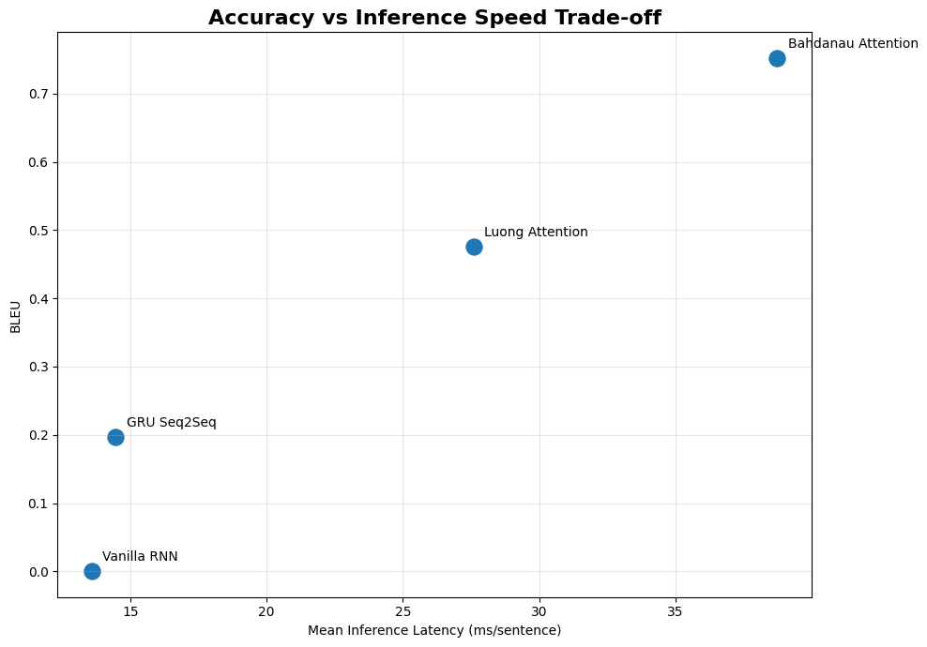
Figure 4: BLEU score plotted against mean inference latency for each model.

4.6 Qualitative Analysis
In addition to the quantitative metrics, sample translations were examined for sentences of varying complexity (simple, complex, and long). Two consistent patterns emerged across these examples:
- The non-attention models (vanilla RNN and GRU) tend to produce generic, high-frequency phrases that are largely disconnected from the meaning of the source sentence, regardless of sentence length. This is consistent with their poor BLEU scores.
- The attention-based models, particularly Bahdanau attention, more frequently produce output that is topically related to the source sentence, correctly picking up on key words or phrases. However, all models, including the attention-based ones, occasionally fall into repetition loops during generation, which is a known limitation of greedy decoding rather than a flaw specific to any one architecture.
This qualitative behaviour is consistent with the quantitative BLEU results and supports the conclusion that the presence of attention, rather than the choice between GRU and RNN alone, is the primary factor driving translation quality in this experiment.

5. Discussion
The results obtained in this study are consistent with the motivation originally given for attention mechanisms in the literature. With a training set of just over five thousand sentence pairs and a hidden state size of 256, the non-attention models are simply unable to compress enough information about the source sentence into a single vector to generate fluent, meaningful translations. This is most visible in the vanilla RNN, which achieves a BLEU score close to zero despite ten epochs of training.
Between the two attention mechanisms, Bahdanau (additive) attention outperformed Luong (multiplicative) attention on every accuracy metric in this experiment. This is likely because the additive scoring function has more learnable parameters and greater flexibility to represent complex alignment patterns between source and target words, compared to the simpler bilinear scoring function used by Luong attention. This additional flexibility, however, comes at a measurable computational cost: Bahdanau attention was the slowest model at inference time, roughly 40 percent slower than Luong attention despite having a similar number of parameters.
These findings suggest a practical trade-off for anyone selecting an architecture for a similar low-resource translation task. If translation quality is the primary concern and inference speed is not critical, Bahdanau attention is the better choice based on these results. If inference speed matters, for example in a real-time or resource-constrained application, Luong attention offers a substantial improvement in quality over non-attention baselines while remaining considerably faster than Bahdanau attention.
It is also worth noting that both attention models show a slight increase in validation loss after around epoch six or seven, which suggests the onset of overfitting. This indicates that further improvements might be achievable through regularization techniques such as dropout, label smoothing, or early stopping, rather than through additional training epochs alone.

6. Limitations
- The dataset used is relatively small (around 6,400 sentence pairs), so the results may not generalize directly to large-scale translation corpora.
- All models were evaluated using greedy decoding; beam search was not implemented, and could improve fluency and reduce repetition for all four models.
- Each model was trained with a single random seed rather than averaged over multiple runs, so the reported metric differences should be interpreted as indicative rather than statistically verified.
- Inference latency was measured on CPU; absolute latency values, though not necessarily the relative ordering between models, would likely differ on GPU hardware.
- BLEU-4 is known to be sensitive to short references and small test sets, so scores should be interpreted comparatively across the four models rather than as an absolute measure of translation quality.

7. Conclusion
This study compared four encoder-decoder architectures for English-to-Korean machine translation under identical experimental conditions. The results clearly demonstrate that attention mechanisms provide a substantial improvement in translation quality over classical fixed-context encoder-decoder models, confirming the core motivation behind their introduction in the literature. Among the two attention mechanisms tested, Bahdanau (additive) attention achieved the best overall translation quality, while Luong (multiplicative) attention offered a favourable balance between translation quality and inference speed. The vanilla RNN, lacking both gating and attention, was unable to produce meaningful translations on this dataset, underlining the importance of both gated recurrence and attention for sequence-to-sequence learning on real-world text.
Overall, this project reinforces that architectural choices in neural machine translation are not purely academic; they have a direct, measurable impact on both translation quality and computational cost, and the right choice ultimately depends on the constraints of the deployment scenario.

References
Bahdanau, D., Cho, K., and Bengio, Y. (2015). Neural Machine Translation by Jointly Learning to Align and Translate. International Conference on Learning Representations (ICLR).
Luong, M.-T., Pham, H., and Manning, C. D. (2015). Effective Approaches to Attention-based Neural Machine Translation. Conference on Empirical Methods in Natural Language Processing (EMNLP).
Sutskever, I., Vinyals, O., and Le, Q. V. (2014). Sequence to Sequence Learning with Neural Networks. Advances in Neural Information Processing Systems (NeurIPS).
ManyThings.org / Tatoeba Project. English-Korean Sentence Pairs Dataset. Available at: https://www.manythings.org/anki/

