Project Name -> QueueForge

Problem Statement ->
Modern applications often perform background tasks such as sending emails, processing payments, generating reports, and scheduling jobs. Existing job queue frameworks simplify these operations but hide the internal mechanisms behind reliable job processing. This project aims to design and develop QueueForge, a reliable background job processing engine that supports durable job storage, automatic retries, dead-letter recovery, priority scheduling, and safe concurrent processing, providing a deeper understanding of how production-grade job queues work internally.

Features ->
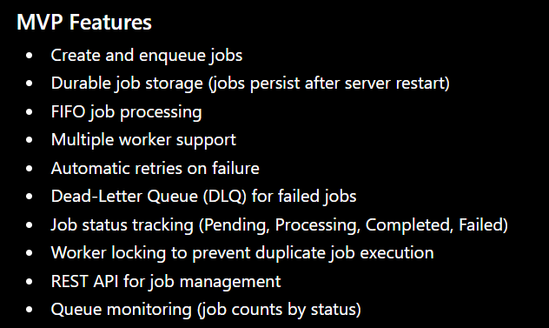

Users ->
1. Developer (Primary User)
- Submit jobs to the queue.
- Monitor job status.
- Retry failed jobs.
- View queue statistics.
2. Worker (System Component)
- Fetch pending jobs.
- Process assigned jobs.
- Update job status.
- Retry failed jobs or move them to the Dead-Letter Queue after exceeding the retry limit.
Note: Although a Worker is not a human user, it is a key actor in the system and should be included.

Tech Stack ->
Component | Technology
Frontend | React.js, Tailwind CSS
Backend | Node.js, Express.js
Database | PostgreSQL
ORM | Prisma
Queue Storage | PostgreSQL
Authentication | JWT (optional in MVP)
API Testing | Postman
Version Control | Git & GitHub
Containerization | Docker (later phase)
Deployment | Vercel (Frontend), Render (Backend), Neon PostgreSQL

Architecture ->
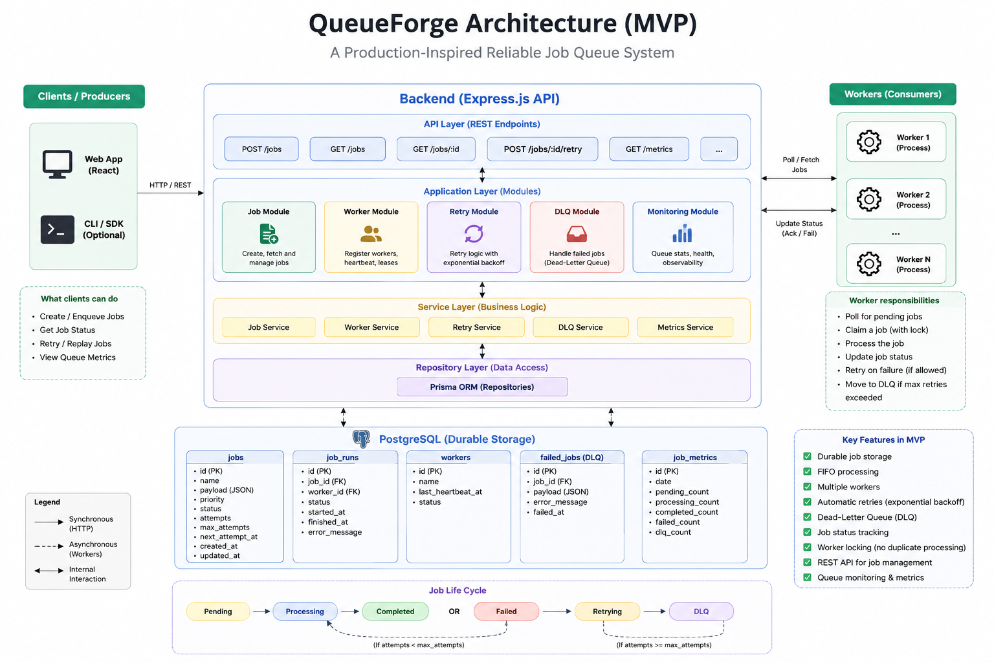

Database (MVP) ->
1. Jobs
Stores all jobs submitted to the queue.
Field | Type | Description
id | UUID | Unique job ID
job_name | VARCHAR | Name of the job
payload | JSONB | Job data
status | ENUM | Pending, Processing, Completed, Failed
priority | INT | Job priority (default: 0)
attempts | INT | Current retry count
max_attempts | INT | Maximum retries allowed
created_at | TIMESTAMP | Job creation time
updated_at | TIMESTAMP | Last update time

2. Workers
Tracks active workers processing jobs.
Field | Type | Description
id | UUID | Worker ID
worker_name | VARCHAR | Worker name
status | ENUM | Active, Idle, Offline
last_heartbeat | TIMESTAMP | Last heartbeat time

3. Dead Letter Queue (DLQ)
Stores jobs that exceeded the retry limit.
Field | Type | Description
id | UUID | DLQ record ID
job_id | UUID | Reference to failed job
error_message | TEXT | Failure reason
failed_at | TIMESTAMP | Failure time

Relationships
Jobs (1)
│
└──────────────► Dead_Letter_Queue (0..1)

Workers
│
└── Process Jobs (No direct foreign key in MVP)

API Endpoints ->
Method | Endpoint | Description
POST | /api/jobs | Create and enqueue a new job
GET | /api/jobs | Get all jobs
GET | /api/jobs/:id | Get details of a specific job
PATCH | /api/jobs/:id/retry | Retry a failed job
GET | /api/workers | Get all active workers
GET | /api/dlq | Get all jobs in the Dead-Letter Queue
PATCH | /api/dlq/:id/replay | Replay a job from the Dead-Letter Queue
GET | /api/metrics | Get queue statistics (Pending, Processing, Completed, Failed, DLQ)

Folder Structure ->
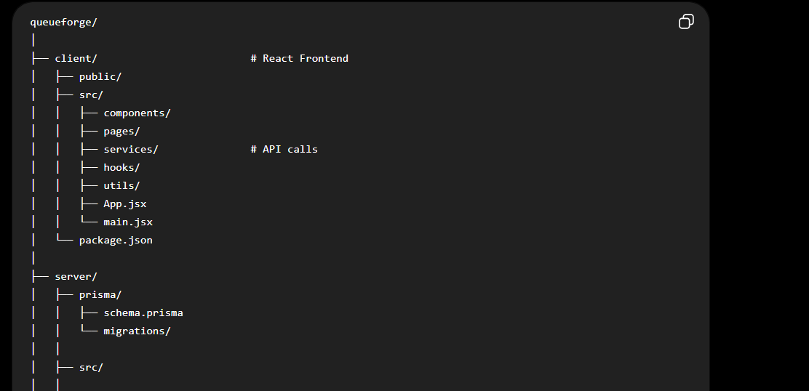
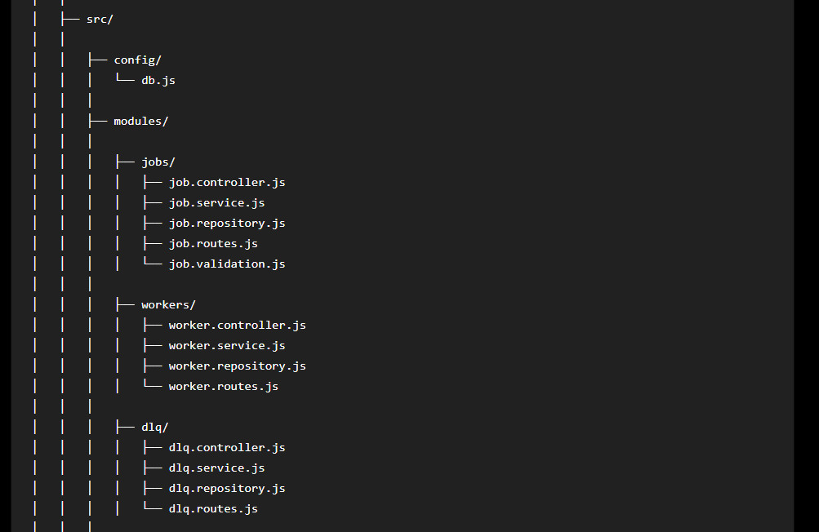
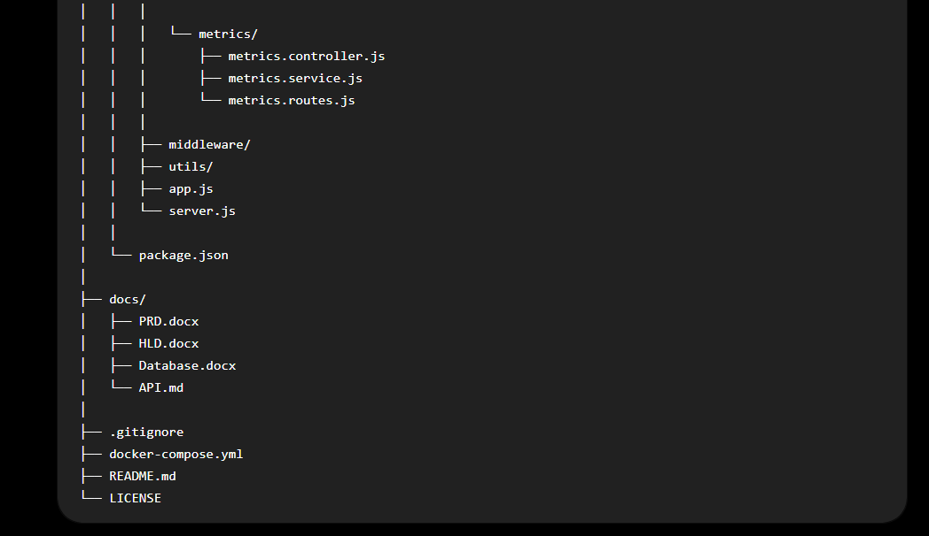

Flow Diagram ->
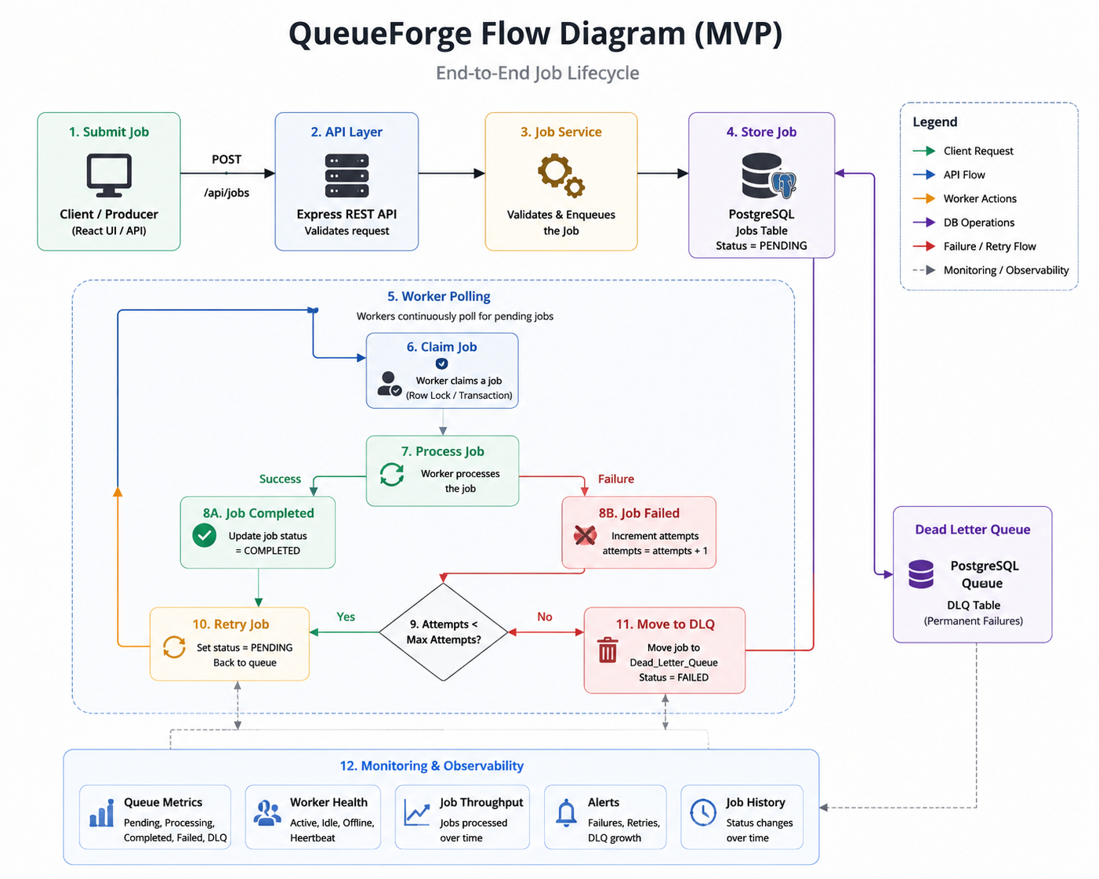

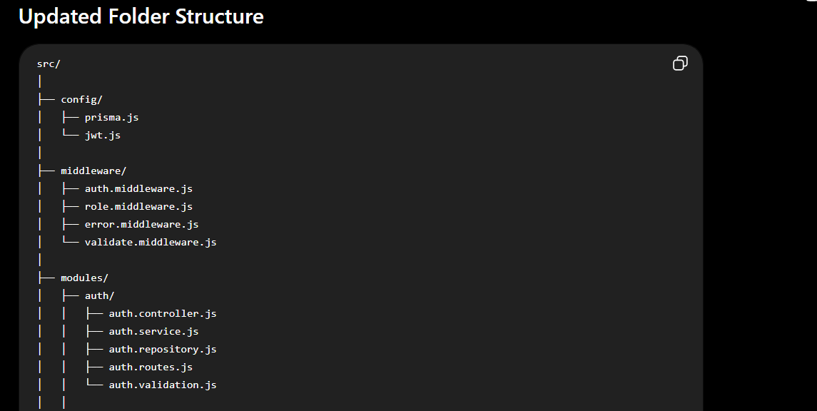
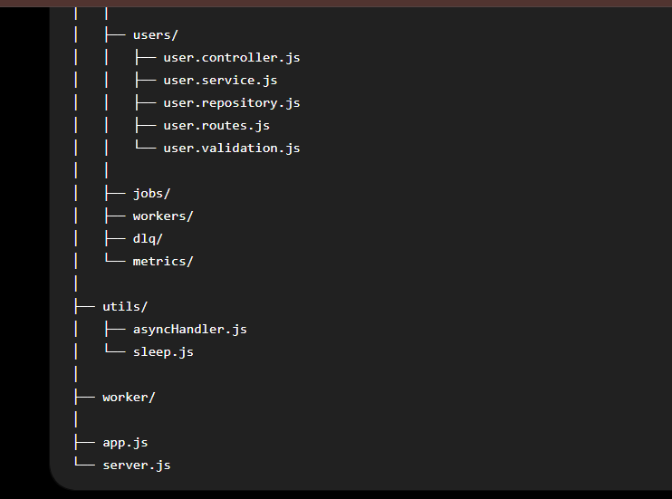

Features
Authentication
- User Registration
- User Login
- User Logout
- Refresh Access Token
- Password Hashing (bcrypt)
- JWT Access Token
- Refresh Token
- HTTP-only Cookie Authentication

User Management
- Get Current User Profile
- Update User Profile
- Change Password

Authorization
- JWT Authentication Middleware
- Role-Based Access Control (RBAC)
- Protected API Routes

Database (Authentication)
User
Field | Type | Description
id | UUID | Unique User ID
name | VARCHAR | User Name
email | VARCHAR | Unique Email
password | VARCHAR | Hashed Password
role | ENUM | Developer / Admin
refresh_token | TEXT | Stores latest Refresh Token
created_at | TIMESTAMP | Creation Time
updated_at | TIMESTAMP | Last Updated Time

Authentication APIs
Method | Endpoint | Description
POST | /api/auth/register | Register a new user
POST | /api/auth/login | Authenticate user
POST | /api/auth/logout | Logout user
POST | /api/auth/refresh | Generate new Access Token

User APIs
Method | Endpoint | Description
GET | /api/users/me | Get logged-in user profile
PATCH | /api/users/me | Update profile
PATCH | /api/users/change-password | Change password

Authentication Flow
Client
│
Register/Login
│
▼
Auth Controller
│
▼
Auth Service
│
▼
Auth Repository
│
▼
PostgreSQL
│
▼
Generate JWT
│
▼
Access Token + Refresh Token

Client
│
Bearer Access Token
│
▼
Authentication Middleware
│
Verify JWT
│
▼
Attach User to req.user
│
▼
Protected Route
│
▼
Controller
│
▼
Service
│
▼
Repository
│
▼
Database

Security Features
- Password Hashing using bcrypt
- JWT Access Token Authentication
- Refresh Token Rotation
- HTTP-only Cookies
- Protected API Endpoints
- Role-Based Authorization
- Secure Password Storage
- Session Revocation using Refresh Token

