**Binomial Distribution**

In [probability theory](https://en.wikipedia.org/wiki/Probability_theory) and [statistics](https://en.wikipedia.org/wiki/Statistics), the **binomial distribution** with parameters *n* and *p* is the [discrete probability distribution](https://en.wikipedia.org/wiki/Discrete_probability_distribution) of the number of successes in a sequence of *n* [independent](https://en.wikipedia.org/wiki/Statistical_independence) [experiments](https://en.wikipedia.org/wiki/Experiment_(probability_theory)), each asking a [yes–no question](https://en.wikipedia.org/wiki/Yes%E2%80%93no_question), and each with its own [Boolean](https://en.wikipedia.org/wiki/Boolean-valued_function)-valued [outcome](https://en.wikipedia.org/wiki/Outcome_(probability)): *success* (with probability *p*) or *failure* (with probability q=1- *p* �=1−�).

Reference: <https://www.mathsisfun.com/data/binomial-distribution.html>

**Examples of binomial event** (2 outcomes)

Ex 1: Tossing a Coin

* We say the probability of the coin landing H is ½
* And the probability of the coin landing T is ½

Ex 2: Throw a Die

* The probability of a four is 1/6 (one of the six faces is a four)
* The probability of not four is 5/6 (five of the six faces are not a four)

**Examples of the discrete probability distribution of the number of successes in a sequence of n independent experiments, each asking a yes–no question**:

Ex 1: Toss a fair coin three times. What is the chance of getting exactly two Heads ?

"Two Heads" could be in any order: "HHT", "THH" and "HTH" all have two Heads (and one Tail).

So **3** of the outcomes produce "Two Heads".

Total 8 outcomes: 23 = 8 & Each outcome is equally likely, so each outcome has a probability of 1/8

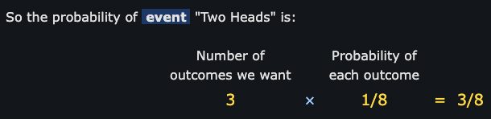

Terms:

* **Outcome**: any result of three coin tosses (8 different possibilities)
* **Event**: "Two Heads" out of three coin tosses (3 outcomes have this)

Math Formula: combination “n choose k”

## Bias

So far the chances of success or failure have been equally likely.

But what if the **coins are biased** (land more on one side than another) or choices are not 50/50.

The probabilities for "two chickens" all work out to be 0.147, because we are multiplying two 0.7s and one 0.3 in each case. In other words

0.147 = 0.7 × 0.7 × 0.3

Now we know the probability of each outcome is 0.147

But we need to include that there are three such ways it can happen: (chicken, chicken, other) or (chicken, other, chicken) or (other, chicken, chicken)

The General Binomial Probability Formula

Notes:

* The trials are independent,
* There are only two possible outcomes at each trial,
* The probability of "success" at each trial is constant.

Example of Binomial Distribution

Example 1: A fair die is thrown four times. Calculate the probabilities of getting:

0 Twos

1 Two

2 Twos

3 Twos

4 Twos

In this case **n=4**, **p = P(Two) = 1/6**

**X** is the Random Variable ‘Number of Twos from four throws’.

Summary: "for the 4 throws, there is a 48% chance of no twos, 39% chance of 1 two, 12% chance of 2 twos, 1.5% chance of 3 twos, and a tiny 0.08% chance of all throws being a two (but it still could happen!)"

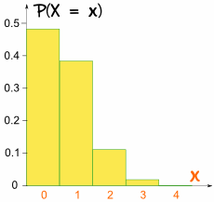

It is skewed because p is not 0.5

Example 2: Your company makes sports bikes. 90% pass final inspection (and 10% fail and need to be fixed).

What is the expected Mean and Variance of the 4 next inspections?

Let's calculate all probabilities.

n = 4,

p = P(Pass) = 0.9

X is the Random Variable "Number of passes from four inspections".

The mean, or "expected value", is:

**μ = np**

The formula for Variance is:

**Variance: σ2 = np(1-p)**

For the sports bikes:

* μ = 4 × 0.9 = 3.6

So we can expect 3.6 bikes (out of 4) to pass the inspection.

* Variance: σ2 = 4 × 0.9 × 0.1 = 0.36
* Standard Deviation is: σ = √(0.36) = 0.6

