# Hypothesis Testing Example

There are 2 types of hypothesis testing: *one-tailed* or *two-tailed* test

There are couple methods to prove/reject a hypothesis

* Traditional method:
  + **z-test**
  + **t-test** (if sample size < 30 & population std is not provided)
* Advanced method: **p-value**

Example 1:



Summary:

Traditional method (z-test):

Since the sample size n=36 > 30, we will use **z-test**

Since Ha: 🡪 this is **two-tailed** test, so rejected region = 0.05 (or 5%) divided by 2 = 0.025 for both ends of the normal distribution.

AL = 0.95 + 0.025 = 0.975 where AL is the cummulated area from the left

🡪 Need to find the z-value via **postive z-score** table corresponding with AL = 0.975

From the z-score table, 0.975 will be corresponding to +1.9 + 0.06 = 1.96 so zCV = 1.96

Calculate the zc  = 2.31 > zCV = 1.96 🡪 reject Ho

p-value method:

Step 1: calculate the zc  = 2.31 🡪 using the postive z-score value to find the area AL that corresponding to the zc

In this case, z = (2.3, 0.01) will be 0.98956 🡪 AL = 0.98956

So the shaded area = 1 – AL = 1 – 0.98956 = 0.01044

🡪 p-value = 2*shaded area = 0.01044 * 2 – 0.02088 < = 0.05 🡪 reject Ho

Example 2 (one-tail t-test):



Summary:

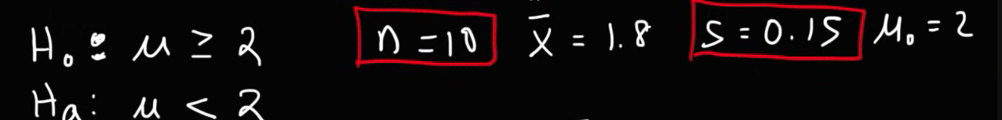

Since n < 30 🡪 using t-test

99% level of confidence ~ = 0.01

🡪 need to find the critical *t-value* corresponding with = 0.01 via t-distribution table

degree of freedom (df) = n-1 = 10-1 = 9

= 0.01

🡪 critical t-value = 2.8214 ~ 2.82, and since this is the negative one-tail test, so critical t = -2.82

With the sample size, mean and std, we have tc = -4.22 < t = -2.82, failing into the rejected region 🡪 reject Ho

