README.md Content

**📝 ToDo App – React (Vite)**  
Hi! 👋 This is a small project I built to practice and explore **React.js** using **Vite**.   
It’s a simple **ToDo app** where you can add tasks, mark them as complete, and delete them when done.   
All your tasks are saved in your browser’s **local storage**, so they’re still there even if you refresh the page.  
  
---  
  
**✨ What this app can do**- Add new tasks 🆕  
- Mark tasks as complete ✅  
- Delete tasks ❌  
- Save everything in local storage 💾  
- Works on mobile and desktop 📱💻  
  
---  
  
**🛠 How to run this project**  
  
If you want to try this project on your computer, here’s what you need to do:  
  
1. **Clone this repo**  
 git clone https://github.com/<your-username>/<repo-name>.git  
 cd <repo-name>  
   
  
2. **Install the dependencie**  
 npm install  
   
  
3. **Start the project**  
 npm run dev  
   
4. **Open the URL shown in your terminal (something like `http://localhost:5173`) in your browser.**  
  
---  
  
📸 **Preview**  
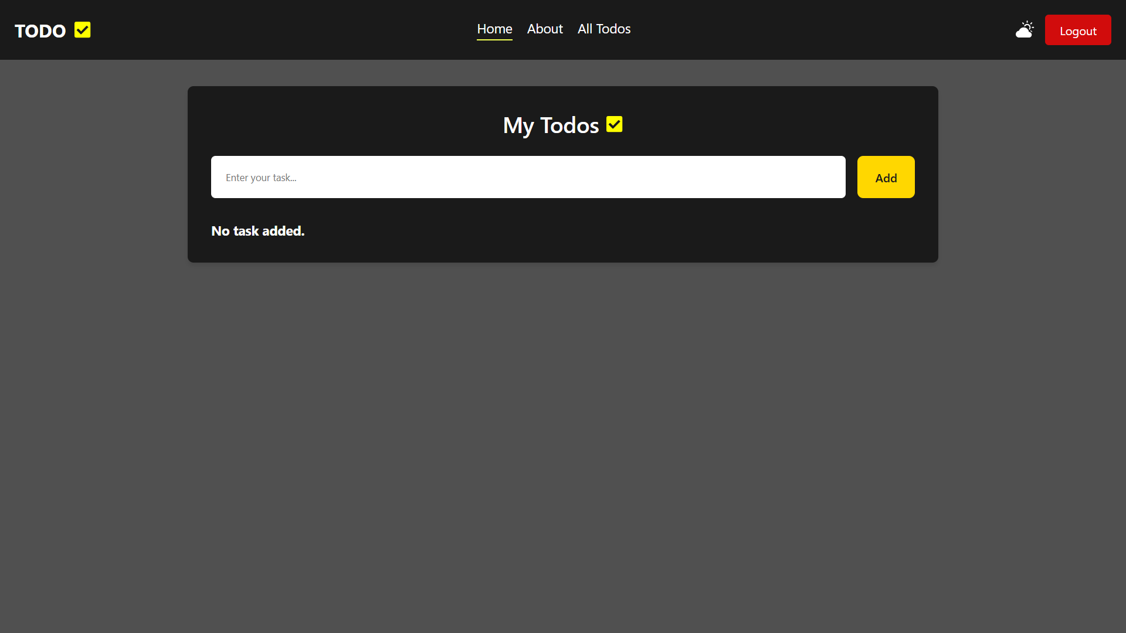  
---  
  
**💡 Why I made this**I wanted to get more comfortable with:  
- React components  
- State management with hooks  
- Using local storage  
- Styling with CSS  
  
---  
  
**📜 License**  
Feel free to use this code in your own projects.   
This project is under the **MIT License**.  
---  
  
**👩‍💻 Made by  
Vishva** **Chauhan**

[https://github.com/CodezHubByte (Vishva Chauhan)](https://github.com/CodezHubByte)