MailCrafter
Smart Email Customization and Automation Solution

Software Requirements Specification
Version 1.0

Danang, Jan 2025
Contents
1. Document History 3
2. Project Introduction 3
3. Software Requirements Specifications 5
3.1 Overall Description 5
3.2 User Requirements 5
3.3 Functional Requirements 6
3.4 Non-Functional Requirements 7

Date | Summary of Changes | PIC | Version
17/01/2025 | Create first draft | HoaiNX | 1.0
18/01/2025 | Add Project Intro, User, Functional, Non-functional Requirement | HoaiNX | 1.0
11/02/2025 | Add usecase, class diagram | HoaiNX | 1.0

Project Introduction
Overview
MailCrafter is a comprehensive email management platform designed to streamline and automate email communications while maintaining personalization at scale. The system enables users to manage multiple email accounts, create dynamic templates, and automate recurring communications through an intuitive interface enhanced by artificial intelligence.
Product Background
In today's digital landscape, businesses and individuals struggle with managing multiple email communications while maintaining personalization. Current solutions often lack the flexibility to handle complex personalization needs or require technical expertise for automation. MailCrafter addresses these challenges by combining powerful customization capabilities with user-friendly automation tools.
Business Opportunity
The email management software market continues to grow as organizations seek efficient ways to handle their communication needs. MailCrafter targets this opportunity by offering:
- Simplified management of multiple email accounts
- Advanced personalization capabilities without technical complexity
- Time-saving automation features for recurring communications
- AI-powered optimization and content generation
- Integration capabilities with existing business tools
Project Scope & Limitations
In Scope
- Multi-email account integration and management
- Template creation and management system
- Custom group creation and management
- Excel file import functionality for contact management
- Property-based personalization system
- Recurring email scheduling system
- Analytics and reporting dashboard
- Conditional logic implementation in templates
- API integration framework
- AI-powered content generation and automation features

Out of Scope
- Email server hosting
- Custom email client functionality
- Direct messaging or chat features
- Social media integration
- Complex workflow automation beyond email tasks

Software Requirements Specifications

Overall Description
Product Perspective
MailCrafter is a standalone web application that integrates with existing email services through secure API connections. It operates as a middleware layer between users and their email service providers, adding advanced automation and personalization capabilities.
Product Functions
- Email account integration and management
- Template creation and management
- Contact group management
- Email automation and scheduling
- Analytics and reporting
- AI-powered assistance
User Classes and Characteristics
- Individual Users: Professionals managing personal email communications
- Small Business Users: Teams requiring shared email management capabilities
- Enterprise Users: Organizations needing advanced automation and integration features
- System Administrators: Technical users managing account settings and integrations

User Requirements
Mutil-Email Integration
- Users must be able to connect multiple email accounts
- Support for major email providers (Gmail, Outlook, etc.)
- Secure storage of email credentials using app passwords
- Unified inbox view for all connected accounts
Template Management
- Create, edit, and delete email templates
- Support for dynamic content placeholders
- Rich text editing capabilities
- Template categorization and search
- Template version history
Group Management
- Create and manage contact groups
- Define custom properties for groups
- Import contacts via Excel files
- Bulk update and delete capabilities
- Group segmentation features

Functional Requirements
Email Account Integration
- Secure OAuth2 authentication for email providers
- Automatic refresh of authentication tokens
- Email sending capability through multiple accounts
- Email signature management per account
Template System
- Dynamic placeholder system
- Conditional content blocks
- Template preview functionality
- Template testing capabilities
- Template performance tracking
Contact Management
- Excel file parsing and validation
- Automatic field mapping
- Duplicate detection
- Contact data validation
- Contact history tracking
Automation System
- Recurring email schedule setup
- Condition-based email triggers
- Queue management
- Failure handling and retry logic
- Automation audit logs
AI Integration
- Natural language command processing
- Content generation capabilities
- Smart scheduling recommendations
- Engagement optimization suggestions

Non-Functional Requirements
Performance
- Email sending capacity: 10,000 emails per hour
- Template rendering: < 1 second
- User interface response time: < 2 seconds
- File import processing: < 5 minutes for 10,000 records
Security
- End-to-end encryption for data transmission
- Two-factor authentication support
- Role-based access control
- Regular security audits
- Compliance with email sending regulations
Reliability
- System uptime: 99.9%
- Automated backup system
- Error logging and monitoring
- Disaster recovery plan
Usability
- Intuitive user interface
- Mobile-responsive design
- Comprehensive help documentation
- Onboarding tutorials
- Accessibility compliance

Usecase Diagram
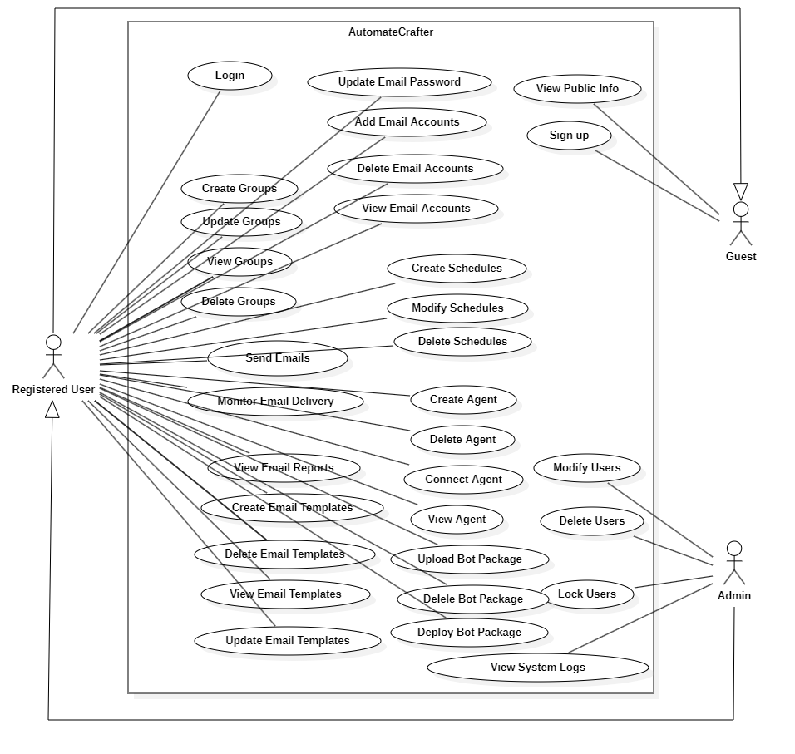

Actor | Usecase | Description of Usecase
Guest | Sign up | Register to create a new account.
User | Login | Log into the system with registered credentials.
User | Manage Email Accounts | Manage email accounts by viewing, adding, or deleting them.
User | View Email Accounts | View all linked email accounts.
User | Add Email Accounts | Add new email accounts to the system.
User | Delete Email Accounts | Remove unnecessary email accounts.
User | Manage Email Templates | Create, edit, or delete email templates.
User | View Email Templates | Browse existing email templates.
User | Add Email Templates | Create and add new email templates.
User | Delete Email Templates | Remove unused or irrelevant email templates.
User | Edit Email Templates | Modify the content or design of existing email templates.
User | Set Up Recurring Email Schedule | Configure recurring email schedules.
User | Customize Recurring Email Content | Personalize content for recurring emails.
Admin | Manage User | Manage user accounts by adding, editing, or deleting them.
Admin | Manage Recurring Email Schedule | Oversee and adjust recurring email schedules for all users.

Class Diagram
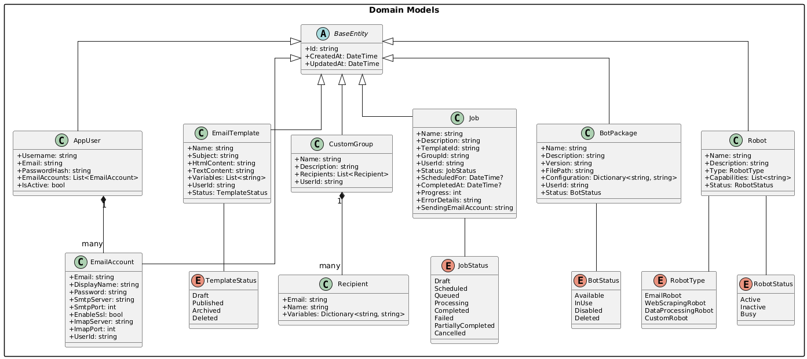
Figure 1. Domain Models Class Diagram

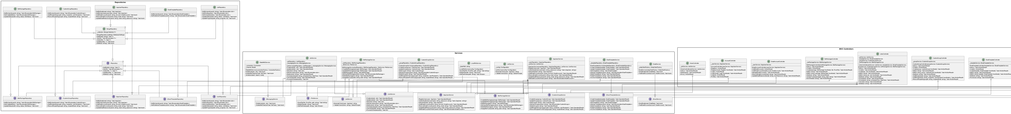
Figure 2. Repositories - Controllers - Services Class Diagram

Sequence Diagram
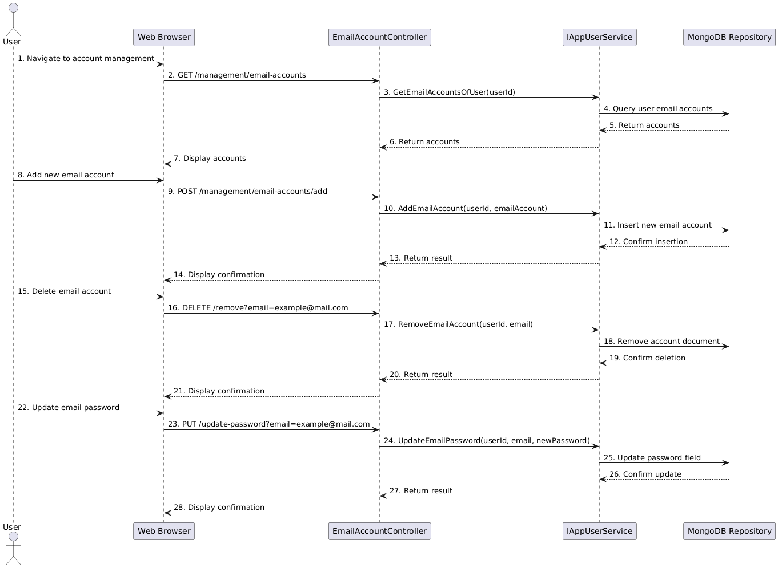
Figure 3. User Email Account Management Sequence Diagram

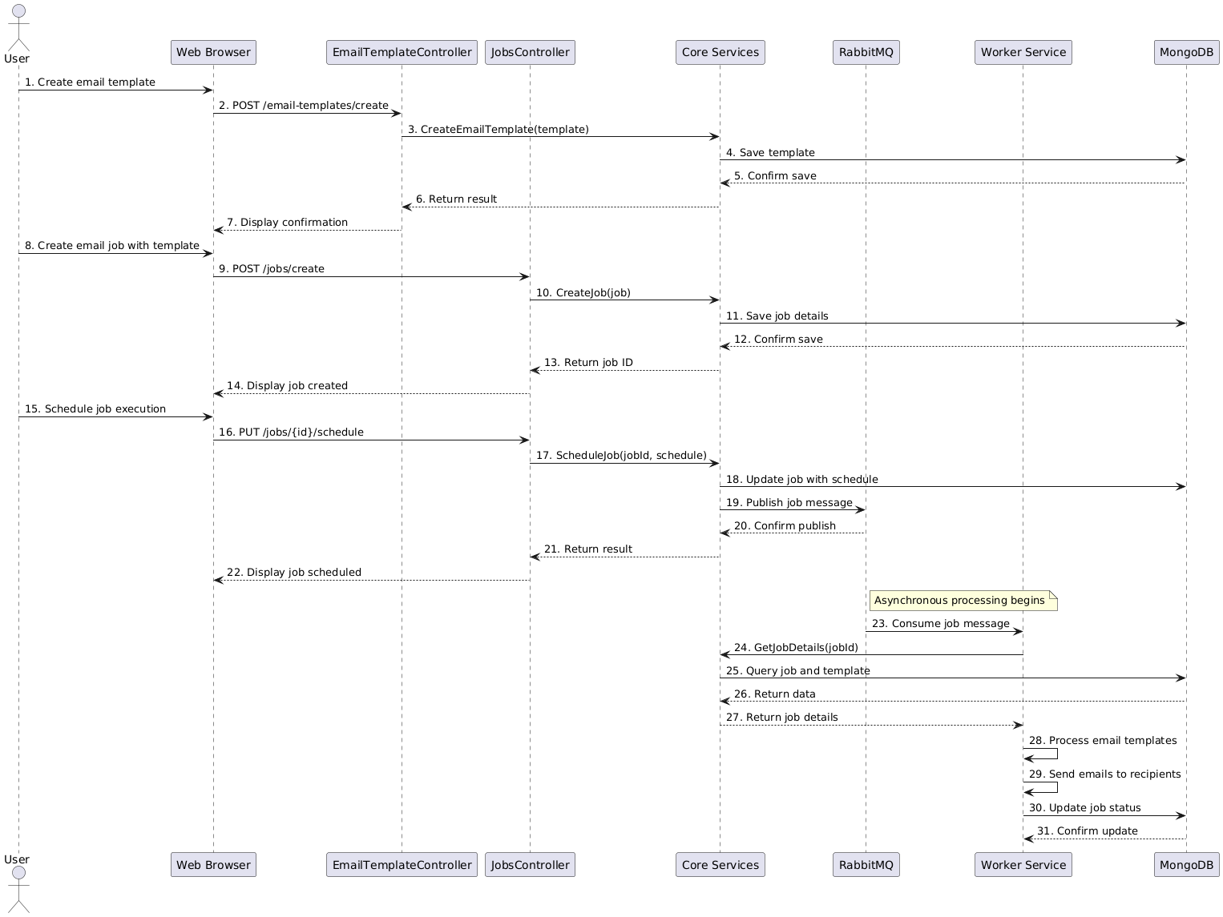
Figure 4. Email Campaign Creation and Scheduling Sequence Diagram

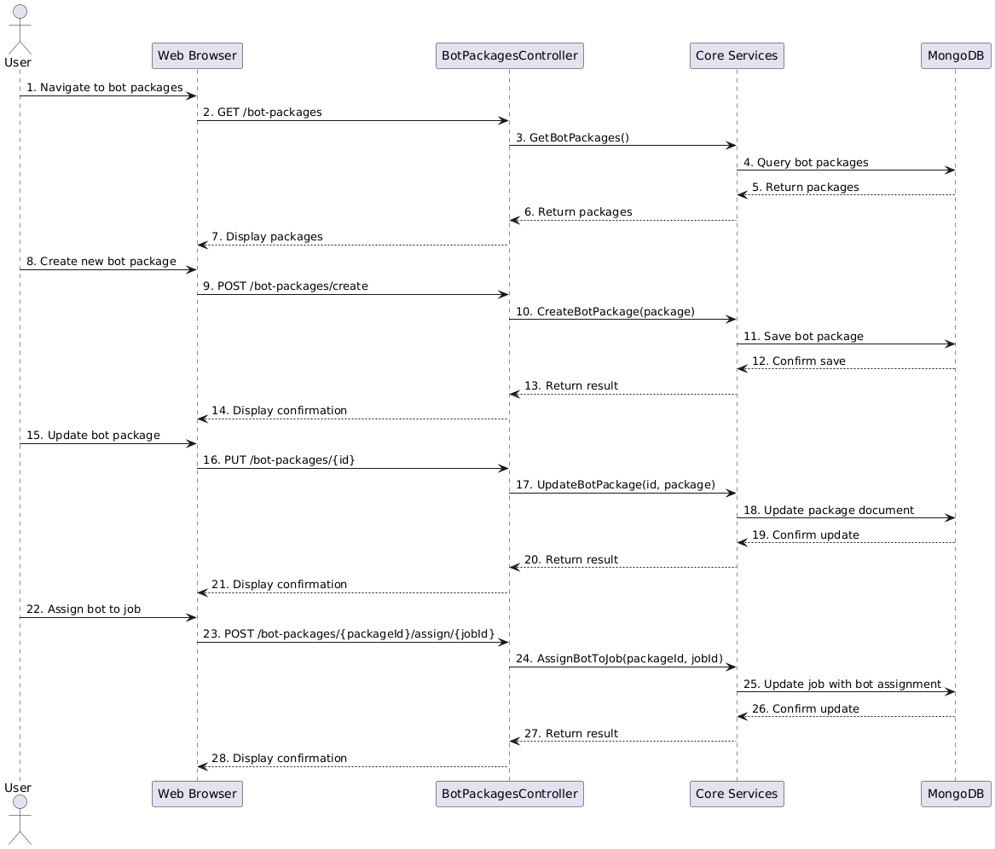
Figure 5. BotPackage Management Sequence Diagram

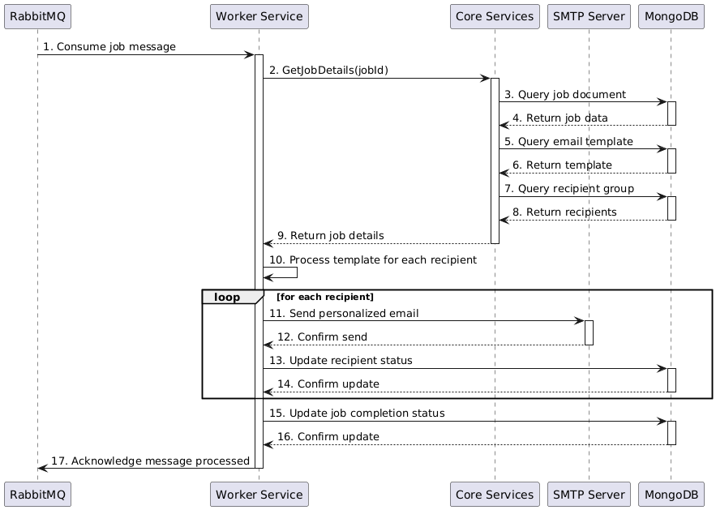
Figure 6. Worker Service Sequence Diagram

