**Microservices**

**# Creating Microservices for account and loan**

**microservices 🡪 account**

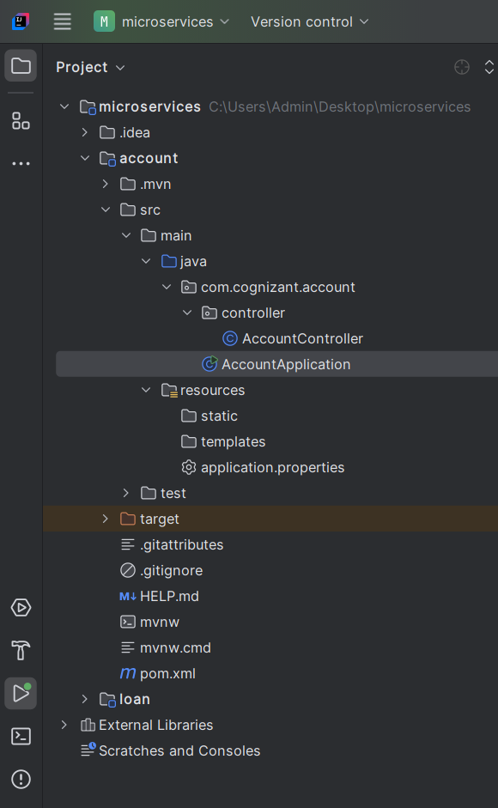

**## resources.application.properties**

spring.application.name=account  
server.port=8082

**##** **com.cognizant.account.controller.AccountController.java**

package com.cognizant.account.controller;  
  
import org.springframework.web.bind.annotation.GetMapping;  
import org.springframework.web.bind.annotation.PathVariable;  
import org.springframework.web.bind.annotation.RequestMapping;  
import org.springframework.web.bind.annotation.RestController;  
  
@RestController  
@RequestMapping("/accounts")  
public class AccountController {  
  
 @GetMapping("/{number}")  
 public Account getAccount(@PathVariable String number){  
 return new Account(number, "savings", 234343);  
 }  
  
 static class Account{  
 private String number;  
 private String type;  
 private double balance;  
  
 public Account(String number, String type, double balance) {  
 this.number = number;  
 this.type = type;  
 this.balance = balance;  
 }  
  
 public String getNumber() {  
 return number;  
 }  
  
 public String getType() {  
 return type;  
 }

public double getBalance() {  
 return balance;  
 }  
 }  
}

**## com.cognizant.account.AccountApplication.java**

package com.cognizant.account;  
  
import org.springframework.boot.SpringApplication;  
import org.springframework.boot.autoconfigure.SpringBootApplication;  
  
@SpringBootApplication  
public class AccountApplication {  
  
 public static void main(String[] args) {  
 SpringApplication.*run*(AccountApplication.class, args);  
 }  
}

**## pom.xml**

<?xml version="1.0" encoding="UTF-8"?>  
<project xmlns="http://maven.apache.org/POM/4.0.0" xmlns:xsi="http://www.w3.org/2001/XMLSchema-instance"  
 xsi:schemaLocation="http://maven.apache.org/POM/4.0.0 https://maven.apache.org/xsd/maven-4.0.0.xsd">  
 <modelVersion>4.0.0</modelVersion>  
 <parent>  
 <groupId>org.springframework.boot</groupId>  
 <artifactId>spring-boot-starter-parent</artifactId>  
 <version>3.5.3</version>  
 <relativePath/> <!-- lookup parent from repository -->  
 </parent>  
 <groupId>com.cognizant</groupId>  
 <artifactId>account</artifactId>  
 <version>0.0.1-SNAPSHOT</version>  
 <name>account</name>  
 <description>Demo project for Spring Boot</description>  
 <url/>  
 <licenses>  
 <license/>  
 </licenses>  
 <developers>  
 <developer/>  
 </developers>  
 <scm>  
 <connection/>  
 <developerConnection/>  
 <tag/>  
 <url/>  
 </scm>  
 <properties>  
 <java.version>24</java.version>  
 </properties>  
 <dependencies>  
 <dependency>  
 <groupId>org.springframework.boot</groupId>  
 <artifactId>spring-boot-starter-web</artifactId>  
 </dependency>  
  
 <dependency>  
 <groupId>org.springframework.boot</groupId>  
 <artifactId>spring-boot-devtools</artifactId>  
 <scope>runtime</scope>  
 <optional>true</optional>  
 </dependency>  
 <dependency>  
 <groupId>org.springframework.boot</groupId>  
 <artifactId>spring-boot-starter-test</artifactId>  
 <scope>test</scope>  
 </dependency>  
 </dependencies>  
  
 <build>  
 <plugins>  
 <plugin>  
 <groupId>org.springframework.boot</groupId>  
 <artifactId>spring-boot-maven-plugin</artifactId>  
 </plugin>  
 </plugins>  
 </build>  
  
</project>

**microservices 🡪 loan**

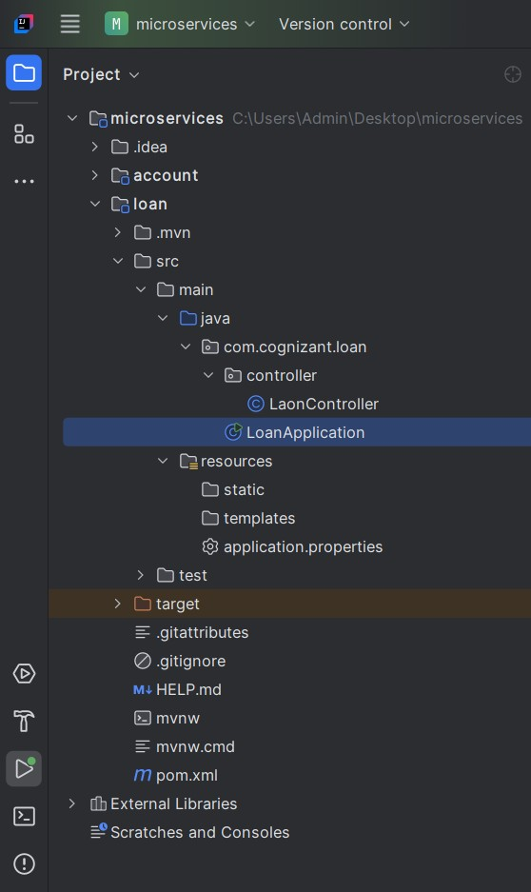

**## resources.application.properties**

spring.application.name=loan  
server.port=8081

**## com.cognizant.loan.controller.LoanController.java**

package com.cognizant.loan.controller;  
  
import org.springframework.web.bind.annotation.GetMapping;  
import org.springframework.web.bind.annotation.PathVariable;  
import org.springframework.web.bind.annotation.RequestMapping;  
import org.springframework.web.bind.annotation.RestController;  
  
@RestController  
@RequestMapping("/loans")  
public class LaonController {  
  
 @GetMapping("/{number}")  
 public Loan getLoan(@PathVariable String number){  
 return new Loan(number, "car", 400000, 3258, 18);  
 }  
  
 static class Loan{  
 private String number;  
 private String type;  
 private double loan;  
 private double emi;  
 private int tenure;  
  
 public Loan(String number, String type, double loan, double emi, int tenure) {  
 this.number = number;  
 this.type = type;  
 this.loan = loan;  
 this.emi = emi;  
 this.tenure = tenure;  
 }  
  
 public String getNumber() {  
 return number;  
 }  
  
 public String getType() {  
 return type;  
 }  
  
 public double getLoan() {  
 return loan;  
 }  
  
 public double getEmi() {  
 return emi;  
 }  
  
 public int getTenure() {  
 return tenure;  
 }  
 }  
}

**## com.cognizant.loan.LoanApplication.java**

package com.cognizant.loan;  
  
import org.springframework.boot.SpringApplication;  
import org.springframework.boot.autoconfigure.SpringBootApplication;  
  
@SpringBootApplication  
public class LoanApplication {  
  
 public static void main(String[] args) {  
 SpringApplication.*run*(LoanApplication.class, args);  
 }  
}

**## pom.xml**

<?xml version="1.0" encoding="UTF-8"?>  
<project xmlns="http://maven.apache.org/POM/4.0.0" xmlns:xsi="http://www.w3.org/2001/XMLSchema-instance"  
 xsi:schemaLocation="http://maven.apache.org/POM/4.0.0 https://maven.apache.org/xsd/maven-4.0.0.xsd">  
 <modelVersion>4.0.0</modelVersion>  
 <parent>  
 <groupId>org.springframework.boot</groupId>  
 <artifactId>spring-boot-starter-parent</artifactId>  
 <version>3.5.3</version>  
 <relativePath/> <!-- lookup parent from repository -->  
 </parent>  
 <groupId>com.cognizant</groupId>  
 <artifactId>loan</artifactId>  
 <version>0.0.1-SNAPSHOT</version>  
 <name>loan</name>  
 <description>Demo project for Spring Boot</description>  
 <url/>  
 <licenses>  
 <license/>  
 </licenses>  
 <developers>  
 <developer/>  
 </developers>  
 <scm>  
 <connection/>  
 <developerConnection/>  
 <tag/>  
 <url/>  
 </scm>  
 <properties>  
 <java.version>24</java.version>  
 </properties>  
 <dependencies>  
 <dependency>  
 <groupId>org.springframework.boot</groupId>  
 <artifactId>spring-boot-starter-web</artifactId>  
 </dependency>  
  
 <dependency>  
 <groupId>org.springframework.boot</groupId>  
 <artifactId>spring-boot-devtools</artifactId>  
 <scope>runtime</scope>  
 <optional>true</optional>  
 </dependency>  
 <dependency>  
 <groupId>org.springframework.boot</groupId>  
 <artifactId>spring-boot-starter-test</artifactId>  
 <scope>test</scope>  
 </dependency>  
 </dependencies>  
  
 <build>  
 <plugins>  
 <plugin>  
 <groupId>org.springframework.boot</groupId>  
 <artifactId>spring-boot-maven-plugin</artifactId>  
 </plugin>  
 </plugins>  
 </build>  
</project>

**## Output**

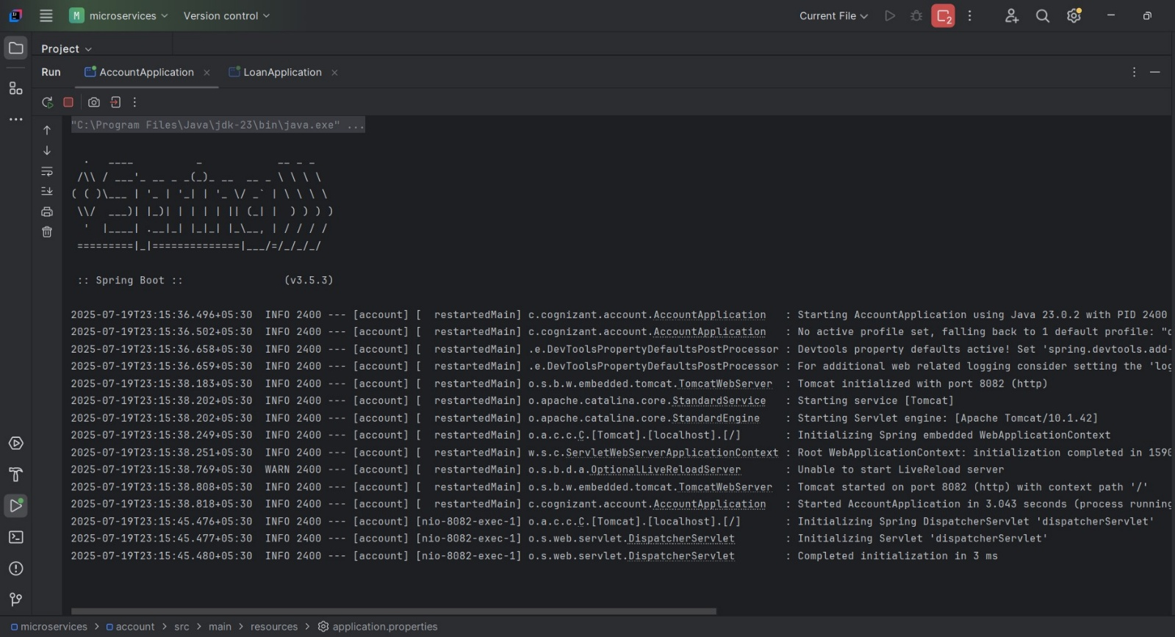**com.cognizant.account.AccountApplication.java**

**http://localhost:8082/accounts/00987987973432**

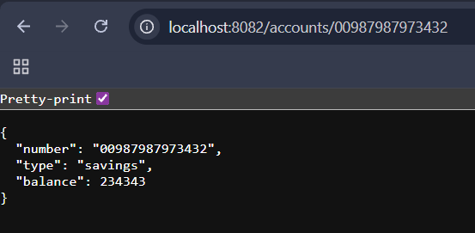

**com.cognizant.loan.LoanApplication.java**

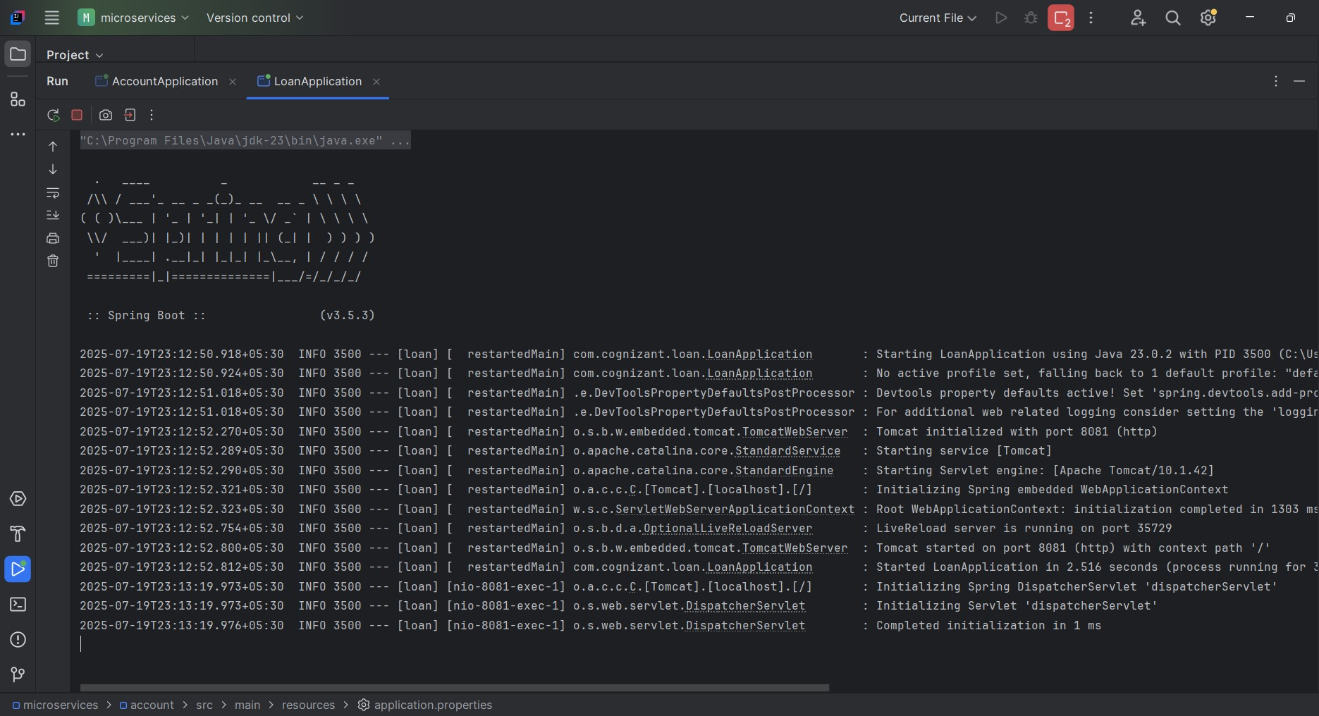

**http://localhost:8081/loans/H00987987972342**

